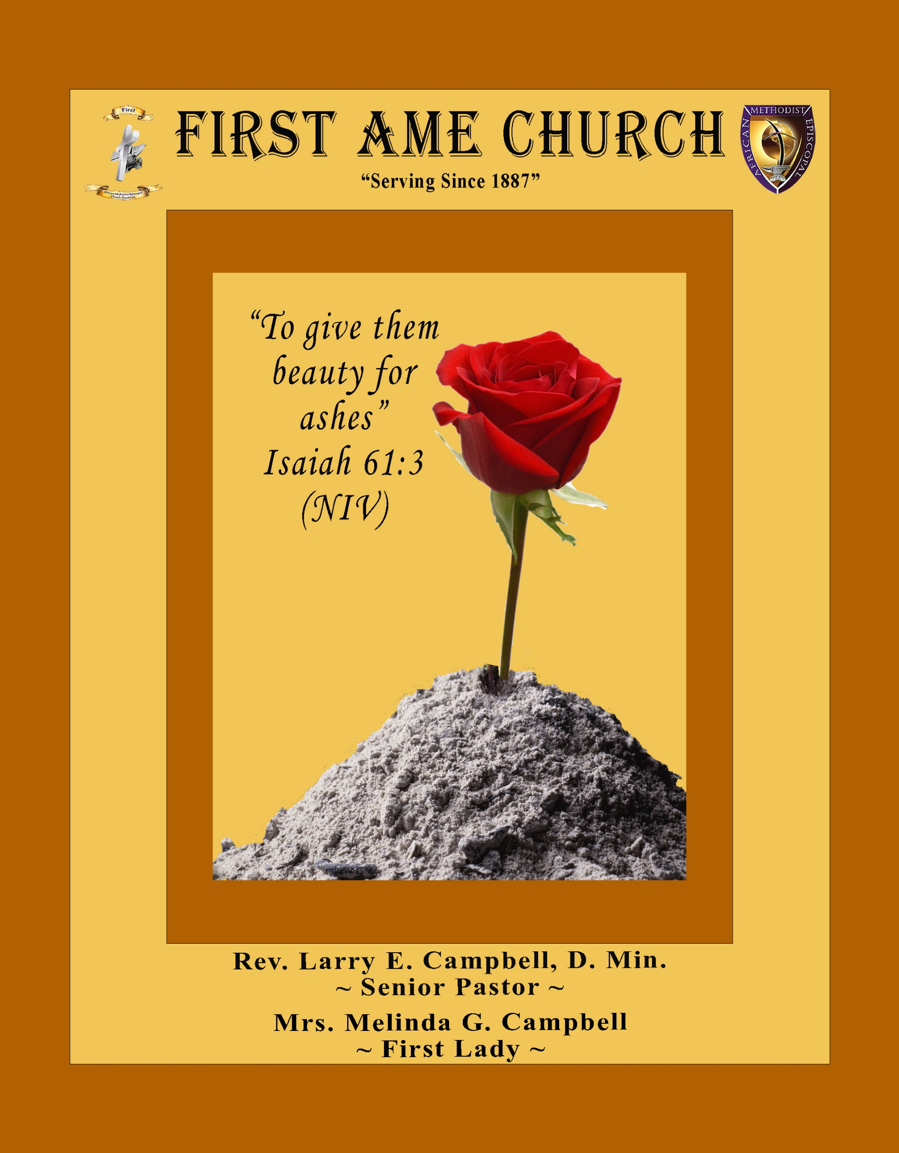
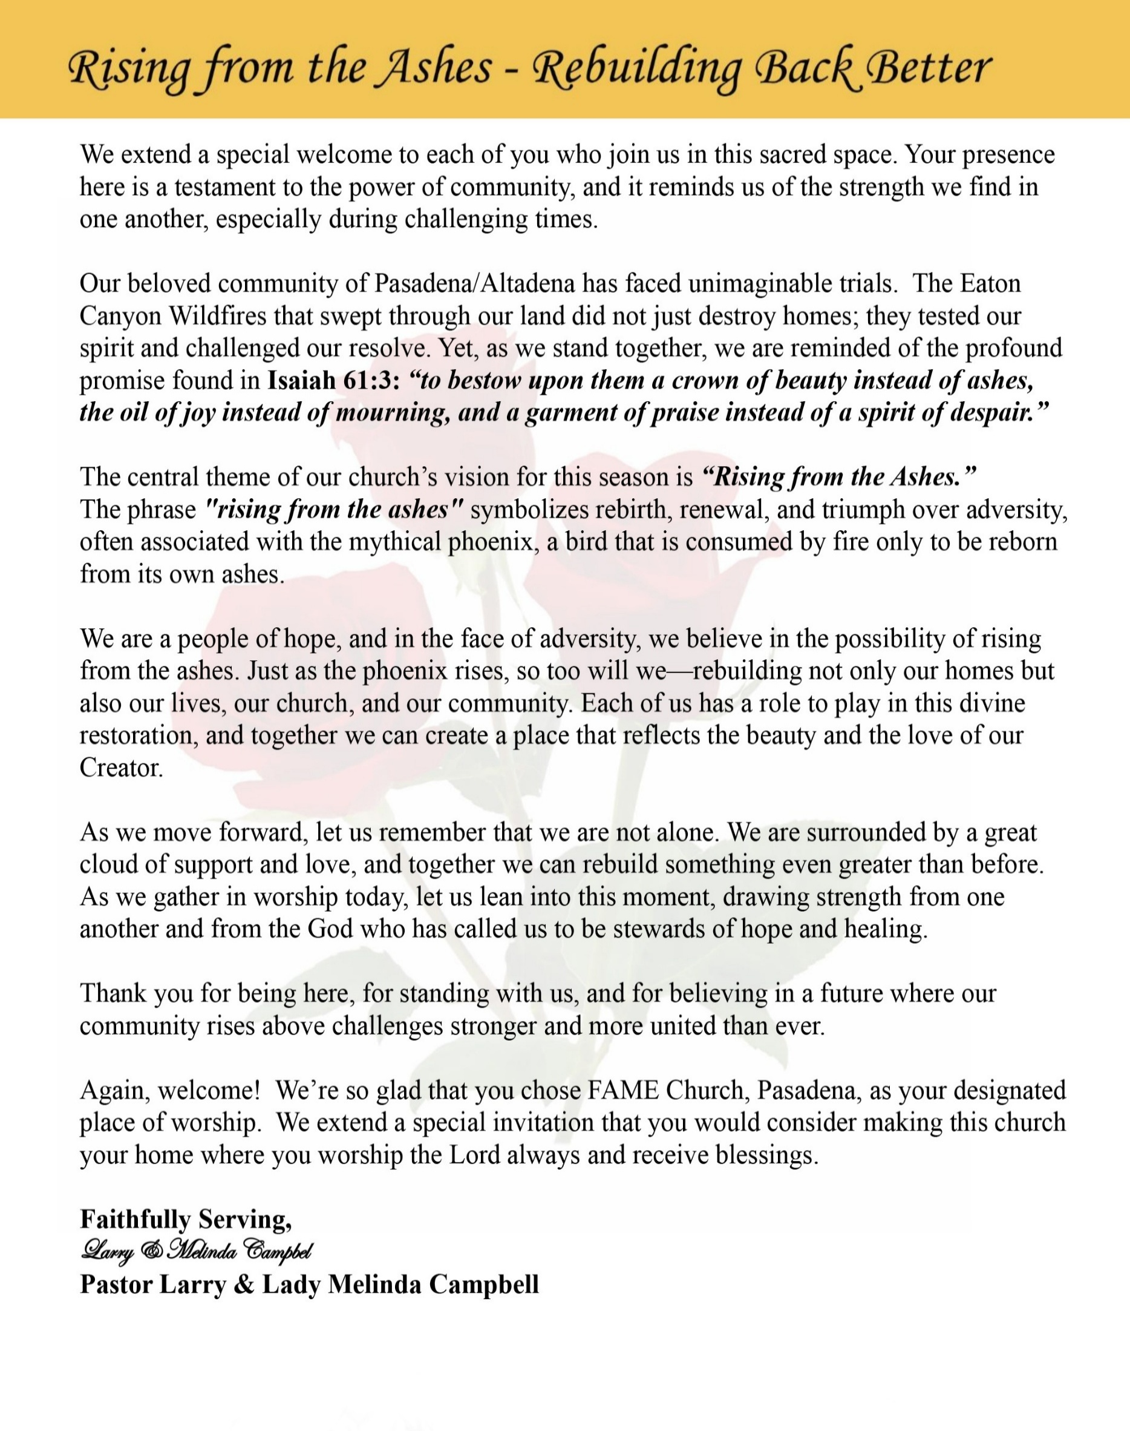

Sunday, September 6, 2026 | 9:30 a.m.

Rt. Rev. Francine A. Brookins, Esq., Presiding Bishop
Rev. Miriam Burnett, MD, MPH, Supervisor of Missions
Rev. Roosevelt Lindsey, Jr. Presiding Elder

The Rev. Dr. Larry E. Campbell ~ Senior Pastor ~ Minister

Mobile: (951) 587-1894 ~ Email: larrycampbell@famepasadena.org

Our First Lady: Mrs. Melinda G. Campbell

The Reverend Dr. Jennifer Oliver ~ Itinerant Elder -
The Reverend Dr. Nikia Smith-Robert ~ Itinerant Elder (Affiliated)
The Reverend Lois Woodard ~ Itinerant Elder Superannuated (Retired)
The Reverend Rochelle Wright Moore ~ Itinerant Deacon
The Reverend Deborah West-Jones ~ Local Elder
The Reverend Philis J. Griffin, MDiv ~ Local Elder
Dr. Phyllis Beech ~ Evangelist
Sister Tessie Bonner ~ Deaconess

Community Resource Center Director ~ Ms. Kischchen Hazelton Venerable
Church Administrative Assistant: Ms. Letha Rhymes

Church Office Hours:
Tue - Wed 9:00 am - 5:00 pm, & Fri 9:00 am -3:00 pm.
Closed for Lunch Daily: 12:00 pm - 1:00 pm.

Music Ministry
Dr. Timothy Davis, Minister of Music
Bro. Jimmy Watlington, Percussionist ~ Bro. Carlos Caldwell, Organist
Bro. Darien Dorsey, Keyboardist
Sis. Karen Law, Women’s Chorus Director ~ Sis. Tonia Graham, Children’s Choir Director
Bro. J. Renard Washington, New Generation’s Choir

FREE WI-FI service is available on the FAME Campus by accessing FAME 1700
Password: 6267980503

-3-

~ Order of Worship Experience ~

Warning: This order of worship is subject to change without warning or prior notice --- everything is governed by the Sovereignty of the Holy Spirit



+++ The Altar Call +++
Praise & Worship

Doxology: “Praise God From Whom All Blessings Flow”

The Call to Worship Pastor Larry E. Campbell

Leader: I was glad when they said unto me, let us go into the house of the Lord, our feet shall stand within Thy gates O Jerusalem! (Psalm 122:1)

People: For a day in Thy courts is better than a thousand. I had rather be a doorkeeper in the house of my God than to dwell in the tents of wickedness. (Psalm 84:10)

Leader: Because of the house of the Lord our God, I will seek Thy good.
(Psalm 122:9)

People: Those that be planted in the house of the Lord, shall flourish in the courts of our God. (Psalm 92:13)

Leader: Blessed are they that dwell in Thy house. Lord, I have loved Thy habitation, the place where Thy honor dwelleth. (Psalm 26:8)

People: For the Lord is in His holy temple; let all the earth keep silence before Him.
(Habakkuk 2:20).

Leader: Let the words of my mouth and the meditation of my heart, be acceptable in Thy sight, O Lord my strength and my redeemer. (Psalm 19:14)

Unison: O Sing unto the Lord a new song, for He has done marvelous things. Make a
joyful noise unto the Lord, all the earth, sing His praises. (Psalm 98:1, 4)

-4-

The Hymn of Praise A.M.E. Hymnal of #405

What Can Wash Away My Sins
Nothing but the Blood

1 What can wash away my sin?
Nothing but the blood of Jesus.
What can make me whole again?
Nothing but the blood of Jesus.

Refrain:
O precious is the flow
that makes me white as snow;
no other fount I know;
nothing but the blood of Jesus.

2 For my pardon this I see:
nothing but the blood of Jesus.
For my cleansing this my plea:
nothing but the blood of Jesus.
[Refrain]

3 Nothing can for sin atone:
nothing but the blood of Jesus.
Naught of good that I have done:
nothing but the blood of Jesus.
[Refrain]

4 This is all my hope and peace:
nothing but the blood of Jesus.
This is all my righteousness:
nothing but the blood of Jesus.
[Refrain]

The Invocation Rev. Dr. Nikia Smith Robert

Ministry of Music The Mass Choir

-5-

Responsive Scripture Lesson Rev. Deborah West-Jones
(Please Stand for the Reading of God’s Words)
Exodus 16:1-18 (New International Version) — Manna and Quail
Leader: The whole Israelite community set out from Elim and came to the Desert of Sin, which is
between Elim and Sinai, on the fifteenth day of the second month after they had come out of
Egypt.

People: ² In the desert the whole community grumbled against Moses and Aaron. ³ The Israelites
said to them, “If only we had died by the Lord’s hand in Egypt! There we sat around pots
of meat and ate all the food we wanted, but you have brought us out into this desert to
starve this entire assembly to death.”

Leader: ⁴ Then the Lord said to Moses, “I will rain down bread from heaven for you. The people are to go
out each day and gather enough for that day. In this way I will test them and see whether they
will follow my instructions. ⁵ On the sixth day they are to prepare what they bring in, and that is
to be twice as much as they gather on the other days.”

People: ⁶ So Moses and Aaron said to all the Israelites, “In the evening you will know that it was
the Lord who brought you out of Egypt, ⁷ and in the morning you will see the glory of
the Lord, because he has heard your grumbling against him. Who are we, that you should
grumble against us?”

Leader: ⁸ Moses also said, “You will know that it was the Lord when he gives you meat to eat in the
evening and all the bread you want in the morning, because he has heard your grumbling against
him. Who are we? You are not grumbling against us, but against the Lord.”

People: ⁹ Then Moses told Aaron, “Say to the entire Israelite community, ‘Come before the Lord,
for he has heard your grumbling.’”

Leader: ¹⁰ While Aaron was speaking to the whole Israelite community, they looked toward the desert,
and there was the glory of the Lord appearing in the cloud.

People: ¹¹ The Lord said to Moses, ¹² “I have heard the grumbling of the Israelites. Tell them, ‘At
twilight you will eat meat, and in the morning you will be filled with bread. Then you will
know that I am the Lord your God.’”

Leader: ¹³ That evening quail came and covered the camp, and in the morning there was a layer of
dew around the camp. ¹⁴ When the dew was gone, thin flakes like frost on the ground appeared
on the desert floor. ¹⁵ When the Israelites saw it, they said to each other, “What is it?” For they
did not know what it was.

People: Moses said to them, “It is the bread the Lord has given you to eat. ¹⁶ This is what the Lord
has commanded: ‘Everyone is to gather as much as they need. Take an omer for each person you have in your tent.’”

Leader: ¹⁷ The Israelites did as they were told; some gathered much, some little.

Unison: ¹⁸ And when they measured it by the omer, the one who gathered much did not have too
much, and the one who gathered little did not have too little. Everyone had gathered just as
much as they needed.

-6-

THE AFFIRMATION OF FAITH (The Apostle Creed)

Minister: What do you Believe?

People: I believe in God the Father Almighty, Maker of heaven and earth, and in Jesus
Christ His only son our Lord who was conceived by the Holy Spirit, born of the Virgin Mary, suffered under Pontius Pilate, was crucified, dead and buried. The third day he arose from the dead; he ascended into heaven and sitteth at the right hand of God the Father Almighty; from thence he shall come to judge the quick and the dead. I believe in the Holy Spirit, the Church Universal, the communion of saints, the forgiveness of sins, the resurrection of the body and the life everlasting. Amen.
THE PRELUDE TO THE DECALOGUE

“From all that dwell below the skies, Let the Creator’s praise arise;
Let the Redeemer’s name be sung. Through every land, by every tongue.”

THE DECALOGUE (An Affirmation of God’s Law)

Minister: Let us express our commitment to keep God’s Law

People: God of our salvation, only You are God.
We will make no idols.
We will not invoke with malice your name, O God.
We will remember the Sabbath Day and keep it holy.
We will honor our father and our mother.
We will not commit murder.
We will not commit adultery.
We will not steal.
We will not be a false witness.
We will not covet anything that belongs to our neighbor.
Minister: Jesus said: “You shall love the Lord your God with all your heart, and with all your soul and with all your mind. This is the great and first commandment.”

ALL: Jesus also challenged us to love justly with a second commandment
which is like the first. We shall love our neighbor as ourselves! On these
commandments depend all the law and the prophets.

-7-

THE GLORIA PATRI
Glory be to the Father, and to the Son, and to the Holy Ghost.
As it was in the beginning, is now and ever shall be, world without end. Amen Amen!!

Abbreviated Announcements/ Visitor’s Welcome

Pastoral Remarks

The Offertory (Tithes ~ Gifts ~ Benevolent Offerings) Sis. Barbra McPheeters

In order to satisfy the steady increase of inflation, we are asking each member to consider increasing your Tithe, Offerings & Gifts.

The following Electronic GIVING Platforms are creditable methods to GIVE to FAME:

#1. GIVELIFY - Mobile Giving App available on the App Store. It’s easy to set up, just follow the guidelines.

#2. Cash App: $FirstAMEPASADENA

#3. Mail in your Tithes & Offering - If you would like to mail your tithes and offering by check or money order, please send it to: First AME Church, 1700 N. Raymond Avenue, Pasadena, CA 91103.

#4. Drop off your Tithes & Offering - During business hours in the basket outside of the office.

Choral Response: “All things come of Thee, O Lord; and of Thine own have we given Thee. Amen.”

CHILDREN’S CHURCH DISMISSAL

Sermonic Selection The Mass Choir

Proclamation of The Word: Pastor Larry E. Campbell

The Invitation (Public/Private)

-8-

The Sacrament of the Lord’s Supper or Holy Communion

THE SOLICITATION

You that do truly and earnestly repent of your sins, and are in love and charity with your neighbor, and intend to lead a new life, following the commandments of God, and walking from henceforth in His holy ways, draw near with faith and take this holy sacrament to your comfort; and make your humble confession to Almighty God.

THE GENERAL CONFESSION

Minister: Let us humbly confess our sins unto Almighty God.

Minister and People:

Almighty God, Father of our Lord Jesus Christ, Maker of all things, Judge of all men, we acknowledge and bewail our manifold sins and wickedness which we from time to time most grievously have committed by thought, word, and deed against Your divine Majesty, provoking most justly Your wrath and indignation against us. We do earnestly repent and are heartily sorry for these, our misdoings; the remembrance of them is grievous unto us. Have mercy upon us, have mercy upon us, most merciful Father for Your Son our Lord Jesus Christ’s sake; forgive us all that is past, and grant that we may ever hereafter serve and please You in newness of life, to the honor and glory of Your name through Jesus Christ our Lord.

Amen. (Choral). (You may be seated).

THE PRAYER OF PARDON

Almighty God, our Heavenly Father, who of Your great mercy has promised forgiveness of sins to all them that with hearty repentance and true faith turn unto You, have mercy upon us; pardon and deliver us from all our sins; confirm and strengthen us in all goodness; and bring us to everlasting life through Jesus Christ, our Lord.

Choral Response: Amen.

THE PRAYER OF CONSECRATION

Minister: Loving God, our Father in heaven, in Your great mercy You gave Your only Son, Jesus Christ, to die on the cross so we could be saved. Through His sacrifice — offered once and for all — He made a complete and perfect offering for the sins of the whole world. And in the gospel, He told us to keep remembering His precious death until He comes again.
So we ask You, merciful Father, hear our prayer. As we receive this bread and this cup, according to the way our Savior Jesus taught us, help us remember His suffering and death, and allow us to share in the blessing of His body and His blood.
On the night He was betrayed, Jesus took bread. After giving thanks, He broke it and gave it to His disciples, saying,
“Take and eat. This is my body, given for you. Do this to remember me.”
In the same way, after supper He took the cup. After giving thanks, He gave it to them and said,
“Drink from it, all of you. This is my blood of the new covenant, poured out for you and for many so that sins may be forgiven. Whenever you drink it, do this to remember me.” Amen!

THE LORD’S PRAYER (ALL)
THE ELEMENTS SHARED
THE BENEDICTION

-9-

ANNOUNCEMENTS
\
WELCOME! WELCOME! WELCOME! It is with great pleasure and joy that we officially welcome Sis. Lugene Haynes to the FAME Family kinship. We are truly blessed and very grateful for her presence and valued membership in our church family.

MEMORIAL SERVICE
Honoring the Life of Brother Odis “Konata” Doxey,
Thursday, September 10, 2026 |11:00 a.m. | First African Methodist Episcopal Church of Pasadena
During this difficult season of bereavement, we ask that you keep the entire Doxey family lifted in your thoughts and prayers.

FIRST A.M.E. CHURCH PASADENA
Celebrating 139 Years of Faithful Service
The Heritage Committee invites you and your family to join us in celebrating our 139th Church Anniversary. The Theme is: HONORING OUR PAST; EMBRACING OUR FUTURE. This will be a Family Affair, so please join us as we Praise God for His rich blessings on Sunday, September 13, 2026, at 9:30 AM. A wonderful meal will be served following the worship service.

Los Angeles South/ Las Vegas District Cluster
Presiding Elder Roosevelt Lindsey will hold the Fourth Quarterly Cluster on Saturday, September 19, 2026, at 10:00 a.m. The event will take place at Bryant Temple AME Church. The participating churches include Christ Our Redeemer, Bethel LA, Bethel Barstow, Brookins-Kirkland, First Pasadena, Greater Harvest, Bethel Oxnard, Brown Memorial, Walker Temple, Rose of Sharon, Johnson Chapel Santa Ana, Holy Trinity Long Beach, Bryant Temple, and Grant Long Beach. All ministers, officers, and church members are invited to attend.

FAME PASADENA IS MAKING HISTORY!
VOLUNTEERS NEEDED — THIS IS A FAMILY AFFAIR!
It is with great honor, excitement, and anticipation, FAME Pasadena will host the 102nd Session of the Southern California Annual Conference and Fifth District Planning Meeting, taking place:
Wednesday, October 21 – Tuesday, October 27, 2026, Hilton Los Angeles Airport
As we welcome clergy, delegates, lay members, and guests from across the Fifth Episcopal District, we have a wonderful opportunity to bring the spirit of Pasadena to Los Angeles through our warmth, hospitality, excellence, and Christian service. WE NEED YOU!

We are seeking dedicated volunteers to serve in the following areas:
Decorations & Hospitality Conference Registration Health & Welfare Ushers Logisticians
Prayer Room Attendants Greeters & Hospitality Transportation Stewards
📢 SPECIAL VOLUNTEER BRIEFING & REGISTRATION
A special volunteer briefing and registration will be held in the Fellowship Hall TODAY during our Sunday Community Luncheon. Please plan to attend, learn more about the various areas of service, and register to volunteer.

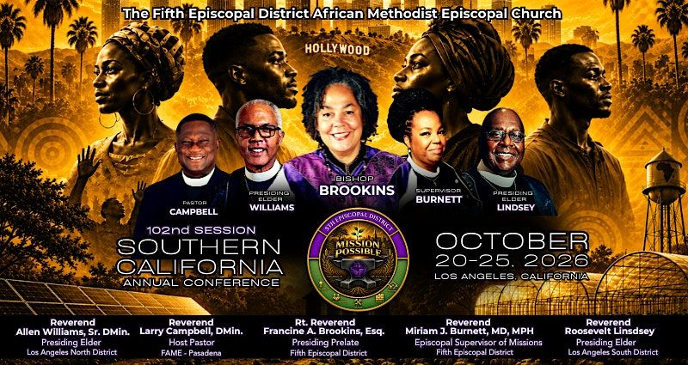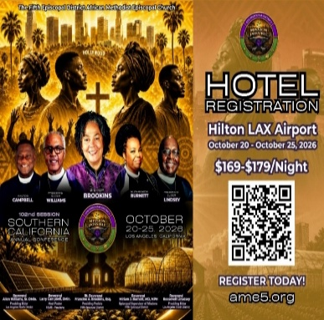

-10-

ANNOUNCEMENTS (Continued)

Official Board
Tuesday, September 29, 2026 | 7:00 p.m.

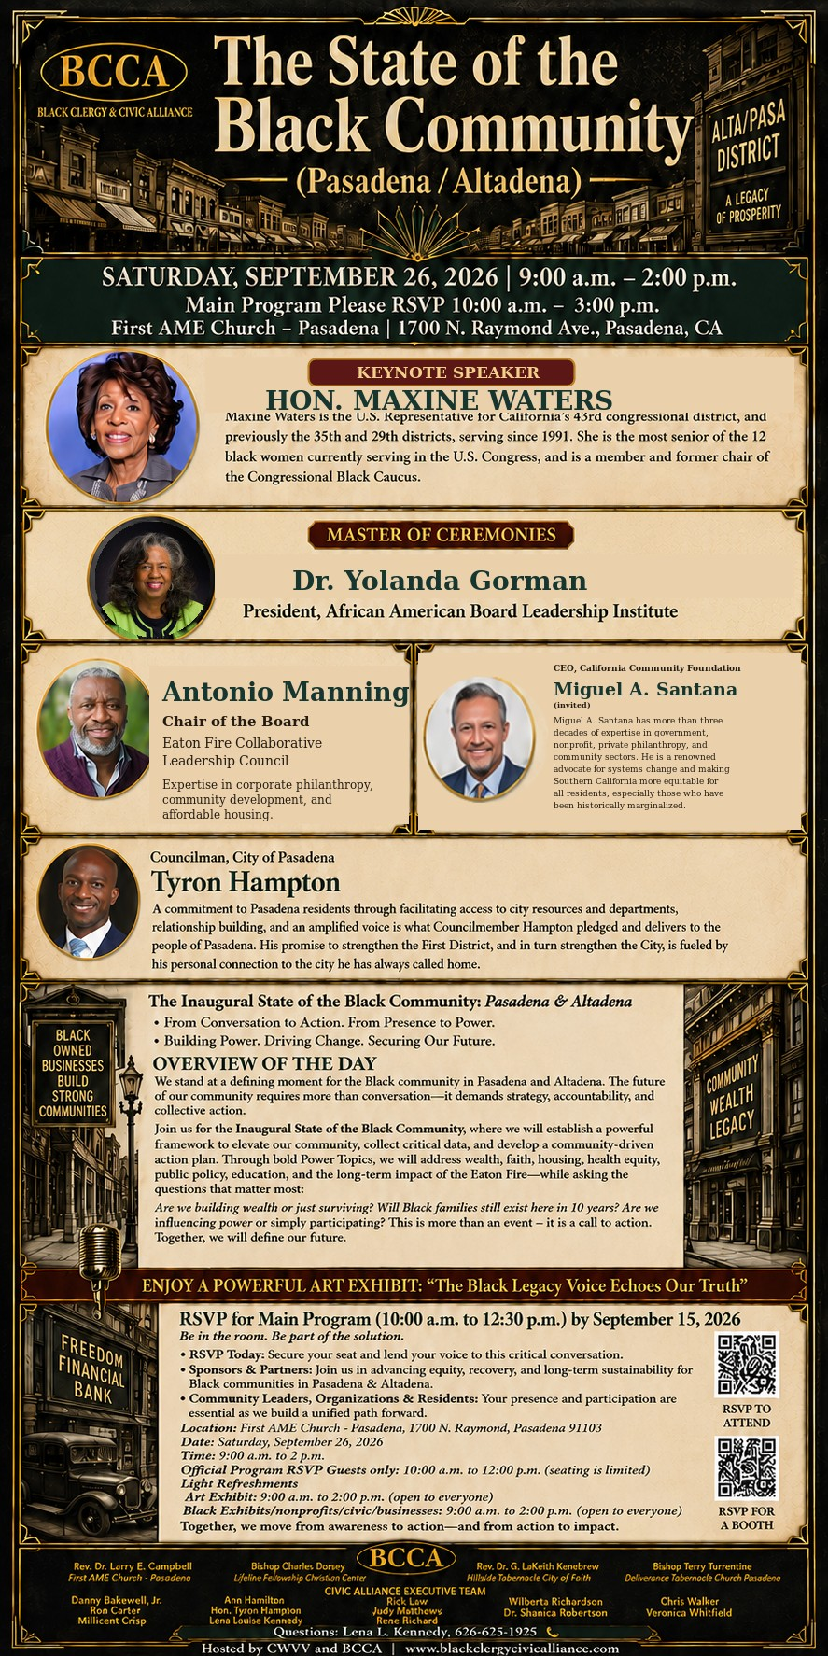

-11-

Scripture of the Day
God’s Provisions. “But my God shall supply all your need according to his riches in glory by Christ Jesus.” Philippians 4:19

Quote of the Day
“When God is your source, your supply is not determined by your circumstances.”
Author Unknown
Thought of the Week
GOD WILL PROVIDE. “The Lord is my shepherd; I shall not want.” — Psalm 23:1
A shepherd takes responsibility for the sheep. He leads them to green pastures, guides them beside still waters, protects them from danger, and makes sure they have what they need. David reminds us that God is our Shepherd—and because He is our Shepherd, we can trust His provision.
There may be seasons when we cannot see where the next blessing will come from. There may be moments when our resources seem limited and our circumstances overwhelming. But Psalm 23:1 reminds us that our provision is not determined by what we have; it is determined by who our Shepherd is.
When the Lord is your Shepherd, you may walk through valleys, but you will not walk alone. You may face uncertainty, but you do not have to live in fear. God knows what you need, God has what you need, and God is faithful to provide what you need.
Today, declare with confidence: “The Lord is my Shepherd. I will trust His guidance, depend upon His grace, and rest in His provision.”

Humor of the Week
An elderly lady handed her bank card to the teller and said, “I’d like to withdraw $10.” The teller told her, “For withdrawals under $100, please use the ATM.” The old woman wanted to know why… The teller returned her bank card and said irritably, “These are the rules, please leave if there’s nothing else. There’s a line of customers behind you.” The lady remained silent for a few seconds and returned the card to the teller and said, “Please help me withdraw all the money I have.” The teller was surprised to check the account balance. She nodded, bowed, and respectfully said, “You have $300,000 in your account, but the bank doesn’t have that much money right now. Could you make an appointment and come back tomorrow?” The old woman then asked how much she could withdraw immediately. The teller told her any amount up to $3,000. “Well, please let me have $3,000 now.” The cashier kindly handed her $3,000, very friendly and with a smile. The lady put $10 in her purse and asked the cashier to deposit $2,990 back into her account. The moral of this story is... Don't be hard on the elderly, they've spent their whole lives learning this skill.
HOME DAILY BIBLE READINGS
September 7, 2026 – September 13, 2026 (Week 51, 2 John)
Monday Day 351 Hebrews 5-6, Proverbs 29
Tuesday Day 352 Hebrews 7-8, Proverbs 30
Wednesday Day 353 Hebrews 9-10, Proverbs 31
Thursday Day 354 Hebrews 11, Ecclesiastes 1
Friday Day 355 Hebrews 12-13, Ecclesiastes 2
Saturday Day 356 James 1-5, Ecclesiastes 3
Sunday Day 357 1 Peter 1-5, Ecclesiastes 4

-12-

Prayer Request(s)
Please notify the Church Office of Sick & Shut-in additions, deletions, or status/address changes.

Bishop Francine A. Brookins, Esq. Supervisor Miriam Burnett, MD Presiding Elder Roosevelt & Dr. Kaye Lindsey Rev. Dr. Larry & Melinda Campbell Richard Craig Hazel Clark Erica Woodard Jason Shirley Joshua Shirley Julian Shirley Ayanna Terry Cheryl Jamerson Gwendolyn Flowers Andrea Anderson Ocilda Files Danielle Clark Rev. Charles Brooks Kimberly Woods Cynithia Grace Calle Burns Noel Johnson The Taylor Family
Zechariah Robinson Christopher McCarthy Wilma Haynes Jacquelyn Walker Brittney Petty Selene Cox Deborah Burton Nettie McChristen The Caple Family Mel Beech Michael Dotson
Rev. Rochelle Moore Lorene Butler Stella Pulliam Collette Blizzard The Eaton Canyon Fire Victims

College Students

Let’s continue to support and pray for our beloved College Students

Isaiah Crowell Alecia Davis Chase Johnson Grant Blizzard Gabriel Blizzard

Tyler Johnson Richard Jones Tyrikk Lawson Makia Rose Talbert Isaiah Ringo Journey Rogers Elyse Sharp Kylee Sharp Zion Otano Elise Tervalon Grace Jones Jordan Patterson Kimberly Robinson Donovan Williams Jasmine Collins Brandon Bates

Sick and Shut-Ins
Andrew Oliver 1405 N. Roosevelt Avenue, Pasadena, CA 91104
Barbara Buchanan 616 Rio Grande St. Pasadena, CA 91104
Bettina Ayers Pasadena Meadows Nursing Home, 150 Bellefontaine St., Pas., CA 91105
Betty Betts Turner 1625 S. Magnolia Ave., Unit 4125, Monrovia, CA 91016
Bobby Thomas 1052 E. Morada Place, Altadena, CA 91001
Diane Jordan 1719 Fremont Ave., #302, S. Pasadena, CA 91030
Donita Towler 14148 Francisquito Ave., Baldwin Park, CA 91706
Doris Curd 11619 Woodcock Avenue, San Fernando, CA 91340
Edmund Riddle Active Care Mission Bay, 2440 Grand Avenue, San Diego, CA 92109
Eleanor Towler 975 E. Union Street, Unit #417, Pasadena, CA 91106
Elois Blizzard P. O. Box 3646, So. Pasadena, CA 91031
Emily Cormier-Ross 2549 La Fiesta Avenue, Altadena, CA 91001
Ernestine English 26 W. Fair Oaks Drive, Pasadena, CA 91103
Fred Caple 51 North 15th Street, Haledon, NJ 07508
Hugh Hamberry 19225 Chole Rd., Apple Valley, CA 92307
Jessie Smith 3925 S. Jones Blvd., Apt. 2118, Las Vegas, NV 89103| Spring Valley Community
Josephine Brown 15607 Saddleback Rd., Riverside, CA 92506
Lenora Moore 2445 E. Del Mar Blvd., #338, Pasadena, CA 91107
Linnie G. Nollie 2250 E. New York Drive, Altadena, CA 91001
Malika G. Hendry P. O. Box 94082, Pasadena, CA 91109
Mildred Lewis C/O Hazel Rohr, 884 W. Jane Court, Upland, CA 91786
Norma Burnett 618 Fairview Avenue, Unit #228, Arcadia, CA 91007
Opal Hampton 1030 Chevron Court, Pasadena, CA 91103
Paul Ratliff P.O. Box 40407, Pasadena, CA 91114
Virlyn Grant 15122 Orange Ave., Paramount, CA 90723
Wanda Nelson 3618 N. Fair Oaks Avenue, Altadena, CA 91001
William Hilliard 7504 Wynstone Pl., Fontana, CA 92336
Zell L. Hill 375 Barthe Drive, Pasadena, CA 91103

-13-

Sermon Notations

Scripture: _____________________________________________________________

Subject: _______________________________________________________________

Points of the Message: ___________________________________________________
_______________________________________________________________________
_______________________________________________________________________
_______________________________________________________________________
_______________________________________________________________________
_______________________________________________________________________
_______________________________________________________________________

Main Ideas of the Sermon: ________________________________________________
_______________________________________________________________________
_______________________________________________________________________
_______________________________________________________________________
_______________________________________________________________________
_______________________________________________________________________

Illustrations I want to remember: _________________________________________
_______________________________________________________________________
_______________________________________________________________________
_______________________________________________________________________
_______________________________________________________________________
_______________________________________________________________________
_______________________________________________________________________

What should I do as a result of this Sermon? ________________________________

_____________________________________________________
_____________________________________________________
_____________________________________________________
_____________________________________________________

-14-

