
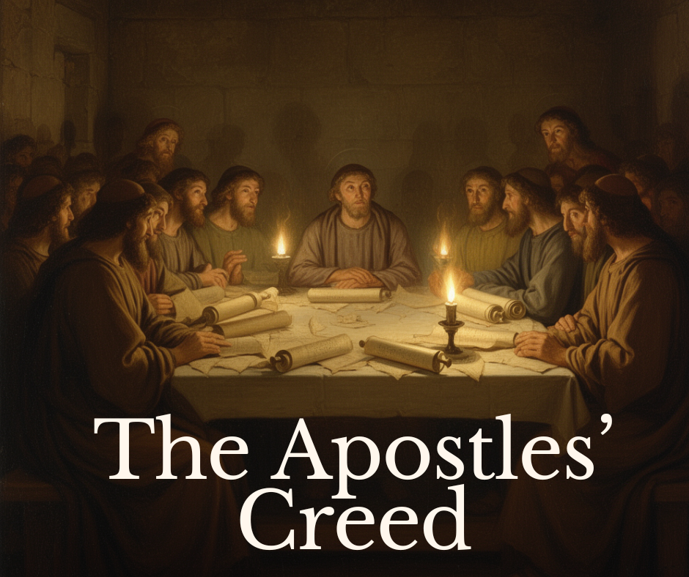

Our Mission: “To Worship God and Proclaim Jesus Christ”

Our Vision: “To Grow in Faith, so that every member will impact where they live, work, worship, and play for Jesus Christ.”
Sunday, August 16, 2026 @ 10:30 a.m.
143 S. Prospect St.
Marion, OH 43302
Rev. Michael Morris, Pastor – michael@1presby.org
Joann Roszman, Organist
Styler Buyer, Director of Finance/Office Manager – admin@1presby.org

WELCOME & ANNOUCEMENTS

*CALL TO WORSHIP:
In the name of the Father, and of the Son, and of the Holy Spirit.
Amen.
Alleluia! Christ is risen!
He is risen indeed! Alleluia!
You make known to me the path of life;
in Your presence there is fullness of joy.
Christ has been raised from the dead,
the first fruits of those who have fallen asleep.
Alleluia! Christ is risen!
He is risen indeed! Alleluia!

*PRAISE TEAM: (1) Raise A Hallelujah
The Ushers will pick up your prayer request cards.
(2) How Great Is Our God

PRAYER OF ADORATION

VIDEO: “When It All Falls Apart”

PRAYER OF CONFESSION:
Gracious God, have mercy on us. In Your compassion forgive us our sins, known and unknown, things done and left undone. Strengthen us by Your Spirit so that we may live and serve You in newness of life, to the honor and glory of Your holy name; through Jesus Christ, our Lord. Amen.

(Please take a moment of silence to confess your own particular sins and failings)

ASSURANCE OF PARDON:
Hear the Good News of forgiveness from God’s Word – For God so loved the world that He gave His one and only Son, that whoever believes in Him shall not perish but have eternal life. For God did not send His Son into the world to condemn the world, but to save the world through Him.
Be at peace, your sins are forgiven!

*THE GLORIA PATRI:
Glory be to the Father, and to the Son, and to the Holy Ghost; As it was in
the beginning, is now, and ever shall be, world without end. Amen, Amen.

PASTORAL PRAYER

THE LORD’S PRAYER
*Please stand if you are able

INTRODUCTION OF NEW COVENANT PARTNERS

*STATEMENT OF FAITH: The Apostles’ Creed
I believe in God the Father Almighty, maker of heaven and earth,

And in Jesus Christ his only Son our Lord; who was conceived by the Holy Spirit, born of the virgin Mary, suffered under Pontius Pilate, was crucified, dead, and buried; he descended into hell; the third day he rose again from the dead; he ascended into heaven, and sits at the right hand of God the Father Almighty; from there he shall come to judge the living and the dead.

I believe in the Holy Spirit; the holy catholic church; the communion of saints; the forgiveness of sins; the resurrection of the body; and the life everlasting. Amen.

PRESENTING OUR GIFTS TO GOD:
Offertory: Simple Gifts Arr by Russell Schultz-Widmar

*DOXOLOGY
Praise God from whom all blessings flow, praise Him all creatures here below. Praise Him above ye heavenly host. Praise Father, Son, and Holy Ghost. Amen.

*PRAYER OF THANKSGIVING

THE FIRST SCRIPTURE READING: Isaiah 25:1-12

MOMENTS WITH CHILDREN
After Moments with Children, those who are kindergarten age and younger,
may go to Worship Child Care located downstairs.
All other children are asked to return to their seats to worship with their families.

THE SECOND SCRIPTURE READING: 1 Corinthians 15: 50-58

MESSAGE: Rev. Michael Morris
“The Forgiveness of Sins, the Resurrection of the Body, and the Life Everlasting”

*HYMN: We Come, O Christ, to You #110

*BENEDICTION

*POSTLUDE: Siciliana by William Walong



YOUTH FELLOWSHIP OUTING

All youth in grades 6th - 12th are invited! Pizza and Bowling
TODAY, Sunday, August 16th at 4 p.m.
Bluefusion Fun Center
Bring a Friend!
(Be sure to have socks for bowling.)


The August craft will be String Art
led by Cassy Lutz.
It will be held on Sunday, August 30th
from 2:00 p.m. – 4:00 p.m.
All supplies will be provided.
Please bring a hammer if you have one.
You may bring a treat to share.
Sign up and check the display
near the Library Annex.


The Church Picnic….

will be on Sunday, August 23rd at McKinley Park. Please bring a main dish, salad or dessert to share as well as a lawn chair. Hamburgers, hotdogs, paper products and drinks will be furnished. The worship music will start at 10 a.m. After the meal there will be Euchre, cornhole, and other things to do to continue our fellowship together. In case of rain everything will be held at the church.


A Special Thank You…

to Mary Ann Jenkins, Jeannette Ferguson, and Jana Bartram for purchasing, organizing, planting, and weeding the flower bed near the Tower Entrance of our church. Their work earned 2nd place in the Downtown Marion INC’s Adopt – a – flowerbed Program. Good Job Ladies!


COFFEE TIME & FELLOWSHIP

August 16th – Jan Garverick on behalf of the Deacons

August 23rd – Church Picnic

August 30th – Jim Schertzer on behalf of B & G Committee

September 6th – OPEN

September 13th – Session

If anyone would like to sign up for Fellowship please do so in the Reception Room or reach out to the church office @ 740-382-9545.


August 16th
#3 – Bridget Chivington
#4 – Georg Anne Cunningham
Balcony – Patty Muir
Elevator – Gayle Sutherin

August 23rd
Gayle Sutherin
Bridget Chivington
Deb Thibaut



Worship Committee – Monday, August 17th @ 5 p.m.

Session – Wednesday, August 19th @ 6:30 p.m.



AUGUST – Jan Garverick

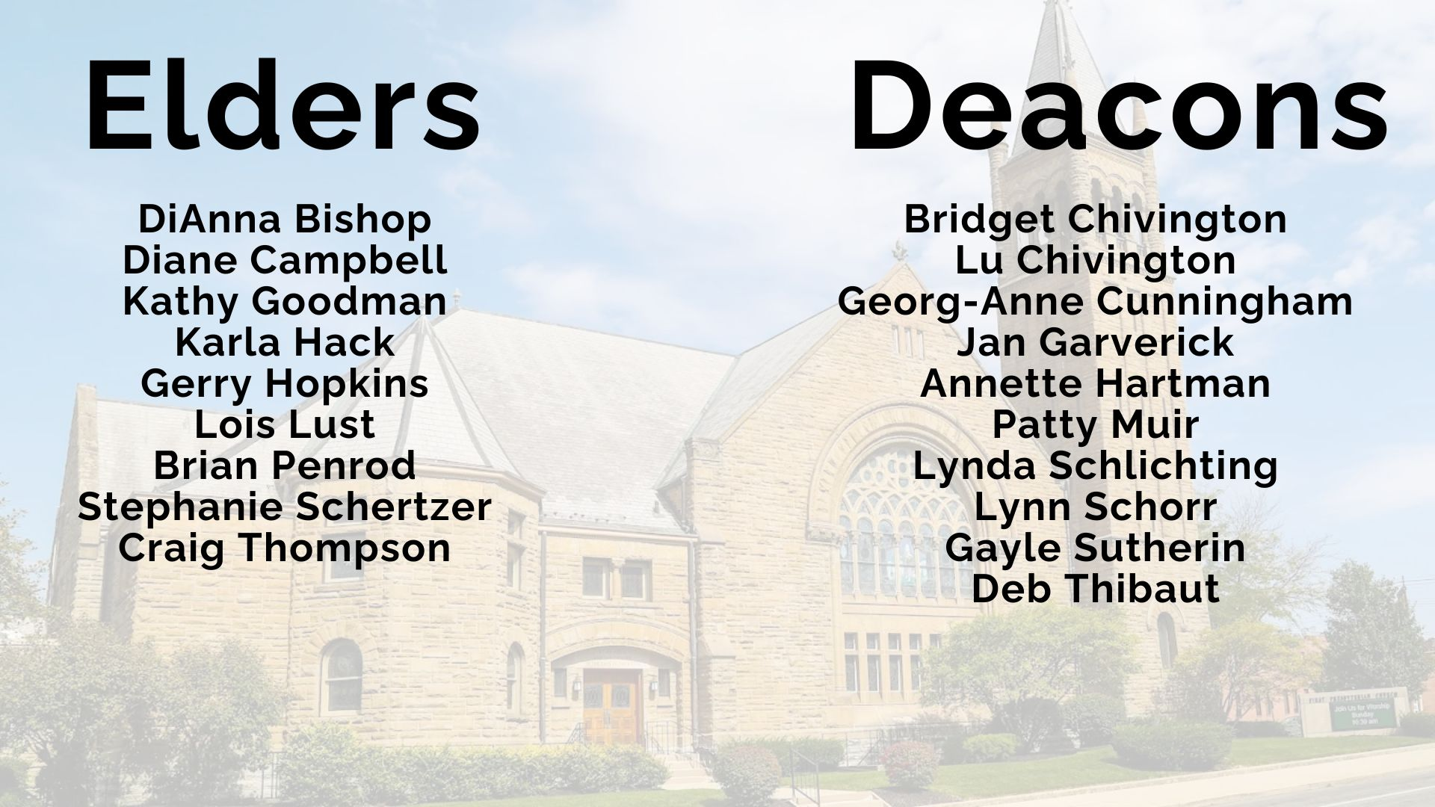

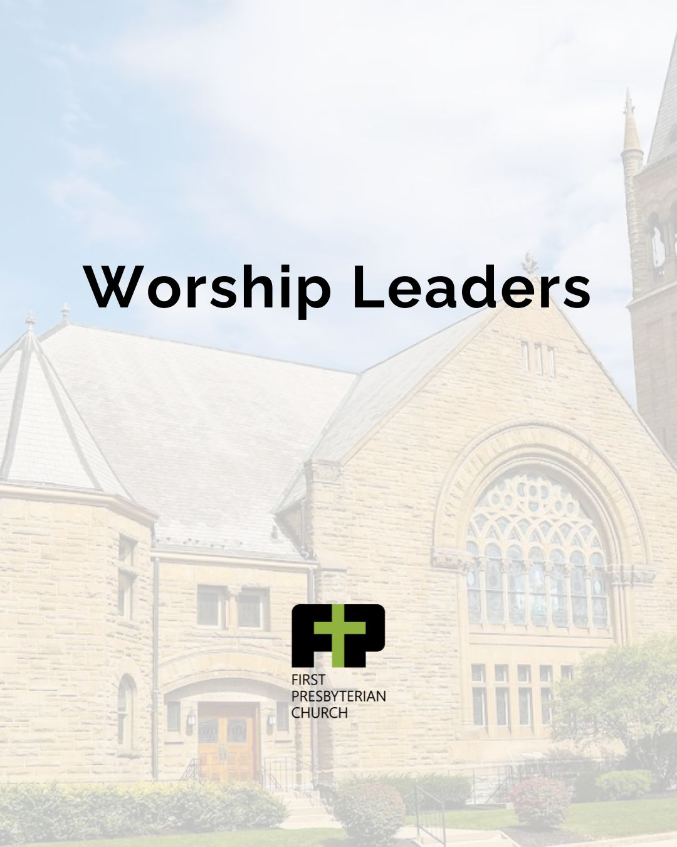
August 16th – Beverly Marshall

August 30th – Guy Schlichting

September 6th – Brian Penrod

September 13th – Lynda Schlichting


Prayer Requests
Service Men & Women:
Doctors, nurses, fire fighters, police officers, & military personnel
Missionaries:
Mark & Melinda Cathey, Eric & Susan Bartels
Friends & Families:
Loma Wilson (DiAnna Bishop’s sister)
Church Family:
John Burns, Don Easley, Mark Hartman, Joyce Ann Jones, Phyllis Larsen, Lois Lust, Kevin Orth, Carol Penrod, Tim Weiss, and our Deacons, Elders, Staff, and Volunteers

THIS WEEK AT THE CHURCH

SUNDAY August 16, 2026
9:15 a.m. Sunday School Class
10:00 a.m. Fellowship & Coffee Time: Jan Garverick on behalf of the Deacons
10:30 a.m. Worship Leader: Beverly Marshall
4:00 p.m. Youth Fellowship Outing – Pizza & Bowling @ Blue Fusion Fun Center

MONDAY August 17, 2026
5:00 p.m. Worship Ministry Team Meeting

TUESDAY August 18, 2026

WEDNESDAY August 19, 2026
6:30 p.m. Session Meeting

THURSDAY August 20, 2026

FRIDAY August 21, 2026

SATURDAY August 22, 2026

SUNDAY August 23, 2026
10:00 a.m. Church Picnic & Worship @ McKinley Park



TO OUR GUESTS…We thank you for joining us for worship and
extend a warm welcome from our family at
First Presbyterian Church.

Please come again!

1presby.org (website)
First Presbyterian Church, ECO – Marion, OH (Facebook)

First Presbyterian Church
143 South Prospect Street Marion, OH 43302
740-382-9545 (Phone)
admin@1presby.org (church office email)
1presby.org (wifi password)

