Jesus…In the Gospel of Luke
Defeating Temptation!

Luke 4:1-13 Pastor Mel Svendsen
June 21, 2026

Bottom Line:
No Christian is exempt from temptation. It confronts both young and old, new and seasoned believers. The encouraging truth is this: temptation itself is not sin. Even our Lord Jesus Christ was tempted. Yet He remained perfectly sinless and gave us a powerful example to follow.

1. Temptation will often occur in the areas
where God is at work in your life. Luke 4:3-4

A. Satan creates doubt about who we are in Christ.
Luke 4:3-4
The devil whispers:
“How could God treat you this way?”
"If God really loved you..."
"If you were truly saved..."
"If you were really valuable...”
“You’re not worthy to serve God”

Temptation can take the form of self-hatred and self-
rejection, feeling unworthy of Christ…
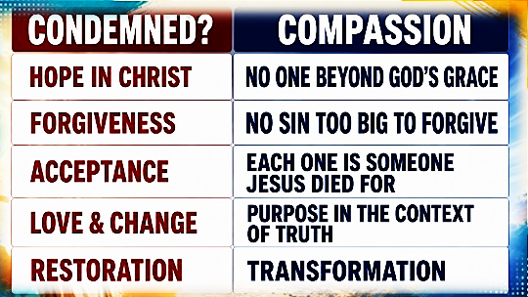

B. Satan tempts us to meet legitimate needs in
illegitimate ways. Luke 4:3-4
2. Temptation is always coupled with
destructive deception! Luke 4:5-13; Gen.3:1-5

- Satan offers shortcuts that bypass God's will.
Luke 4:6-7
A.W. Tozer
"The victorious Christian neither exalts nor downgrades himself. His interests have shifted from self to Christ."

B. Satan abuses Scripture to encourage
disobedience. Luke 4:6-7; Genesis 3:1-5

Now What?
1: Recognize your vulnerability. 1 Cor. 10:12
The first step toward victory is humility.

2: Fill Your mind with God's Word.
Psalm 119:11 “It is written…”

3: Stay in close fellowship with Jesus before
temptation comes. Matthew 26:41
E.M. Bounds
"Prayer is not preparation for the greater work; prayer is the greater work.”

4: Run from situations that feed temptation
2 Timothy 2:22. God commands us to flee!

5: Walk moment by moment in the H.S.’s power
Galatians 5:16. Step by step dependency

6: Live in edifying accountability. Hebrews 3:13
James 5:16. With the help of other trusted
believers, temptation loses much of its power.

7: Focus on Christ and His eternal reward
Hebrews 12:2 “ Look to Jesus”

