Lesson 24

YES


Principle 8: Yield myself to God to be used to bring this Good News to others, both by my example and by my words.

“Happy are those who are persecuted because they do what God requires.”(Matthew 1:10)

Step 12: Having had a spiritual experience as the result of these steps, we tried to carry this message to others, and practice these principles in all our affairs.

“Brothers, if someone is caught in a sin, you who are spiritual should restore him gently. But watch yourself, or you also may be tempted.”
(Galatians 6:1)

Introduction

Modern technology is something else! Take an old, beat-up Diet Coke can—dirty, dented, holes in it. A few years ago, it would have been thrown in the garbage and deemed useless, of no value. Today it can be recycled, melted down, purified, and made into a new can—shiny and clean—that can be used again.
We’re going to talk about recycling tonight—recycling your pain by allowing God’s fire and light to shine on it, to melt down your old hurts, habits, and hang-ups so they can be used again in a positive way. They can be recycled to show others how you worked the principles and steps with Jesus’ healing into the solution and how you have come through the darkness of your pain into Christ’s glorious freedom and light.
Society tells us that pain is useless. In fact, people are coming to believe that people in pain are useless! At Celebrate Recovery, we know that pain has value, as do the people who experience it. So while the world says no, tonight we say yes!

Yes

Tonight’s acrostic couldn’t be any more positive! It is the word YES.

Yield myself to God
Example is what is important
Serve others as Jesus Christ did.

The Y is Principle 8 itself: YIELD myself to God to be used to bring this Good News to others, both by my example and by my words.
To truly practice this principle, we must give God the latitude He needs to use us as He sees fit. We do that by presenting everything we have—our time, talents, and treasures—to Him. We hold loosely all that we call our own, recognizing that all of it comes from His hand. When we have yielded to Him, God can use us as His instruments to carry the message to others in word and action.
Galatians 6:1–2 (TLB) tells us: “If a Christian is overcome by some sin,... humbly help him back onto the right path, remembering that the next time it might be one of you who is in the wrong. Share each other’s troubles and problems, and so obey our Lord’s command.”
People take your example far more seriously than they take your advice.
That leads us to the E in yes: EXAMPLE is what is important!
Your walk needs to match your talk. We all know that talk is cheap, because the supply always exceeds the demand.
If you want someone to see what Christ will do for them, let them see what Christ has done for you.
Here is a question to ask yourself when you get to this principle: Does my lifestyle reflect what I believe? In other words, does it show others the patterns of the world—selfishness, pride, and lust—or does it reflect the love, humility, and service of Jesus Christ?
“Arouse the love that comes from a pure heart, a clear conscience, and a genuine faith” (1 Timothy 1:5 GNT).
This year, we have all been blessed by some outstanding and courageous testimonies at Celebrate Recovery. I would like all those who gave their testimonies this year to stand. These people believe in Principle 8! They believe in it enough to share not only in the safety of their small groups but also with the whole recovery family. They believe in Jesus Christ enough to share their lives with others. They stood up here and shared their weaknesses and strengths with others who are suffering from similar pain, hurts, hang-ups, and habits. They gave others a piece of their heart—not a piece of their mind.
Our goal again for next year is to have two testimonies each month as we work on each step. So, if you have been in recovery for a while and haven’t shared your story as yet, get busy, write it out, and get it to me. We need to hear and you need to share your miracle in the coming year.
The last letter in yes is S: SERVE others as Jesus Christ did.
When you have reached Principle 8, you are ready to pick up the “Lord’s towel,” the one with which He washed the disciples’ feet in the upper room the night before He was crucified.
Jesus said, “And since I, the Lord and Teacher, have washed your feet, you ought to wash each other’s feet. I have given you an example to follow: do as I have done to you” (John 13:14–15 TLB).
You don’t all have to give your testimonies to three hundred people to do service. All service ranks the same with God. You can say “y-e-s” to Principle 8 in many ways!
- Be an accountability partner. Find someone in your small group who agrees to encourage and support you as you work through the principles. You agree to do the same for them. You hold one another accountable for working an honest program.
- Be a sponsor. A sponsor is someone who has worked the steps. Their job is to guide a newcomer on their journey through the steps. They can give a gentle nudge when the person who they are sponsoring is procrastinating, and slow them down when they are rushing through a step. Sponsors do so by sharing their personal journey on their road to recovery.
- Become a greeter. Greeters get to Celebrate Recovery at 6:45 P.M. They welcome and provide directions for newcomers. They provide the newcomer with the important first impression of Celebrate Recovery!
- Help with the Solid Rock Cafe. You need to arrive by 6:00 P.M. to help set up. If you can’t get here early, stay a few minutes after to help clean up. You can bake a cake.
- Help with the Bar-B-Que. We’ll be starting in the spring. We need help with set-up, clean-up, and everything in between.
- Invite someone to church. Ask someone from your secular groups or a neighbor, a friend, or a coworker!
The world is full of two kinds of people—givers and takers. The takers eat well and the givers sleep well. Be a giver. There are many, many more areas to serve! Make suggestions! Get involved!
Principle 8 comes down to this: Do what you can, with what you have, where you are.
Make your life a mission, not an intermission!

Wrap-Up

The road to recovery leads to service. When you reach Principle 8 the road splits (see page 206 for a diagram). Some of you will choose to serve at Celebrate Recovery. Others will choose to serve in other areas of the church. The fact is, we need both.

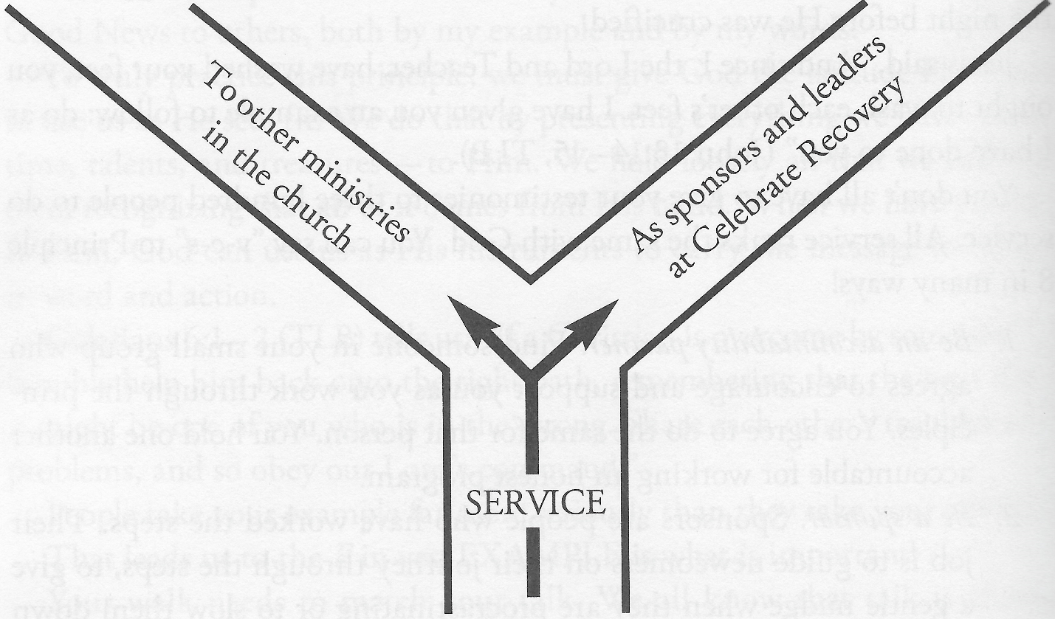

We need you to share your experiences, strengths, and hopes with newcomers here on Friday nights. You do that as leaders, sponsors, and accountability partners. But the church also needs your service. As you serve outside of Celebrate Recovery, you can share with others and get them into recovery when they are ready to work on their hurts, hang-ups, and habits.
Every morning, before I get out of bed I pray this Principle 8 prayer:

Dear Jesus, as it would please You, bring me someone today whom I can serve. AMEN.

Will you pray it this week?

