  Noah’s Boat BUILD
  This week, the kids get to create their own boat to remember today’s Bible story, Noah and the Flood. This craft will help them remember they can believe in God and do what God says, just like Noah did.
  Directions
  PREP
  - Print out the Noah’s Boat Build printable.
  - Cut or tear brown paper into 1-2” strips that are different lengths. Prepare about 5 strips per child.
  - Gather the printables, brown paper strips, crayons, and glue for leaders.
  MAKE
  - Explain a little about the craft to the kids. Say something like, “You get to make your very own boat, just like Noah! Noah’s boat was made of wood, but we’re going to use brown paper.”
  - Pass out the printables and strips of paper to the kids.
  - Kids will:
  - Color the printable scene with Noah.
  - Glue strips of brown paper in the shape of the boat onto the printable scene. They can tear their strips to adjust the length of the “wood” pieces.
  - As the kids make their crafts, discuss the talking points.
  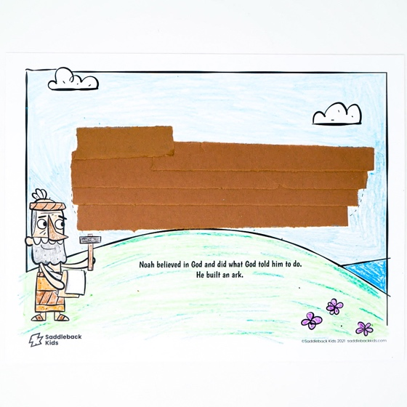
  SUPPLIES NEEDED
  Noah’s Boat Build printable
   |     Brown paper  Scissors
  Yarn
   |  | 
  Crayons |  | Glue
  Talking points
  Who built a big boat?
  Why did Noah build the boat?
  What special book did God give us to help us believe in him?

