  Royal Crown
  The kids will make their own royal crowns! They can pretend to be young kings and queens to remember Josiah, the young king they learned about in today’s Bible story. Josiah believed the Book of the Law was for him and the kids can believe the Bible is for them, too.
  Directions
  PREP
  - Print out the Royal Crown printable.
  - Cut out one Royal Crown printable per child.
  - Cut one paper strip per child to size crowns.
  - Have tape, crayons, paper strips, and headbands ready for the leaders.
  MAKE
  - Explain a little about the craft to the kids. Say something like, “Today, you get to make your very own royal crown to wear, just like Josiah! We’re going to color our crowns and then we get to wear them and pretend to be queens and kings to help us remember today’s Bible story about Josiah.”
  - Pass out the crowns to the kids.
  - Allow time for kids to color and create their own special crown.
  - Once they are done coloring, help fit the headband to each kid’s head.
  - Use an extra strip of paper to add length.
  - Tape accordingly.
  - As the kids color and create, discuss the talking points.
  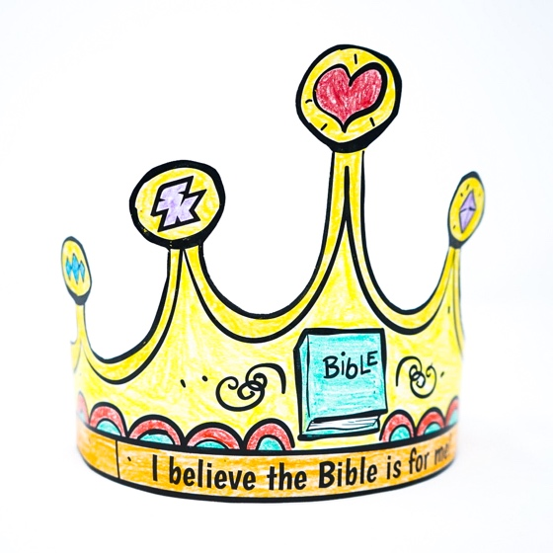
  SUPPLIES NEEDED
  Royal Crown printable
   |     Paper strips  Scissors
  Yarn
    Tape |  | 
  Crayons
  Talking points
  What picture is on your crown?
  Who is the Bible for?
  The Bible is God’s special book for you. What is your favorite story to read in the Bible?

