  Joseph Story Order
  This week, the kids learned that God was with Joseph in good and bad times. They will remember what happened in the Bible story by putting Joseph’s story in the correct order. The kids can remember God is with them, too.
  Directions
  PREP
  - Print out the Joseph Story printable.
  - Cut out the picture cards.
  - Gather crayons, Joseph Story Order printable, glue, and picture card pieces (1 set per child).
  MAKE
  - Explain to the kids that they will be putting the pieces from Joseph’s life in the order that they happened to help them remember today’s Bible story.
  - Pass out the Joseph Story Order printable and Picture Card pieces to the kids.
  - Allow time for kids to color the picture scenes.
  - As the kids color, discuss the talking points and talk about what they see in each picture.
  - Once they are finished coloring, have the kids glue the cards in order. Ask, What happened first? What happened next?
  - Tip: Have the kids lay the story cards in order over the Joseph Story Order printable. Once they are in the correct order, they can glue.
  - Read the heading and read through Joseph’s story together.
  - Ask the kids, When was God with Joseph? Emphasize that God was with Joseph all the time and is with them all the time too.
  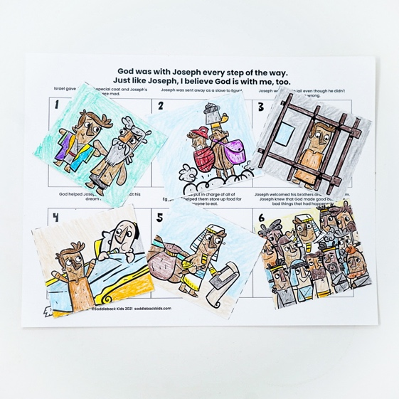
  SUPPLIES NEEDED
  Joseph Story printable
   |     Crayons  Scissors
  Yarn
   |  | 
  Glue
  Talking points
  Who was today’s Bible story about?
  What bad things happened to Joseph?
  What did Joseph believe about God that helped him when things were good and bad?

