  PART THE RED SEA
  This week, the kids will create a craft to help them remember how God showed Moses the right path by parting the Red Sea. They will remember this Bible story about Moses, and that God will show them the right path, too.
  Directions
  PREP
  - Print out the Red Sea and Moses and the Israelites printables.
  - Cut out the Moses character printable.
  - Cut the Red Sea printable along the dotted wave lines. Discard the middle piece.
  - Line the bottom water piece to the bottom edge of the brown paper. Tape together along the side edges only, creating an opening.
  - Have printables, taped papers, craft sticks, crayons, glue, and tape for the leaders.
  MAKE
  - Explain to the kids that they will be making a craft to remember today’s Bible story about a time God showed Moses the right path!
  - Pass out the printable sets to the kids.
  - Allow time for kids to color. As they color, discuss the talking points.
  - Have the kids glue the top half of the water onto their brown paper. Remind the kids to leave space between the waves to show the path God made for Moses and the Israelites.
  - Have the kids tape the Moses and the Israelites printable onto a craft stick.
  - Show the kids how to insert Moses and the Israelites through the opening at the bottom to show them walking across dry land.
  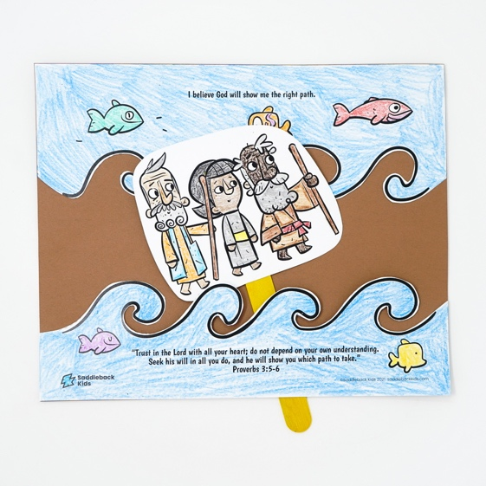
  b
  SUPPLIES NEEDED
  Red Sea and Moses printables
    Glue and tape |     Scissors
  Yarn
   |  |  |   
  Crayons  Brown paper |  | Craft sticks  ticks
  Talking points
  Who are you coloring?
  What did God do to show Moses the right path?
  When they saw the right path, what did Moses and the Israelites do?

