  Laughing Sarah
  This week, the kids learned about the Bible story, Sarah Laughs. With this craft, the kids will create their own laughing Sarah to remember this Bible story. Kids can remember that even when they don’t understand, they can believe anything is possible for God.
  Directions
  PREP
  - Print out the Sarah Laughs printable on cardstock paper.
  - Cut out the printable.
  - Pre-fold the printable on the numbered lines across Sarah’s mouth.
  - Gather prepared Sarah, crayons, craft sticks, and tape.
  MAKE
  - Explain to the kids that they will be making their very own Sarah from the Bible story. What’s special about this Sarah is that we can move her mouth to show her laughing!
  - Pass out one Sarah printable to each kid.
  - Allow time for kids to color.
  - As the kids color, discuss the talking points.
  - When they are finished coloring, help the kids tape one end of the craft stick to the back of Sarah’s head so it sticks out to the side.
  - Show the kids how to hold their Sarah craft with one hand and move the stick with the other hand to make Sarah laugh.
  - Remind the kids that nothing is too hard for God. We can believe anything is possible for our big God who loves us all so much!
  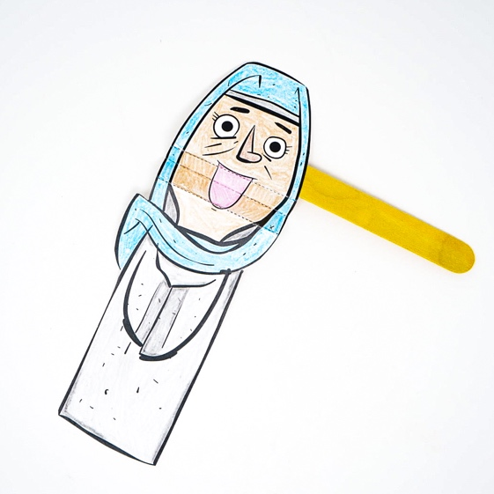
  SUPPLIES NEEDED
  Sarah Laughs printable
   |     Craft sticks  Scissors
  Yarn
   |  |  |   Tape
  Crayons
  Talking points
  Who are you coloring?
  What did Sarah do when she heard God said she would have a baby?
  Why did Sarah laugh?
  Is anything too hard for God?

