  prayer clay
  This lesson, the kids are learning that they can go to Jesus with anything they face, like the woman went to Jesus for help in the Bible story. They can have faith Jesus will help them! They will remember they can go to Jesus in prayer.
  Directions
  PREP
  - Print one Prayer Clay printable per child.
  - Cut out Prayer Clay printables.
  - Gather printables, Ziploc bags, stapler, colorful air-dry clay, and crayons or markers for leaders.
  MAKE
  - Pass out a Prayer Clay printable, Ziploc bag, and golf ball-sized portion of air-dry clay to each child.
  - Explain, This is your prayer clay! When you want to talk to Jesus, you can hold, squish, or rub your clay while you say a prayer to him. You can talk to God about anything! He loves you, and he is real.
  - Let them roll, mold, and play with the clay.
  - Let them color the printable.
  - When they are done, they will put it in the Ziploc bag and seal it to use again later.
  - Go around and staple their printable to the corner of the Ziploc bag.
    - Read some of the feelings you see written on the printable. It says they can share those feelings with Jesus!
  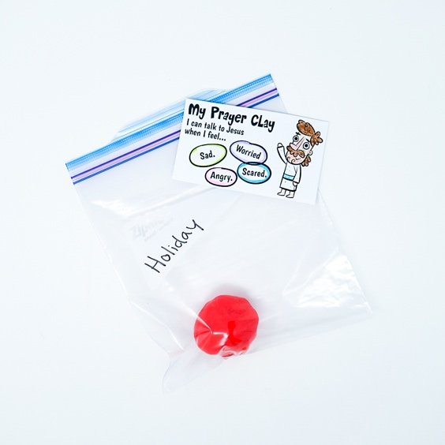
  SUPPLIES NEEDED
  Prayer Clay
  printable
   | Ziploc bag (snack size) |  |  |     Scissors
   |  |   Stapler
  Crayons or markers |  |  | Colorful  air-dry clay
  Talking points
  Who can you talk to when you need help?
  What is something you need help with? Is that something you can pray about and tell Jesus?

