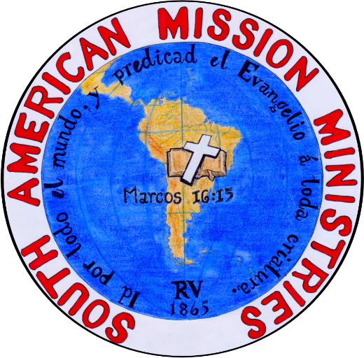
January 20, 2023
I send special greetings in the name of our Lord and Saviour, Jesus Christ.
Thank you to all the brethren who continue and pray for our ministry. In the last letter, I wrote about a visit to the region of Urabá in our department (state). Thanks be to God, we could visit the location and preach the gospel and the doctrine of God there. A woman’s group, that were discipled by a sister at our church, listened to the word of God. I also was able to preach at an independent church there. The pastor asked me about independent baptist doctrine, then allowed us to lead the service (singing some hymns) and me to preach the word that Sunday. I ask for your prayers for the woman’s group and for the pastor and his small congregation. His name is Francisco Montenegro. It was a great blessing to visit our brethren there, who for work reasons now do not live in Medellín.
The church in Copacabana continues to preach in the streets. Some of the brethren that have come together as a group to perform this work are brother Elmer, brother Román, brother Luis, and brother José Luis. It is a blessing to be able to preach in the streets and that these brethren accompany and complete the ministry. It is evident that, after 18 years in Copacabana, many people in the city know that independent baptists preach and pass out tracts in the streets.
The mission in Barbosa continues as well. There, a young man named Fabián, who sells lottery tickets with a megaphone, allowed me to use his megaphone to preach in the streets of this town. Later, this young man invited us to his home, and there we could preach to him and a woman that lived there with him. It was a great blessing. Fabián continues to wait for us every Sunday, similar to another gentleman named Carlos, so that we can bring the word of God to that town (it is about 30 minutes from Copacabana). We are currently looking for a place in Barbosa to rent in order to begin having formal services. About 50,000 people live there and there is no baptist church.
We had a reunion with some pastors in a missionary conference at the Iglesia Bíblica Bautista la Roca in Cali. I was invited to preach the word, along with Pastor Iván Acevedo from the church in Marinilla, and brother Eduar Betancur from the church in Montenegro. It was a special time to share experiences as ministers and have fellowship. There, we prayed for one another, and we hope, Lord willing, to have an event that is for pastors and the wives of pastors (leaders and their wives) in Colombia. A man who listens to the messages on the internet in Cali came to the conference with his wife. His name is Javier Guerrero. Please pray for him. I also encountered a young lady who read the message booklets that we have published, and she was very happy to meet me for the first time.
With regards to the recording of the Reina Valera 1865 Bible, I would like to say that we have arrived at the prophetic books. I hope, with God’s help, to finish this reading of the entire Bible by the middle of this year so that we can begin to distribute the word of God by audio to thousands of people in Latin America. Please do not forget to pray for this great project, this great blessing.
The children’s ministry did a missionary presentation “I go.” For that day, we closed up the street in front of our locale and the children of the church shared the missionary work with other children in the street that came and asked about their presentations. We were very happy to see our children manifest Christian character, like learning missions and sharing the gospel, in their lives. Our children are now also evangelists. Glory to God!
I visited the Iglesia Bíblica Bautista of Marinilla, a church that started as a mission from the church in Copacabana. There, the brethren are firm in the faith. We have three brethren from there who are now part of the Bible Institute. The day I visited the church, the Lord allowed me to preach there. A friend, who is also my student at the university, came and listened to the gospel message.
As you all know, my secular career is as a university professor. Just as at the church in Marinilla this student named Francisco came, at the church in Copacabana there are also two young ladies that attend: Luisa and Alejandra. Another student in Marinilla has asked me for counsel on how to find God. Likewise, another student from a town called Don Matías asked the same. At the end of my History classes, a student stayed with me to ask about the word of God. We prayed together. Now this student plans to go to church. My desire is to help these young adults who do not feel heard in their homes, in the universities, and many times not in their churches.
We continue to work with the youth at the church. We have approximately 14 young men and women. For my part, I was able to take four of the men to a town close by. I spoke with them about the history of the town, I prayed for them, I shared the word, and I shared renewed vision of the work of God in creation. They were very happy and every day trust me more, as we are like a family in truth. My wife and the other sisters also began to fellowship with the young women. They ask to be heard and to grow closer to the God that loves them, and thus desire to know Him more each day.
With regards to our publications, we have succeeded in buying a good sound card so that the audio sermons can be heard very clearly. The people in the church in Copacabana share through electronic means these sermons to friends and family. They are practical messages that always bring the gospel of salvation no matter the topic. I was able to publish my final booklet with seven messages from 2 Corinthians. These are the same messages I preach on Sundays, but written. Now, we pray to God for a good video camera to have quality and excellence in that message form, always hoping that the message itself is also excellent.
At the start of 2023, I was able to visit the city of Arequipa, Perú with my wife. This country is in the middle of political protests, and I did not want to go. I was afraid that I would not be able to return because some protestors had taken control of some airports, including those in Arequipa. Nevertheless, we went. Our airline that flew to Lima was delayed and we lost our flight to Arequipa, so we had to sleep in the airport in Lima to take the next flight to Arequipa that following morning. In the end, I thought, “Though it may be that I do not want to go in the middle of political protests, this is the moment that I should accompany my brethren who are in the middle of these many problems.” Many times, the will of God is not what we think it should be, and like Paul, my spirit would not have rest unless I was able to see the brethren there. I ask for your prayers for this small group, where the leader is a young man of 23 years names Luis Huerta.
Lastly, I want to tell you that we are about to close a contract with the owner of the building where we congregate, and have congregated for 17 years. At the end of 2022, God has blessed the brethren in Colombia with both a beloved church in the United States and beloved brethren throughout the United States who have desired to support our ministry economically. We give GLORY TO GOD for this. We ask for your prayers that this contract is closed soon. It seems like a dream that this could be accomplished before the coming of our Lord.
I am writing this letter from the Iglesia Bíblica Bautista de Montenegro during their 18th anniversary. I am with beloved people, reminiscing on the memory of Nevado del Ruíz who this day, the first time, could see with a cloudless sky. The sisters are asking that we do another ESPECTACULAR DE MUJERES, three brethren desire to be baptized, and the pastor’s wives desire to fellowship… May God give us the strength to continue until the day of CHRIST.
Fabio Carballo.
Pastor, Iglesia Bíblica Bautista de Copacabana.
Translated by Pastor Manuel Hernandez, Bible Baptist Church of Noblesville

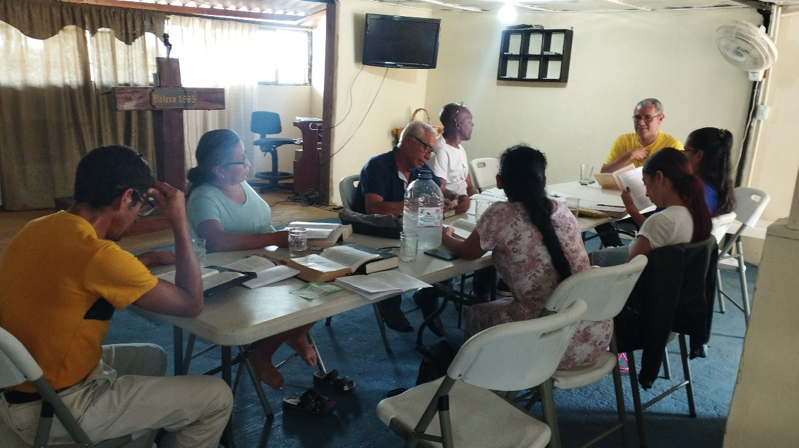
Montenegro Bible Institute

Trip with the Youth from the Church in Copacabana

Preaching in Urabá along with my brother in Christ, Sebastián
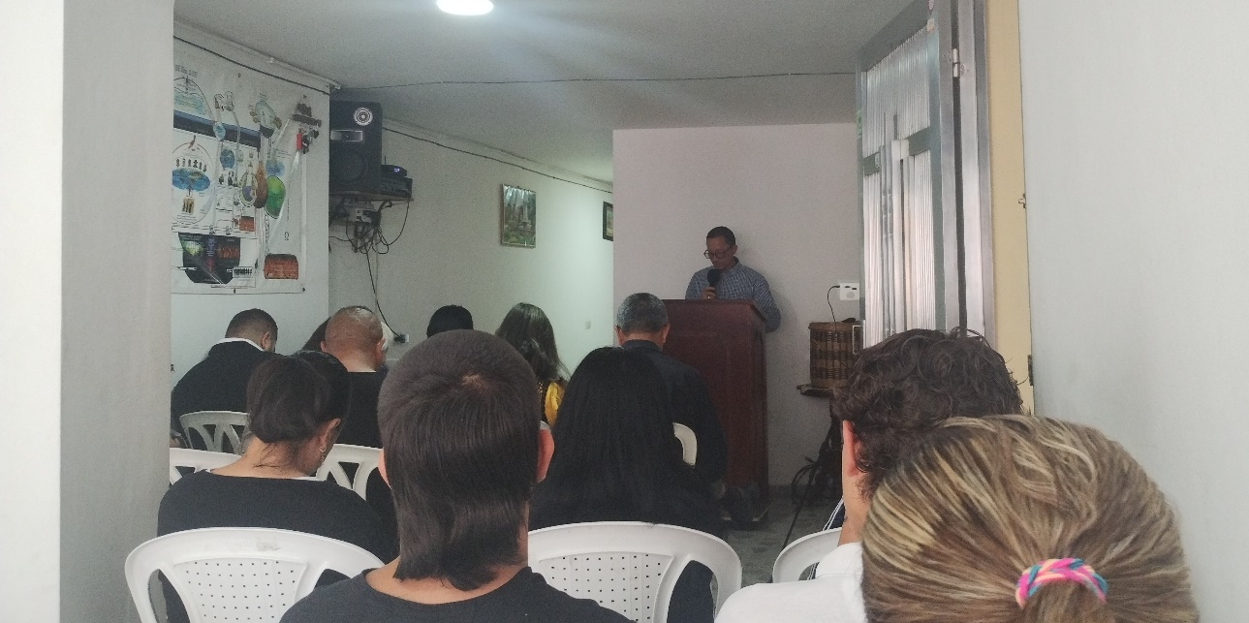
Brother Eduard leading the service in Marinilla
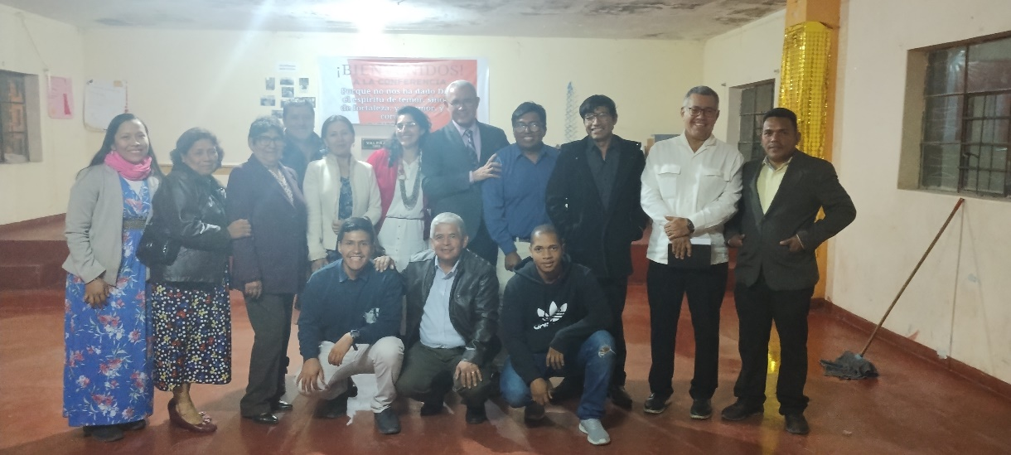
Conference in Arequipa, Perú

Sleeping in the Airport in Lima
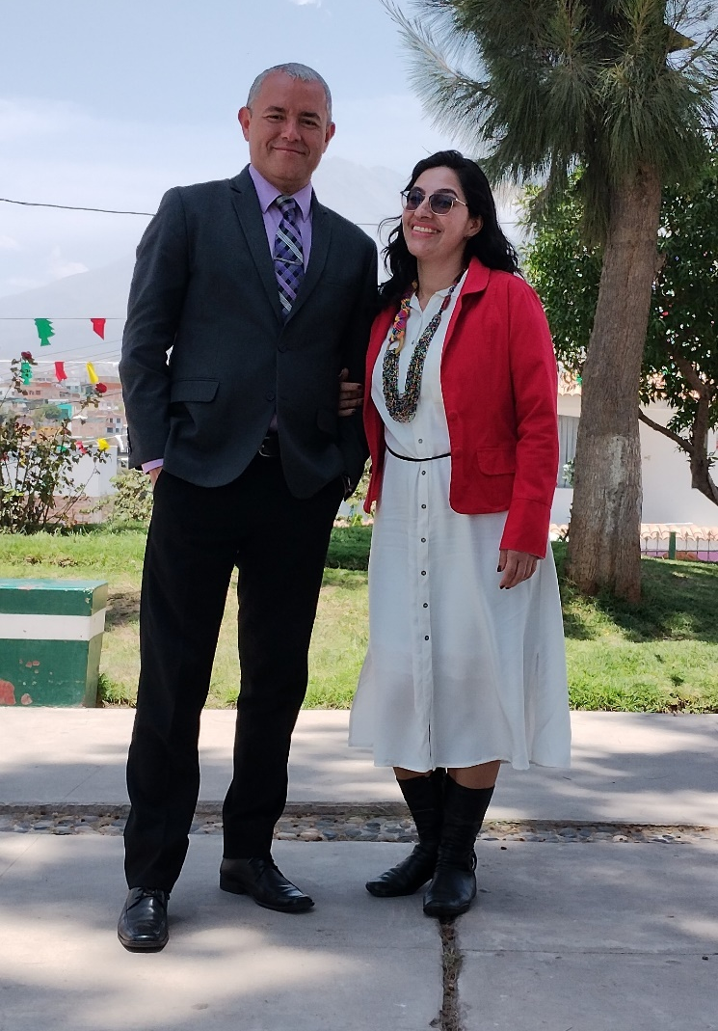
With my beloved Diana
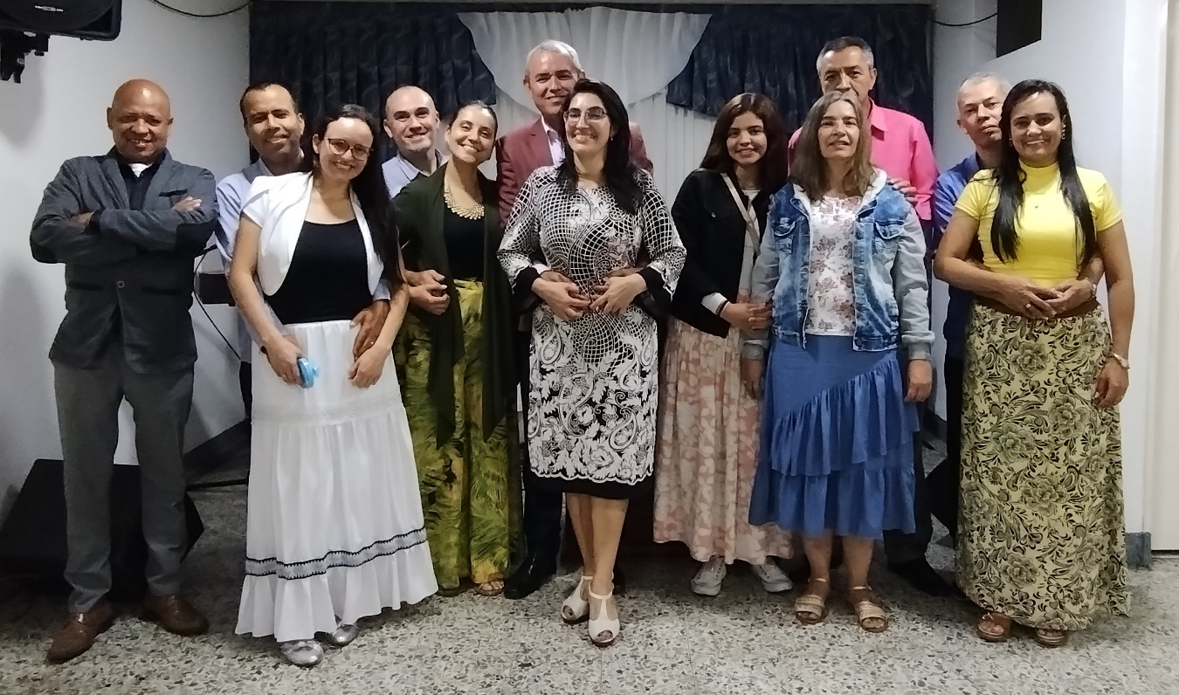
Fellowship with Pastors and Their Wives
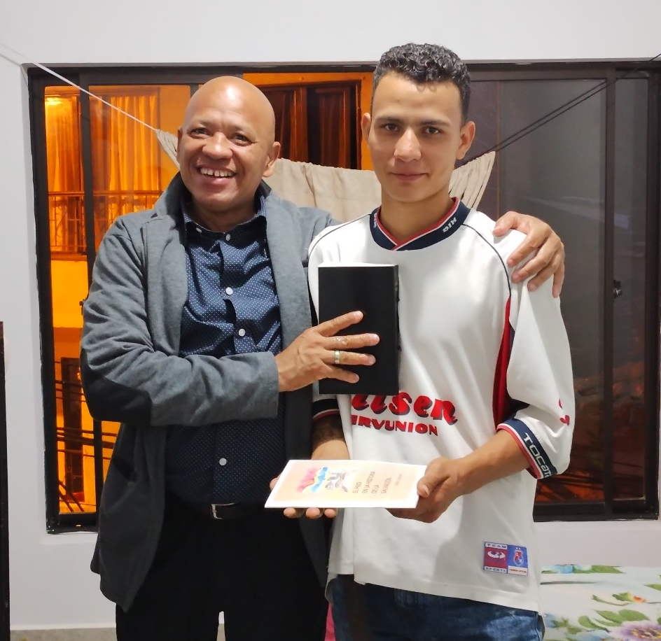
Fabián in Barbosa
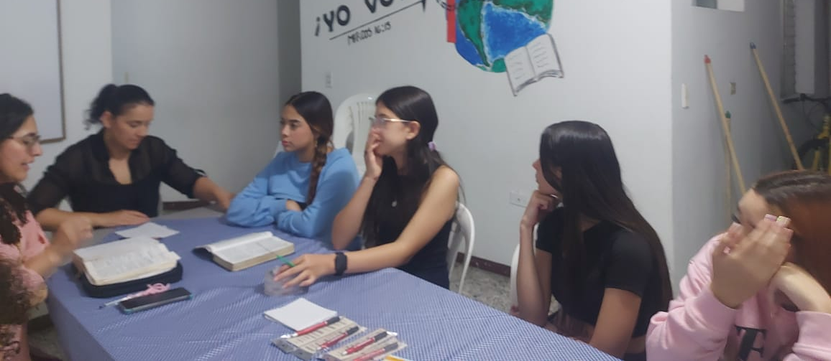
Fellowship with Our Young Ladies
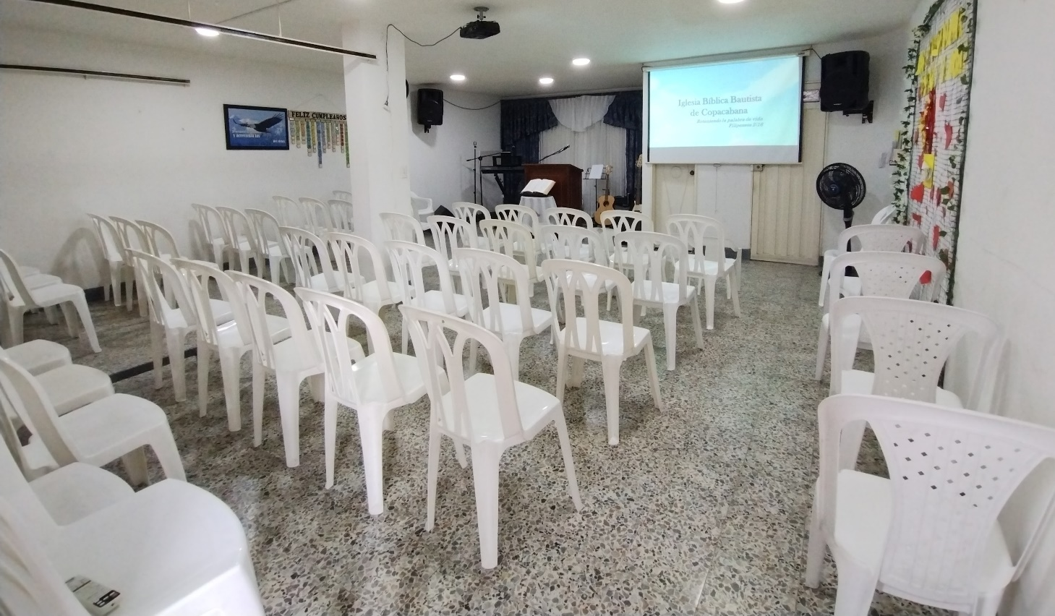
The Locale We Plan to Purchase
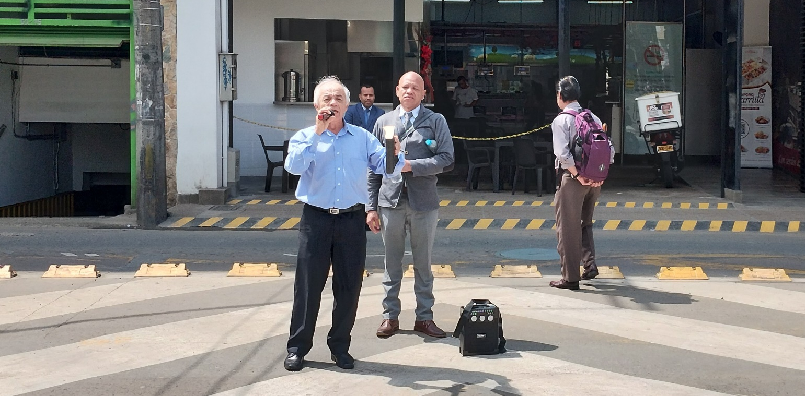
Our Street Preachers

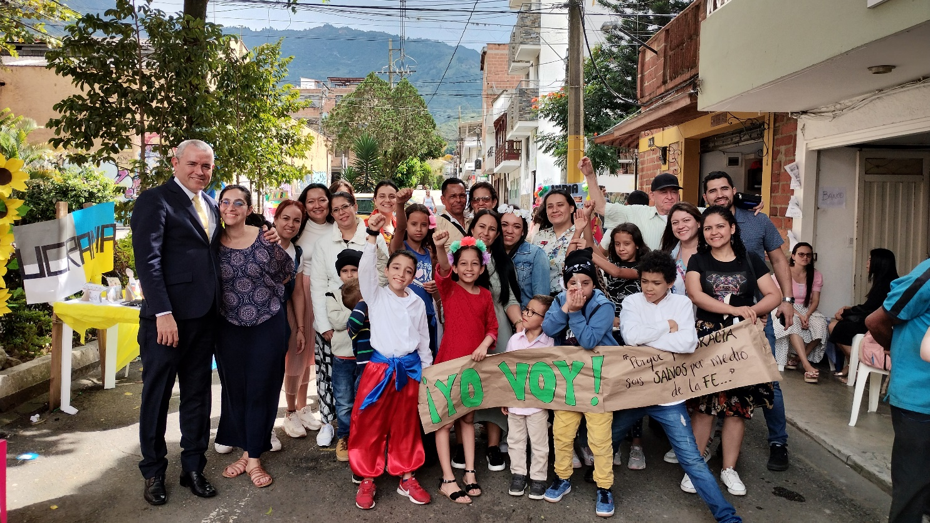
Children’s Missionary Presentation

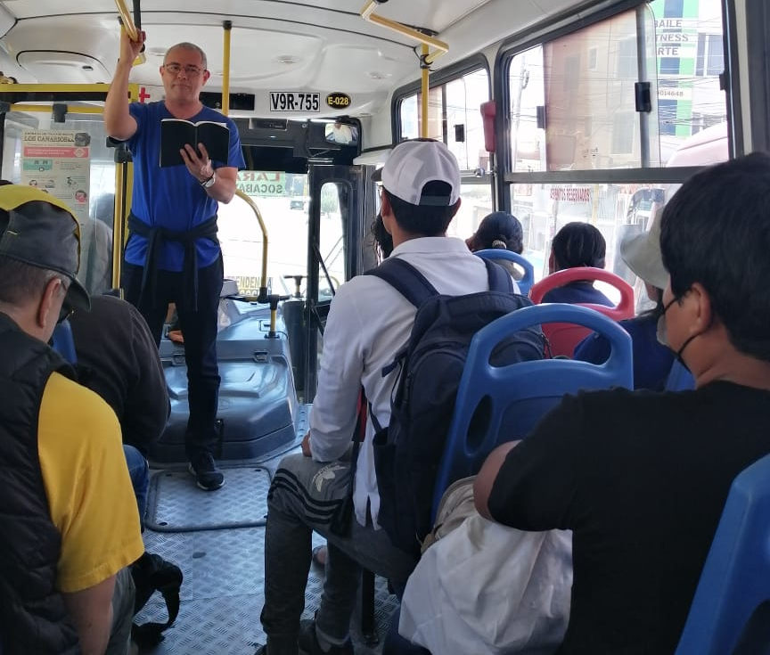
Preaching on the Bus

Young Adults Who Have Read the Message Booklets

University Students to Whom I Have Given the Gospel

