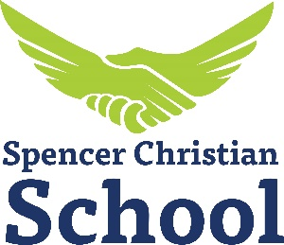
Spencer Christian School
5720 Taylorsville Road
Fisherville, Kentucky 40023
(502) 477-9617 x200
school@spencerchristian.org

Grades 1-8 Teacher Job Description

Qualification Requirements:
*Must meet at least one of the following three educational/experience requirements:
- Bachelor’s Degree (in any major; education degree preferred)
- Associate degree in Education
- Masters in Education
- Previous experience teaching in public school
- Previous experience teaching in Christian Education (private school)
*teaching certificate preferred

- Regular attendee of a church and a baptized believer
- Sign a statement of agreement to Spencer Christian Church’s statement of faith
- Completed application from Spencer Christian School and resume
- References: previous employer, personal, minister/church leader
- Approved background check

Salary:
*Base salary starting at $16,500 + add-ons dependent on experience and credentials.

Responsibilities:
- Attend teacher training week in August before school starts back; work last week of school to clean up room for summer and parent/teacher conferences.
- Workday 8:30AM-3:45PM Tuesday-Thursday for 34 weeks of school
  - There are a few special events during the year outside of school hours that teachers are asked to attend (Beginning of school Bash, new parent meeting/Open house, Christmas program)
- Assess students on a regular basis and communicate grades to students and parents (report cards are given at the end of each trimester)
- Meet with parents for parent/teacher conferences once each semester (Fall and Spring)
- Keep daily attendance
- Create a pacing guide for the school year to make sure you are able to cover all the necessary curriculum
- Prepare weekly lesson plans for how you plan to carry out classroom instruction (Director can access these at any point for feedback and guidance).
- Collaborate with parents to assign and grade weekly homework
- Share the gospel of Jesus’ love and salvation with the students on a daily basis
- Notify Director of any sick/personal days you need to use and find a sub for the day (you get 6 sick days)
*Teachers are required to be CPR/First Aid certified for school.

