Prayer Wheel

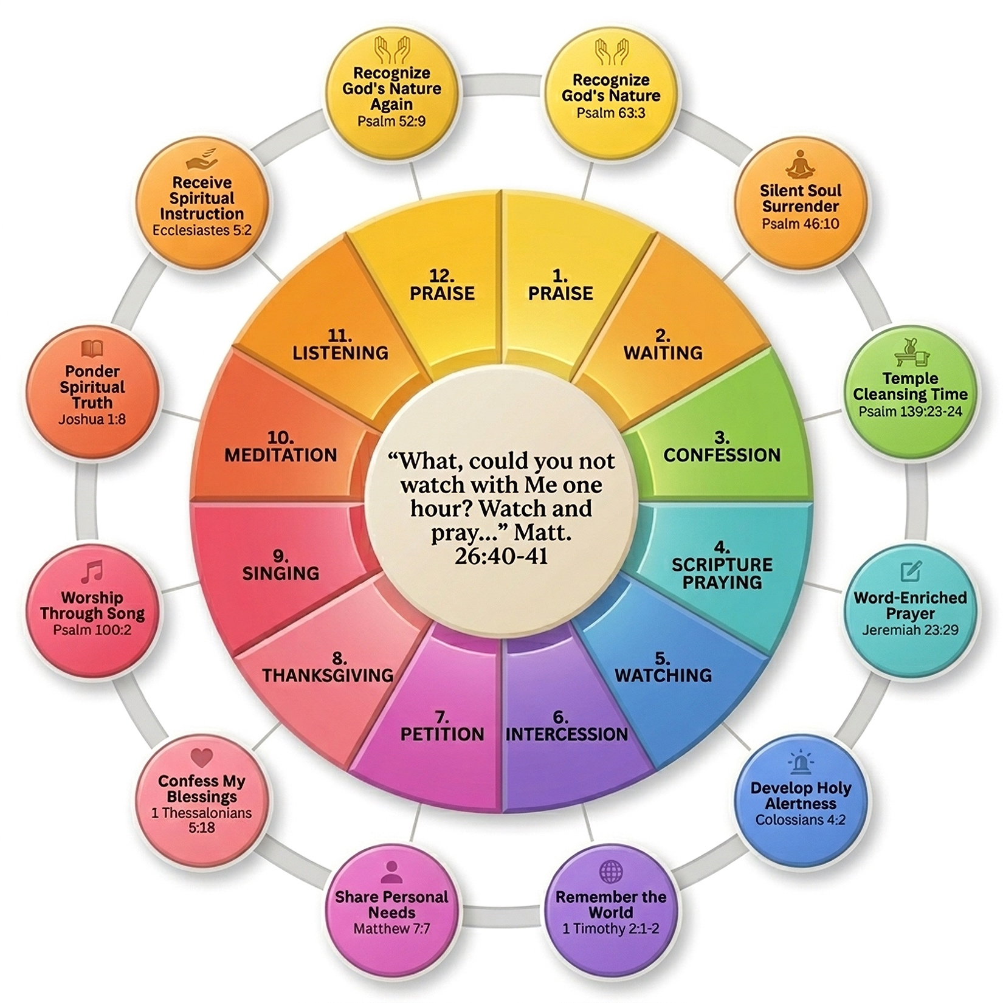

JourneyChristian.com/PrayerWheel

Prayer Wheel Guide

1. PRAISE
Psalm 63:3 “Because your love is better than life, my lips will glorify you.”
Focus your heart on who God is, not just what He has done. Speak His character back to Him and let it shape your perspective. Let worship lead your thoughts. Name specific attributes of God and linger on them. Let your praise become personal and genuine.

2. WAITING
Psalm 46:10 “Be still, and know that I am God.”
Slow down and be still before the Lord. Release control and allow your soul to rest in His presence. Sit quietly and trust that He is at work. Resist the urge to rush. Let silence become a place where your faith deepens.

3. CONFESSION
Psalm 139:23–24 “Search me, God, and know my heart… See if there is any offensive way in me.”
Invite God to search your heart honestly. Confess sin without excuses and receive His grace. Let this be a moment of cleansing and renewal. Be specific rather than general. Walk away confident in His forgiveness.

4. SCRIPTURE PRAYING
Jeremiah 23:29 “Is not my word like fire… and like a hammer that breaks a rock in pieces?”
Bring God’s Word into your prayer. Pray Scripture back to Him and let it guide your thoughts. Allow truth to shape how you speak to God. Personalize the verses you read. Let His Word reshape your thinking.

5. WATCHING
Colossians 4:2 “Devote yourselves to prayer, being watchful and thankful.”
Stay spiritually alert and attentive. Ask God to sharpen your awareness of His work around you. Be present and ready to respond. Pay attention to what He might be highlighting. Stay engaged, not distracted.

6. INTERCESSION
1 Timothy 2:1–2 “I urge… that petitions, prayers, intercession and thanksgiving be made for all people.”
Pray for others with intention. Lift up your family, church, leaders, and those far from God. Carry their needs before the Lord. Pray specifically, not generally. Ask God to move powerfully in their lives.

7. PETITION
Matthew 7:7 “Ask and it will be given to you… seek and you will find.”
Bring your needs honestly before God. Ask boldly, knowing He invites you to come. Trust Him with both big and small concerns. Be clear about what you are asking. Surrender the outcome to Him.

8. THANKSGIVING
1 Thessalonians 5:18 “Give thanks in all circumstances; for this is God’s will for you in Christ Jesus.”
Reflect on what God has done in your life. Thank Him specifically for His faithfulness. Let gratitude reshape your outlook. Look for things you may have overlooked. Let thankfulness shift your attitude.

9. SINGING
Psalm 100:2 “Worship the Lord with gladness; come before him with joyful songs.”
Worship God through song, even quietly. Let your heart express praise in a personal way. Engage your emotions in honoring Him. If you know a song, sing it. If not, simply speak your praise rhythmically.

10. MEDITATION
Joshua 1:8 “Keep this Book of the Law always on your lips; meditate on it day and night.”
Slow down and think deeply about truth. Let Scripture settle into your heart and mind. Allow God’s Word to shape your thinking. Repeat a verse slowly. Let it move from your head to your heart.

11. LISTENING
Ecclesiastes 5:2 “Do not be quick with your mouth… God is in heaven and you are on earth.”
Be still and listen for God’s voice. Create space for Him to speak into your life. Pay attention to what He is stirring in you. Write down impressions if helpful. Stay open and responsive.

12. PRAISE
Psalm 52:9 “For what you have done I will always praise you… I will hope in your name.”
End where you began by fixing your eyes on God. Return to praise and anchor your heart in who He is. Let worship close your time with Him. Celebrate His faithfulness. Leave with confidence in Him.

