March 2023 Newsletter

Hello parents of teens and volunteers!
Happy March! I hope you all are doing well. Here’s a look at what we did in February and what we have coming up in Ramoth Baptist Church’s youth ministry!
LAST MONTH’S HIGHLIGHT

Valentine’s Day Cards & Gifts for Local Firefighters
Although we had to make some adjustments to our original plans because someone forgot about a little something called the Superbowl (whoops!), February was still a success! We had a Valentine’s Party where teens split up into teams to compete in games, which included constructing buildings out of candy and playing circle soccer! On February 23rd, my wife and I also got to goof off and play at Reclaim Arcade with some High Schoolers and parents!
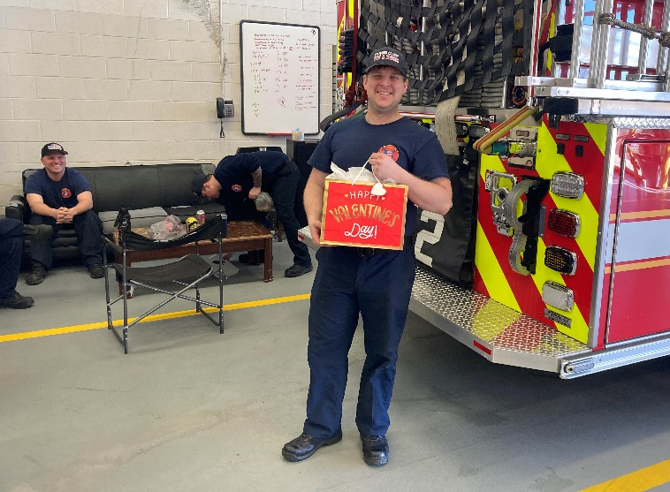
However, the highlight for the month was the Valentine’s Day cards and candy the youth handpicked and wrote to give to our local Firefighters. We thanked them for their hard work and risk-taking service for our community and affirmed they are loved by God and us. In total, we made 33 valentine cards! On Valentine’s Day, I got to load up the gift bags with their cards and candy to deliver to Mountainview Volunteer Fire Department off Kellogg Mill Road, Stafford County Fire & Rescue Department Station 14 off Garrisonville Road, and Stafford County Fire and Rescue Department off Warrenton Road. The gifts were well received with smiling faces and happy thank-yous! Please pray for our local Firefighters and for the positive influence of the encouragement and gospel message in the cards we gave them.

WHAT’S HAPPENING NEXT

- Mon. Mar. 6th 7:00-8:30 PM: Science & Biblical Faith Teen Small Group 1st Meeting!
The dates and times have been switched and settled to include interested students. The teen small group will meet at the parsonage on Monday nights from 7:00-8:30pm. It will go for 4 sessions on March 6th, 13th, 20th, and 27th.

- Sun. March 26th 5:00 PM: Awana Grand Prix & Youth Camp Fundraiser
There will be no Youth Praise Team or Youth Group this night. Rather, many of the teens and I will help at the Awana Grand Prix! Also, we plan to have a Youth Camp Fundraiser Stand in the chapel where people may get a drink and/or snack for a donation of any size. All donations will go towards cutting down the cost of summer camp for teens. If your teen plans to attend summer camp, please sign them up virtually to help at this link: https://docs.google.com/document/d/1o_ZlRWqzAaAjiMAfcgvvHTkFrL_1HJ3lZN9X6WP-5J8/edit?usp=sharing
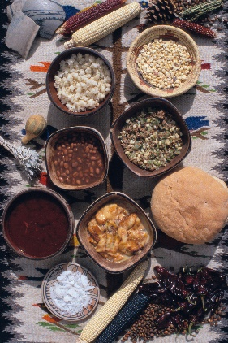
- Fri. March 31st 6:00-8:30 PM: Youth Family Potluck & Game Night
This will be a night of food, games, and family fun! The event is for the teens and their whole family to attend! Each family is asked to bring a dish, side, or dessert. Drinks will be provided. To help coordinate the event there is a sign-up sheet in the foyer. Dinner will be in the fellowship hall. Various board, card, and video games for all ages will be set up downstairs. The games will range from Go Fish to Pool to Monopoly. Although some games are geared for elementary age children, parents are responsible for watching their little ones because childcare will not be provided.

WHAT WE’RE TEACHING

Sunday School:
BIBLE STUDIES FOR LIFE: RECOGNIZING GOD’S VOICE – A STUDY THROUGHOUT SCRIPTURE
Jesus says, “My sheep hear my voice, I know them, and they follow me” (John 10:27). Earlier Jesus explained, “The sheep follow him [the Gatekeeper] because they know his voice.” (John 10:4). How can we know Jesus’ voice? What does this look like and mean for us? In March, we will continue studying truths from the Bible, God’s recorded voice, that give us signs about how we can recognize God’s voice. When God’s voice is clear to us, then so will be the right way of life.

Youth Group:
CONTROL: UNDERSTANDING OUR AUTHORITIES – A 3-WEEKS BIBLE STUDY ON THE AUTHORITIES GOD HAS GIVEN TO HUMANITY
Stereotypically, teens are seen as rebellious, but the truth is all humans tend to resist authority. This all stems from humanity’s roots in Adam and Eve rejecting God’s authority in the Garden of Eden. In this 3-weeks study inspired from a series from RightNow media, we will consider the authorities God has given to humanity, why we should submit to them, and how we are currently doing at submitting to them. These Bible lessons will examine the ultimate authority of God, and the God-given authorities of parents and human government.

Small Group:
ANSWERS IN GENESIS: ANSWERS ACADEMY – BIBLICAL ANSWERS FOR REAL LIFE
According to Pew Research Center, 73% of those who never or seldom attend religious services see science and religion as frequently in conflict (“Religion and Science,” 2015). Among those who attend a religious service weekly, a significant 50% share the same view! This small group will aim to help teens tackle this issue head on, ask questions in a safe place, and be able to stand on and defend their faith in God’s Word. The plan is to watch a 25 to 30 minute video from Answers in Genesis, and then have an open discussion about it. In 4 sessions, we will learn about the Bible and observational science, biochemistry and evidence for God’s existence, and natural selection and creation of kinds.

~ Blessings, Pastor Jonathan

