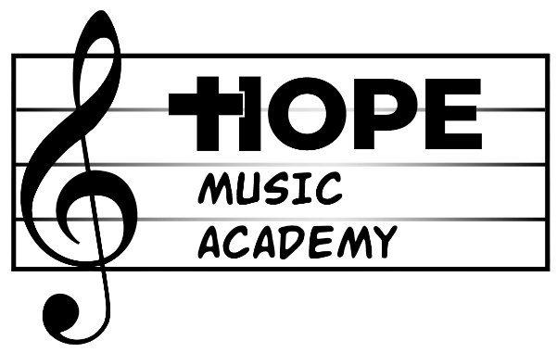

Thank you for your interest in Hope Music Academy (HMA). We offer private and group lessons in Piano, Guitar, Voice, Bass Guitar, Ukulele, Trombone, Trumpet, and Drums. If you’d like to learn a different instrument, please feel free to let us know and we will be happy to find an instructor for you.

Please take a look at our course descriptions and prices below to help you decide which option is best for you.

Private lessons (30 minutes, 1X/ week): $130/ month
The most popular option among students and teachers alike, you get 30 minutes every week with your private instructor focused exclusively on your personal progress. This allows for the instructor to develop a lesson plan specifically built around your own needs. Students often experience the most progress in private lessons.

Group lessons (2-4 students, 45 minutes. 1X/ week): $130/ month
Students who may not yet feel ready for private lessons will be put together with up to 3 other students of similar age and skill level. While this option does not offer the advantage of a personalized lesson plan, it is a great way to help shy or anxious learners step out of their comfort zone and experience the joys of making music.
- This option is currently only available for guitar and ukulele. Piano Lab group lessons will be coming soon.
- If only one student is registered for a specific group lesson time, the class will be conducted as a 30-minute private lesson until a second student registers.
- -If only one student shows up to any given group lesson (even though multiple students are registered), the class will be conducted as a 30-minute private lesson.

Single lesson (30 minutes, 1X/ week): $40
Students who want to take lessons but may not wish to commit to an entire month may consider this week-to-week option.
- Please not that the pricing for this plan is different than our monthly private lesson prices.
- This option is only available for private lessons. Not for group lessons or any other programs we may offer.

**Students will need to purchase a method book. This is separate from the lesson tuition. The price varies depending on the instrument but will generally be between $6 and $10.

“RockOUT!” band class (60 minutes, 1X/week): $120/ month
Do you want to be in a band? Do you dream of one day being a rock star? This class offers you the opportunity to learn what it’s like. Students will be placed in an ensemble with other students of similar age and skill level. They will learn the fundamentals of teamwork, musical interpretation, and even improvisation in a fun and relaxed atmosphere.
- This class is offered as an addition (not alternative) to private lessons; therefore, the student MUST be taking private lessons at HMA before registering for this class and continue lessons while enrolled in this class.

SUMMER JAM- Children and Teen Music Program (6 days total): $380
This is a 2-week program, 3 days each week (Wednesday, Thursday, and Friday during the early afternoon/ evening) consisting of private lessons and group classes.
The program will run from August 6th to August 15th and will conclude with a student recital the evening of August 15th so the students may showcase what they learned throughout the course of the program.

If you’d like more information on any of our programs, please call us at
(312) 929-3546 or email us at hopemusicchicago@gmail.com

Items to note:

- Students will be responsible for bringing their own instrument (excluding piano and drums). If your lesson cannot be conducted because you forgot your instrument,
- If you do not own an instrument and would like help in getting one, please let us know. It would be our pleasure to help find a good quality affordable instrument.
- Monthly fees must be paid by a credit card, which will be kept on file and auto charged at the beginning of the month.
- Monthly fees assume 4 weeks in the month. If a student’s lesson day or “RockOUT!” band class occurs 5 times in a specific month, the monthly fee will be adjusted at an additional $32.50 and $30 respectively.
- Likewise, if a student’s lesson time or “RockOUT!” band class occurs less than 4 times due to a holiday, the academy being closed, or the student enrolling in the middle of the month, the monthly fee will be prorated per lesson or class at $32.50 and $30 respectively.
- The lesson agreement will state that the student is paying for the time slot that the lesson is taking place (e.g.: Thursdays at 6 pm), not the lesson in and of itself. You CANNOT change your lesson time without first talking to the person in charge of scheduling.
- Cancellations MUST be made at least 24 hours in advance. Cancellations made more than 24 hours in advance will be made up according to the teacher’s availability.
- Cancellations made less than 24 hours in advance will NOT be made up. Rare exceptions may be made on a case-by-case basis.
- “RockOUT!” cancellations made by students will NOT be made up regardless of if 24-hour notice was given or not. If a rehearsal must be cancelled due to low attendance, fees will be prorated only for the student(s) who did not cancel and showed up ready to work.
- Any and all cancellations made by the instructor will be made up or deducted from the following month’s fees.
- If a student decides to not continue with lessons or “RockOUT!” band class, 2 weeks’ notice must be given. Otherwise, they will be charged for the first week of the following month.

