
Moses and the Burning Bush
Exodus 3:1–4:17
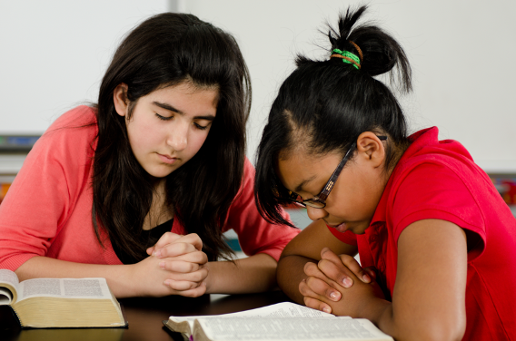
Here’s what happens…
Moses is tending his sheep when he sees a strange sight: a bush that’s on fire but not burning up. When he goes to investigate, he hears God speak to him and sees God give clear signs of who he is. Moses’ encounter makes it clear that God is real.

Bible Point:
God is real.

Family Together Time
- Light a birthday candle and sit around it as a family. (Make sure only parents handle lighters or matches,0and address any fire safety tips as needed.)
- Watch as the flame melts the wax and consumes the candle.
- Talk about what flames normally do and why the burning bush was so unusual.
- Share evidence you’ve seen that God is real. We like to call those God Sightings!

Church Announcements

- Each week children are challenged and encouraged to invite/bring a friend and their Bible.

- Each Wednesday Night- Children are learning interpretive dance and sign language.

Coming Soon

October 12th – Selma Kids Parent Meeting following morning service (Christmas!!!).

October 29th- Trunk or Treat (Candy Provided)

October 26th- Interpretive Dance (Children participate in service)

October 15th – Preparation for Christmas, Live Nativity Practice Begins
Talk About This…
- Share why you believe God is real.
“O Lord, our Lord, your majestic name fills the earth!
Your glory is higher than the heavens” (Psalm 8:1).

