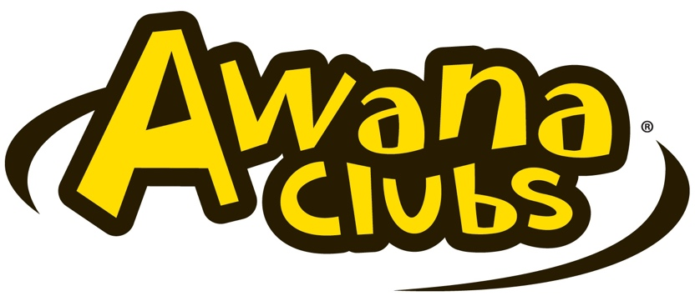

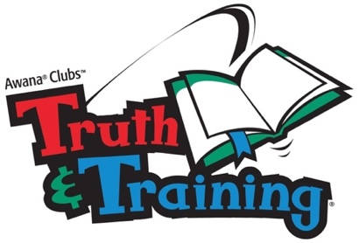


Kentuck Baptist Church
Weekly Schedule – Fall 2026

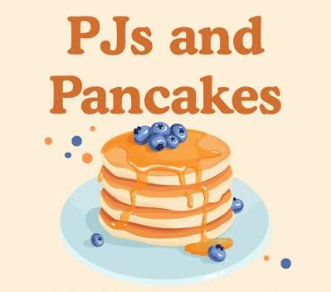
September 2 Registration / Parent Meeting
9 Crazy Hat
16 Bring-A-Friend
23 Big Games Night
30 PJs & Pancakes
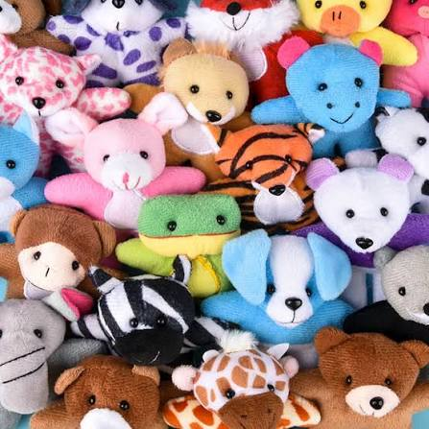
October 7 Backwards Night
14 Stuffed Animal Night
21 Double Bucks
28 Crazy Hair

November 4 Dodgeball Night
11 Operation Christmas Child Shoebox Packing Party
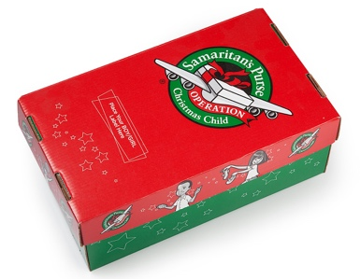
18 Count Your Blessings
25 NO AWANA - Happy Thanksgiving!

December 3 Dress Like Christmas
10 Christmas Store
17 NO AWANA - Merry Christmas!
24 NO AWANA - Merry Christmas!
31 NO AWANA - Happy New Year!
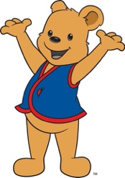
Looking Ahead …
January 6 Welcome Back
13 Bring-A-Friend

