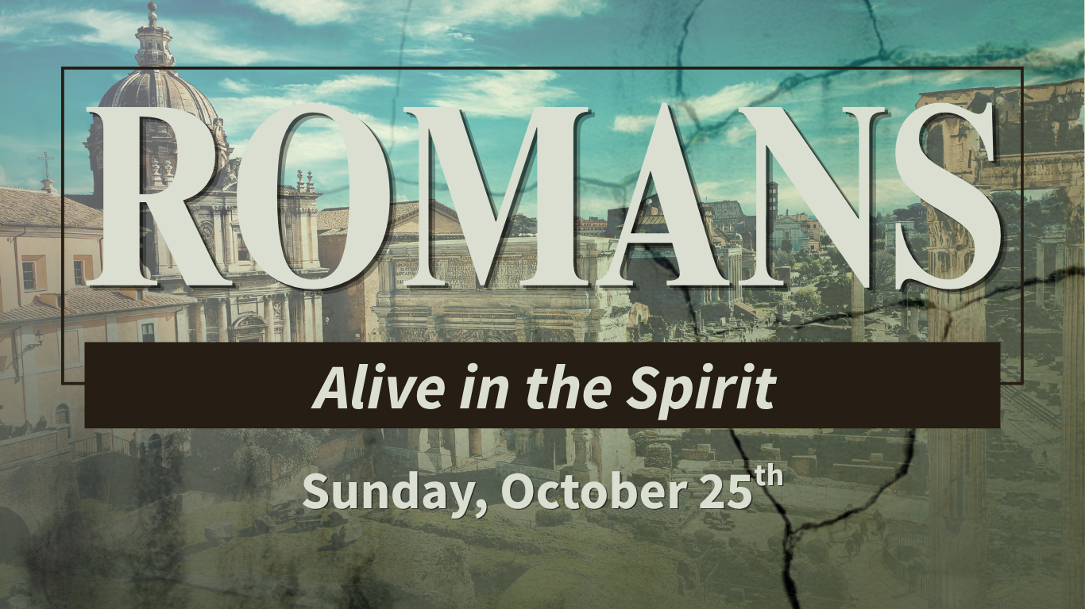
Romans 8:1–17 | Congregational Outline
Pastor Al Soto
Big Idea: We cannot overcome sin or live the Christian life in our own strength. Through Jesus, we are freed from condemnation, empowered by the Holy Spirit, and adopted into God’s family.

1. Walk in the Spirit by Living Free from Condemnation
Romans 8:1–4 | In Christ, ______________________ is removed and the Spirit empowers a ___________ life.
- Remember your new standing before God: failure does not have the final word; Jesus does.
- Depend on the Spirit’s power: the Law exposes sin but cannot rescue us from its mastery.
- Live out the righteous life God desires: grace changes both our standing and how we walk.
Greek words: katakrima (κατάκριμα), condemnation; eleutheroō (ἐλευθερόω), set free; peripateō (περιπατέω), walk/live.

2. Walk in the Spirit by Changing the Way You Think
Romans 8:5–8 | The _____________ of our lives is shaped by what occupies our minds and governs our desires.
- The flesh-centered mindset asks, “What do I want?” The Spirit-directed mindset asks, “What does God desire?”
- The mind set on the Spirit leads to life and peace; independence from God cannot produce spiritual life.
Greek words: phroneō (φρονέω), set one’s mind; sarx (σάρξ), fallen humanity operating apart from God; eirēnē (εἰρήνη), peace, wholeness, well-being.

3. Walk in the Spirit by Depending on His Power Every Day
Romans 8:9–13 | The Spirit dwells in believers and empowers us to reject sin.
- Remember who lives in you: you are not left to fight sin _________________.
- Tune in to the Spirit through Scripture, prayer, worship, and listening; _______________ throughout the day.
- Obey what God shows you: take practical steps of repentance, accountability, and new patterns.
Greek words: oikeō (οἰκέω), dwell/make a home; thanatoō (θανατόω), put to death.

4. Walk in the Spirit by Living as a Beloved _____________ of God
Romans 8:14–17 | The Spirit leads us, assures us, and forms our identity as God’s children.
- Follow the Spirit’s leading toward Christlikeness, truth, holiness, love, and service.
- Live from love rather than fear: through Christ, we are welcomed into God’s family.
- Receive the Spirit’s assurance and live with the hope and responsibility of an heir with Christ.
Greek words: agō (ἄγω), lead/guide; huiothesia (υἱοθεσία), adoption into the family; symmartyreō (συμμαρτυρέω), bear witness together.

Summary: Four Ways to Walk in the Spirit
Romans 8 | Key response
8:1–4 | Receive freedom from condemnation; walk in grace.
8:5–8 | Set your mind on the Spirit; pursue life and peace.
8:9–13 | Depend on the Spirit and put sinful patterns to death.
8:14–17 | Live as God’s beloved child and heir with Christ.

Six Key-Point Fill-in-the-Blanks
Complete each statement using the key points from the message.
- In Christ, I am free from Condemnation.
- The Holy Spirit empowers me to live a CHANGED/TRANSFORMED life.
- My mindset influences the DIRECTION of my life.
- The Spirit dwells in me, so I do not have to fight sin ALONE.
- Walking in the Spirit means I must listen and then stay attentive.
- Because of Jesus, I am a beloved CHILD of God.
Answer Key: condemnation; changed/transformed; direction; alone; obey; child.

Huddle Group Discussion
Read Romans 8:1–17 together. Choose the questions most helpful for your group.
- How is the Holy Spirit’s conviction different from condemnation? What helps you live in the freedom Christ gives?
- What most often shapes your thinking when you are stressed or tempted? What helps you set your mind on the Spirit?
- Where are you tempted to rely on willpower instead of the Spirit’s help?
- What habit, attitude, or behavior may God be asking you to confront, and what practical step can you take?
- How does knowing you are God’s beloved child change how you approach Him and face failure?
Take-home challenge: Identify one thing to stop feeding, one truth to keep in mind, and one step of obedience to take this week.
Closing prayer: Holy Spirit, renew our minds, empower us to reject sin, and help us live confidently as beloved children of our heavenly Father. Amen.

Greek Word Notes and Textual Footnotes
1. Katakrima (κατάκριμα): condemnation, a judicial sentence of guilt. Romans 8:1’s shorter reading—“There is therefore now no condemnation for those who are in Christ Jesus”—is supported by early witnesses and adopted by modern critical editions. The longer phrase about walking according to the Spirit likely reflects harmonization with Romans 8:4. See Nestle-Aland, Novum Testamentum Graece, 28th ed., and Metzger, A Textual Commentary on the Greek New Testament, 2nd ed. (1994).
2. Eleutheroō (ἐλευθερόω): set free or liberate. In Romans 8:2, manuscripts vary between “you” (σε) and “me” (με); “you” has stronger early support, while “me” may reflect assimilation to Paul’s first-person struggle in Romans 7:24. See Metzger, A Textual Commentary, discussion of Romans 8:2.
3. Peripateō (περιπατέω): to walk; figuratively, to conduct one’s life.
4. Phroneō (φρονέω): to set one’s mind on something or adopt an outlook.
5. Sarx (σάρξ): flesh; here, fallen humanity operating apart from God, not merely the physical body.
6. Eirēnē (εἰρήνη): peace, wholeness, harmony, and comprehensive well-being; closely related to the Hebrew concept shalom.
7. Oikeō (οἰκέω): dwell, reside, make a home; from oikos (οἶκος), house/home. Romans 7:17–20 describes sin dwelling within; Romans 8:9, 11 describes the Spirit dwelling in believers.
8. Thanatoō (θανατόω): put to death; in Romans 8:13, sinful practices are put to death by the Spirit.
9. Agō (ἄγω): lead, guide, bring along.
10. Huiothesia (υἱοθεσία): adoption into the family with full status and inheritance. Paul’s “sons” language emphasizes full family status for all believers, women and men alike.
11. Symmartyreō (συμμαρτυρέω): bear witness together; the Spirit testifies with our spirit that we are God’s children.

Selected Resources
- Black, Matthew, et al., eds. The Greek New Testament. United Bible Societies, 1966/1968.
- Bromiley, Geoffrey W. Theological Dictionary of the New Testament: Abridged in One Volume. Eerdmans / Paternoster Press, 1985.
- Cranfield, C. E. B. A Critical and Exegetical Commentary on the Epistle to the Romans, vol. 1. T&T Clark, 1975/1982.
- Fee, Gordon D. God’s Empowering Presence: The Holy Spirit in the Letters of Paul. Hendrickson, 1994.
- Metzger, Bruce M. A Textual Commentary on the Greek New Testament, 2nd ed. Deutsche Bibelgesellschaft, 1994.
- Murray, John. The Epistle to the Romans. Eerdmans, 1959/1965.
- Rienecker, Fritz, and Cleon Rogers. Linguistic Key to the Greek New Testament. Zondervan, 1976.
- Witherington III, Ben, and Darlene Hyatt. Paul’s Letter to the Romans: A Socio-Rhetorical Commentary. Eerdmans, 2004.

