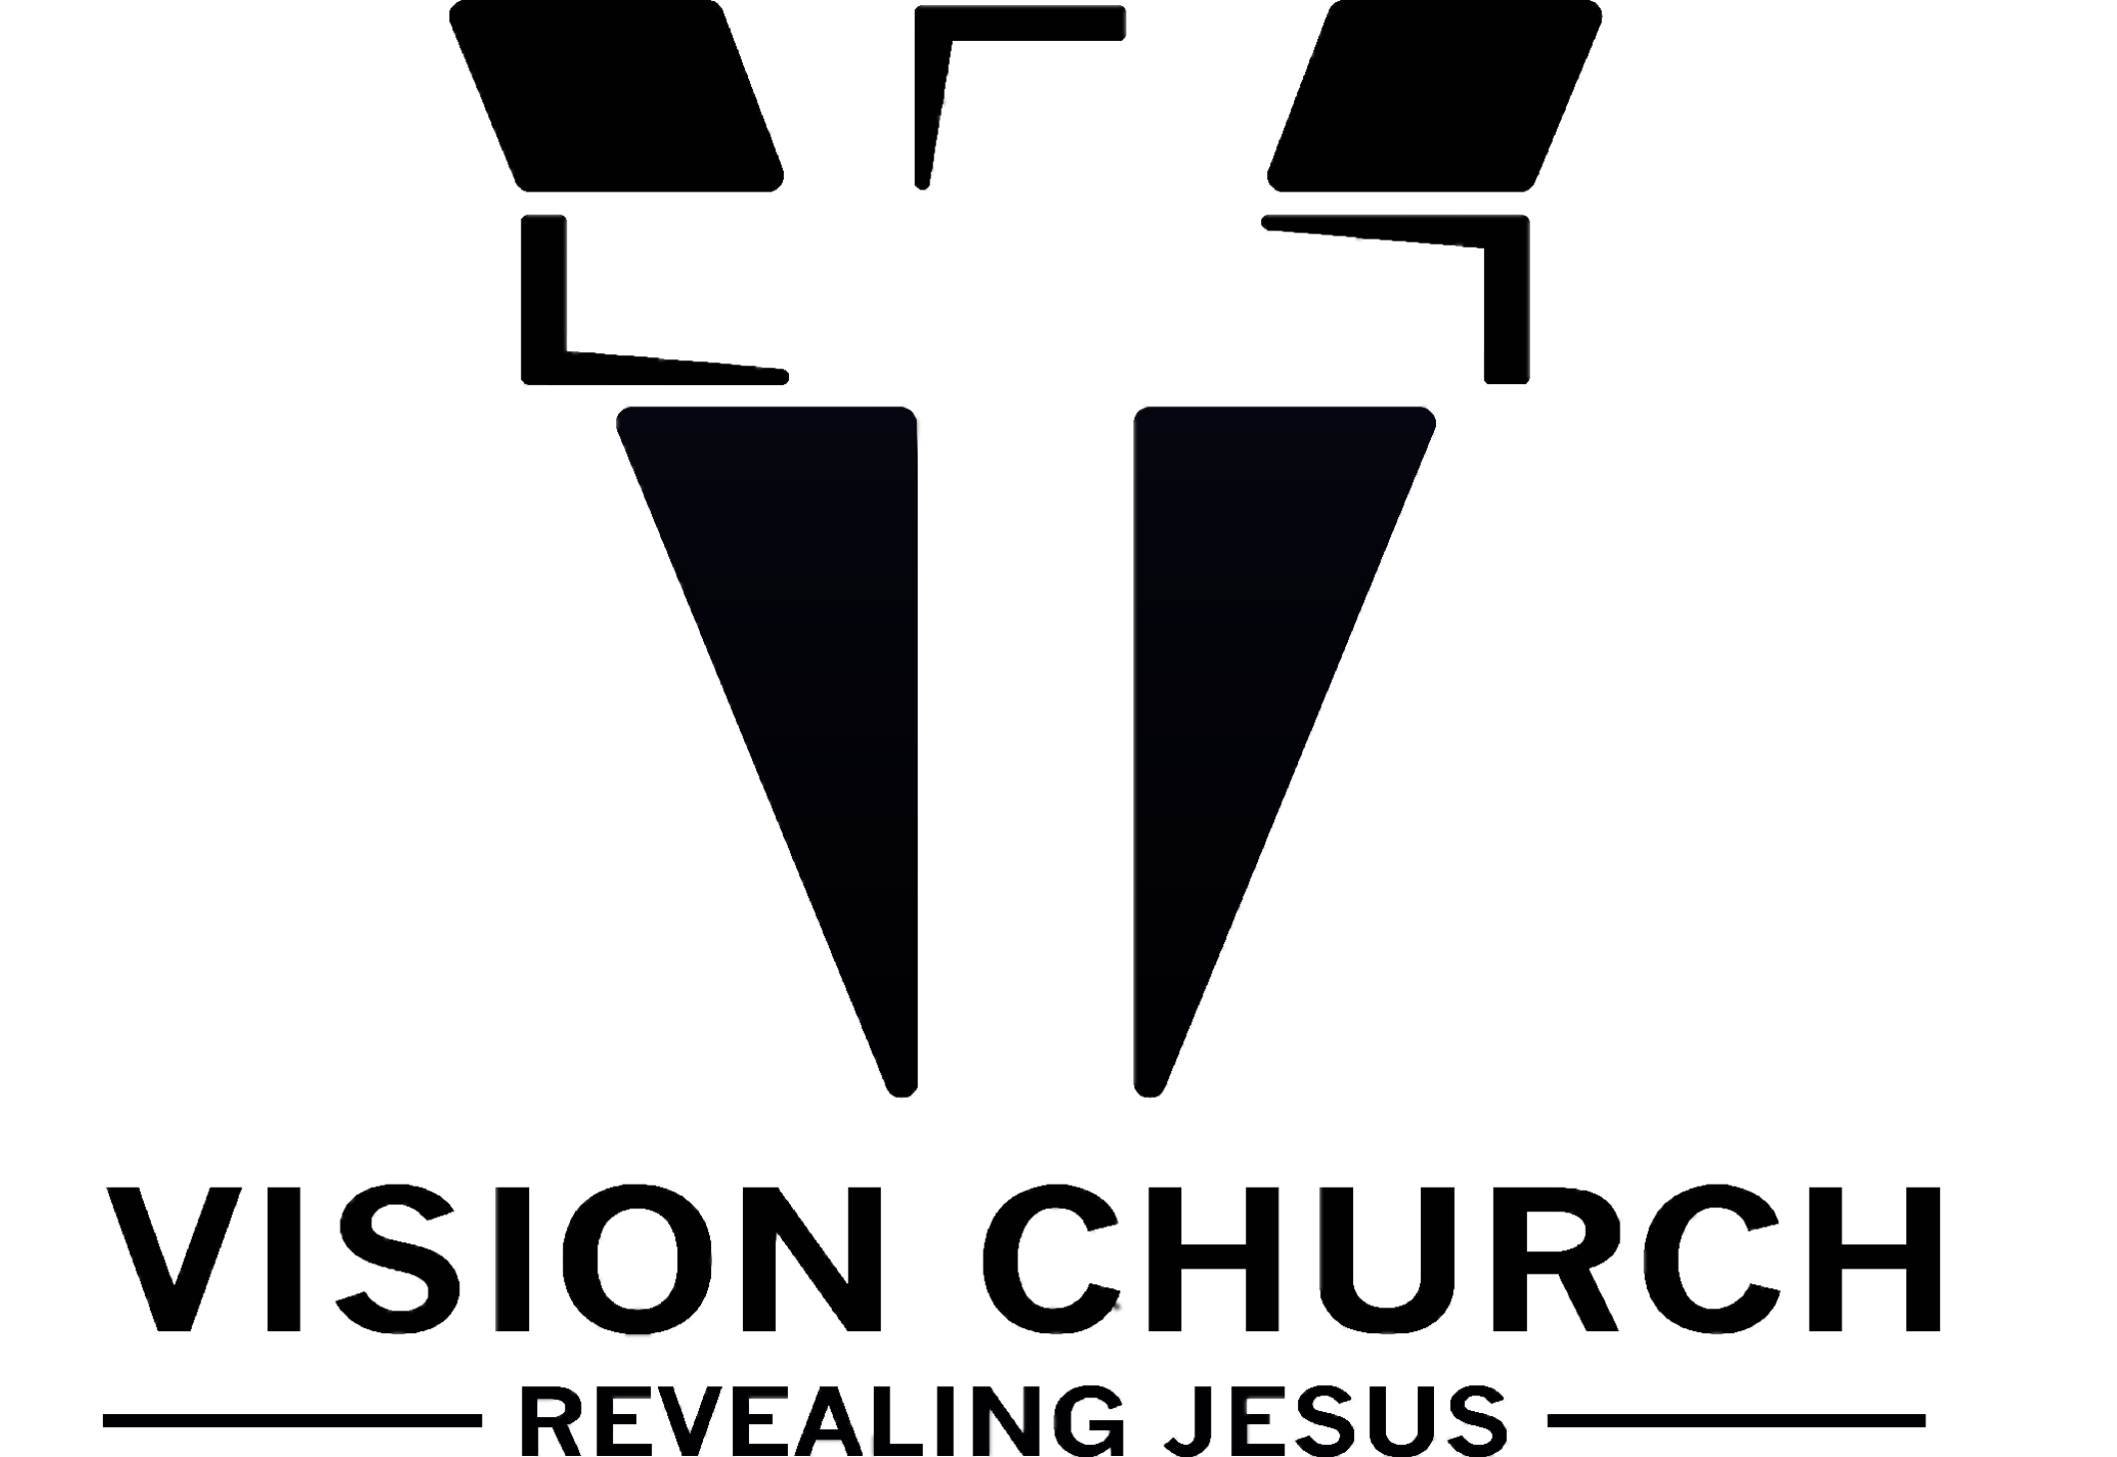

StepONE
BECOME A MEMBER

Our Vision
Build churches that reveal Jesus, by making disciples, that discover purpose. Vision Church helps people recognize their destiny and design in Jesus. We are part of the solution for a broken world in desperate need of Christ. We are a church that bridges generational divides. We reveal Jesus to the world so they know who He is and help the world know who they are in Him.
OUR MISSION
Equip, position, and launch followers of Christ into God's dreams.
OUR PURPOSE
Our purpose as a ministry is to love Jesus and be loved by Him. We were created for this purpose. Jesus came into the world because He loved us and we minister because we love Him. This is a love based relationship not a performance based ministry. Because he first loved us, we also share that love through the commission of bringing the good news of Jesus Christ by revealing him to the world.

I HAVE COME THAT THEY MAY HAVE LIFE, AND HAVE IT TO THE FULL.” JOHN 10:10

Vision Church Next Steps guide you to discover your redemptive purpose and live the life God created for you. Next Steps is made up of three steps that move you forward to
1) connect to the church, 2) discover the strengths of your design, and 3) use your God-given gifts to make a difference in the lives of others.

StepONE – Become a Member
Explore the ministry of vision Church and find out how to connect with our church in the app.

StepTWO – Discover Your Design
Dive into the details of your personality, discover your gifts, and see how your design reveals your purpose in life and your best fit in ministry. Step Two takes place in the app under the “Join Vision Church” tab. Fill it out to plug in.

StepTHREE – Join the Team
Connect to the opportunities available at Vision to live out your purpose and serve others by using your God-given gifts. Under the “messaging” tab in our app you can ask to join a team and that leader will connect with you.

OUR PRAYER FOR YOU
“Let there be real harmony among you so there won’t be any splits in the church. I plead with you to be of one mind, united in thought and purpose.” 1 Corinthians 1:10 (LB)

OUR MULTIPLYING MOVEMENT
- SMALL GROUPS – Small faith communities that meet in homes to lead people to Jesus. These gatherings are established through a free market approach and feature live or video teaching, food, and fun around a theme or common interest.
.
- NEW PLANT- A new location that we have launched as a result of raising up leaders to start a new location or an entirely new sovereign church that God has given someone Vision for.
THE VISION CHURCH STORY

This Vision started with a dream one night in 2007 where a man said to me to buy his land. I offered him money and he said no just give me a dollar to make it legal. I paid him and purchased the property that I had never seen and would not be able to visit until the future and awoke. Then in 2016 we were at a Christian vacation camp. We listened to a minister share a story about a Hong Kong Christian ministry school for street kids who purchased a $1.2 million dollar facility. They tried to fundraise and did not raise any donations except for one letter from a little girl who sacrificed her ice cream money totaling one dollar. They offered it to the brokerage even though they felt embarrassed, because they believed God was in it and He was. After hearing that story, I reached into my wallet and took out all the money I had... which was one dollar.
I found the one dollar bill in a parking lot on the ground during lunch the day before and it felt special at that moment. Little did I know I was going to be placing it in an offering bucket by faith, believing that God was going to give us what we could not purchase on our own.
Fast forward several years with multiple prophetic confirmations and we find ourselves at 49 Greenbush trying to buy a building with no money. We did not have the money for the asking price, but believed God was saying yes! At a very low moment, standing in front of the church building, I was feeling lost with no path forward. I was looking in the church mailbox and found all sorts of bills from the past owners. It brought all the expenses and financial needs to the forefront of my thinking. “How would we ever pay for this?” While rummaging through the pile of mail, a loose one-dollar bill fell out of the stack. In that moment I remembered the different dreams, the Hong Kong Ministry, and many other prophetic confirmations about one dollar from over the years.
Suddenly I knew without a doubt in my mind that the Lord was saying yes and that the Lord would provide for every need. Now can you guess what the purchase price on the deed said? The owner made us an offer to buy at 1 dollar with a balloon payment in 10 years for the total asking price.

Today, the dream is now reality, we must steward and fulfill the mission of equipping, positioning, and launching people into God's dreams.

We are seeking a ______________ not a _____________.

In order to transform people we need common values.
- Lordship: makes God the________ and trusts His lead wherever it goes.
- Crucifixion: We embrace_______________to receive Jesus dreams and make Him our desire.
- Charisma: We serve using ____________________ empowered by the Holy Spirit.
We are ____________ not _____________.

Servants- Are givers who find purpose through elevating others.
- Carry the presence of God because Jesus came to serve.
- Rely upon and experience the power of God in their lives to serve.
- Are free from pride and selfishness that pollutes the heart.
- Gain the mind and heart of God.

Consumers-Are consumed with themselves and offer nothing.
- Only experience the outward presence of God through others.
- Rely upon human strength and will power.
- Wrestle with pride and self centered behaviors that plague them.
- Cannot receive the things of God and unwittingly oppose them.

OUR MOVEMENT HELPS PEOPLE TAKE FOUR STEPS:
(People need to know that discipleship happens at every step of the way. Each step is leading people to Jesus. These steps are more like catalysts for growth. Every believer needs all of them to be healthy. You can grow but not become mature.)

1._____________________________________________
“[I pray]… that you may know Him better [personally].” EPHESIANS 1:17–18

2. _____________________________________________
“Therefore confess your sins to each other and pray for each other so that you may be healed.” JAMES 5:16

3. _____________________________________________
“We have different gifts, according to the grace given us.” ROMANS 12:6

4. _____________________________________________
“This is to my Father’s glory, that you bear much fruit, showing yourselves to be my disciples. I have told you this so that my joy may be in you and that your joy may be complete.” JOHN 15:8, 11

1. KNOW GOD - __________________________
We consider reaching people who do not know God personally to be one of our greatest responsibilities.

Teamwork makes the _______________work!
On Sunday we focus on five values:
1. _____________________________________________
We believe church should be enjoyable.
“I was glad when they said to me, ‘Let us go into the house of the Lord.’” PSALM 122:1 NKJV
2. _____________________________________________
We believe church should be a place where people experience God’s presence.
“But…when some unbelievers or ordinary people come in, they will be convinced of their sin by what they hear. They will be judged by all they hear, their secret thoughts will be brought into the open, and they will bow down and worship God, confessing, ‘Truly God is here among you!’” 1 CORINTHIANS 14:24–25 GNT
3. _____________________________________________
We believe church should be a place where people learn how the Bible applies to their daily lives.
“So Christ Himself gave the apostles, the prophets, the evangelists, the pastors and teachers, to equip His people for works of service, so that the body of Christ may be built up.” EPHESIANS 4:11–12

4. _____________________________________________
We believe church should be a place where everyone actively participates every weekend.
“What then shall we say, brothers and sisters? When you come together, each of you has a hymn, or a word of instruction, a revelation, a tongue or an interpretation. Everything must be done so that the church may be built up.” 1 CORINTHIANS 14:26
5. ____________________________________________
We believe church should be a place where people can accept Jesus as their Lord and Savior.
“‘Everyone who calls on the name of the Lord will be saved.’ But how can they call on Him to save them unless they believe in Him? And how can they believe in Him if they have never heard about Him? And how can they hear about Him unless someone tells them?” ROMANS 10:13–14 NLT

How we share Christ with others: ___________________________
“Go out into the country…and urge anyone you find to come, so that the house will be full.” LUKE 14:23 TLB
- Accept the personal________________________.
- Build a personal __________________________.
- Share your personal _______________________.
- Give a ____________________.
- Follow the__________________.

Where we share Christ
- “In Jerusalem” - Our home.
- “In Judea and Samaria” - Our city.
- “To the ends of the Earth” - Our world
How we can participate
- ___________
- ___________
- ___________
2. FIND FREEDOM - _____________________________________________
We believe life change happens in the context of relationships. God created us to live in community with others, and it is only then that we can experience the full life He intends for us. Discipleship was never intended to be a classroom. It requires doing life together with other believers who desire to live the way Jesus showed us.

- A place to__________________ with others.
- A place to __________________each other.
- A place to __________________together.

Four things to know about Vision Groups:

1. Our groups are _____________________________________.
We want people to gather together based on things they enjoy and are important to them. Essentially, the things you are already doing in your life are the things that can make up your Small Group! From sports groups to lunch groups, parenting groups to student groups, Bible study groups to creative arts groups, our groups are as varied as we are.

2. Everyone _____________________________________________ a group.

Find your group in the App

4. Anyone ______________________ a group.

We believe hosting a group is simple because we all have something to offer others. Whether it’s something you are passionate about, an experience you’ve had that can help others, or an area in which you are looking to grow, hosting a group is a great way to bring people together in a meaningful community.

3. DISCOVER PURPOSE- _____________________
Vision Church exists to help you discover and develop your purpose and live the full life God created for you. Next Steps is made up of three steps, which guide you in your journey to know God, find freedom, discover purpose, and make a difference.

“Let us move beyond the elementary teachings about Christ and be taken forward to maturity.” HEBREWS 6:1

1. StepONE — _____________________________________________.
Explore the ministry of Vision and find out how to connect with our church.

2. StepTWO — _____________________________________________.
Dive into the details of your personality, discover your gifts, and see how your design reveals your purpose in life and your best fit in ministry.

3. StepTHREE — _____________________________________________
Learn the high calling of service.

3. Step FOUR-
______________________________________
Connect to the opportunities available at Vision to live out your purpose and serve others by using your God-given gifts.

4. MAKE A DIFFERENCE -___________________________________
Discover what you do well and take steps to use your gifts to make a difference. We believe your life will never make sense until you find, develop, and fulfill your purpose.

- Every member is a ____________________________________.

- Every person is ________________________________ in some area.

- Every _____________________________________ is important.

“For we are God’s handiwork, created in Christ Jesus to do good works, which God prepared in advance for us to do.”
EPHESIANS 2:10

“Now God gives us many kinds of special abilities…and there are different kinds of service to God [ministry]…All of you together are the one Body of Christ and each of you is a separate and necessary part of it.” 1 CORINTHIANS 12:4–5, 27 TL

VISION CHURCH GOVERNMENT
As you consider investing your heart, time, family, and finances into the life of a church, it is important for you to feel confident in church leadership. Our goal in sharing the details of Vision churches government is that you will understand that our church is structured to support the values of integrity, accountability, and spiritual authority.

Our church government is made up of three groups of elders:

1. Guided by _____________________________________________.
The Pastoral Staff team is led by Pastor Nate. This team oversees the day-to-day ministry and operations of the church. These pastors serve the congregation and are responsible for the development of the spiritual life of the church. The Senior Pastor Leadership Team serves as Staff Elders.

2. Protected by _____________________________________________.
Our Trustees are 3 members of the congregation appointed by the Senior Pastor to oversee the finances and direct the provision of the facilities needed by the church. They provide counsel to the Senior Pastor regarding the major financial commitments of the church. The Trustees serve as Non-Staff Elders.

3. Strengthened by _____________________________________________.
The Overseers are t pastors of respected congregations and ministries who love vision Church and are willing to provide spiritual protection to the church. They may be called upon to help in accountability matters relating to the Senior Pastor if requested to do so by the Pastors or Trustees. The Overseers serve as Apostolic Elders.

A NOTE REGARDING CHURCH FINANCES
At Vision Church, we practice tithes & offerings for the support of Christ’s body, the church, as God commands.

1. _____________________________________________.
The tithe, or “first fruits” of our labor/income belong to God. We find this principle all through God’s Word. Tithing, giving God the first 10% of our income to the local church, is the primary, practical way we acknowledge that God is first (Proverbs 3:9–10).

“Be sure to set aside a tenth of all that your fields produce each year.” DEUTERONOMY 14:22–26

“Bring the whole tithe into the storehouse, that there may be food in my house. Test me in this,” says the Lord Almighty, “and see if I will not throw open the floodgates of heaven and pour out so much blessing that there will not be room enough to store it.” MALACHI 3:10.

2. _____________________________________________.
An offering is giving over and above the tithe. The Bible says that by giving generously, we are able to “take hold of the life that is truly life.” You aren’t really living unless you are freely giving (1 Timothy 6:18–19).

“Every Sunday each of you make an offering and put it in safekeeping. Be as generous as you can. When I get there you’ll have it ready, and I won’t have to make a special appeal.”1 CORINTHIANS 16:1–4 MSG

3. We want people to understand they are giving to God __________________________________ not to the church.

4. The giving of tithes and offerings is _____________________________________ to Jesus and an expression of the relationship between the individual giver and the Lord. Funds are not “income only,” they are worship and are not considered to be a business transaction but an expression of gratitude toward God.

BECOMING A MEMBER
Having received Christ as my Lord and Savior and being in agreement with the values and ideas presented in Step One of Next Steps, I now feel led by the Holy Spirit to unite with the Vision church family. In doing so, I make the following commitment to God and my fellow church members:

1. I will _______________ regularly: Church and Small Groups faithfully. Acting in love toward other members. Refusing to gossip and Follow the leaders.

“Let us not neglect our meeting together...but encourage one another.” HEBREWS 10:25 NLT

“Have confidence in your leaders and submit to their authority, because they keep watch over you as those who must give an account. Do this so that their work will be a joy, not a burden, for that would be of no benefit to you.” HEBREWS 13:17

2. I will ____________ regularly: Discovering my gifts and talents. Using my God-given gifts to make a difference in the lives of others. Developing a servant’s heart. Praying for its growth and health. Inviting the unchurched to attend. Warmly welcoming those who visit.
- “Serve one another with the particular gifts God has given each of you.” 1 PETER 4:10 PH
- “Go out into the country…and urge anyone you find to come in, so that the house will be full.” LUKE 14:23 TLB
- “So, warmly welcome each other into the church, just as Christ has warmly welcomed you; then God will be glorified.” ROMANS 15:7 TLB

3. I will _________________ regularly.

“Every Sunday each of you make an offering and put it in safekeeping. Be as generous as you can. When I get there you’ll have it ready, and I won’t have to make a special appeal.”
1 CORINTHIANS 16:1–4 MSG

