APRIL 2023, VOL. 40
 | AMAZING  GRACE  CONNECTIONS

Faith > Family > Community
Grace Lutheran Church of Lily Lake
5N600 Hanson Rd, St. Charles, IL 60175
Pastor David Mercurio

Worship every Sunday at 9 am
with Communion
Sunday, April 2, Palm Sunday, Coffee Hour & Sunday School
Thursday, April 6, Maundy Thursday Worship at Grace 7 pm
Friday, April 7, Good Friday Worship at Burlington
Methodist, 7 pm
Sunday, April 9, Easter Worship, Breakfast from 8-11 am Sunday, April 16, Worship & Sunday School
Sunday, April 23, Worship, Pastor Jane Perkolup preaching
Sunday, April 30, Worship, Pastor Jane Perkolup preaching


.
This Photo by Unknown Author is licensed under CC BY

Sunday, April 2 – Palm Sunday Worship at Grace at 9 am,
Jesus’ triumphant entry to Jerusalem
Monday April 3 – Jesus clears the temple
Tuesday, April 4 – Jesus goes to the Mount of Olives to pray
Wednesday, April 5 – Jesus’ action unknown, perhaps a day of rest
Thursday, April 6 – Maundy Thursday service at 7 pm at Grace; Jesus and his disciples celebrate Passover and the Lord’s Supper
Friday, April 7 – Community Service at Burlington Methodist, 7 pm
Jesus’ trial, death and burial
Holy Saturday, April 8 – Jesus in the tomb; his followers mourn. We too are given this one day to mourn, one holy day to pause, to grieve, to be empty, to focus on what Christ did for us. Don’t jump to
Easter too fast. Be quiet and live in Christ.
Sunday, April 9 – Easter Worship at Grace, 9 am
Easter Breakfast in Fellowship Hall 8 – 11 am
Resurrection of Jesus, Alleluia!

"Don't be afraid! I know you are looking for Jesus, who was crucified. He isn't here! He is risen from the dead, just as he said would happen." (Matthew 28:5-6)

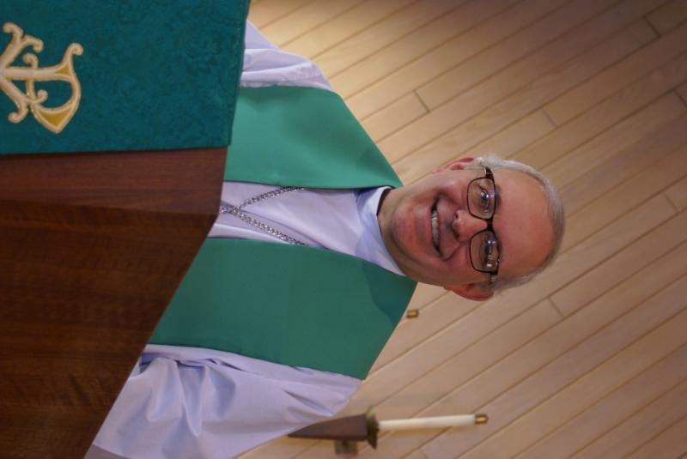
PASTOR’S MESSAGE

From the desk of Pastor David, April, 2023
Since the start of the new liturgical year in November, I have been very encouraged by what I see happening here at Grace. As Covid subsides, our attendance at our weekly worship service has been trending up. Former members are returning; new visitors are appearing. Our Sunday School program is gaining traction thanks to the hard work of Pat, Kelly, Marty, Nancy, Janice and Natalia. Nancy’s line dancing class on Thursday nights brings out huge crowds (and no small good will offerings). Special events such as “Chili Bingo” are drawing large crowds (thank you Candice and Jon). George has been working hard to get the choir back up and running on a regular basis. Rebecca Circle continues to love and serve. We have resumed using the building for public forums and voting. In other words, blood is flowing through our veins once again and we are letting the community know we are here to serve and to deliver God’s Good News to all who would receive it.
The year is not even half over and there is so much more to come, so much more work to do. I can’t say thank you enough to all of you for all the things you do, big and small, visible and hidden, to make this community what it is, a small but mighty band of sisters and brothers in the Lord. Please continue to share with the Vision Team and the Worship Team your ideas and suggestions that will help us continue to give glory and honor to God. In His name we pray.
Blessings to you all,
Pastor David
Pastor’s Hours at church
Tuesdays and Thursdays from 6 pm – 9 pm
Saturdays from 9 – noon Sundays from 8:30 am for 3-4 hours

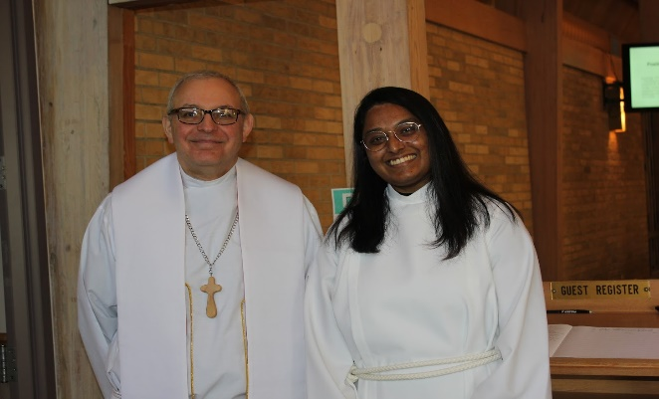

Pastor Mercurio with guest preacher, Vicar Sharai Jacob from Geneva Lutheran Church.
She will complete her training at the end of July and be open to a call then.
You will have an opportunity to hear her preach once again on May 7th.
February VISION TEAM REPORT
The Vision Team met on February 13th

- Approved minutes and the February financial report
- Pastor will be on vacation April 20 through May 6
- Easter schedule of services will be in the newspaper
- Tree trimming has been completed and front driveway is again open
- Lee Strom will be replacing parking lot bulbs
- Memorial Policy rewrite is in process

Please remember to greet visitors each Sunday and ask them to sign the register.

The Vision Team meets on the second Tuesday of each month. If you have items you feel should be discussed by the team, please send them to Marty by the first Tuesday of the month.

Easter Blessings, Marty Bradley, President


MANY THANKS AND PRAYERS TO THOSE WHO HAVE RECENTLY DONATED THEIR TIME AND TALENTS, including, but not limited to:

- Pastor for the great Bible Studies during Lent and for the leaders during the soup luncheons, Kurt Redemann, Marty Bradley, Nancy Schnaitman, and Jan Docherty
- All those involved in the Chili Bingo night, especially Candice Hopkins
- Heidi and Nathan Anderson for wiping down the sanctuary after worship every Sunday
- Kurt and the Maintenance team for dealing with tree trimming estimates and getting the job approved and completed
- Ken Kusch for replacing the bathroom switches & other small electrical issues

- Again, we thank the team (Suzanne Girsch, Kathy Hooey, Twyla Strom, Margaret Swanson and Cathy Whiteside) that reviewed our membership roster and sent letters to folks we had not seen for a long while. In updating our membership for the annual ELCA report, we can now report that we have 109 adult confirmed members and 125 including children who have not yet been confirmed. Numbers are based on the definition of membership in our constitution.

VOLUNTEERS NEEDED
- Volunteers needed to assist with computers during worship – easy tech items; please see George if you can help
- Fall Sunday School: coordinator and teachers needed, see Marty to volunteer

FINANCIAL MATTERS – APRIL 2023
- Thank you, Thrivent Members – we have received $546 from your Thrivent Choice Dollars. The deadline for completing any further allocations to Grace is March 31st.
- Presently the Building Maintenance Fund balance is $4,656. A Building Maintenance Team has been formed and will be reviewing and addressing building needs. If you wish to donate to this specific fund, please notate “Building Maintenance Fund”, so the donation will be designated accordingly.

Brief recap of February financials:
2023 2022
Feb 2023 Year-to-Date Year-to-Date

INCOME $ 16,229.31 $ 34,752.82 $ 27,965.84
EXPENSES $ 16,024.47 $ 33,618.86 $ 32,769.32
NET +/- $ 204.84 $ 1,133.96 $ -4,803.48

Pray for blessings upon Grace as we continue our missions with goals and challenges in 2023 ~
In Peace, Tricia Painter, Treasurer
.
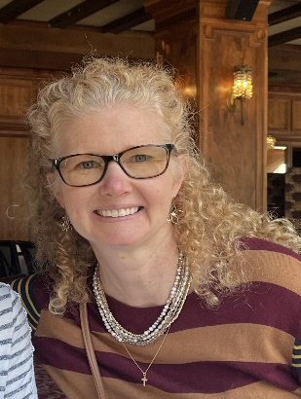
GETTING TO KNOW…
My name is Janice Muncie. I have been living in Campton Hills on Burlington Road since May 2016 with my husband of 28 years, Ed, and my twin daughters, Katie and Jessie (now they are almost 24 years old). We moved from Clarendon Hills where we raised our girls. I work at Hickory Knolls Nature Center as a preschool teacher for 3, 4 and 5 year olds and I love it! I used to teach Sunday school at my church in Clarendon Hills and I’m so glad to be able to continue to teach here at Grace Lutheran. My daughter, Jessie, was the one who introduced me to you all last summer. She voted here at the church and told me right away, “Mom, you’ve got to check out this church! It reminds me so much of our old church in Clarendon Hills.” And I am so thankful that I did! You have all been so welcoming and are truly a blessed congregation. Thank you so much for opening up your doors to me and introducing me to everything Grace has to offer. Blessings to you all!


Blessings and congratulations to Nick and Mandy Rex on the birth of their new son, Cort Frank Rex! Emric, have lots of fun with your new brother.
This Photo by Unknown Author is licensed under CC BY-ND


This Photo by Unknown Author is licensed under CC BY
Saturday, April 1st
4 – 7 PM in fellowship hall
Come join us for a Spaghetti Supper as we will be
supporting Northern Illinois Food Bank with half of the free will donation profits. All are invited.
➢Pasta ➢Red Sauce w/ & w/o meat
➢Meat Balls ➢Salad
➢Garlic Bread ➢Desserts
Carry out available

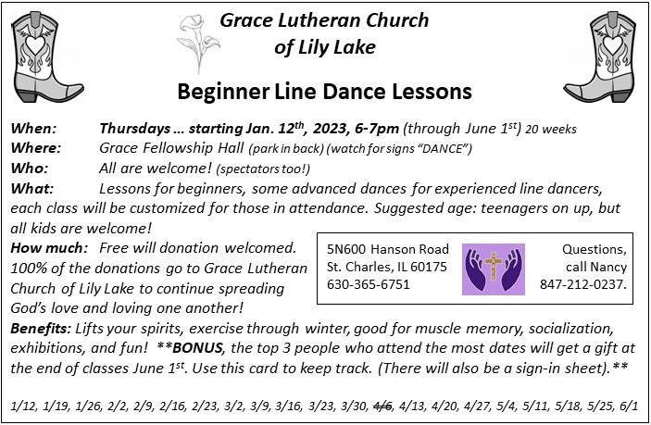
*Additional DATES TO REMEMBER*
- April 3rd Set up for the Kane County Consolidated Election and
Voting on the 4th in Fellowship Hall

- May 19 & 20 (set-up May 18) – Yes, the Spring Rummage Sale
"SPRING RUMMAGE SALE " - Please mark your calendars for our Spring Rummage Sale on May 19 & 20. We will be setting up on May 18 and need volunteers for setting up items in Fellowship Hall, SS room, 'outdoor' items in garage and clothing items under the pavilion. We will need many helping hands to help throughout the areas during set-up and especially at sale time. ​**RE: DONATIONS = we will be accepting small boxes/bags of donations on Sundays - April 30, May 7 & 14 after our church service. It would be so so helpful if you would have your items separated (i.e., clothing, outdoor items, etc.) Larger items to be dropped off May 16, 17, 18 as there are still Scout meetings through May 15. Please do not leave your items in front of doors, walkways in the church, please do not block fire exits, nor blocking lawn mowers in garage. **Gentle reminder, please no older TVs , no TV cabinets or 'entertainment' cabinets. Items that are clean, vacuumed and in working order, with cords, accessories, etc. Ask yourself: "Would I buy this?" if your answer is "no", we would sincerely appreciate you passing it on yourselves (we don't have the woman/manpower to go through boxes of clutter). Contact any of us w/questions, or how you can help:
Tricia Painter (cell# 708-624-0400) Linda Smykowski (cell# 708-309-3444) Cathy Whiteside (cell# 630-605-1096)
**More details coming in the weekly bulletin after Easter & in May newsletter. ​

- June 3 – 2023 Metropolitan Chicago Synod Assembly
Theme: In Jesus: Make Disciples
Assembly will be held at the Q center in St. Charles
Please see Marty Bradley if you wish to register. Registration is required by April 14th. Any church member may attend (no vote).

COVID 19, FLU AND RSV SAFETY PROTOCOLS
We follow the recommendations of the CDC, ELCA and IL Department of Health.
If you wish to mask and social distance, please do so. Please do not come to church if
have symptoms of illness. If you do not feel comfortable worshipping with others, we invite
you to join us for worship via our website.





GRACE ROADRUNNERS
Registration has begun for the Grace Roadrunners trip to Niagara Falls, September 18-23. Some places and sights we’ll be exploring are Notre Dame, RV/MH Museum, Rock and Roll Hall of Fame and many sites around Niagara Falls including Niagara on the Lake and Old Fort Niagara. As we head back home we’ll see a Jaws with Paws demonstration and Rutherford B. Hayes’ home. This trip will cost $1100-$1300 per person based on double occupancy and how many people sign up. A deposit of $500 due by May 15th holds your place with the balance due August 1st. The first 40 registrations are guaranteed a spot and then a wait list will be started. Registration forms will be in the Roadrunner mailbox in the church office. Contact Suzanne Girsch if you have questions.

BUILDING USE DONATIONS

The Vision Team has approved a guide for donations for personal use of areas of the building and staff (Pastor, Organist, Tech Person, and Sexton) for both members and non-members. I.E.: weddings, funerals, family gatherings, outside meetings, etc. This is standard procedure for congregations and will assist us in maintaining our building as well as covering the use of utilities/maintenance. A copy of the donation list is available in the Church Office.
If you have any questions, please contact any Vision Team Member.

THIS AND THAT

LOCKING CHURCH DOORS: We have had a couple instances when church doors
have not been locked as people leave. Please make sure if you are last person out,
that the doors are locked. Thank you.

WEBSITE INFORMATION: Marla Roach has graciously become our website coordinator.
When you look at our website, you will see many events listed that have already occurred. The upcoming events will always be listed first. This is intentional – in her expertise in this area, she says that people will be more interested in Grace if they can see what goes on during the year. This is a format to keep our various ministries front and center. Please remember to view the newsletter regularly.

LIGHTS: We are trying to keep our utility bills as low as possible. In that regard,
please do as you probably do at home, and only turn on lights in the church that you need and do so just before they are needed; and remember to turn them off immediately when they are no longer needed. Please make sure all lights are turned off when you leave the
building. Don’t forget to check the bathrooms. Thank you.

Grace & peace to you, siblings in Christ. I am Amanda White, the ELCA’s Director for Congregational Generosity. I am writing today to express my gratitude for your generosity to ELCA World Hunger, particularly the Good Gifts program.
These gifts are certainly worth celebrating! I give thanks to God for Grace of Lily Lake’s faithful, generous outpouring of love for your neighbor.
Your gifts help build God’s kingdom, a world where all are loved, cared for, and know the love of God.
I will hold you all in my prayers. Peace,
 |  | Amanda White  Director, Congregational Generosity  Office of the Presiding Bishop, ELCA  773.380.2876| Microsoft Teams Chat  Amanda.white@elca.org  (she/her)

CONTACTS:
For emergencies please contact Marty Bradley, President, at 640-777-1074 or leave a message at the church office at 630-365-6751.
For prayer requests or other needs please call Kathy Hooey at 630-341-2293 or leave a message at the church office at 630-365-6751. Messages are checked daily at noon & 5 pm.

Information for the May newsletter will be due by April 25th – please send it to Marty Bradley at martybradley@mchsi.com. Thank you!

Send me a Surprise
Lord, send me a surprise.
One that catches me off guard and makes me wonder.
Like Easter.
Send me a resurrection
when everything looks dead and buried.
Send me light
when the night seems too long.
Send me spring
when the cold and frozen season seems endless.
Send me a new idea
when my mind is empty.
Send me a thing to do
when I am just waiting around.
Send me a new friend
when I am alone.
Send me peace
when I am afraid.
Send me a future
when it looks hopeless.
Send me your resurrection when I die, Jesus.

By Herbert Brokering, Lutheran Pastor and author of the hymn, Earth and All Stars.



