 | APRIL 2024
 | AMAZING GRACE  CONNECTIONS  Faith > Family > Community
Grace Lutheran Church of Lily Lake
5N600 Hanson Rd, St. Charles, IL 60175
Pastor David Mercurio

Worship every Sunday
At 9:30 am with Communion
- April 7 – Worship with Sunday School and coffee hour following
- April 14 – Worship,
- April 21 – Worship with Sunday School
- April 28 – Worship


This Photo by Unknown Author is licensed under CC BY-NC-ND
SUNDAY SCHOOL
Sunday School for 3 through 13 year olds EVERY 1ST and 3RD SUNDAY at 9:30 am in the Grace Room.
April dates are Sundays the 7th and 21st.
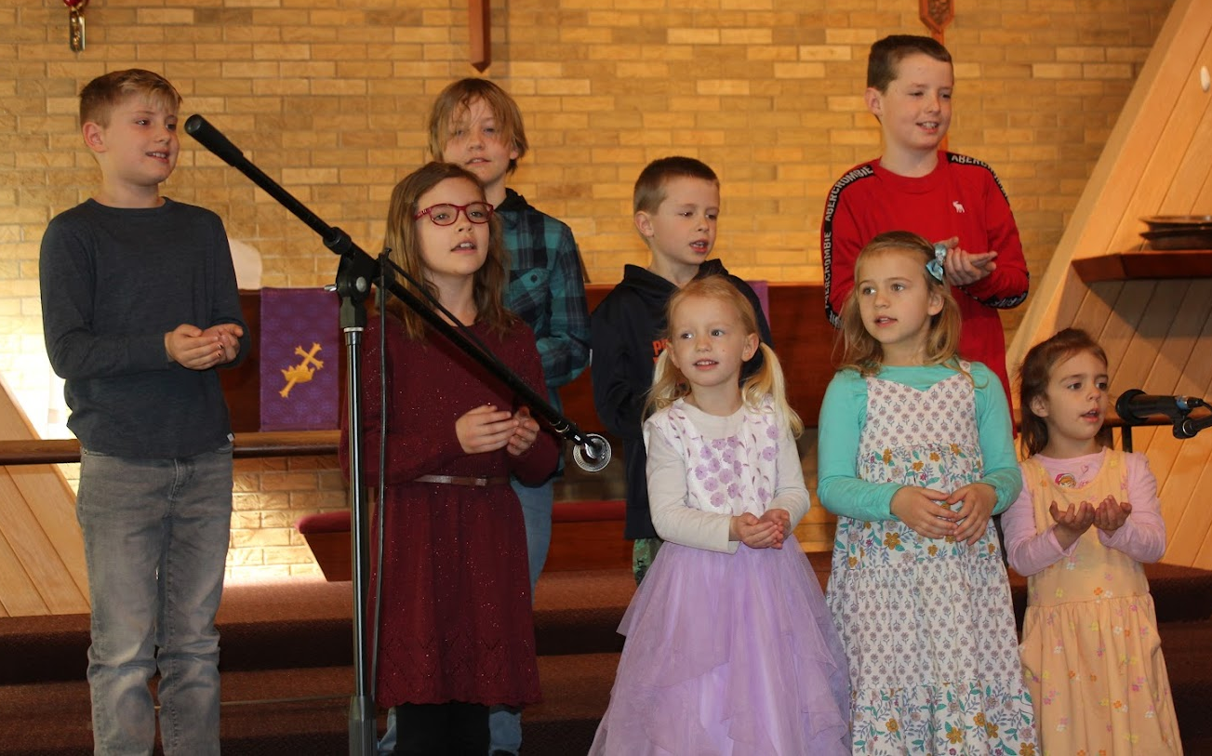

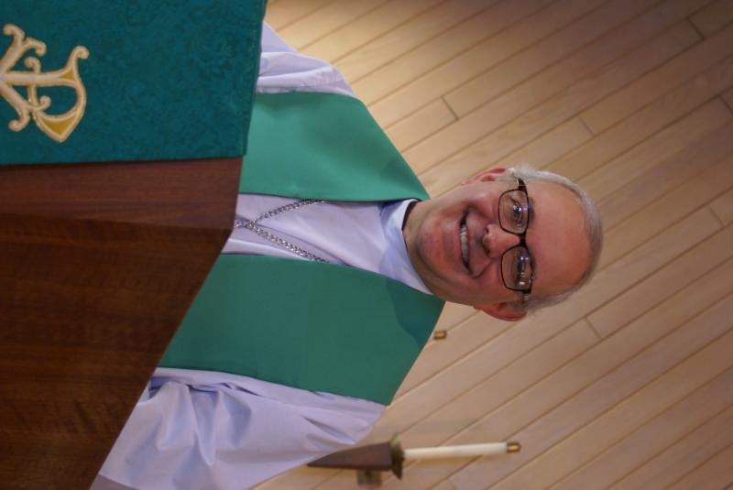
FROM the DESK of PASTOR DAVID, April 2024

Hallelujah, Christ is risen! As I write this letter, Easter is still a week away, but it has been a glorious Lenten season at Grace. We averaged 25 participants a week for our Lenten Bible study surveying world religions; we welcomed six new members into the church; and attendance at our weekly Sunday service has been consistently healthy and growing. The choir, under George’s leadership, has been singing regularly with their angelic voices, and we look forward to seeing more of them in the months ahead. Our Children’s Ministry has been vibrant and growing and I want to extend a hearty thank you to our creative and loving teachers: Janice, Nancy, Natalia, and Pat. Our community outreach is healthy and growing: Line Dancing, Rummage Sale (May 17, 18), Pancake Breakfast, Easter Breakfast, and stay tuned for a new medical education series starting in April led by Nancy Corbige.
But there is also a business side to the church. Bills need to be paid and the building needs to be maintained. The Congregation elected a new Vision Team this year and new officers were appointed, led by Dallas Peters as president. (Thank you, Marty, for all your hard work during the last two years. You came in at a challenging time and helped us navigate across rough waters through your willingness to sacrifice your time and hard work for the glory of God.) Please continue to pray for our Vision Team because they have many complex decisions to make, including the repair of our heating system, the stewardship of our building, and the ongoing financial health of Grace Lutheran Church.
And this gospel of the kingdom will be preached in the whole world as a testimony to all nations.
Pastor’s Hours: Tuesdays and Thursdays from 6 pm – 9 pm, and Sundays from 8:30 am for 3-4 hours and by appointment when requested.


MANY THANKS AND PRAYERS TO THOSE WHO HAVE RECENTLY DONATED THEIR TIME AND TALENTS, including, but not limited to:

- All participants in the Palm Sunday, Maundy Thursday, Good Friday and Easter worship services and to George Theros for the many hours he put in to make them happen
- Cathy Whiteside for keeping the event board outside up to date and for handling our facility use for voting and Life Line Screening and her ongoing clothing drive
- Kathy Hooey for coordinating all the altar changes, communion, ushering and Sunday’s event handouts (with additional helpers)
- Sunday School kids and teachers for singing, “He’s Got the Whole World” during worship
- All who have assisted recently with funeral preparations and meals
FINANCIAL MATTERS – APRIL 2024

- Thank you to those who have contributed to the Noisy offering. Several weeks’ donations in March were being collected in support of an Eagle Scout project – new fire pit area for everyone’s use.
- Presently the Building Maintenance Fund balance is $2,875. Warmer temperatures are coming and several projects will be reviewed for repairs. If you wish to donate to this specific fund, please notate “Building Maintenance Fund”, to ensure the donation will be designated to this specific account.
- We thank you for waiting patiently for Giving Statements for 2023; and those that needed correcting. ~ We are a volunteer team ~

Brief recap of February financials:
2024 2023
Feb 2024 Year-to-Date Year-to-Date

INCOME $ 15,079 $ 30,415 $ 34,752
EXPENSES $ 14,696 $ 29,276 $ 33,618
NET +/- $ 383 $ 1,139 $ 1,134

MARCH VISION TEAM REPORT
- Approved minutes and treasurer’s report from February
- Voted to set up a Committee to deal w/options relative to the mortgage - to report to Vision Team by end of Oct.
- Discussed prioritization of the items on Kurt's church maintenance property list for the benefit of Vision Team decision making going forward, in process.
- Discussed finding outside volunteer support for Trisha (on site) - to better understand our accounting program, accounting in general and obtain the ability to maximize the use of the program's functionality. Pastor has someone in mind, but it must wait until post tax season.
- Discussed Synod Assembly and Lay Leadership meetings and who will be attending.
- Discussed previously approved Eagle Scout project - siting/materials change and cost sharing. Voted to use loose change offerings from 3 Sundays
- Raised issue of previously tabled Fellowship Hall floor work and revisited cost of project. Discussed prior inability to do what's necessary to maintain our facility, and as we do this the issues get worse. In that light, reviewed the prior annual maintenance costs related to the boiler as an example (2015 to date obtained from CMS).
- Boiler and Organ update - Correspondence from Lutheran Brotherhood - In general, things look promising. Need to submit info. from RJ O'Neil when received and then we should be able to get a concrete response from insurance carrier. Still waiting for necessary documentation regarding Organ.

SPECIAL WELCOME TO NEW MEMBERS
Ann and Steve Butcher, Meghan Brannen (children, Ryder and Emmy) and Jane and Jim Cutler.

GETTING TO KNOW: Megan Brannen
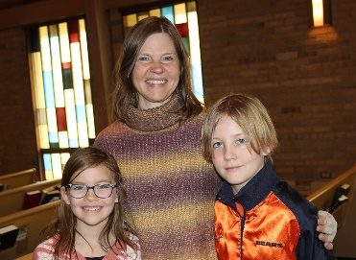
My name is Megan Brannen and my husband, Chris, and I have two children, Ryder (10) and Emmy (8). I am originally from Elgin, and went to St.John’s Lutheran School in Elgin from kindergarten through 8th grade. After meeting Chris in college, we got married at St. John’s and soon after moved to Washington state where we lived from 2001 until 2023. While in Washington, we spent much of our time enjoying the outdoors: cycling, snowboarding, and camping. As much as we loved the Pacific Northwest, all of my family is still in Elgin, and Ryder and Emmy both wanted to be near them. Last June, we decided it was time for a change so we made the move to The Windings. We love being near family and the outdoor activities the area has to offer. Both Ryder and Emmy attend Lily Lake Grade School and participate in the basketball league offered through the district. They are also taking piano lessons with Dottie Mansch. Ryder enjoys flag football and video games and Emmy loves anything to do with art and gymnastics.

We are so blessed to have found Grace. After settling in, Ryder and Emmy mentioned how much they missed their Sunday school “Kids club” in Washington. At that same time I noticed the Sunday School yard signs Grace had placed throughout Lily Lake. We decided to visit Grace that Sunday and after the warm welcome we received on our first visit, I knew that Grace was for us!
Welcome!

UPCOMING SPECIAL DATES
- LINE DANCING every Wednesday from 6-7 pm in the Fellowship
Hall
- LIFE LINE SCREENING at Grace, April 12 from 8 am to 5 pm. Contact Cathy Whiteside for more information.

SUNDAY, APRIL 7, 2024, 11:15am,
EDUCATION HOUR ON THE TOPIC OF LYMPHEDEMA
At Grace Lutheran in the large Sunday School
room in the basement

Nancy Corbige, LMT, BCTMB, CLT will be hosting an hour of education on the topic of Lymphedema. What is Lymph? What is Lymphedema? What are the main causes? What are the effects? Can it be cured? Why should we know about this? And what is Complete Decongestive Therapy? Location: Grace Lutheran Church of Lily Lake, 5N600 Hanson Rd., St. Charles, IL 60175, back of church entrance, classroom to the right. Questions: contact Nancy directly 847-212-0237.

SPAGHETTI DINNER AT GRACE
SATURDAY APRIL 13
4 – 7 PM IN FELLOWSHIP HALL
More information to come – check your weekly Sunday “What’s Happening Sheet.” Contact George Theros if you can help.




REBECCA CIRCLE

Well, if you missed our March meeting/luncheon, you missed a good one. First, it was so good to be together again after our winter break. And then, we had a really nice luncheon provided by Adrian Mikrut and Nancy Corbige. And it was served on lovely china! Nancy gave a devotion about the really important things in life. Ask her about her “pearls”.

Our April meeting will be on April 16th in the Fellowship Hall. Margaret Swanson and Cheryl Nelson will be the hostesses. Please join us if you are able and if you should need a ride, please call Jan Docherty (630-292-3122 or 815-901-0910) or Kathy Hooey (630-341-2292).

The Rebecca Circle soup sales are over for this season. Not only were soup, cornbread and taco dip mixes sold before and after church, they were sold at line dancing classes on Wednesday nights, the fall rummage sale, the Christmas Cookie sale and at the voting polls that took place at Grace March 19th. March 19th is when we sold out! $600 has been given to Grace’s General Fund from this fundraiser. Thank you to all of you for supporting Rebecca Circle’s fundraising efforts. (from Suzanne Girsch)

SPRING RUMMAGE 

We are getting ready for our Spring Rummage Sale on May 17 (9am-4pm) and May 18 (9am-2pm) - please mark your calendars ~
We kindly ask that you hold your donations until May as we are trying to not clutter up entryways, doorways, walkways, etc. We are scheduled for a fire inspection in April. If you have items that can be stored in the garage (nothing with cloth or fabric please), stored in critter proof containers - please contact Linda Smykowski to coordinate drop-off (708-309-3444). If you have a clothing donation, please contact Cathy Whiteside (630-605-1096) - **she collects clothing year-round & pls contact Cathy if you can help throughout the year also**
Also, when considering your donations, please ask yourself "would I purchase this?, does it work/operational?, are the cords or all pieces intact?, doesn't smell like smoke and free of pet hair?, it is (fairly) clean, etc.?" - if not, please understand if we say 'no thank you' - we don't have the volunteers nor time to go through it all. As a reminder, we cannot accept TV cabinets, older TVs, and large furniture pieces. Thank you for your understanding and cooperation.
MAY - Drop-Off Times:
Monday, May 13 - 6-7pm
Tuesday, May 14 - various times - pls watch weekly announcements
Wednesday, May 15 - 10am - 6pm
Thursday, May 16 - 10am-3pm; set-up volunteers needed throughout the day
Friday, May 17 - volunteers needed all day of sale (9am-4pm)
Saturday, May 18 - volunteers needed all day of sale (9am-2pm) & sale clean-up - 2pm until ??
Any further questions, please contact me = Tricia Painter, 708-624-0400 (leave message or text)

 ROAD RUNNERS TRIP 2024
The Grace Roadrunners decided at their October potluck to travel to the Smoky Mountains/Gatlinburg, TN area in 2024. They will be leaving Grace on Monday, September 16^{thand} return on the 20th or 21st, 2024. The planning committee will begin meeting the first Tuesday of the month starting January 2024

NOISY OFFERING
Every Sunday we collect a “noisy offering” when you wish to empty your change purse or pockets. We are currently collecting for maintenance items, including our boiler. Thank you.

COVID 19, FLU AND RSV SAFETY PROTOCOLS
We follow the recommendations of the CDC, ELCA and IL Department of Health.
If you wish to mask and social distance, please do so. Please do not come to church if
have symptoms of illness. If you do not feel comfortable worshipping with others, we invite
you to join us for worship via our website.

CONTACTS:
For emergencies, please contact the church office at 630-365-6751.
For prayer requests or other needs please call Kathy Hooey at 630-341-2293 or leave a message at the church office at 630-365-6751. Messages are checked daily at noon & 5 pm.

Information for the May newsletter will be due by April 25th – please send it to Marty Bradley at martybradley@mchsi.com. Thank you



Easter Season
Mar. 31, 2024 through
May 22, 2024

