 | APRIL 2026
 | AMAZING GRACE  CONNECTIONS  Faith > Family > Community
Grace Lutheran Church of Lily Lake
5N600 Hanson Rd, St. Charles, IL 60175
Pastor David Mercurio
Worship every Sunday
At 9:30 am with CommUNION
- April 2 – Seder meal and communion at 6 pm, by reservation only.
- April 3 – Good Friday Community worship at the Congregational Church on Empire Road at 7 pm.
- April 5 – Easter Sunday Worship; breakfast from 8:30am to 11:30 am
- April 12 – Worship and Sunday School
- April 19 – Worship
- April 26 – Worship and Sunday School



HOLY WEEK, MARCH 29 – APRIL 5
Holy Week is a significant period in Christianity that commemorates the final events of Jesus
Christ's life, leading up to His crucifixion and resurrection, symbolizing sacrifice, redemption, and the establishment of the New Covenant which offers salvation to all who believe. It helps to shape our faith and relationship with God. Holy Week is observed during the week leading up Easter Sunday. It begins with Palm/Passion Sunday and concludes with Easter Sunday.

Key Events of Holy Week

Palm/Passion Sunday commemorates Jesus’ triumphant entry into Jerusalem where crowds met Him by waving palm branches and shouting “Hosanna”. The passion part reminds us of the passion with which Jesus willingly went to the cross in order to pay for the sins of his people. It includes the betrayal of Jesus by Judas Iscariot, his prayers in the garden of Gethsemane, his arrest and scourging by Roman soldiers and his crucifixion and burial.
Maundy Thursday remembers the Passover and Last Supper where Jesus shared a final meal with his disciples, instituting Communion and washing the disciples feet demonstrating humility and service.
Good Friday is observed in remembrance of Jesus crucifixion as the ultimate act of love and redemption.
Holy Saturday is a time of waiting and reflection as we remember the time Jesus spent in the tomb.
Easter Sunday, the culmination of Holy Week, celebrates the resurrection of Jesus from the dead, signifying victory over sin and death and the promise of eternal life for believers.

Holy week is filled with deep meaning and reflection on the events that shape our faith and relationship with God.

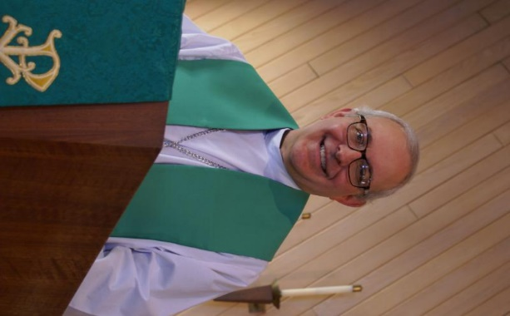
FROM PASTOR DAVID, APRIL 2026

I know that many of my newsletters over the past year have had a negative tone to them as I have commented on the world around us. I’ve never had such a hard time finding good news! But today we’re in luck. It’s a mere glimmer, but I have noticed an increasing number of articles coming out that are acknowledging the damage that technology is having in the classroom. Multiple studies are showing that schools that stick with traditional books, chalkboard, pen and paper produce children with higher IQ’s and more positive self-esteem.
And this trend to kick tech out of the classroom is apparently gaining traction. It has even been acknowledged by some tech titans that they don’t allow their own children to have cell phones or tablets! Why is this good news for the Christian church? Well, it’s no secret that social media in particular has led to the anti-socialization and even demonization of young minds. Add to that the fact that tech devices and their content have reduced children’s attention spans to an all time low. Teachers and even college professors report that their students don’t read books or write papers anymore, rather allowing AI to do all the work for them. These behaviors just lead to dependency and easy indoctrination. It’s no wonder that young people have been leaving the church in large numbers as they travel along the wide road of self-indulgence. Hopefully, parents and school administrators are finally waking up to the value of traditional methods of learning and the development of critical thinking skills.
Sixteen hundred years ago, St Augustine wrote that faith (religion) and reason (science) are intertwined; our faith motivates us to understand the world around us, and our critical thinking allows us to make good choices, including the ability to fathom the truth of the Gospel. May God open the eyes of more families to come to a saving grace in God and return to our Christian communities.

Pastor’s Hours: Mondays, Wednesdays and Fridays plus Sundays and as needed and by appointment when requested.
VISION TEAM REPORT
If you have any questions or concerns, please contact a Vision Team member:
Dallas Peters (President), Steve Butcher, Cathy Lindquist, Nancy Schnaitman, & Lee Strom
At their March meeting the Vision Team:
- Approved minutes and treasurer’s reports
- Discussed the status of our technology upgrades
- Began setting 2026 goals (what we would like to accomplish including property needs and maintenance
- Discussed need to replace some bulbs in the sanctuary which are on the side walls above the second beam. Will need to assess how to reach them.
- Discussed upcoming events including Holy Week and the Rebecca Circle Bread Monk event
- Pastor’s report included visitations, confirmation class (we now have 4 students), ashes at the train station, Ash Wednesday service (15 in attendance), Preschool open house, and the Lenten Bible Study
- Noted that Cathy Whiteside is unable to continue with her clothing drives and distribution including the Rummage Sale

FINANCIAL MATTERS – APRIL 2026

- Our March donations have met the needs of our expenses.
- We have received $1,295 in Thrivent Choice Dollars ~ thank you to the members and friends who have designating Grace as the recipient of your dollars.
- Spaghetti dinner was enjoyed by many and freewill offering collected was $650. These funds have been shared with the Elburn Food Pantry and a church family.
- The Capital Improvements savings (Building Maintenance Fund) balance is $9,700. Warmer temperatures are approaching and we will be embarking on the structural brick work on the west side of the building. The congregation approved this $12K project last year. We would like to build up this fund and if you wish to donate to this fund, please notate “Building Maintenance or Capital Improvement Fund” on your check to ensure the donation is designated to this specific account.
- Grace received a generous $8,000 gift to our Capital Improvement Fund and were able to purchase a 2025 zero turn lawn mower for the church property.
Brief recap of January financials:
Feb 2026 Feb 2026 2025
Year-to-date Year-to-date Year-to-date
INCOME $ 28,874 $ 41,823 $ 81,068**
EXPENSES $ 20,310 $ 37,510 $ 35,624
NET +/- $ 8,564 $ 4,313 $ 45,444
**(Income reflects $39,513 Norm Nelson memorial gift)

We are thankful for your time, talents and tithes to Grace, as we continue our mission and ministry in 2026 ~ In Peace ~ Tricia Painter, Treasurer
GETTING TO KNOW KURT REDEMANN
Getting to Know You… Kurt G. Redemann
Kurt was born in Burlington, Wisconsin and moved with his family to Glenview, IL when he was 3 months old. His family joined St. Peter’s Evangelical Church in Glenview. He has German heritage on his Dad’s side and his Mother was part Irish. In case you are wondering why Kurt has just the initial “G” for a middle name, it came about when his parents used the “G” from his mother’s dad, George and also from his dad’s dad, Gustav. He is an only child of Oledene and Harry Redemann. His family moved to the farm near Maple Park in 1964. Kurt participated in Confirmation at St. Peters after the family moved to Maple Park = he was baptized and confirmed on the same day. His family joined Grace in 1972. He graduated from Kaneland HS in 1969 and graduated from Joliet Jr. College in 1971.
Kurt shared that his dad worked a busy full-time job and was pressed for time to do farm work at home. When Kurt was 16, his dad told him to run their 30-acre farm, which at that time included pigs. A challenge for him but he did it. Kurt continues to live on the family farm. His father passed in 1991 and his mother in 2013. Oledene was known as one of the ‘kitchen ladies’ at Grace. Many VBS pictures are of her in the kitchen making treats for the kids.
Kurt still manages the farm although without animals and hires out the planting and harvesting of the grain. He likes to work outside at his home on gardening and growing flowers. He starts some flowers from seeds and some of the beautiful flowers we enjoy in the church flowerbeds are compliments of Kurt’s labor!
Kurt works as a seasonal truck driver for CHS in Elburn. When asked if he was ever tempted to become a school bus driver like his mother, he emphatically says “no” . He does like driving and seeing new places and also the importance of earning a salary, BUT not as a bus driver.
At Grace, Kurt trims trees, tends to the various flowerbeds and other landscaping. He is usually available to help with special projects around church. He volunteers as an usher, greeter, lector and bell ringer. He participates in Bible study, Memorial Team, Grounds Team. Most weeks he is the first one at church on Sundays. Kurt has a whole family of friends at Grace. ~ Thank you Kurt for sharing about yourself with your fellow members ~


REBECCA CIRCLE

Rebecca Circle will be hosting a soup luncheon featuring the “Bread Monk” at noon on Saturday April 11th . The last day to purchase your ticket is April 5 th. See Ann Butcher or any Rebecca Circle member for tickets.

Our next meeting will be Tuesday, April 21st at 1:00. Items for the food pantry are always
welcome.

SPECIAL THANKS TO ALL WHO HAVE GIVEN OF THEIR TIME, TALENT AND GIFTS
- All those who assisted with the Seder meal
- Ann Butcher for coordination of the Bread Monk program
- Cathy Whiteside for her immense work with our clothing programs

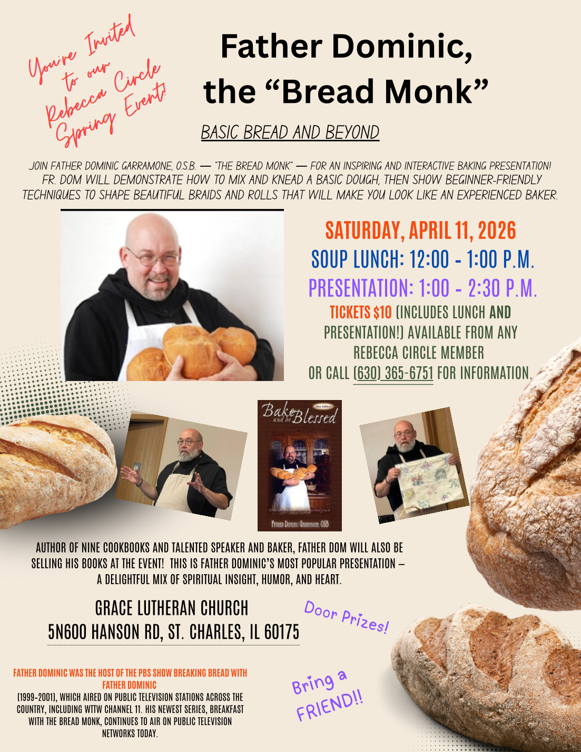


SPRING RUMMAGE SALE, MAY 15 & 16
We are getting ready for our Spring Rummage Sale on May 15 (9am-4pm) and May 16 (9am-2pm) ~ please mark your calendars ~
We kindly ask that you hold your donations until May , as we are trying to not clutter up entryways, doorways, walkways, etc. With Holy Week, Seder dinner, Easter service & breakfast approaching, and ongoing preschool, Line Dancing and Scouts, we are not able to have extra items "in the way." If you have items that can be stored in the garage (nothing with cloth or fabric please), or stored in critter proof containers - please contact Linda Smykowski to coordinate drop-off (708-309 3444).
Requesting "seasonal" (spring and summer clothing donations to be dropped off on Sunday mornings OR during the week left between the double entryway on upper level. Pls write on the bag or box that it is for “Rummage Clothing sale”. Thank you.
Please note, when considering your donations, please ask yourself "would I purchase this?, does it work/operational?, are the cords or all pieces intact?, doesn't smell like smoke and free of pet hair?, it is (fairly) clean, etc.?" if not, please understand if we say 'no thank you' - we don't have the volunteers nor time to go through it all. As a reminder, we cannot accept TV cabinets, older TVs, and large furniture pieces. Thank you for your understanding and cooperation.
MAY - Drop-Off Times:
Tues, May 12 - various times; Wed, May 13 - donations accepted 10am - 4pm; volunteer sale set-up hours anytime 10am - 5pm
Thurs, May 14 - donations accepted 10am-3pm; volunteer sale set-up hours anytime 10am - 5pm;
Friday, May 15 - volunteers needed all day of sale (9am-4pm) & Saturday, May 16 - volunteers needed all day of sale (9am-2pm) & sale clean-up - 2pm until ??

Any further questions, please contact Tricia Painter 708-624-0400 (leave message or text)


ROADRUNNERS 2026 TRIP

The next Roadrunners trip is scheduled for September
21-25 (or 26), 2026. We will be going to Frankenmuth, Michigan. Save the dates – more information to come.


LINE DANCING continues on Tuesdays
from 6-7 pm in Fellowship Hall from 1/6/26 to 4/28/26. Continue thanks to Nancy Corbige for teaching this class. Come enjoy the fun.

SPECIAL MINISTRY INFORMATION
Bridge to Life Group’s Jesus Closet (homeless in Elgin): Items needed are backpacks, blankets, gym shoes, t-shirts, jeans, coats and socks. Thank you for all the donations. Clothing and miscellaneous items for those in need in Chicago are collected and given to Pastor Anna-Kari Johnson for distribution in Chicago. Thank you to all who donate. A new volunteer is need to continue to coordinate this ministry. Let Pastor know if you can help.
HABITAT FOR HUMANITY - POTTAWATOMIE
Grace Lutheran is a partnership church. Nancy Corbige, our representative to Habitat for Humanity, reports that they have started building a new house in St. Charles, north of Rte 64 and that volunteers are needed. Times you may volunteer include, Wednesday, Friday or Saturday from 8:30 am to 4 pm.

If you can volunteer a day or more, please send your name and email address to Nancy at ncorbige@gmail.com. She will keep us updated on the progress of the build. Volunteers do a variety of jobs, including providing lunches, doing clean up, painting and construction work.

NOISY OFFERING Every Sunday we collect a “noisy offering” when you wish to empty your change purse or pockets. We are currently collecting for maintenance items. Thank you.

MISCELLANOUS INFORMATION
- SPECIAL TECH NEED: Are you familiar with IT / computer technology / streaming ?? We are asking for several people to become familiar with or learn the technology that we use to record our church services with. Seeking several people so we will be able to spread out the weekly tasks ~ contact Pastor or Tricia Painter
- If you can knit or crochet, we need you to help make more prayer shawls as we are running low. We have the yarn so please contact Helen Gruber if you can help. If you know of someone needing a PRAYER SHAWL, please let Twyla Strom know.
- The Finance Team is looking for volunteers to sign up as counters (counting our weekly offerings after worship). Please see Linda Smykowski or Tricia Painter.

CONTACTS:
For emergencies, please contact the church office at 630-365-6751. For prayer requests or other needs please call Kathy Hooey at 630-341-2293 or leave a message at the church office at 630-365-6751. Messages are checked daily at noon & 5 pm.

Information for the May newsletter will be due by April 25th– please send items to Marty Bradley at masbradley50@gmail.com. Thank you



