.AUGUST 2022, VOL. 32
 | AMAZING  GRACE  CONNECTIONS
Faith > Family > Community
Grace Lutheran Church of Lily Lake
5N600 Hanson Rd, St. Charles, IL 60175
Pastor David Mercurio

Worship every Sunday at 9 am
With Communion
Sunday, August 7, Worship in the sanctuary, with baptism
Music by Pastor Jane and Steve & Coffee hour
Sunday, August 14, Outdoor Worship, Music by Pastor Jane & Steve
Sunday, August 21, Outdoor Worship, Pastor Jane Preaching
Sunday, August 28, Outdoor Worship
You are welcome to bring your own chair for outdoor worship if you wish.
(The nursery is available on Sundays for use by any parent)

Sunday School Begins in September
Dates to be announced. We hope to have two classes:
- Ages 3 - 6 will meet in the nursery during the whole worship service time.
- Ages 7 - 11 will meet in the Grace Room at the beginning of the worship service and will come to the sanctuary for communion and the close of the service.
Please contact Marty Bradley, Kelly Diehl or Pat Penfold if you can assist as a teacher, substitute teacher or assistant. Registration is requested. Thanks!

COVID-19 Safety Protocols
We follow the recommendations of the CDC, ELCA and the IL Department of Health. Face masks are recommended, but optional. We will continue to practice social distancing. .. If you don’t feel comfortable worshipping with others we invite you to join us virtually for worship via our website.
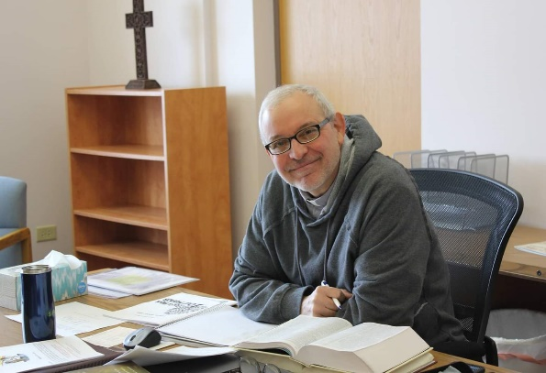
PASTORS MESSAGE
From the desk of Pastor David, August 2022

I hope that all of you are enjoying a safe and relaxing summer. We have been blessed with plenty of sunshine and the crops and gardens are looking healthy as far as the eye can see. We continue to enjoy our Sunday outdoor services with new faces and old friends joining us for worship, including a pair of sandhill cranes that have taken up residence on “the back 40.”

We have another baptism scheduled for this month and it is so encouraging to see young parents who want to raise their children in a Godly way in the face of increasing worldliness. It is also exciting to see our choir becoming more active once again. Their voices rise up as a fragrant offering.

Even now the Vision team, the Worship Team and I are working on events to bring more visitors to Grace Lutheran Church and programs and lessons to encourage the saints for the fall and winter. So, stay tuned! May our God continue to bless you abundantly for your faithfulness to Him and His church.

I regard everything as loss because of the surpassing value of knowing Christ Jesus my Lord. For his sake I have suffered the loss of all things, and I regard them as rubbish, in order that I may gain Christ and be found in him, not having a righteousness of my own that comes from the law but one that comes through faith in Christ, the righteousness from God based on faith. (Philippians 3:8-9)

Pastor David
Pastor’s Hours at church
Tuesdays and Thursdays from 6 pm – 9 pm
Saturdays from 9 – noon Sundays from 8:30 am for 3-4 hours

VISION TEAM REPORT

- Eblast (constant contact information) will now be in your email on Fridays and you should only receive one email.
- Rebecca Circle is working on a shepherding program for the church. This program would designate people to respond to specific requests such as a visit, hospital information, notification of death, and other needs.
- Briefly discusssed the building maintenance list including items that are more urgent. We have received several generous donationa for maintenance including the garage roof and will be proceeding with the roof, some bell tower fixes and other items. We will maintain the fund indefinitely as all building need regular upkeep.
- Nancy Corbige discussed hosting a car show on our property. The Team agreed to have her bring a more specific proposal to us including potential dates, times, possible food, and who would be assisting her with the show.

In Christ, Marty Bradley

FINANCIAL MATTERS – AUGUST 2022
- Mid-year Giving statements will be sent out by mid-August (via email or USPS). Computer glitches caused a slight delay -- if you do not receive yours, please contact Cara Turner. Please review your statements and reflect on meeting your mid-year goals from your pledge for 2022, for Grace of Lily Lake; if you did not make a pledge to Grace, reflect on your commitment and support to Grace of Lily Lake.
- 2 Corinthians 9:6-8: Remember this, whoever sows sparingly will also reap sparingly, and whoever sows generously will also reap generously. Each of you should give what you have decided in your heart to give, not reluctantly or under compulsion, for God loves a cheerful giver.
- Unfortunately, in summer months, with vacations, etc., the giving receipts tend to decrease as we forget to make our contributions – please review, reflect, and ‘catch up’ now – as it will be easier than at the end of the year.
- Something to consider?? Did you know that giving a gift from a tax-deferred retirement account can be one of the most tax-efficient ways to be charitable both during your lifetime and through your estate? Unlike a distribution to you or an heir, which would be a taxable event, charitable donations from retirement accounts lay no additional tax burden on you or the charity. Estate gifts from these accounts can go directly to charities through a donor-directed distribution agreement or fund named endowments. Contact a representative from your retirement fund company to learn further details.
- Noisy Offering continues to be collected and will go toward the expenses of getting the lightbulbs replaced in our sanctuary and the front and back parking lots, along with rental cost of a lift to get to the high ceilings.

Short recap on our June financials:
 |  |  |  | 2022 |  | 2021
 |  | June, 2022 |  | Year-to-Date |  | Year-to-Date
INCOME |  | $ 11,466.83 |  | $85,373.58 |  | $89,724.34
EXPENSES |  | $15,963.86 |  | $108,457.77 |  | $89,873.45
NET +/- |  | -$4,497.03 |  | -$23,084.19 |  | -$149.11

- We had wonderful support from volunteers for our Spring rummage sale and raised funds for Grace. Please mark your calendars for our Autumn rummage sale Oct 7 & 8 (set-up Oct 6). Many hands makes the tasks at hand come to fruition!
In Peace, Tricia Painter, Treasurer

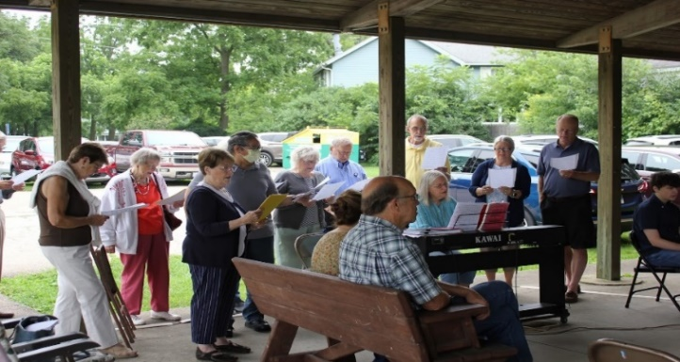
Getting to know Vicki Linden
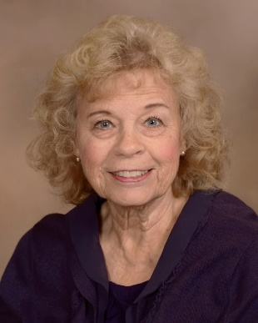
My connection to Grace Lutheran really has been lifelong. My parents, Harry and Violet Johnson were lifelong members after their marriage in 1940. My sister Karen Johnson Rolston was baptized by Pastor Sutherland in 1942, and I was baptized by Pastor Roger Oliver in 1946. I attended Sunday School regularly throughout my youth. Margaret Swanson and Edna Strom were a few of the teachers on Sunday mornings. My mother insisted on my singing in the youth choir, which was a big mistake, because I can’t carry a tune. My sister had all the musical talent. She and Rianne Strom could play the pipe organ and on occasion would substitute for Mrs. Oliver when needed. I clearly remember that beautiful, old sanctuary in that wood frame church. In 1960 I was confirmed by Pastor Julius Peterson in the new building. My class was the first group of confirmands to be confirmed there. In 1967 I was married to my now ex-husband by Pastor Arne Walker. After marrying we always attended a Lutheran Church where we lived -Geneva, Hinsdale, Elgin, Galesburg, and Madison, Wisconsin.
After high school I continued my education at the University of Wisconsin, Whitewater, earning a Master’s Degree at N.I.U. I taught language arts to 7th and 8th graders off and on for 25 years. I never regretted staying home for 11 years with my beloved boys, Chad, and Greg Johnson. I have 3 stepchildren and 8 grandchildren. I have helped raise the youngest Dean Johnson three days a week so that Greg and his wife Kate could continue their careers in nursing and paramedics. Some of you will remember Chad who served on the Vision Team, and also helped Nick and Mandy get the contemporary worship service off the ground. Our hearts remain broken since Chad’s unexpected passing at age 32 as well as losing Greg and Kate’s first born in 2014. Losing a child and grandchild are losses a parent and grandparent never stop grieving.
My main interest outside of church and family is reading historical fiction. Nowadays I find myself forgetting what I have read all too quickly. I am very proud of my Swedish heritage. All four of my grandparents emigrated from Sweden. My keen interest in past years was Swedish genealogy. I found the Swedish website Arkivdigital was much more accurate than Ancestry. Using this site meant I had to learn a few basic Swedish words as it is the authentic photographic record of the books in each local parish. My study proved rewarding as I was able to delve into some records dating back to the late 1600’s. Other interests I have involved some adventures like snowmobiling in Yellowstone National Park and fishing in Northwest Ontario and fishing for muskie on Squirrel Lake in Minocqua, Wisconsin with my husband of 24 years, Larry Linden. Incidentally, he is a faithful parishioner in the Catholic Church. In recent years we have given up snowmobiling and fishing and now enjoy UTVing in and around Lake Ripley at Cambridge, Wisconsin where we also enjoy pontooning all summer long.
To conclude, my life has been blessed by my faith, church, and family. Faith, Hope, Family – these are the lifelines I hold onto.
Vicki Linden

 JOIN US FOR A PET BLESSING SERVICE
Pastor will be holding a pet blessing service on Saturday, September 17th, outside at the pavilion. Time to be announced. No reptiles please.

MANY THANKS AND PRAYERS TO THOSE WHO HAVE RECENTLY DONATED THEIR TIME AND TALENTS, including, but not limited to:

- Suzanne Girsch, Kathy Hooey, Margaret Swanson, Twyla Strom and Cathy Whiteside for reviewing our membership roster.
- Janice Muncie, Marla Roach and Kelly Gwizdala for assistance with computer needs!!!
- Kurt Redemann for his work around the church caring for some of our landscaping.
- Pastor for the great children’s sermons and to the kids who come forward with a special thanks to Odin for his enthusiastic participation.
- Rebecca circle for the wonderful church picnic and bingo event. Also for the special packages they mailed to those serving in the armed forces.
- Lori U’Ren for coordinating the purchase of new pads for the AED.
- Cathy Whiteside, Margaret Swanson and Shirley Turner for the coordination of mailings on behalf of Grace; Dottie Mantsch for the donation of stamps.
- Twyla Strom for the donation of the greeting/birthday cards for the Cradle Roll
- Tricia Painter for the donation of a new rolling cart for outdoor worship; for the donation of the annual Zoom subscription for Grace; for donation of stamps for various mailings of bills and giving statements.
- All who have donation to the Building Maintenance fund and especially those who designated the garage roof – it is being done soon!

If you wish to volunteer, please
contact Pastor or any Vision Team member.


2022 Elburn Days Parade: Heidi Anderson and Cathy Whiteside are organizing a float for the parade on August 19, 2022, to represent Grace Church. Volunteers are needed to help plan the theme and decorations for our float. Kelly Diehl has offered the use of his trailer. The Elburn Lions theme for the 2022 Parade is “ELBURN LIONS Soar to the Skies for Eyes!” The Lions have many charities they sponsor. Through Recycle for Sight, Elburn Lions collects new and gently used eyeglasses, sunglasses, hearing aids and cell phones and cell phone chargers. Grace has a collection box for used glasses in the Gathering Room. Those donations are then passed on to the Elburn Lions.
Please contact Heidi Anderson (630/746-5073) or Cathy Whiteside (630/605-1096). Thank you in advance for any help you can give us with this project.

Rebecca Circle 2022 Picnic and Bingo: Thirty people (members and guests) had a good time at our Picnic and Bingo event. Thank you to Karen Patterson and Cathy Whiteside for organizing the event. Everyone helped make it a success. Delicious food and a fast-moving game of Bingo that used everyone’s White Elephant prizes. Some White Elephants prizes were pretty popular and involved a lot of “taking away” of some else’s prize. Boxes of puzzles were changing hands often. Thank you to Kathy Hooey for serving as moderator of the meeting. Thank you also to Nancy Corbige, who did great job as the Bingo caller.
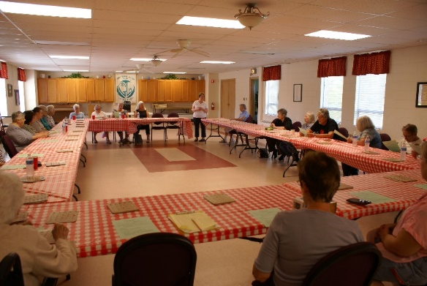
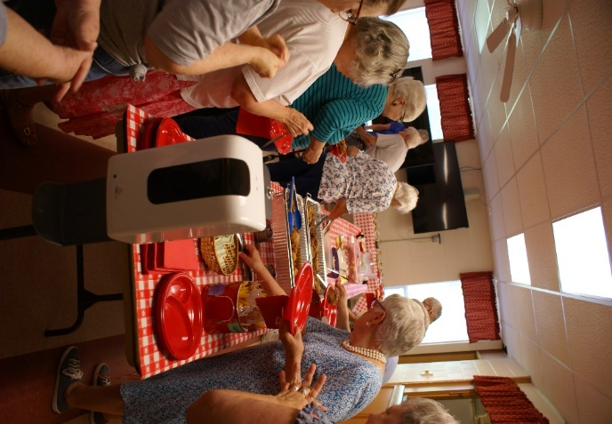

MINISTRY NEWS

Homeless in Chicago: Cathy Whiteside took the donated jeans, hoodies, sweat shirts, suitcases, back packs, bags and hand sanitizer to Anna-Kari in June. Thank you to everyone for all the great donations.

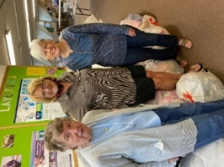
Lord of Life Lutheran Church in Schaumburg -Mission Quilters & Layettes: A large quantity of sheets and children’s clothes size 0-2T and blankets was taken to them from Grace in July. A thank you note was received from the Mission Quilters. They are so grateful and will put the donations to good work. They said to imagine the comfort those who receive a quilt we have helped supply will feel. Cathy Whiteside was able to take the items to Schaumburg with the blessing of Carol and Dave Langseth (they are still not getting around much). A huge thank you for all the donations!
Jesus’s Closet at Newlife Covenant Church Elgin IL: The donations of clothes for the homeless was taken to Elgin. Some items were from the last Rummage Sale at Grace and some given specifically for Elgin homeless. Thank you for the donations!
Redeemer Fellowship Church in St. Charles opens a free clothes closet once a month for those in need. Cathy Whiteside, Paul and Dottie Mantsch brought summer clothes and linens and blankets to Redeemer in July. These clothes were left over from our Rummage sale and also a very generous collection of children’s clothes brought to us by Tricia Painter from her niece’s resale shop in Paw Paw, IL. Such beautiful clothes that give a person a good feeling to pass them on to those in need. Thank you Lord.

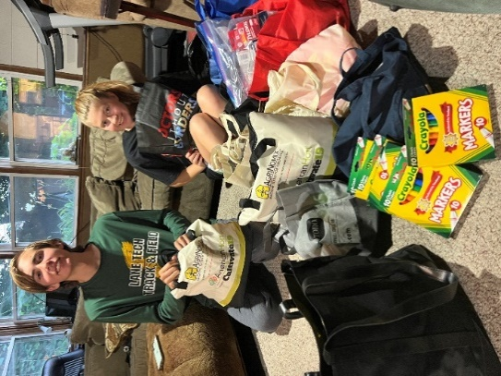
El Salvador Mission Trip 2022: Pastor Kristian Johnson and Pastor Anna-Kari Johnson will lead a group of about 30 people to El Salvador on August 1st – 7th.
So far in 25 years their world-changing friendships have helped; start 6 new congregations; sponsor 500+ school children; bring 60 solar panels systems to homes without electricity; over 12 Medical Campaigns.
This year, people of Grace have donated miscellaneous school and medical items to be taken to El Salvador. Hope and Emanuel Johnson met Cathy Whiteside at Grace on 7-26-2022 and picked up the donations. They are very appreciative for the thoughtful donations Grace has given them. On their way to Grace, Emanuel and Hope stopped by their grandparents in Huntley for a visit. Hope graduated from High School this year and will start this fall at Valparaiso University in Indiana. She plans to be a pastor, following the footsteps of her grandfather and parents. God Bless her on her journey to becoming a pastor.
Emanuel and Hope Johnson

GRACE LUTHERAN CHURCH
HELP WANTED!
We are still looking for part time secretarial help (10-12 hours/week) in the church office. Microsoft Word and Powerpoint needed. Please pass this along to anyone who may be interested and have them contact Marty Bradley at general@graceoflilylake.com or 630-777-1074.
Please spread the word.
CONTACTS:
For emergencies please contact Marty Bradley, President, at 640-777-1074 or leave a message at the church office at 630-365-6751.
For prayer requests or other needs please call Kathy Hooey at 630-341-2293 or leave a message at the church office at 630-365-6751. Messages are checked daily at noon & 5 pm.
ELCA MISSION WEBSITES

LUTHERAN DISASTER RESPONSE:
https://www.elca.org/our-work/relief-and-development/lutheran-disaster-response
ELCA WORLD HUNGER APPEAL:
https://www.elca.org/Our-Work/Relief-and-Development/ELCA-World-Hunger
LUTHERAN WORLD RELIEF:
https://lwr.org/
REFUGEE ONE https://www.refugeeone.org/
Information for the September newsletter will be due by
August 25th – please send it to Cathy Whiteside Cathy@imotay.com Thank you!

