AUGUST 2023, VOL. 44
 | AMAZING  GRACE  CONNECTIONS

Faith > Family > Community
Grace Lutheran Church of Lily Lake
5N600 Hanson Rd, St. Charles, IL 60175
Pastor David Mercurio

Worship every Sunday at 9 am
with Communion
Sunday, August 6, Outdoor worship with inside coffee hour
Sunday, August 13, Outdoor Worship
Sunday, August 20, Outdoor Worship
Sunday, August 27, Outdoor Worship
Worship will remain outdoors through the summer unless weather is prohibitive, then we will worship indoors; signs will be posted.
Worship time change: beginning September 10th, worship will start at 9:30 instead of 9. That is also the first Sunday of Sunday School!

PASTOR MERCURIO’S CALL TO GRACE LUTHERAN
was officially approved by the Metropolitan Chicago Synod
of the ELCA on July 11th and his first Sunday as our
called Pastor was July 16th.
WELCOME PASTOR!
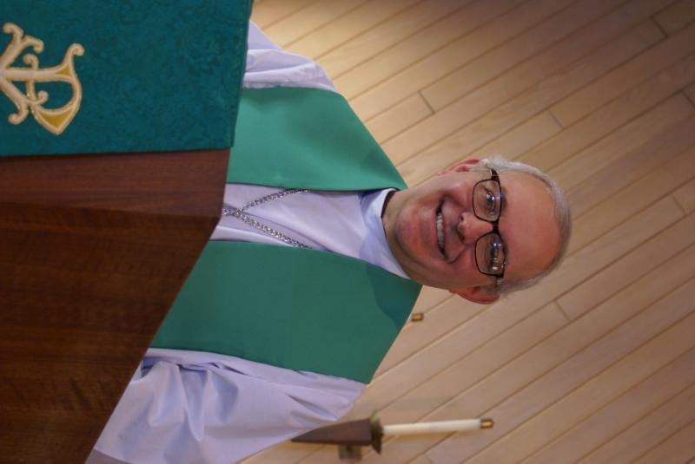
PASTOR’S MESSAGE

From the desk of Pastor David, August, 2023
I recently preached on the parable of the wheat and the tares (weeds). In this story, Jesus warns us that wherever he plants his disciples (the wheat), then Satan quickly follows to plant his (the tares). Therefore, we need to be discerning to recognize the fruits of the true Spirit versus the fruits of our enemy, which are always a counterfeit forgery, often with the appearance of goodness. Satan is an angel of light. After the sermon, a few members asked me, in one form or another, how we can reach out to more of the unsaved tares to help them become saved wheat. My response was, we cannot, because by definition, a disciple of the evil one has irrevocably rejected God’s invitation, so God has given that person over to a reprobate mind, sealing his fate for destruction. No one was happy with that answer.

But if you believe that a tare can become wheat, then you also have to accept the possibility that wheat can become a tare, a scary thought, to say the least. But I understand the concerns our brothers and sisters had, so let me try to address them. First, understand that no one knows the human heart of another except God alone. Therefore, it would be impossible (and very wrong) for us to look at another and conclude: “You’re clearly a tare doomed for destruction,” or “You’re clearly a disciple and your salvation is guaranteed.” Why, most of the time, we can’t even interpret our own hearts let alone those of others. So, what are we to do? If anyone claims to be a Christian, then believe that person and accept him or her as a brother or sister in Christ until and unless they prove themselves otherwise (a wolf in sheep’s clothing). For everyone else, never assume they are beyond redemption and doomed to destruction. That is only for God to know. Do assume there is always a chance for repentance and redemption. (Many convicts and drug dealers repented and became believers). God is patient and filled with mercy. (“As surely as I live, declares the Sovereign Lord, I take no pleasure in the death of the wicked, but rather that they turn from their ways and live.” Ezekiel 33:11). Therefore, continue to love and serve our neighbors, share the good news of the Gospel with everyone and let the fruits of the Spirit within you shine for all to see. All these things this congregation does best. AMEN

Blessings to you all, Pastor David
Pastor’s Hours at church Tuesdays and Thursdays from 6 pm – 9 pm
Saturdays from 9 – noon Sundays from 8:30 am for 3-4 hours

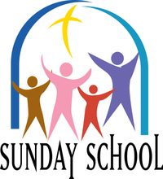 FALL SUNDAY SCHOOL
This Photo by Unknown Author is licensed under CC BY-NC-ND
Sunday School for 3 through 12 year olds will start on September 10th. This is also the Sunday the time for worship will change to 9:30 am. We are looking for more volunteers to teach and assist. Please prayerfully consider volunteering and contact Marty Bradley for more information and to volunteer.

JULY VISION TEAM REPORT
The Vision Team met on July 13th
With sadness, we accepted the resignation of Kelly Diehl from the Vision Team due to his increased involvement as President of the Village Board. Per our constitution, the Vision Team was able to appoint a replacement for the remainder of Kelly’s term (through January 2024). Thank you to Dallas Peters Jr. who has graciously agreed to fill this position.
- Approved minutes and treasurer’s report from the June meeting
- Pastor, Marty and George met with several Boy Scout leaders and discussed their use of our facilities and thanked them for all that they have done for Grace. A facilities agreement will be signed.
- Discussed tornado and fire response. More information to come.
- Continued discussion of insurance needs. Waiting for an additional quote.
- Discussed pipe issues in our kitchen and possible asbestos covering.
- Proposed ELCA congregational constitution changes tabled to October.

Please remember to greet visitors each Sunday and ask them to sign the register.

The Vision Team meets on the second Tuesday of each month. If you have items you feel should be discussed by the team, please send them to Marty by the first Tuesday of the month.

Blessings, Marty Bradley, President

LAZARUS HOUSE NEEDS

As you probably know, Lazarus House in St. Charles is one of the ministries we support. It is a community based support for meeting the needs of the homeless including shelter and food.

Currently, we are asking for donations to support them, including:
Paper towels Toilet paper Paper plates Disposable bowls
12 oz plastic and styrofoam cups Laundry soap Lg Nitrile gloves
Cases of bottled water

Boxes labeled “Lazarus House” are located between our entry doors. Thank you!
FINANCIAL MATTERS – AUGUST 2023

Financial Matters – August 2023

- The mid-year Giving Statements were emailed or US Postal mailed to you. If you did not receive your statement, please contact Cara Turner – email: clturner2063@yahoo.com. If you have questions on your statement please contact Dottie/Paul Mantsch – email: mantsch@sbcglobal.net or phone: 630-584-5388.
- Summer months are upon us, and generally our giving donations trend downwards. ** Your continued donations are a blessing to Grace and allow a variety of ministries to continue at Grace and help serve our community.
- Presently the Building Maintenance Fund balance is $ 3,827. The Building Maintenance Team reviews building and safety needs, outside of the regular maintenance services. If you wish to donate to this specific fund, please notate “Building Maintenance Fund”, so the donation will be designated accordingly.

Brief recap of June financials:
2023 2022
June 2023 Year-to-Date Year-to-Date

INCOME $ 12,147** $ 91,405 $ 85,373
EXPENSES $ 13,986 $ 92,729 $ 108,458
NET +/- $ - 1,839 $ - 1,324 $ - 23,085

Pray for blessings upon Grace as we continue our mission and ministry, with goals and challenges in 2023. In Peace, Tricia Painter, Treasurer


MANY THANKS AND PRAYERS TO THOSE WHO HAVE RECENTLY DONATED THEIR TIME AND TALENTS, including, but not limited to:

- Natalia Diehl and Jan Docherty for providing the piano music during Dottie’s vacation. Beautiful. Also, prayers for Natalia who recently broke her wrist.
- Those who are assisting with the set-up for outdoor worship and with running the power points during worship
- Cara Turner for getting our mid-year donation reports to us
- All those who help with community ministries
- Those who helped with the picnic and bingo (Rebecca Circle)

Getting to know the Gwizdala Family
Piotr, Kelly (Tetzlaff), James, Nathan, & Claire
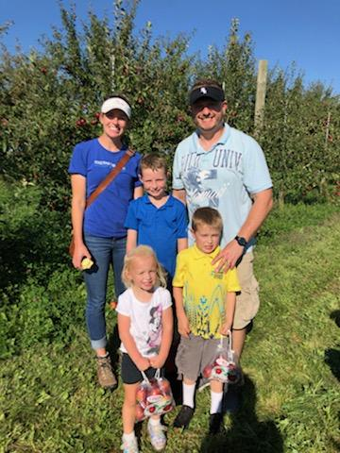
Kelly grew up in St. Charles and was baptized and confirmed at Grace Lutheran Church. After college she moved to Chicago and while working as a nurse met her husband Piotr, also a nurse. Piotr was born in Poland and came to the US with his family when he was 8 years old. We worked together for a few months before transferring units, and eventually separate jobs. We married and had our oldest son, James, in Chicago. We then moved to Elgin, and had 2 more children, Nathan, and Claire. Together as a family of 5, we enjoy attending Grace and all the wonderful welcoming people. Our kids especially enjoy the Sunday School program.

UPCOMING SPECIAL DATES
- August 11th – Rebecca Circle 11 am lunch out and Riverboat Cruise (see below)
- August 18th - Elburn Days Parade, 6 – 8 pm
Grace will have a float in the parade. Volunteers to help decorate
the float, walk along side and ride on it are needed. Call Cathy Whiteside
- September 10th Worship time changes to 9:30 am and Sunday School begins
- September 14th from 6 – 7 pm beginning of fall Line Dancing thru Dec. 14th
Every Thursday (except Nov. 23rd)
- September 18 – 23 - Roadrunners Trip to Niagara Falls
See Suzanne Girsch for more information
- September 30th – Octoberfest from 5 – 9 pm at Grace
Please contact George Theros if you can help; sign up sheets to come soon
- October 6 & 7th – Fall Rummage Sale
Start saving items for the sale (please do not bring to church until that week)
- November 10th – Life Line Screening at Grace

REBECCA CIRCLE – AUGUST MEETING
This Photo by Unknown Author is licensed under CC BY-NC

On Friday, Aug. 11th, at 11am, come and have lunch with the REBECCA CIRCLE at the BRUNCH CAFE in St. Charles (lunch at your own expense). And then, at 1:30pm, take a ride with us on the St. Charles Riverboat Paddle Cruise. Just like in the era of Mark Twain, we'll share about 45 minutes aboard the Paddleboat enjoying God's world, watching for eagles, osprey, turtles and fox families and listening to an audio of historic sights and stories . Cost of the boat ride is $12. So bring your appetite, your binoculars, and your sunscreen and join us in St. Charles on Aug. 11th. We need pre-registration for the boat, so please contact Jan Docherty (815-901-0910) or Kathy Hooey (630-341-2293) with your confirmation by Aug. 6th. You can join us for one or both of these gatherings, but please do let us know of your intentions!

Addresses:
The BRUNCH CAFE is at 172 So. First Street in St. Charles.
The paddleboat is at Pottawatamie Park, 8 North Ave, St. Charles.

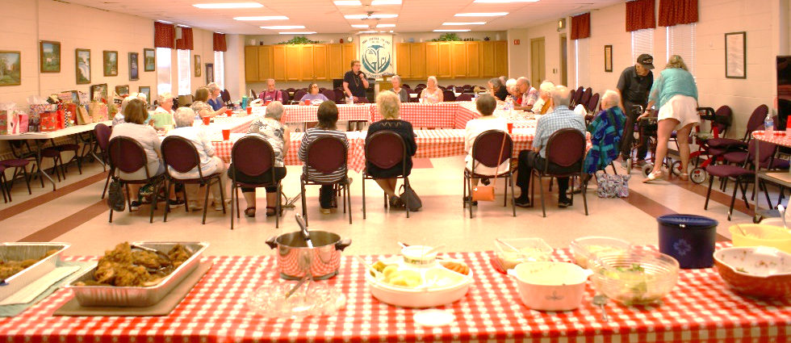
Rebecca Circle 2023 Picnic/Bingo Meeting on July 18, 2023. Thirty-two (members and guests) enjoyed a lot of good food, a fun game of Bingo with the challenge to keep a popular “White Elephant” prize from being taken from them by the latest Bingo winner. Karen Patterson and Cathy Whiteside were hostesses with Jan Docherty serving as moderator of the meeting. Cathy Lindquist was our Bingo Caller Extraordinaire. Thank you to all who made this a very fun meeting.


2023 Elburn Days Parade: Karen Patterson (847 683-2043) and Cathy Whiteside (630 605-1096) are organizing a float for the August 18th parade, representing Grace Lutheran Church. Volunteers are needed to help decorate our float. The Barton Family is providing their trailer and van with the Mark Anderson family providing hay bales. The Elburn Lions theme for the 2023 Parade is “Elburn Lions … Serving for a Better Tomorrow!” The Elburn Lions have many charities they sponsor. Through Recycle for Sight, Elburn Lions collects new and gently used eyeglasses, sunglasses, hearing aids, cell phones and cell phone chargers. Grace has a collection box for used glasses in the Gathering Room. Those donations are then passed on to the Elburn Lions.
Karen P., a Thrivent member, received $250 from a Thrivent Action Plan for Grace’s Float. We have used that money to buy pencils imprinted with “We love because He first loved us. I John 4:19 – Grace Lutheran Church of Lily Lake -www.graceoflilylake.com” to hand out during the parade. Donations of $$’s to buy candy to hand out during the parade will be needed. Anyone interested in riding on the float or being a walker to pass out candy and pencils during the parade please call Cathy Whiteside at 630-605-1096 or Cathy@imotay.com. A huge thank-you to all who volunteer for this project.


GRACE ROADRUNNERS

Registration is still open for the Grace Roadrunners trip to Niagara Falls, September 18-23. Some places and sights we’ll be exploring are Notre Dame, RV/MH Museum, Rock and Roll Hall of Fame and many sites around Niagara Falls including Niagara on the Lake and Old Fort Niagara. As we head back home we’ll see a Jaws with Paws demonstration and Rutherford B. Hayes’ home. This trip will cost $1100-$1300 per person based on double occupancy and how many people sign up. A deposit of $500 holds your place with the balance due August 1st. The first 40 registrations are guaranteed a spot and then a wait list will be started. Registration forms will be in the Roadrunner mailbox in the church office. Contact Suzanne Girsch if you have questions.

 FIRST AID KITS NEED UPDATING
This Photo by Unknown Author is licensed under CC BY-NC

Grace’s First Aid Kits need to be checked and updated. We are looking for 1-2 volunteers to take care of this task. Please let Marty know if you can help us out. You need not be responsible for paying for all the updated materials. Thank you.
NOISY OFFERING
Every Sunday we collect a “noisy offering” when you wish to empty you change purse or pockets. We are currently collecting for caulking of windows. We have several windows that need work. Thank you, cha-ching…

COVID 19, FLU AND RSV SAFETY PROTOCOLS
We follow the recommendations of the CDC, ELCA and IL Department of Health.
If you wish to mask and social distance, please do so. Please do not come to church if
have symptoms of illness. If you do not feel comfortable worshipping with others, we invite
you to join us for worship via our website.

CONTACTS:
For emergencies please contact Marty Bradley, President, at 640-777-1074 or leave a message at the church office at 630-365-6751.
For prayer requests or other needs please call Kathy Hooey at 630-341-2293 or leave a message at the church office at 630-365-6751. Messages are checked daily at noon & 5 pm.

Information for the September newsletter will be due by August 25th – please send it to Marty Bradley at martybradley@mchsi.com. Thank you!


.

