 | AUGUST 2024
 | AMAZING GRACE  CONNECTIONS  Faith > Family > Community

Grace Lutheran Church of Lily Lake
5N600 Hanson Rd, St. Charles, IL 60175
Pastor David Mercurio

Worship every Sunday
At 9:30 am with Communion
- August 4 – Indoor Worship with Baptism and Coffee Hour
- August 11 – Outdoor Worship
- August 18 – Outdoor Worship
- August 25 – Last Outdoor Worship

SUNDAY SCHOOL – FALL 2024

Fall Sunday School for 3 year olds – 13 year olds will begin again on Sunday, September 15th and continue thereafter on every 1st and 3rd Sunday. Please see Janice Muncie, Pat Penfold or Marty Bradley to register your children if you did not do so last year.

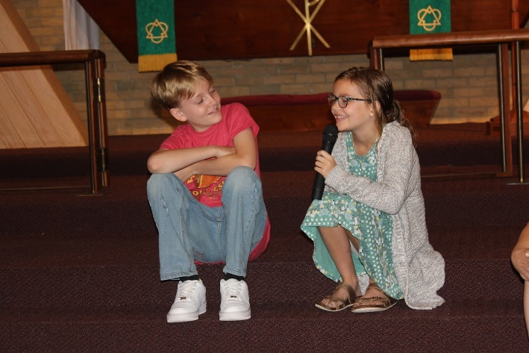

MISCELLANOUS INFORMATION
- If you know of someone who could benefit from having a PRAYER SHAWL, please let Twyla Strom know. We have a good supply of them and would like to share them with those in need.
- Spare BIBLES? If you have extra Bibles you are not using, please bring them to church as we are supporting a ministry that is sending Bibles to South Africa. Please leave them on the balcony steps on the 1st Sunday of the month.
- Our new website sign on is graceoflilylake.org (not .com)

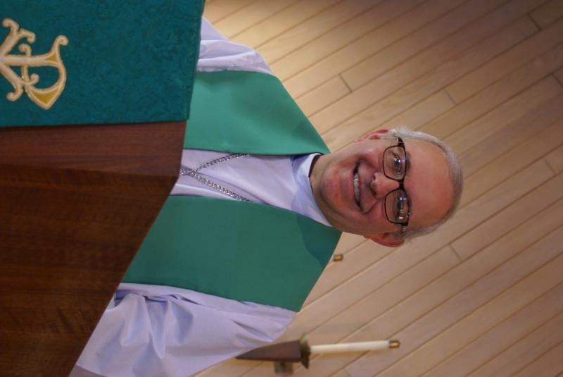
From the Desk of PASTOR DAVID, August 2024
Why I am a Lutheran
I recently listened to a roundtable discussion among clergy from different denominations: a Roman Catholic priest, an Episcopalian minister, a Lutheran pastor, a Baptist preacher, and a Pentecostal minister. During the discussion, the question was asked, “How long are your sermons?” The Catholic and Episcopalian both said about 5 minutes; the Lutheran said 15-20 minutes; and the Baptist and Pentecostal said 45 minutes to an hour. Then the Episcopalian said something that I guess I knew subconsciously, but never gave it much thought. She said, “Well, the Catholics and Episcopalians are more sacramental, and the Baptists and Pentecostals are more Word oriented. (A sacrament is a religious ritual that is divinely influenced and directed). She was trying to justify her short sermon time, but her statement caused me to ponder the differences among the five faith traditions.
Sacramental churches (Roman Catholic, Eastern Orthodox, Anglican (the Roman Catholic church severed from Rome by Henry VIII and nationalized), and Episcopalians (the Anglican church in America) all have a long tradition of statues, paintings, stained glass windows, candles, chanting, ancient and traditional hymns, altars adorned with white linen and silver chalices, priests in colored flowing robes administering holy water from golden buckets and incense of myrrh from a swinging censer. There is a strong mysticism in their worship. They recognize and practice many sacraments: baptism, communion, confirmation, confession and penance, anointing of the sick, marriage, and holy orders (“last rites include a combination of the preceding). Their liturgy is filled with piety and spirituality. There is a quiet nobility to their services, like the crowning of a new king.
On the other end of the spectrum, Baptists and Pentecostals don’t claim any “sacraments,” per se. They recognize Baptism and Communion but call them “ordinances” or practices that symbolize the teachings of Jesus and remind them about him. Many newly formed churches in these traditions will meet in a rented school cafeteria in which tables may be adorned with a half-eaten, discarded PB& J sandwich, but no white tablecloths or chalices. Music tends to be modern, loud, and electronic. You will probably not even find a cross in their services. However, what they lack in liturgical tradition, they more than make up in expository preaching. They want their people to know God’s word for what it says, what it means, and how it applies to them. Every member brings a Bible to service and opens it along with the preacher, diligently following along and taking notes. Regular reading of one’s Bible and memorizing verses is highly encouraged.
And what about us Lutherans? How do we compare? “In medias res,” (in the middle, all things). I believe we have taken the best of both these extremes and, over our 500+ year tradition, blended them into a worship experience that is holy, noble, and pleasing to God. That is why I am a Lutheran.
Blessings to you. Pastor David
Pastor’s Hours: Tuesdays and Thursdays from 6 pm – 9 pm, and Sundays from 8:30 am for 3-4 hours and by appointment when requested.

MANY THANKS AND PRAYERS TO THOSE WHO HAVE RECENTLY DONATED THEIR TIME AND TALENTS, including, but not limited to:

- John Verner for the hours he spends mowing the church grass; for Danny who fills in when needed and for John’s brother who helps with mower repairs.
- Kurt Redemann for all the flowering garden work he does reqularly
- For some of our Sunday School kids ( James, Nathan and Olivia Gwizsdala and Ryder and Emmy Brennen and a few friends for planting 40 begonias under the bell tower.
- For all those who helped coordinate and participated in the Rebecca Circle picnic in July
- Janice Muncie, Pat Penfold, Piotr and Kelly Gwizdala for all their help with the children’s events in June and July

FINANCIAL MATTERS –AUGUST 2024

- Summer months are upon us, and generally our giving donations trend downwards for a month or so. Your continued donations are a blessing to Grace and allow a variety of our ministries to continue to help serve our community.
- Presently the Building Maintenance Fund balance is $ 7,827. The Vision Team Building Maintenance Team reviews building and safety needs, outside of the regular maintenance services . If you wish to donate to this specific fund, please notate “Building Maintenance Fund”, so the donation will be designated accordingly.
- We are behind in getting out the mid-year giving statements due to vacations. We will be working on this in August ~ thank you for your patience.

Brief recap of June financials:
2024 2023
June 2024 Year-to-Date Year-to-Date

INCOME $ 15,591 $ 100,998 $ 91,405
EXPENSES $ 16,154 $ 90,298 $ 92,729
NET +/- $ - 563 $ 10,700 $ - 1,324

Pray for blessings upon Grace as we continue our mission and ministry, with challenges as we achieve our goals in 2024 ~ In Peace, Tricia Painter, Treasurer

VISION TEAM REPORT
Meeting was held on June 18th
- May meeting minutes and treasurer’s reports were approved.
- Parent’s Day Out – Brotherhood Insurance has quoted liability with medical coverage for the Parents Day Out program which will be implemented when the program starts. Cost is $205/year.
- Also, the Fire Department has issued an inspection certificate for the Parent’s Day Out program. Health Department is not involved as no food service is planned for the program.
- Mortgage Committee – met with American Eagle Bank which stated that Grace can renew the current mortgage for a variable rate 30 year term with payment to increase about $400/month. The mortgage renews in February of 2025. A letter will be sent out regarding our mortgage status and asking for donations against the principal.
- Videos are available to assist Trisha Painter, Treasurer, in the use of Church Windows program.
- Gutters have been cleaned out.
- Boiler for basement heat is in the process of being replaced; donations to cover a large portion of the cost have been received.


This Photo by Unknown Author is licensed under CC BY-ND
Parents day out
A new ministry at grace

Our new Parents Day Out program, under the direction of Janice Muncie will begin on Monday September 9th. The program for children 3 – 5 years (potty trained only) will be open on Mondays and Wednesdays in Fellowship Hall from 9:15 am – 1:15 pm. Two teachers will be on site each day. The program will be using Christian materials. Costs and registration are now open. If you wish to register your child or volunteer to be a substitute teacher, please contact Janice at Janice.muncie@gmail.com.


2024 Elburn Days Parade: Janice Muncie (630/854-1066), Karen Patterson (815/909-2402) and Cathy Whiteside (630 605-1096) are organizing a float for the August 16th parade representing Grace Lutheran Church. Volunteers are needed to help decorate our float at 9am at Cathy Whiteside's house in Elburn (418 W Reader St.). The Barton Family is providing their trailer and van with the Mark Anderson family providing hay bales for seating. The Elburn Lions theme for the 2024 Parade is “Elburn Lions … Nurturing Tomorrows Leaders Today!" The Elburn Lions have many charities they sponsor. Through Recycle for Sight, Elburn Lions collects new and gently used eyeglasses, sunglasses, hearing aids, cell phones and cell phone chargers. Grace has a collection box for used glasses in the Gathering Room. Those donations are then passed on to the Elburn Lions.

UPCOMING SPECIAL DATES
- Rebecca Circle August meeting - lunch at the Brunch Café and boat trip on the Fox River
- Friday, Aug 16th – Elburn Days Parade with our own Grace Lutheran float
- Octoberfest will be Saturday, September 28th, time to be announced
- October 4th and 5th – Fall Rummage Sale, no drop offs until September 21st. Please do NOT put items in the entryways or classrooms.
- Sunday, October 13th – We will celebrate Grace’s 130th Anniversary during worship and coffee hour. Special guest Pastor Anna-Kari Langseth-Johnson.

SPECIAL MINISTRY INFORMATION:
Operation Christmas Child –Shoe Box Ministry: Need shoe boxes, toys, and more ideas can be found at https://www.samaritanspurse.org/what-we-do/operation-christmas-child/ Cathy Whiteside (630/605-1096 Contact person@ Grace. Thank you to all helping with this ministry.
Bridge to Life Group’s Jesus Closet (homeless in Elgin): Items needed are backpacks, blankets, gym shoes, t-shirts, jeans, coats and socks. Please mark donated items to the attention of Cathy Whiteside (630/605-1096). Thank you for all the donations.
Clothing and miscellaneous items for the migrants in Chicago are being collected by Cathy Whiteside (630/605-1096) to be given to Pastor Anna-Kari Johnson for distribution in Chicago. Thank you to all who have donated in the past. Left overs from our Spring Rummage Sale were already passed on to this ministry in June.

REBECCA CIRCLE

CRUISE A LOVELY RIDE ON THE FOX RIVER with your friends from the Rebecca Circle as our August meeting. As of this date, the actual date for our cruise is "to be determined". We will be sending out the confirmation notice the week of July 29th to all Rebecca Circle members and then to the congregation in the President's note to be sent on Friday, August 2nd. We will, once again, share a delightful lunch at the Brunch Cafe before the cruise.
So please watch your email for further info. We will be checking with you!

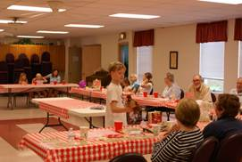

Rebecca Circle 2024 Picnic/Bingo Meeting on July 16, 2024. Thirty (including 6 children, members and guests) enjoyed a lot of good food, a fun game of Bingo with the challenge to keep a popular “White Elephant” prize from being taken from them by the latest Bingo winner. Karen Patterson and Cathy Whiteside were hostesses with Jan Docherty serving as moderator of the meeting. Nancy Corbige was our Bingo Caller Extraordinaire. Thank you to all who made this a very fun meeting.

 ROAD RUNNERS TRIP 2024
Adventures in the Smokies!
Registration for the September Roadrunner trip has begun. We will be leaving Grace on Sunday, September 15th and returning Saturday, September 21^{st.} Some places we’ll be visiting are Anakeesta: a new attraction in Gatlinburg, Dollywood, the Island in Pigeon Forge, The Biltmore in NC and Brushy Penitentiary. The estimated cost of this trip will be $1400-$1450. Registration forms will be in the Roadrunner mailbox in the church office or see Suzanne Girsch.
NOISY OFFERING
Every Sunday we collect a “noisy offering” when you wish to empty your change purse or pockets. We are currently collecting for maintenance items, including our new boiler. Thank you.

COVID 19, FLU AND RSV SAFETY PROTOCOLS
We follow the recommendations of the CDC, ELCA and IL Department of Health.
If you wish to mask and social distance, please do so. Please do not come to church if you have symptoms of illness. If you do not feel comfortable worshipping with others, we invite you to join us for worship via our website, graceoflilylake.org

CONTACTS:
For emergencies, please contact the church office at 630-365-6751.
For prayer requests or other needs please call Kathy Hooey at 630-341-2293 or leave a message at the church office at 630-365-6751. Messages are checked daily at noon & 5 pm.

Information for the September newsletter will be due by August 25th – please send items to Marty Bradley at martybradley@mchsi.com. Thank you



Once again, we thank Linda Smykowski for planting and maintaining our garden
which provides food for the Elburn food pantry and our members.

