
WELCOME TO
GRACE LUTHERAN CHURCH
OF LILY LAKE, IL
5N600 Hanson Road, St. Charles, IL 60175
OFFICE: 630-365-6751 * E-mail: general@graceoflilylake.com
Web Address: www.graceoflilylake.com
Sunday, December 13, 2020 * 9 AM * ONLINE



those who dream... keep awake (hope)

Third Sunday in Advent

INTRODUCTION – Ultimately, dreams sow joy, even if that joy doesn’t immediately spring forth. Sowing seeds into the soil always feels risky and feeble—how can something so small become something so beautiful, so big, and so nourishing? Like Mary, we are called to tend and nurture the dreams God has woven into us.

THANK YOU FOR JOINING US FOR SUNDAY MORNING FROM HOME.
Print out your bulletin or use it on your phone or tablet to follow along.
Announcements are televised or found on our website

Be creative how you worship and remember God during this time. It will calm your soul, give you peace and enliven your spirit.

Our community gathers in unity with others in-person and a virtual way.
We hope all people find it easy to follow along.

GOD GATHERS US
WELCOME & ANNOUNCEMENTS
Announcements are found on our website

PRELUDE The Shepherd's Song Paxton

We invite you to read/respond to the texts, pray the prayers, using this as a meditation guide all week long.

Call to Worship²
P O God, gather us in your holy arms as we worship you.
ALL Wrapped in your love, there should be no end to our joy
P With a sky full of stars and a world full of flowers, there should be no end to our joy.
ALL Yet, instead of singing like Mary, or dancing like David instead of decorating my very being with joy, I make other choices. Passing by remarkable beauty and love most days, unfazed. Forgive me.
P Teach us the ways of children,
ALL who laugh and dance and sing as if joy is the very thing that keeps them alive.
P Friends, anytime we gather together to worship God, we are here in God’s arms.
Decked in God’s glory, may we recognize that gift, and in doing so, may we sow joy.
ALL Let us worship Holy God.
SANCTIFIED ART THOSE WHO DREAM WORDS FOR WORSHIP | “Adapted from a prayer by Sarah Are | A Sanctified Art LLC | sanctifiedart.org.”

Candle Lighting Liturgy | The Candle of Joy ADVENT 3 DEUTSCHMANN

OPENING SONG “Praise to You O God of Mercy” ELW 208
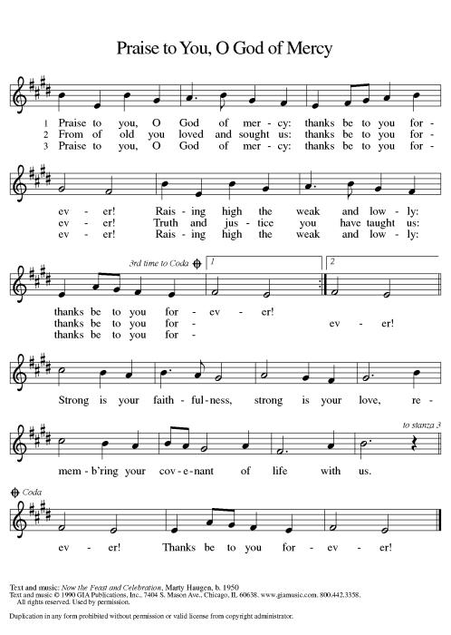
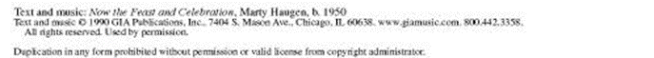
PRAYER OF THE DAY
P Creator God, Scripture is flooded with dream-like images:
the lion lying down with the lamb, justice rolling like a mighty river,
swords being beaten into plowshares, the prisoner being set free,
good news to the oppressed, the whole world rejoicing.
To our human ears, there are times when these words can sound
like nothing more than a far-off dream— not prophecy but fantasy.
However, what we know is that to dream is to hope,
and to hope is to imagine, and to imagine is to wonder,
and to wonder is to believe,
and to believe is to live and breathe for your promised day.
So give us the strength to listen as we dream, O God.
For deep down, we know your words are the very thing we need.
ALL Amen.

SHARING OF PEACE
P May you know comfort. May you know peace.
ALL May you also.

GOD’S WORD
FIRST READING Isaiah 61:1-4, 8-11
Introduction – Though the people had returned to Jerusalem from exile in Babylon, they continued to face hardship and oppression. In the language of the jubilee year described in Leviticus 25, the prophet, moved by the spirit of God, announces deliverance for those who are oppressed and comfort for those who mourn.

R - ¹The spirit of the Lord God is upon me, because the Lord has anointed me;
he has sent me to bring good news to the oppressed,
to bind up the brokenhearted,
to proclaim liberty to the captives, and release to the prisoners;
²to proclaim the year of the Lord’s favor, and the day of vengeance of our God;
to comfort all who mourn;
³to provide for those who mourn in Zion—
to give them a garland instead of ashes,
the oil of gladness instead of mourning,
the mantle of praise instead of a faint spirit.
They will be called oaks of righteousness, the planting of the Lord, to display his glory.
⁴They shall build up the ancient ruins, they shall raise up the former devastations;
they shall repair the ruined cities, the devastations of many generations.

⁸For I the Lord love justice, I hate robbery and wrongdoing;
I will faithfully give them their recompense,
and I will make an everlasting covenant with them.
⁹Their descendants shall be known among the nations,
and their offspring among the peoples;
all who see them shall acknowledge that they are a people whom the Lord has blessed.
¹⁰I will greatly rejoice in the Lord, my whole being shall exult in my God;
for he has clothed me with the garments of salvation,
he has covered me with the robe of righteousness,
as a bridegroom decks himself with a garland,
and as a bride adorns herself with her jewels.
¹¹For as the earth brings forth its shoots,
and as a garden causes what is sown in it to spring up,
so the Lord God will cause righteousness and praise to spring up before all the nations.
R Word of God; Word of Life. All Thanks be to God.




“Dressed in Joy!”

What is Pastor cooking up today?

THE HOLY GOSPEL according to St. Luke. Luke 1:46b-55

ALL Alleluia. Show us your steadfast love, O Lord,* and grant us your salvation. Alleluia. (Ps. 85:7)

^{46b}My soul proclaims the greatness of the Lord,
⁴⁷my spirit rejoices in God my Savior,
⁴⁸for you, Lord, have looked with favor on your lowly servant.
From this day all generations will call me blessed:
⁴⁹you, the Almighty, have done great things for me and holy is your name.
⁵⁰You have mercy on those who fear you, from generation to generation.
⁵¹You have shown strength with your arm and scattered the proud in their conceit,
⁵²casting down the mighty from their thrones and lifting up the lowly.
⁵³You have filled the hungry with good things and sent the rich away empty.
⁵⁴You have come to the aid of your servant Israel, to remember the promise of mercy,
⁵⁵the promise made to our forbears, to Abraham and his children forever.

P The Gospel of the Lord All Praise to You O Christ.

MESSAGE FOR ALL
“Those Who Dream….Sow Joy & Jubilee”
Pastor Dawn Roucka

REFLECTION QUESTIONS
- What does it mean for us to be people of Advent in this our time?

- Like Mary and many of God’s chosen servants, we are called to tend and nurture the dreams/seeds God has planted in us. As we await their growing and taking root, what small actions will cultivate joy?

- Mary’s song is full of aspiring dreams, hope and joy despite being unseen in a harsh world. What are our sources of dreams, hope and rejoicing in what feels like a year of tears? Can we create jubilee?

RESPONDING TO GOD’S GOODNESS
AFFIRMATION OF FAITH
P Great Creator,
ALL We are in awe of you.
We will never know how you managed to dream up
Mountains and valleys, freckles, dimples, and curly hair,
A cool morning mist, the change of seasons, or the magic of music.
Your greatness is beyond our reckoning.
And because we are in awe of you,
We believe we must follow Mary’s lead. And allow our souls to sing.
We believe that the appropriate reaction to your goodness is complete gratitude,
Which looks like love for our neighbor,
Justice for the poor, Food for the hungry, And joy that overflows.
And even though we do not always believe in ourselves,
We believe that our song is pleasing to you. We believe. Help our unbelief.
In Christ’s name we pray, amen.

OFFERING IS WELCOMED
P God calls us to love with all our hearts, souls, minds, and strength, and to love our neighbors as
ourselves. Our offerings are a symbol of that commitment and one of our contributions to our congregation’s witness in our neighborhood, in our region, and in our world. You are invited to give generously.

PLEASE CONSIDER IN THIS TIME OF NEED, TO CONTINUE TO SUPPORT YOUR CHURCH, IF POSSIBLE, AND SUPPORT OTHERS AS WELL BY BEING AS GENEROUS WITH YOUR TIME, YOUR TALENTS AND YOUR VARIOUS TREASURES.

You may mail offerings to Grace at 5N600 N. Hanson Road, St. Charles, IL 60175
or send through your bank or online; there is also a DONATE on our website or a plate by the entryway.



OFFERTORY PRAYER
P Let us pray. Generous God, you have created all that is, and you provide for us in every season.
Bless all that we offer, that through these gifts the world will receive your blessing.
In the name of Jesus, Emmanuel, we pray.
ALL Amen.

PRAYERS OF GOD’S PEOPLE
See list of those Grace is currently praying for at end of this document or online. Please let us know your prayer needs.

Please respond accordingly
P O God of hosts, All Restore us; let your face shine upon us.

THE LORD’S PRAYER
(Traditional) (Modern)
Our Father, who art in heaven, Our Father in heaven,
hallowed be thy name, hallowed be your name,
thy kingdom come, your kingdom come,
thy will be done, your will be done,
on earth as it is in heaven. on earth as in heaven.
Give us this day our daily bread; Give us today our daily bread.
and forgive us our trespasses, as we Forgive us our sins as we forgive those forgive those who trespass against us; who sin against us.
and lead us not into temptation, Save us from the time of trial
but deliver us from evil. And deliver us from evil.
For thine is the kingdom, and the power, For the kingdom, the power, and the glory
and the glory, forever and ever. Amen. are yours, now and forever. Amen

GOD SENDS US
COMISSION & BENEDICTION (based on 1 Thessalonians 5: 16-24)
P Go now, for you are called in faith and sent in the Spirit.
Pray at all times, be thankful in all circumstances.
Do not quench the Spirit! Choose Joy!
Bear witness that the time has come for the Lord to save his people.
And may God, Creator of the Stars, give you peace and bless your Advent waiting;
May the long-expected Savior clothe you with joy and fill you with love;
And may the unexpected Spirit guide your journey and dreaming, ☩ now and forever.
ALL Amen!

CLOSING SONG “Savior, Of the Nations, Come” ELW 263
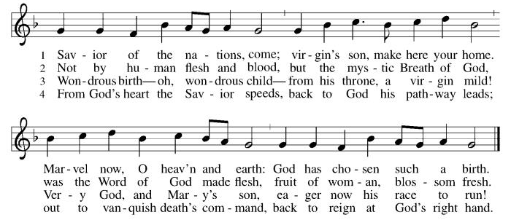

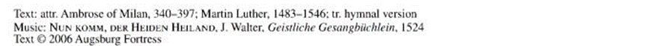

DISMISSAL
P Go in peace . Prepare the way of the Lord, ALL Thanks be to God. Amen.

POSTLUDE Rise Up Shepherd and Follow Hughes

ANNOUNCEMENTS
December 13, 2020

ZOOM FELLOWHIP WILL CONTINUE WEEKLY AT 10 AM on Sundays following our online worship services. Join our Grace family for sharing news, prayers information and more. Don’t miss out! Check your eblast for details.
~~~~*~~~~*~~~~*~~~~
ADVENT begins TODAY. If you have not gotten, but want, special Advent take-home kit, please contact Pastor to make arrangements to get one at Grace or have one delivered. This gift bag is a special Advent meditation gift for you/ your family. Don’t miss out!

Bags include a weekly Advent Devotion activity easy for all ages. They also have a fuller Advent Devotion Booklet themed “Those Who Dream”, our Advent series that includes prayers, reflections, and activities.

Sunday, November 29 – HOPE Monday, Dec 21, 2020 – Longest Night Service 7PM
Sunday, Dec. 6, 2020 – PEACE (Opportunity to lament the losses and grief of 2020)
Sunday Dec. 13, 2020 – JOY Thursday, Dec. 24, 2020 Christmas Eve
Sunday Dec. 20, 2020 – LOVE Join us for a special parking lot service! Time: 3PM & 5 PM

ADVENT & CHRISTMAS SERVICES WILL ALL BE ONLINE!
Get all access through our website! Share with a friend

~~~~*~~~~*~~~~*~~~~
See Website for Christmas GIVING OPPORTUNITIES
Giving Tree
ELCA Barnyard
~~~~*~~~~*~~~~*~~~~

~~~~*~~~~*~~~~*~~~~

Please consider turning in your 2021 Commitment Card today – online, in the mail or drop it by church today.
~~~~*~~~~*~~~~*~~~~
Annual Reports due – December 28th
send to Cathy Whiteside by/on December 28th. If you need re-typed, leave copy in Cathy’s box.
Annual Meeting – January 31st
Save the date

REAL NEWS TO USE DURING THESE TIMES

VISIT OUR Website www.graceoflilylake.com FOR THE LATEST NEWS AND SERVICES
Check out our updated website. Get ALL the news you NEED there – including our weekly services
And our FACEBOOK PAGE or Youtube page for activities and posts of interest:
https://www.facebook.com/GraceOfLilyLake/
https://youtube.com/graceoflilylake.com
630-365-6751

THOSE TO KEEP IN YOUR PRAYERS
FOR THE WHOLE CHURCH
* God’s Church in all time and place, that God be seen and heard.
* As we face these times both together and while apart, keep us from fear, suffering and death.
* Ministries of the ELCA and Metro Chicago Synod, especially Bishop Yehiel Curry.
* Asst. to the Bishop Sunitha Mortha on the death of her mother in India
* Efforts of Lutheran World Relief, ELCA World Hunger, and Disaster Relief

FOR THE WORLD
- For every living person, including the First Family and staff, facing the threat of coronavirus – it affects us all, our loved ones and our worldwide neighbors together.
- For those facing natural disasters of wildfires, hurricanes, earthquakes

FOR OUR CONGREGATION
* For God's Spirit to guide Pastor Dawn, Vision Team, and whole congregation as we face transition and change.
* As we begin Advent, help us dream powerful dreams and watch and wait with God..

FOR THOSE IN THE MILITARY (members, relatives, and friends of members of our congregation)
* Glenn Adams, son of Mark and Renee Adams * Adam Sajdak, grandson of Bill and Lori U’Ren
* William Delmer, grandson of Kirk and Kathy Hooey * Lucy Adams
(If you know of someone currently serving our country, please share their information with the Church office.)

FOR ALL
* The continued support of our members * For all members of healthcare around the world
* For those serving as first responders and in the military * For our Nation, that extend peace in all things.

FOR THOSE SICK IN BODY, MIND OR SPIRIT
Fred Altstadt, Vicki Barclay, Carl Ekstrom, Carol Hammers, Jamie Hext, Manfred Kaufman, Jeannine Luchs, Joan Mortensen, Donald Overby, Ken Deutschman, Ken Patterson, Nicole Puralewski, Darlene Rentner, Pastor Rex, The Reynolds Family, Chris Richards, Nancy Schaefer, John Schnaitman, Shirley Turner, Pete and Carol Prevanas, Lisa Leyden, Pat Hill, Paul Kinsel, Pam Bohlin’s brother, Dottie’s brother, Paul Mantsch, Mike Meyer, Glenn (& Kathy) Fritschel, Alex & Katie Tarr

FOR THOSE WHO GRIEVE

Please let us know your prayer requests for inclusion in our public prayers.
Type them in the comments or send them to the church office via our prayer card on our website.

GRACE’S MISSION IS
To share God’s GRACE with all through our rich traditions of faith, family, and community.
Gospel – God’s love shared in all we say & do
Respect for all God’s people & creation
Action – response to the Gospel
Community – Loving God, neighbor, & self
Everyone – we are all God’s children

GRACE LUTHERAN CHURCH OF LILY LAKE
5N600 Hanson Road, St. Charles, IL 60175
Office: 630-365-6751
E-mail: general@graceoflilylake.com
Web Address: www.graceoflilylake.com

