
WELCOME TO
GRACE LUTHERAN CHURCH
OF LILY LAKE, IL
5N600 Hanson Road, St. Charles, IL 60175
OFFICE: 630-365-6751 * E-mail: general@graceoflilylake.com
Web Address: www.graceoflilylake.com
Sunday, November 15, 2020 * 9 AM * ONLINE



Twenty-fourth Sunday of Pentecost

INTRODUCTION – In a world filled with violence and despair, people of faith gather around signs of hope and celebrate. Today we celebrate Christ’s coming in our midst and all the blessings God bestows upon us.

THANK YOU FOR JOINING US FOR SUNDAY MORNING FROM HOME.OR IN PERSON
Print out your bulletin or use it on your phone or tablet to follow along.
Announcements are televised or found on our website

Be creative how you worship and remember God during this time. It will calm your soul, give you peace and enliven your spirit.

Our community gathers in unity with others in-person and a virtual way.
We hope all people find it easy to follow along.

GOD GATHERS US

WELCOME & ANNOUNCEMENTS
Announcements are televised or found on our website

PRELUDE Jesu, Joy of Man’s Desiring Bach

We invite you to read/respond to the texts, pray the prayers, using this as a meditation guide all week long.

CALL TO WORSHIP
P This is the Lord's Day, the day of wonder and grace.
All This is the day to worship the One who calls us here.
P This is the Lord's Day, the day we are given joy and peace.
All This is the day promised to us, the day of healing and renewal.
P This is the Lord's Day, and it has come just in time!
All This is the day we gather with hope, with faith, with love!
Adapted from the work of Thom Shuman, Lectionary Liturgies

OPENING SONG “Lord of Glory, you have Bought Us” ELW 714 vs.1, 2
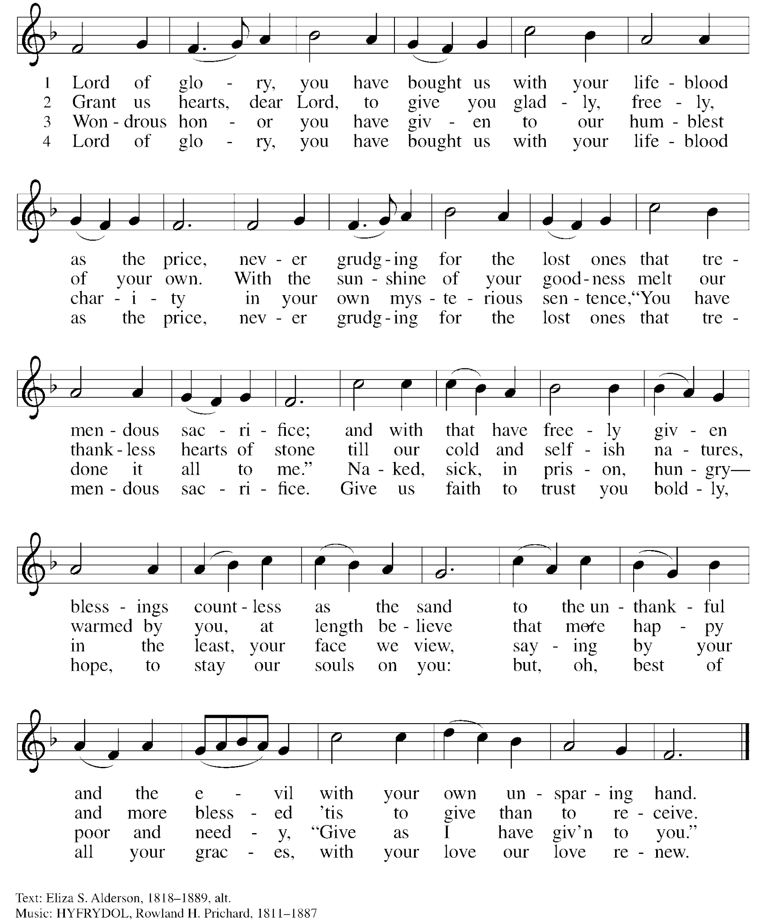

GREETING & PRAYER OF THE DAY
P The Grace of our Lord Jesus Christ, the love of God and the communion of the Holy Spirit be with
you all.
ALL And also with you.
P Let us pray,….. Righteous God, our merciful master, you own the earth and all its peoples, and
you give us all that we have. Inspire us to serve you with justice and wisdom, and prepare us for the joy of the day of your coming, through Jesus Christ, our Savior and Lord.
All Amen.

SHARING OF PEACE

GOD’S WORD
FIRST READING 1 Thessalonians 5:1-11 (The MSG)
Introduction - Though we do not know and cannot calculate the day of Christ’s return, we live faithfully in the here and now as we anticipate the day when we will be given eternal salvation through our Lord Jesus Christ.
R 5 ¹⁻³ I don’t think, friends, that I need to deal with the question of when all this is going to happen. You know as well as I that the day of the Master’s coming can’t be posted on our calendars. He won’t call ahead and make an appointment any more than a burglar would. About the time everybody’s walking around complacently, congratulating each other—“We’ve sure got it made! Now we can take it easy!”—suddenly everything will fall apart. It’s going to come as suddenly and inescapably as birth pangs to a pregnant woman.
⁴⁻⁸ But friends, you’re not in the dark, so how could you be taken off guard by any of this? You’re sons of Light, daughters of Day. We live under wide open skies and know where we stand. So let’s not sleepwalk through life like those others. Let’s keep our eyes open and be smart. People sleep at night and get drunk at night. But not us! Since we’re creatures of Day, let’s act like it. Walk out into the daylight sober, dressed up in faith, love, and the hope of salvation.
⁹⁻¹¹ God didn’t set us up for an angry rejection but for salvation by our Master, Jesus Christ. He died for us, a death that triggered life. Whether we’re awake with the living or asleep with the dead, we’re alive with him! So speak encouraging words to one another. Build up hope so you’ll all be together in this, no one left out, no one left behind. I know you’re already doing this; just keep on doing it.
R Word of God; Word of Life. All Thanks be to God.



“Dressed up for God”

What is Pastor cooking up today?



THE HOLY GOSPEL according to St. Matthew, the twenty-fifth chapter. 25:14-30

ALL Alleluia. Keep awake and be ready, for you do not know on what day your Lord is

coming. Alleluia.

Introduction - Jesus tells a parable about his second coming, indicating that it is not sufficient merely to maintain things as they are. Those who await his return should make good use of the gifts that God has provided them.

[Jesus said to the disciples:] ¹⁴“For it is as if a man, going on a journey, summoned his slaves and entrusted his property to them; ¹⁵to one he gave five talents, to another two, to another one, to each according to his ability. Then he went away. ¹⁶The one who had received the five talents went off at once and traded with them, and made five more talents. ¹⁷In the same way, the one who had the two talents made two more talents. ¹⁸But the one who had received the one talent went off and dug a hole in the ground and hid his master’s money. ¹⁹After a long time the master of those slaves came and settled accounts with them. ²⁰Then the one who had received the five talents came forward, bringing five more talents, saying, ‘Master, you handed over to me five talents; see, I have made five more talents.’ ²¹His master said to him, ‘Well done, good and trustworthy slave; you have been trustworthy in a few things, I will put you in charge of many things; enter into the joy of your master.’ ²²And the one with the two talents also came forward, saying, ‘Master, you handed over to me two talents; see, I have made two more talents.’ ²³His master said to him, ‘Well done, good and trustworthy slave; you have been trustworthy in a few things, I will put you in charge of many things; enter into the joy of your master.’ ²⁴Then the one who had received the one talent also came forward, saying, ‘Master, I knew that you were a harsh man, reaping where you did not sow, and gathering where you did not scatter seed; ²⁵so I was afraid, and I went and hid your talent in the ground. Here you have what is yours.’ ²⁶But his master replied, ‘You wicked and lazy slave! You knew, did you, that I reap where I did not sow, and gather where I did not scatter? ²⁷Then you ought to have invested my money with the bankers, and on my return I would have received what was my own with interest. ²⁸So take the talent from him, and give it to the one with the ten talents. ²⁹For to all those who have, more will be given, and they will have an abundance; but from those who have nothing, even what they have will be taken away. ³⁰As for this worthless slave, throw him into the outer darkness, where there will be weeping and gnashing of teeth.’ ”

P The Gospel of the Lord All Praise to You O Christ.

MESSAGE FOR ALL
“Talent-Search: Risk & Celebration”
Pastor Dawn Roucka

REFLECTION QUESTIONS
- What is your talent? How do you use it? And how can you use it for God?

- What “one talent” excuses have you been or are you making?

- What dream is God building among the people and ministry of Grace? What joy are we giving God?

RESPONDING TO GOD’S GOODNESS
OFFERING IS WELCOMED
P God calls us to love with all our hearts, souls, minds, and strength, and to love our neighbors as
ourselves. Our offerings are a symbol of that commitment and one of our contributions to our congregation’s witness in our neighborhood, in our region, and in our world. You are invited to give generously.

PLEASE CONSIDER IN THIS TIME OF NEED, TO CONTINUE TO SUPPORT YOUR CHURCH, IF POSSIBLE, AND SUPPORT OTHERS AS WELL BY BEING AS GENEROUS WITH YOUR TIME, YOUR TALENTS AND YOUR VARIOUS TREASURES.

You may mail offerings to Grace at 5N600 N. Hanson Road, St. Charles, IL 60175
or send through your bank or online; there is also a DONATE on our website or a plate by the entryway.

BLESSING OF COMMITMENTS MADE

OFFERTORY PRAYER
P Let us pray. God, whose giving knows no ending,
we offer up the treasure that you have entrusted to us;
we offer up the skills and time that you have graciously given to us;
we offer up ourselves in service and praise.
Receive these gifts by your grace.
Multiply and use them through the power of the Holy Spirit
to accomplish Christ’s work of love in the world. Amen.
ALL Amen.
~ written by Joanna Harader, and posted on the Spacious Faith blog. http://spaciousfaith.com/

PRAYERS OF GOD’S PEOPLE
See list of those Grace is currently praying for at end of this document or online. Please let us know your prayer needs.

Please respond accordingly
P Generous God, All Your mercy is great.

THE LORD’S PRAYER

(Traditional) (Modern)
Our Father, who art in heaven, Our Father in heaven,
hallowed be thy name, hallowed be your name,
thy kingdom come, your kingdom come,
thy will be done, your will be done,
on earth as it is in heaven. on earth as in heaven.
Give us this day our daily bread; Give us today our daily bread.
and forgive us our trespasses, Forgive us our sins
as we forgive those as we forgive those
who trespass against us; who sin against us.
and lead us not into temptation, Save us from the time of trial
but deliver us from evil. And deliver us from evil.
For thine is the kingdom, and the power, For the kingdom, the power, and the glory
and the glory, forever and ever. Amen. are yours, now and forever. Amen

GOD SENDS US
COMISSION & BENEDICTION (based on Psalm 130)

P Wait for the LORD,
ALL We wait with deep longing; standing on God’s promises.
P Hope in the LORD!
ALL The LORD pours out steadfast love and mighty saving power.
P Go into the world with assurance, hope and promise:
the grace of our Lord Jesus Christ rest upon you – and even unsettle you;
the love of God, creator and giver of life, embrace you – and even confront you;
and the presence of the Holy Spirit encourage you – and surprise you, this day and all your days.
ALL Amen!
~ Copyright © Jeff Shrowder 2000. For use in worship, with acknowledgement. Posted on The Billabong website. http://thebillabong.info/

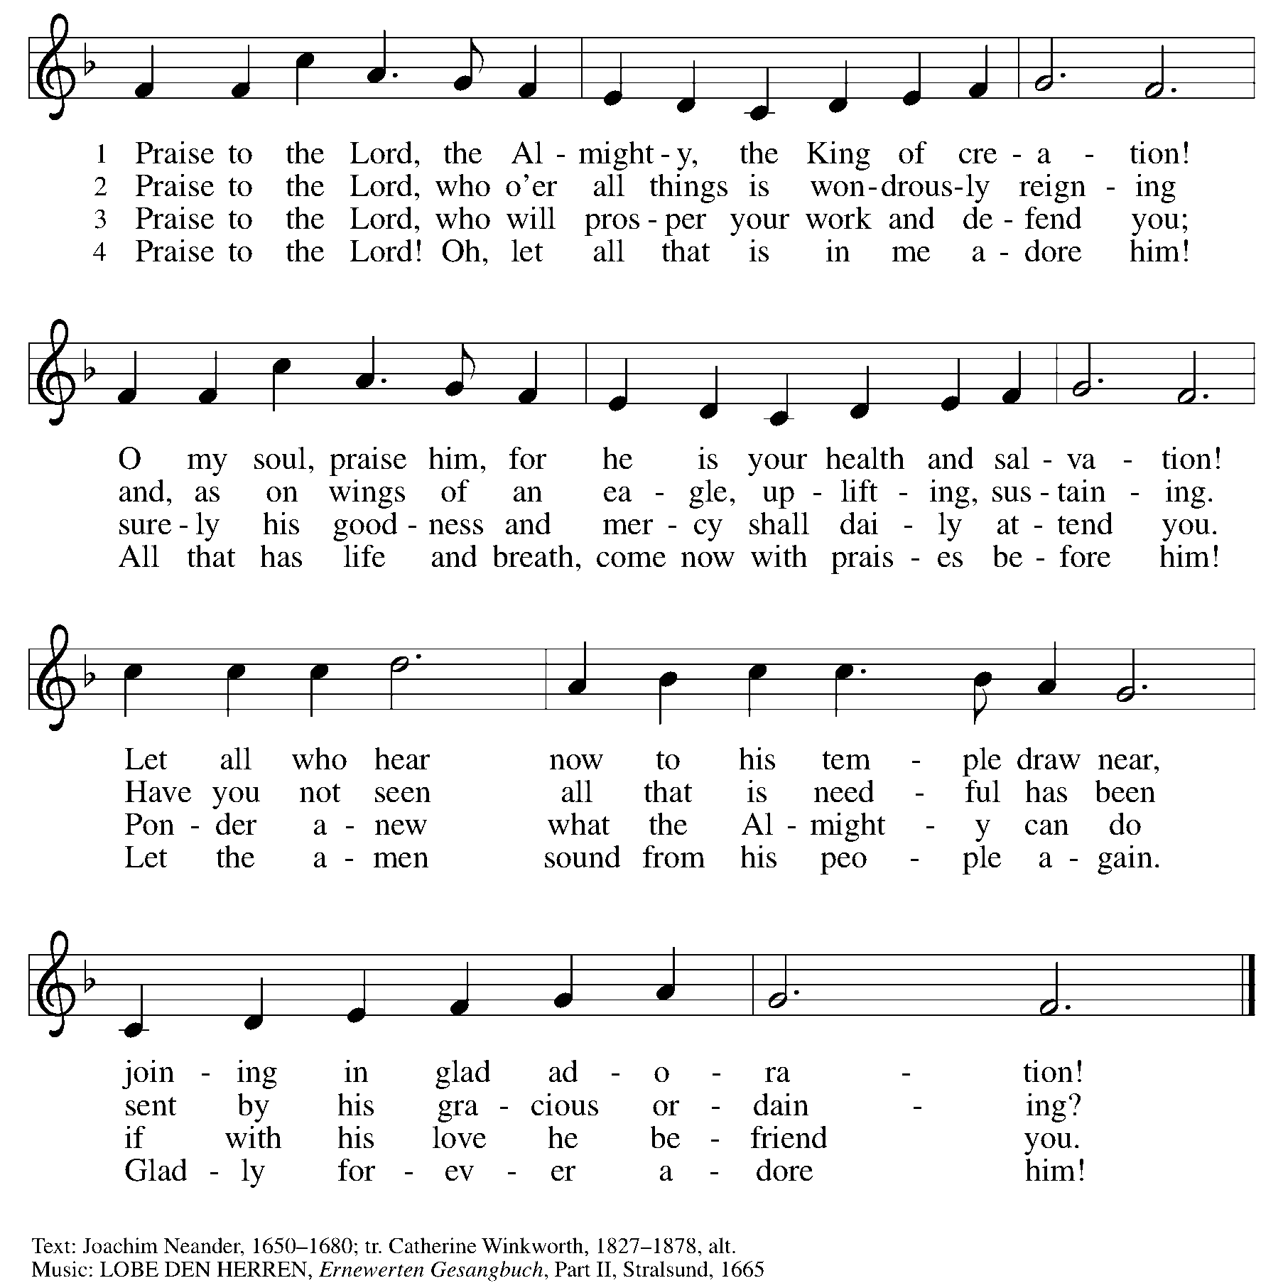
CLOSING SONG “Praise to the Lord, the Almighty” ELW 859vs. 1,2,4 (read all)

DISMISSAL
P Go in peace to love and serve the Lord,
ALL Thanks be to God. Amen.

REAL NEWS TO USE DURING THESE TIMES

VISIT OUR Website www.graceoflilylake.com FOR THE LATEST NEWS AND SERVICES
Check out our updated website. Get ALL the news you NEED there – including our weekly services
And our FACEBOOK PAGE or Youtube page for activities and posts of interest:
https://www.facebook.com/GraceOfLilyLake/
https://youtube.com/graceoflilylake.com
630-365-6751

THOSE TO KEEP IN YOUR PRAYERS
FOR THE WHOLE CHURCH
* God’s Church in all time and place, that God be seen and heard.
* As we face these times both together and while apart, keep us from fear, suffering and death.
* Ministries of the ELCA and Metro Chicago Synod, especially Bishop Yehiel Curry.
* Efforts of Lutheran World Relief, ELCA World Hunger, and Disaster Relief

FOR THE WORLD
- For every living person, including the First Family and staff, facing the threat of coronavirus – it affects us all, our loved ones and our worldwide neighbors together.
- For those facing natural disasters of wildfires, hurricanes, earthquakes

FOR OUR CONGREGATION
* For God's Spirit to guide Pastor Dawn, Vision Team, and whole congregation especially as we face transition and change.
* For our financial wellbeing and growth, being good stewards of all that God has given and calls us to.

FOR THOSE IN THE MILITARY (members, relatives, and friends of members of our congregation)
* Glenn Adams, son of Mark and Renee Adams * Lucy Adams, daughter-in-law of Mark & Renee Adams
* Adam Sajdak, grandson of Bill and Lori U’Ren * William Delmer, grandson of Kirk and Kathy Hooey
(If you know of someone currently serving our country, please share their information with the Church office.)

FOR ALL
* The continued support of our members * For all members of healthcare around the world
* For those serving as first responders and in the military * For our Nation, that extend peace in all things.

FOR THOSE SICK IN BODY, MIND OR SPIRIT
Fred Altstadt, Vicki Barclay, Carl Ekstrom, Carol Hammers, Jamie Hext, , Manfred Kaufman, Jeannine Luchs, Joan Mortensen, Donald Overby, Ken Deutschman, Ken Patterson, Nicole Puralewski, Darlene Rentner, Pastor Rex, The Reynolds Family, Chris Richards, Nancy Schaefer, John Schnaitman, Shirley Turner, Pete and Carol Prevanas, Lisa Leyden, Pat Hill, Paul Kinsel

FOR THOSE WHO GRIEVE
Nancy Corbige at the death of her mom, Gladys

Please let us know your prayer requests for inclusion in our public prayers.
Type them in the comments or send them to the church office via our prayer card on our website.

GRACE’S MISSION IS
To share God’s GRACE with all through our rich traditions of faith, family, and community.
Gospel – God’s love shared in all we say & do
Respect for all God’s people & creation
Action – response to the Gospel
Community – Loving God, neighbor, & self
Everyone – we are all God’s children

GRACE LUTHERAN CHURCH OF LILY LAKE
5N600 Hanson Road, St. Charles, IL 60175
Office: 630-365-6751
E-mail: general@graceoflilylake.com
Web Address: www.graceoflilylake.com

