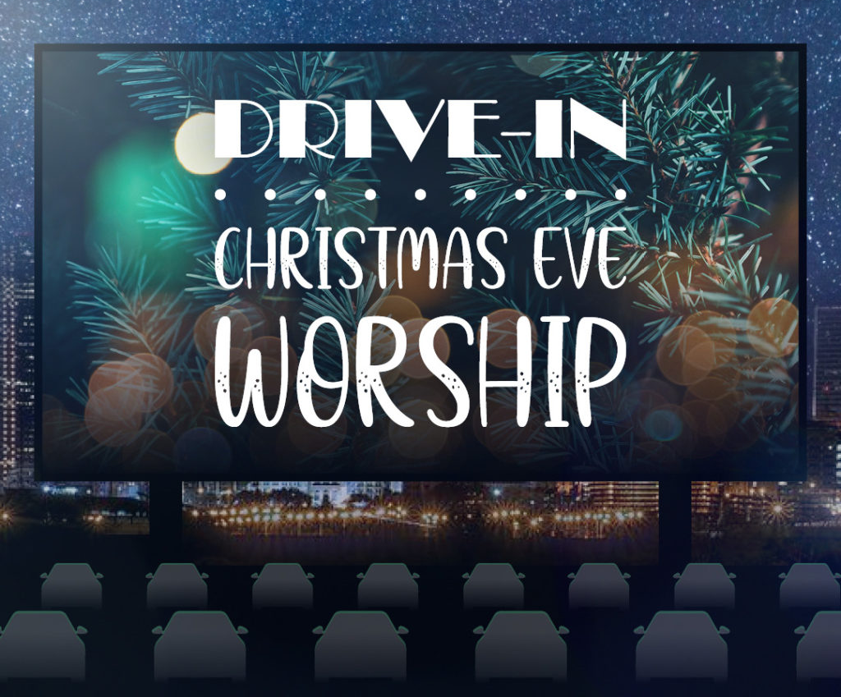
Lessons and Carols in Coronatide

Thank you for Joining us this Christmas. May God be with you, now and always!


We are glad you are here today! Please let us know what you thought of the service and how it made your Christmas meaningful by leaving a word for us at :
OUR Website www.graceoflilylake.com where you can find LATEST NEWS AND INFO
Or our FACEBOOK PAGE or Youtube page for activities and posts of interest:
https://www.facebook.com/GraceOfLilyLake/
https://youtube.com/graceoflilylake.com
630-365-6751

We invite you to stay in your vehicle tonight for safety and warmth and tune in on 103.7 FM

This service will include DRIVE-THRU HOLY COMMUNION at the end of the service. Parade past our front doors at the conclusion of the service from the west drive and receive a pre-packed communion kit FOR YOU.

If you would like to contribute to the ministry of care and compassion as Grace services the WHOLE COMMUNITY, we invite you to donate via our website or at the Grace of Lily Lake App.

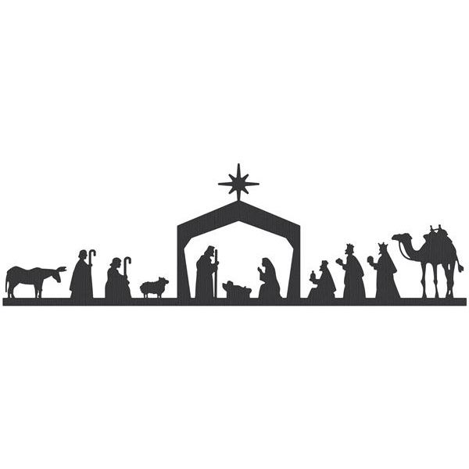

PRELUDE CHRISTMAS PRAISE Grace Choir

CHURCH BELLS

WELCOME George Theros

COME TO BETHLEHEM AND SEE
OPENING CAROL “O Come, All Ye Faithful” ELW 283, vs 1-3
1 O come, all ye faithful,
joyful and triumphant!
O come ye, O come ye to Bethlehem;
come and behold him,
born the king of angels:

Refrain
O come, let us adore him,
O come, let us adore him,
O come, let us adore him,
Christ the Lord!

2 The highest, most holy,
light of light eternal,
born of a virgin, a mortal he comes;
Son of the Father
now in flesh appearing! Refrain

3 Sing, choirs of angels,
sing in exultation,
sing, all ye citizens of heaven above!
Glory to God
in the highest: Refrain

BIDDING PRAYER

A STAR LEADS THE WAY
STAR DIALOG

CAROL “It Came Upon A Midnight Clear” ELW 282, vs 1-2
1 It came upon the midnight clear,
that glorious song of old,
from angels bending near the earth
to touch their harps of gold:
"Peace on the earth, good will to all,
from heav'n's all-gracious king."
The world in solemn stillness lay
to hear the angels sing.

2 Still through the cloven skies they come
with peaceful wings unfurled,
and still their heav'nly music floats
o'er all the weary world.
Above its sad and lowly plains
they bend on hov'ring wing,
and ever o'er its babel sounds
the blessed angels sing.

FINDING HOPE
FIRST READING In the Time of Plague by N. Scott Momday
In the Time of Plague a poem for these times, written in 2020 by Scott Momaday

We keep indoors.
When we dare to venture out
We are cautious. Our neighbors
Smile, but in their eyes there is
Reserve and suspicion.
They keep their distance,
As we do ours, in mute accord.
Much of our fear is unspoken,
For there is at last the weight of custom,
The tender of rote consolation.
We endure thoughts of demise
And measure the distance of death.
Death too wears a mask.
But consider, there may well be good
In our misfortune if we can find it. It is
Hidden in the darkness of our fear.
But discover it and see that it is hope
And more; it is the gift of opportunity.
We have the rare chance to prevail,
To pose a resolution for world renewal.
We can be better than we have ever been.
We can improve the human condition.
We can imagine, then strive to realize,
Our potential for goodness and morality.
We can overcome pestilence, war and poverty.
We can preserve our sacred purpose. We can
Determine who we are in our essential nature
And who we can be. We are committed to this end
For our own sake and for the sake of those
Who will come after us. There is a better future,
And we can secure it. Let us take up the task, and
Let us be worthy of our best destiny.

OPENING PRAYER

TIDINGS OF COMFORT AND JOY

CAROL “COMFORT AND JOY” Grace choir

SECOND LESSON Isaiah 40:1-8
Introduction - God’s People Receive Comfort and Healing

LIGHTING THE ADVENT AND CHRIST CANDLES
adapted from Maren Tirabassi's Advent Wreath Ceremony for Christmas and from THOSE WHO DREAM, A Sanctified Art

O HOLY CHILD OF BETHLEHEM
CAROL “O Little Town of Bethlehem” ELW 279, vs 1, 3, 4

1 O little town of Bethlehem,
how still we see thee lie!
Above thy deep and dreamless sleep
the silent stars go by;
yet in thy dark streets shineth
the everlasting light.
The hopes and fears of all the years
are met in thee tonight.

3 How silently, how silently
the wondrous gift is giv'n!
So God imparts to human hearts
the blessings of his heav'n.
No ear may hear his coming;
but, in this world of sin,
where meek souls will receive him, still
the dear Christ enters in.

4 O holy child of Bethlehem,
descend to us, we pray;
cast out our sin, and enter in,
be born in us today.
We hear the Christmas angels
the great glad tidings tell;
oh, come to us, abide with us,
our Lord Immanuel!

Text: Phillips Brooks, 1835-1893

THERE IN A MANGER
THIRD LESSON Hush by Lucinda Hynett
Intro – SHHhhhhh Listen (whispered)! Our 3rd reading from Lucinda Hynett anticipates the wonder of this night. The hopes, fears and dreams of all met in this whispered wonderful Word made flesh.
HUSsHHHHH
Sssh.
Can you hear it?
An expectant silence,
a hushed anticipation,
as if the very galaxy
is holding its breath.
There are some truths
even the stars know,
like darkness, …..like loneliness
and how the night
can be a living thing.
And how once, long ago,
the night waited in wonder
along with the darkness
and the loneliness,
for the sound of a baby’s cry,
for the miraculous
to come down
to the earth mundane.

— written by Lucinda Hynett, in Alive Now. Posted on the Liturgylink website.

CAROL “Away in a Manger” ELW 277 vs 1-2

Away in a manger, no crib for his bed,
the little Lord Jesus laid down his sweet head;
the stars in the bright sky looked down where he lay,
the little Lord Jesus asleep on the hay.

2 The cattle are lowing; the baby awakes,
but little Lord Jesus, no crying he makes.
I love you, Lord Jesus; look down from the sky
and stay by my cradle till morning is nigh.

“DO NOT BE AFRAID!”

FOURTH LESSON Luke 2:1-14 The Birth of Jesus
Intro – A reading from the Holy Gospel of Luke

CAROL Hark! The Herald Angels Sing
1 Hark! The herald angels sing,
"Glory to the newborn king;
peace on earth, and mercy mild,
God and sinners reconciled."
Joyful, all you nations, rise;
join the triumph of the skies;
with angelic hosts proclaim,
"Christ is born in Bethlehem!"
Refrain
Hark! The herald angels sing,
"Glory to the newborn king!"

2 Christ, by highest heav'n adored,
Christ, the everlasting Lord,
late in time behold him come,
offspring of a virgin's womb.
Veiled in flesh the Godhead see!
Hail, incarnate deity!
Pleased as man with us to dwell,
Jesus, our Emmanuel! Refrain

PONDERING ALL THAT WAS SEEN
FIFTH LESSON Luke 2:15-20
Intro – A reading from the Holy Gospel of Luke about the amazing gift and glory of God shared in the Good News of Jesus birth.

CAROL “The First Noel” ELW 300 vs. 1-2
1 The first Noel the angel did say
was to certain poor shepherds in fields as they lay;
in fields where they lay, keeping their sheep,
on a cold winter's night that was so deep.

Refrain
Noel, Noel, Noel, Noel!
Born is the King of Israel.

2 They looked up and saw a star
shining in the east beyond them far;
and to the earth it gave great light,
and so it continued both day and night. Refrain
REPORT THIS AD

SIXTH LESSON Now the Work of Christmas Begins
Intro – This modern Christmas poem is written by Howard Thurman, African-American theologian, educator, and civil rights leader and highlights that God goes with us into the rest of the story, the glorious work of sharing God’s love.

When the song of the angels is stilled,
when the star in the sky is gone,
when the kings and princes are home,
when the shepherds are back with their flocks,
the work of Christmas begins:
to find the lost,
to heal the broken,
to feed the hungry,
to release the prisoner,
to rebuild the nations,
to bring peace among the people,
to make music in the heart.

CAROL He is Born Grace Choir
CHRIST IS BORN!

INVITATION TO GIVE AND RECEIVE - OFFERING AND HOLY COMMUNION
We offer an opportunity to receive the Lord Incarnate at the table. We invite you at the conclusion of this service to drive through our drive by the front doors from the west or side closest to Rt 47 and we will offer you Holy Communion.. You will also have an opportunity if you wish to continue God’s work by making a gift to the work through Grace Lutheran Church. Tonight or through our website.

CAROL SILENT NIGHT ELW 281
During last verse, everyone is invited row by row or as the car next to you (Wave style) to light any/all lights with you, i.e. car lights, phone lights, flashlights, etc.

1 Silent night, holy night!
All is calm, all is bright
round yon virgin mother and child.
Holy Infant, so tender and mild,
sleep in heavenly peace,
sleep in heavenly peace.

2 Silent night, holy night!
Shepherds quake at the sight;
glories stream from heaven afar,
heav'nly hosts sing, alleluia!
Christ, the Savior, is born!
Christ, the Savior, is born!

3 Silent night, holy night!
Son of God, love's pure light
radiant beams from your holy face,
with the dawn of redeeming grace,
Jesus, Lord, at your birth,
Jesus, Lord, at your birth.

PRAYER FOR CHRISTMAS
(based on prayer by Salt Project)

BLESSING CAROL Joy to the World
1 Joy to the world, the Lord is come!
Let earth receive her king;
let ev'ry heart prepare him room
and heav'n and nature sing,
and heav'n and nature sing,
and heav'n, and heav'n and nature sing.

2 Joy to the earth, the Savior reigns!
Let all their songs employ,
while fields and floods, rocks, hills, and plains
repeat the sounding joy,
repeat the sounding joy,
repeat, repeat the sounding joy.

4 He rules the world with truth and grace
and makes the nations prove
the glories of his righteousness
and wonders of his love,
and wonders of his love,
and wonders, wonders of his love.

BELIEVE
FINAL BLESSING

OFFERING of Holy Communion
We offer an opportunity to receive the Lord Incarnate at the table. We invite you at the conclusion of this service to drive through our drive by the front doors from the west or side closest to Rt 47 and we will offer you Holy Communion..
You will be given pre-packed Communion cups.
- Take the thin film off top and consume the wafer
- Remove the foil top and consume the grape juice.
This is Christ’s body and Christ’s blood given and shed for you!

You will also have an opportunity if you wish to continue God’s work by making a gift to the work through Grace Lutheran Church. Tonight or through our website.

MERRY CHRISTMAS!
JOY TO THE WORLD!

SERVICE LEADERS 3PM 5PM ONLINE
MUSICIAN Dottie Mantsch Dottie Mantsch Dottie Mantsch
READER 1 Pat Penfold Mark Anderson Trish Painter
REASDER 2 Ken Roucka Heidi Anderson Marty Bradley
LESSON 1 Kathy Hooey Trish Painter
2 Kurt Redemann Kathy Hooey
3 Kathy Hooey Twyla Strom
4 Helen Gruber Marty Bradley
5 Helen Gruber Marty Bradley
6 Kurt Redemann Kurt Redemann

CHOIR With Thanks to the Grace Lutheran Church Choir directed/ coordinated by George Theros
PASTOR Pastor Dawn Hanse Roucka
WORSHIP COORDINATOR & TECH GURU George Theros

Thanks to the planning team and all those who ASSISTED – The Anderson Family, Marty Bradley, Nancy Corbige, Helen Gruber, Lee Gerke, Kathy Hooey, Dottie Mantsch, Trish Painter, Pat Penfold, Kurt Redemann, Nick Rex, Ken Roucka, Gloria Theros and Geoge Theros,

PERMISSIONS:
SERVICE - IS BASED ON AND USED BY PERMISSION FROM material by Elsa Cook used with permission PUBLISHED ON November 13, 2020

SONGS & MUSIC – CCLI License
Augsburg Fortress

CCLI Account #2362484
Copyright License A 513895 6/30/2021
+ Streaming License A 20660830 6/30/2021
SongSelect® Premium - - 6/30/2021
Liturgy-Sundays and Seasons May 31, 2021
Augsburg Fortress Liturgies Annual License: SAS007684
Onelicense wPodcast/Streaming
License number: 737193-A
Valid for: 11/11/2020 – 11/10/2021

