DECEMBER 2022, VOL. 36
 | AMAZING  GRACE  CONNECTIONS
Faith > Family > Community
Grace Lutheran Church of Lily Lake
5N600 Hanson Rd, St. Charles, IL 60175
Pastor David Mercurio
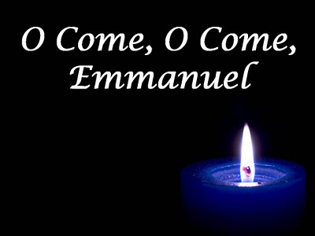
.licensed under CC BY-SA-NC
Worship every Sunday at 9 am
with Communion
Sunday, December 4, Worship and Sunday School,
Second Sunday of Advent
Sunday, December 11, Worship
Third Sunday of Advent
Sunday, December 18, Worship and Sunday School
Fourth Sunday of Advent
Saturday, December 24, Christmas Eve Services
3 pm and 7 pm at Grace
Sunday, December 25, Christmas Day Worship at 9 am

REMINDER: THANK YOU TO THOSE WHO HAVE ALREADY RETURNED THEIR PLEDGES. IF YOU HAVE NOT, PLEASE RETURN 2023 PLEDGES TO THE
CHURCH OFFICE BY DECEMBER 15TH.
The season of advent

The first season of the liturgical year is Advent. This year it begins November 27th and ends on December 24^{th.} As Christians, we use symbols to express visually the basic tenets of our faith and as reminders of the pilgrimage of our life in Christ. Symbols can have heightened meaning for us when associated with particular seasons of that journey. One such symbol is the Advent wreath. The Advent wreath has its roots in the pre-Christian practices of northern Europe. People sought the return of the sun in the dark time of the year (at the winter solstice) by lighting candles and fires. As early as the middle Ages, Christians used fire and light to represent Christ's coming into the world. Using this same symbolism, the Advent wreath developed a few centuries ago in Germany as a sign of the waiting and hopeful expectation of the return in glory of our Lord Jesus Christ. The wreath, a circle, came to represent the eternal victory over death through Jesus Christ. The evergreens were a sign of the faithfulness of God to God’s people, even in death, and the lighted candles were a reminder of the light of Christ brought into the world.



First Advent Candle, The Light of Hope: The first candle symbolizes hope. Also known as the “Prophecy Candle” in memory of the prophets, particularly Isaiah, who prophesied the birth of Christ. It symbolizes the anticipation felt in awaiting the coming Messiah.
Second Advent Candle, The Light of Peace: The second candle signifies peace. In sending Christ, God sent us peace that passes all understanding. Because of Christ, we can live our lives with a sense of calm assurance. We anticipate the birth of our Savior. “Peace on Earth, Good Will Toward Men” (Luke 2:14)..
Third Advent Candle, The Light of Joy: The third candle represents joy. The third Sunday of Advent is meant to remind us of the world's joy at the birth of Jesus. Our cups overflow with goodness and grace, and we rejoice in the promise of eternal life.
Fourth Advent Candle, The Light of Love: The fourth candle is a symbol of Christ’s eternal love for us as well as a reminder that we have been instructed to love others as we love ourselves. Because God is love, and because we were created in God’s image, we ourselves are the embodiment of God’s love here on earth.
The Christ Candle: On Christmas Eve we light all four candles and the Christ Candle celebrating the birth of our Lord and Savior. Prayer: God of light, on Christmas Eve we celebrate the birth of Jesus. We thank you for this most precious of Christmas gifts and we ask that you keep the hope, peace, joy and love of this season in our hearts, now and throughout the coming year. Emmanuel – God is with us now and forevermore. Amen

STEWARDSHIP 2022: HOLY COMMUNION, DISCIPLESHIP AND GIVING

The Stewardship reading for the last Sunday of the program on November 20th was:
As we eat of the bread and wine, we share in the covenant with all who believe. Our community with Jesus is a commitment to a common life and purpose. It encourages
us to remain faithful, take in the presence of Jesus, and be his disciples every moment
of every day. May that presence challenge us to be to be true stewards of God’s kingdom
in every way. The Lord’s Supper connects us and gives our community strength; it encourages us to find power from Jesus’s presence; it helps us to see how a community
that faithfully gathers at the table can be a community that is a witness to the values of the kingdom of God. (What does it mean to me and my stewardship to be part of the covenant with all who believe?)
Shirley Turner’s response to that question is included here:

When Norm & I first attended Grace, we were immediately impressed by the friendliness of everyone! Over time, I realized it was because you all truly cared for and about one another. Anyone who becomes part of a faith family knows those who recognize their need to confess sins and partake of the sacrament of Holy Communion. It draws us together in community when we share in the gift of covenant as described in scripture.

Very simply, a covenant refers to a promise or agreement between two or many. Community is about a group of people who care for one another and have a sense of belonging to one another. Does that sound like Grace Lutheran to you? It does to me.

As time passed, we became aware of the struggles facing Grace. A beloved Pastor was retiring. Key leaders moved. Attendance was falling off and morale threatened to derail the ministry. Of great concern was that those in leadership roles and those serving more quietly were stretched to their limits.

There were legitimate concerns if we could continue to be an active place of worship and ministry. I am in awe of the way many stepped up even more or for the first time. I would be remiss if I didn't express my gratitude to each of you who didn't give up and kept on in faith! Thank you! Are there still very real needs? Yes! However, when a community is tied together in love of Jesus, there is no "we and they." We're all in this together. I've sensed a breath of fresh air during the past year with Pastor David sharing his many gifts and talents as well as the way we have become aware of reality of the financial obligations we have. I want to be a part of this fresh wave of renewal. I want to be a part of the miraculous way God is going to bless us. I want to see the way Phillipians 1:6 comes to fruition here at Grace Lutheran:
" And I am certain that God who began good work with you will continue HIS
WORK until it is finally finished on the day when Jesus Christ returns.”

Amen ? Amen !
(A very special thanks to Shirley for this wonderful and inspiring message!)
COVID-19 Safety Protocols
We follow the recommendations of the CDC, ELCA and the IL Department of Health.
Face masks are optional. If you don’t feel comfortable worshipping with others
we invite you to join us virtually for worship via our website.

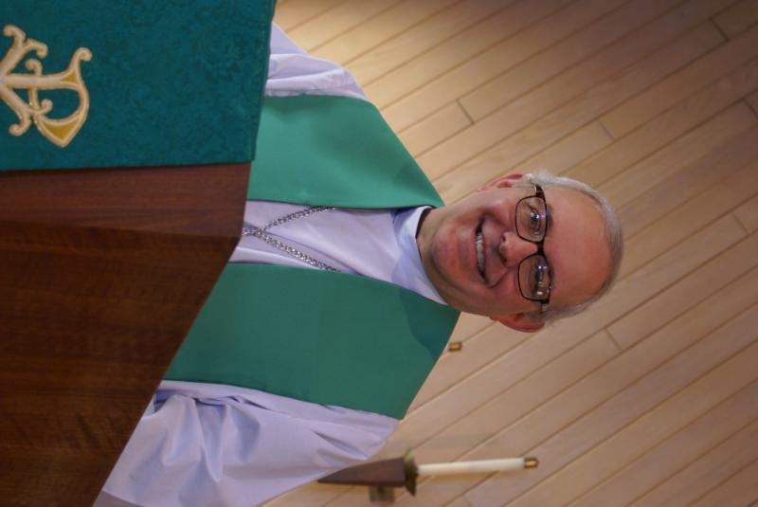
PASTOR’S MESSAGE

A Message from Pastor David for December 2022

As I write this letter, we have just celebrated our annual Community Thanksgiving service with Burlington United Methodist Church, Congregational Church of Lily Lake, and Country Covenant Evangelical Church. And despite our doctrinal differences, it was very clear to me that we were all there to worship our Lord Jesus. Amen! As an added treat for me, The Good Ole Boys performed a number of selections for us. I have been hearing OF them for a year now and I finally was able to hear them live. What a treat. I love Americana Gospel music and they did not disappoint.
We are now entering our busy Christmas season and our celebration of the first coming of Jesus the God-man. While many of our Sunday readings will focus on this event, let’s not forget, more importantly, about our expectation of his second coming, for that is our hope and our faith. May God continue to bless and watch over you and your families this season of Holy Days.
Pastor David
Pastor’s Hours at church
Tuesdays and Thursdays from 6 pm – 9 pm
Saturdays from 9 – noon Sundays from 8:30 am for 3-4 hours

DECEMBER VISION TEAM REPORT

The Vision Team meets on the second Tuesday of each month. If you have items you feel should be discussed by the team, please send them to Marty by the first Tuesday of the month.
- Reviewed schedule for putting together our 2023 budget
- Approved a snow plowing proposal
- Noted that the boiler system has had repairs and fall service is completed
- Church lighting issues are still being addressed
- NOTED that our Building Maintenance Fund will now be close to a $0 balance due to boiler service and repairs, plumbing issue and the new annunciator panel.
Thank you for all of your support and assistance. I wish you a blessed and joy-filled Christmas. Blessings, Marty

.FINANCIAL MATTERS – DECEMBER 2022

- Shopping?? Shopping?? Please support Grace through your Amazon purchases via "AmazonSmiles" link and earmarking Grace Lutheran of Lily Lake as your charitable organization. "Grace of Lily Lake" link is: https://smile.amazon.com/ch/36-2806605 . Note: Please ensure it says "St Charles, IL" as the location (there are many organizations that will be closely named). Grace receives a direct quarterly distribution from Amazon - tho, unfortunately, we did not receive any funds in the 3rd quarter.

- We sincerely appreciate the 25 commitment cards that were returned on Stewardship Sunday, November 20th. We are accepting your commitment card up to December 15, 2022. Having your commitments, allows the Vision Team to work on a budget for 2023 and present this budget to our members at our annual meeting on January 29, 2023. Please review your contributions to Grace over the course of 2022, and please have any year-end donations to the church office by Wed., Dec 28th, in order to be accepted in the year 2022.

- Noisy Offering continues to be collected for specialized lightbulbs to be replaced in our sanctuary, front and back parking lots, the rental cost of a lift to get to the high ceilings. As of Oct. 31, we have collected $800 & thank you in helping this fund grow! Look for the “Noisy Offering” buckets as we will graciously accept those heavy coins in your pocket.

- You are able to make your offering donations electronically -- the Subsplash Giving Link is: - https://graceoflilylake.com/give. Go to our website: graceoflilylake.com, click on the "Giving" link, "Give" , scroll down on the populated page and it will guide you to make a one time, or a recurring donation. We are truly grateful for your financial support @ Grace of Lily Lake.

- Giving a gift from a tax-deferred retirement account can be one of the most tax-efficient ways to be charitable both during your lifetime and through your estate. Unlike a distribution to you or an heir, which would be a taxable event, charitable donations from retirement accounts lay no additional tax burden on you or the charity. Estate gifts from these accounts can go directly to charities through a donor-directed distribution agreement or fund named endowments, i.e. Grace Lutheran Church of Lily Lake. Have you prayerfully considered naming Grace Lutheran Church of Lily Lake in your Trust or Will?

 |  |  |  | 2022 |  | 2021
 |  | Oct, 2022 |  | Year-to-Date |  | Year-to-Date
INCOME |  | $ 19,119.51* |  | $140,578.83 |  | $138,179.01
EXPENSES |  | $ 14,013.09 |  | $165,481.05 |  | $144,585.69
NET +/- |  | $5,106.42 |  | -$24,902.22 |  | -$6,406.68
Brief recap on our October financials:
*rummage sale income
was $6,852
In Peace ~ Your Fellow Grace Member, Tricia Painter, Treasurer
..

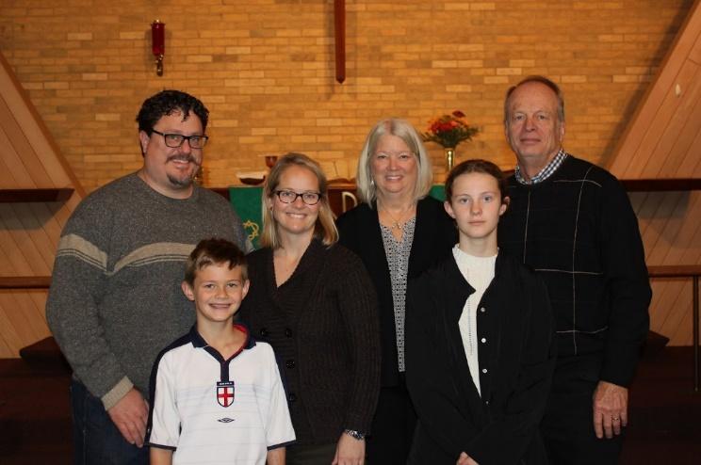

CONGRATULATIONS TO TEDDY AND RIKA BALLARD
ON COMPLETING THE FIRST COMMUNION COURSE WITH PASTOR. Teddy took his first communion on Sunday, November 13. We commend Rika who had completed the course several years ago and wished to increase her knowledge, so joined Teddy in the class.

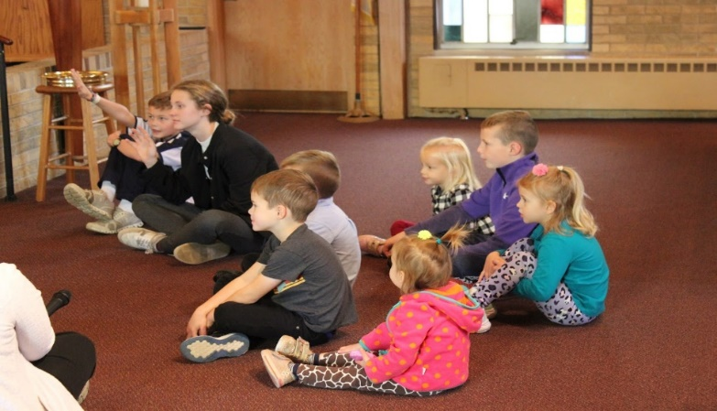

Sunday Children’s Message on November 13th


SERVING GRACE – YOU ARE NEEDED

If you are interested in nominating someone to serve on the Grace Vision Team, Audit Team or Nominating Team, or if you yourself are interested in serving, please contact Heidi Anderson by January 1st. Team members will be elected at the Annual Meeting on January 29th following worship.

  - Lee Gerke’s 90th Birthday

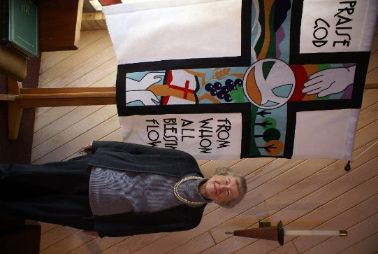
My faith journey began at St. Peter’s Lutheran Church in Chicago where I became a Lutheran at age 14. My mom had just died, and my 22-year-old sister took charge of me, because my father worked nights. She took the responsibility very seriously. She quit working, except when I was at school. She took me everywhere with her, to meetings at church, choir practice, etc. and introduced me to St. Peter’s Lutheran Church where I became active with the Young People Society.

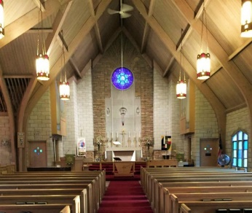
The second photo is of the church we went to before we moved to St. Charles…. Norwood Park Lutheran church. In looking at it recently, there is a strong resemblance to Grace, however, the reason we ended up at Grace and not Bethlehem was because my family decided it was sooo nice to drive through the country to go to church.

Two of the things I love about Grace are the people, my church family, and singing in the choir and working in the kitchen. These are some of the services I give happily and humbly.

I married my husband, Ralph, in 1953 and stayed married. We were active in our church and had 5 children, three girls and two boys. We became members of Grace not long after moving to St. Charles in 1972. We enjoyed driving in the “country” to go to church.
Many blessings Lee!


MANY THANKS AND PRAYERS TO THOSE WHO HAVE RECENTLY DONATED THEIR TIME AND TALENTS, including, but not limited to:

- George Theros, singers and Natalia Diehl for their work on the Community Thanksgiving Service. It was wonderful! $278 was received as offering and will be split with the four congregations to donate to their favorite food pantries.Helen Gruber for putting together the Coffee Hour following the service
- Candace Hopkins for putting together the Cookie Sale/Holiday Bazaar on December 17th
- Pastor for teaching the first communion class
- Nancy Corbige and Pat Penfold for gathering the children together to have a make up Sunday School class on November 13
- Trish Painter, George Theros, Kathy Hooey and Shirley Turner for assisting with the Stewardship presentations during worship
- The letter mailing team: Cathy Whiteside, Margaret Swanson, Shirley and Norm Turner
- Lori and Bill U’ren, our ubiquitous ushers
- Twyla Strom for making the mountains of pillow cases that are donated to children
- All of those who helped decorate the church for Christmas on Sat., Nov. 26th

CONTACT A VISION TEAM MEMBER IF YOU WISH TO VOLUNTEER


THE GIVING TREE

Once again, we have the opportunity to share gifts with children from the Elgin Crisis Center. The Giving Tree in the narthex has tags with children’s information for helping you shop. All gifts should be left unwrapped and put in gift bags with the child’s tag attached. They must be returned to Grace on or before Sunday, December 11th.


This Photo by Unknown Author is licensed under CC BY-SA-NC
ELCA GOOD GIFTS AND GLOBAL BARNYARD

Once again, the Rebecca Circle is sponsoring Grace’s support of the ELCA’s Good Gifts/Global Barnyard. A catalog of gifts that you can purchase is available in the Narthex. There are many new gifts such as blankets, counseling, Sunday school kits, Bibles, vocational training, health care as well as the barnyard possibilities. Purchases can be made beginning November 27th and continue through the end of December.

CHRISTMAS LUNCHEON HOSTED BY OUR REBECCA CIRCLE

Our Rebecca Circle will host the annual Christmas Luncheon Party at Sorrento’s on Route 64 in Maple Park on Tuesday, December 6th at noon. Everyone is invited (even you handsome gentlemen). Meals range from $17 to $28 with tax and gratuity included. Sign up forms available in the narthex. Please call Kathy Hooey or Jan Docherty if you wish to sign up.


COOKIE SALE / HOLIDAY BAZAAR
SATURDAY, DECEMBER 17TH, 9 AM – 1
At Grace in Fellowship Hall

Spread the news and invite your neighbors to attend. There is a baker’s sign-up sheet posted in the Narthex – we can use your favorite cookies or baked goods. Please bring the baking to Grace on Friday, December 16th between the hours of 9am to 12 pm or 5pm to 8pm. We are looking for a couple more vendors who would like to host a table (we possibly have Tupperware, MaryKay, local honey vendor, bake sale; we are looking to those within Grace first, before opening to outside vendors.
At this holiday bizarre, you can do some Christmas shopping with a variety of vendors, gather cookies ($7 a dozen), children can decorate a sugar cookie, there will be a hot cocoa stop and we believe Santa is going to be present – there’s a photo op for you!
If you have questions or would like to help with this event, please contact Candice Verner at
630-362-4659 or email: candicehopkins31@gmail.com


NEW PRAYER CHAIN

If you are interested in being a part of Grace’s new phone/internet prayer chain, please contact Kathy Hooey and she will send you the information.

Swedish Christmas and St. Lucia Festival
Saturday, December 3, 2022 at 3 pm at Bethany Lutheran Church
8S Lincoln St., Batavia, IL
The Swedish American Children’s Choir will be performing
Reservations are required, call 630-414-9700
$15 Adults $8 Children (6-12)


For information about our local Habitat for Humanity or to volunteer to help, please contact our representative, Nancy Corbige, at 847-212-0237 or NCorbige@gmail.com

CONTACTS:
For emergencies please contact Marty Bradley, President, at 640-777-1074 or leave a message at the church office at 630-365-6751.
For prayer requests or other needs please call Kathy Hooey at 630-341-2293 or leave a message at the church office at 630-365-6751. Messages are checked daily at noon & 5 pm.

ELCA MISSION WEBSITES

LUTHERAN DISASTER RESPONSE:
https://www.elca.org/our-work/relief-and-development/lutheran-disaster-response
ELCA WORLD HUNGER APPEAL:
https://www.elca.org/Our-Work/Relief-and-Development/ELCA-World-Hunger
LUTHERAN WORLD RELIEF:
https://lwr.org/
REFUGEE ONE https://www.refugeeone.org/

Information for the December newsletter will be due by December 25th – please send it to Cathy Whiteside Cathy@imotay.com Thank you!

