 | DECEMBER 2023
 | AMAZING  GRACE  CONNECTIONS

Faith > Family > Community
Grace Lutheran Church of Lily Lake
5N600 Hanson Rd, St. Charles, IL 60175
Pastor David Mercurio

Worship every Sunday
At 9:30 am with Communion

- 1st Sunday of Advent, December 3rd, Worship, Sunday School and coffee Hour with celebration of St. Lucia
- 2nd Sunday of Advent, December 10th, Worship and accepting 2024 pledge cards
- 3rd Sunday of Advent, December 17th, Worship and Sunday School
- 4th Sunday of Advent & Christmas Eve, December 24th, Worship service to celebrate both at 9:30 am
- Sunday, December 31st, Worship

2023 FALL STEWARDSHIP PROGRAM
Theme: PREPARE THE WAY OF THE LORD
Please remember to turn in your pledge cards on Sunday, December 10th or to the church office by December 15th if you have not already done so. This allows the Vision Team time to prepare the 2024 budget. Special thanks to John Verner, Nancy Schnaitman, Lee Strom and Marty Bradley for their stewardship temple talks.
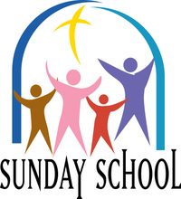
SUNDAY SCHOOL
This Photo by Unknown Author is licensed under CC BY-NC-ND
Sunday School for 3 through 13 year olds EVERY 1ST and 3RD SUNDAY at 9:30 am in the Grace Room. December dates are Sundays the 3th and 17th. The children will also have a chance to participate in worship on December 10th.

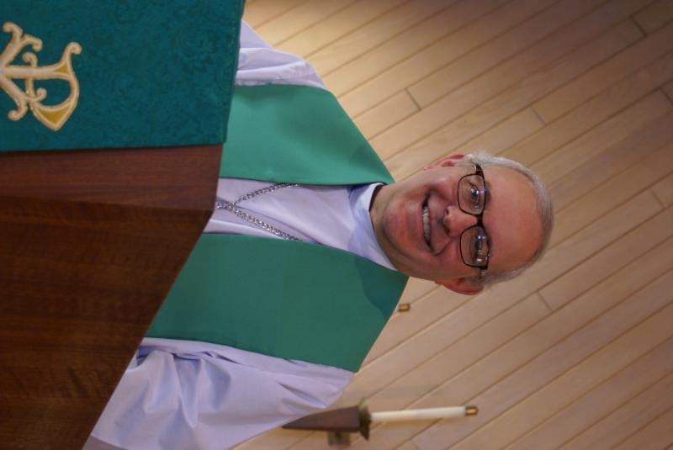
PASTOR’S MESSAGE DECEMBER 2023

I am writing this letter not long after helping to take the dirty dishes off the Thanksgiving dinner table. And you know what that means. It’s a race to Christmas: Black Friday sales, discounts, deals, deals, deals! A few years back a famous radio evangelist bemoaned the fact that Madison Ave had co-opted Christmas, changed its name to a more generic “Holidays” so as not to offend non-Christians, and turned it into a spending binge, all for profit. I took the opposite view. “Thank God the world has moved on, now leave our precious Christmas alone so we can worship appropriately and celebrate it for its true meaning.”
Since year-end is a great time to evaluate the past and plan for the new, I encourage you to rekindle or start a tradition as you celebrate Christmas with the family. After dinner, but before the kids rip into those alluring presents, have everyone gather around and ask the patriarch or matriarch of the family to read aloud Luke chapter 2: 1-40. You can expect some pushback from those who are not religious, but I think it’s a great opportunity to put Christ back into Christmas, and possibly even get some discussions going as to why we believe what we believe. I wish all of you a blessed Christmas this year.
Pastor David
Pastor’s Hours at church Tuesdays and Thursdays from 6 pm – 9 pm
Saturdays from 9 – noon Sundays from 8:30 am for 3-4 hours


MANY THANKS AND PRAYERS TO THOSE WHO HAVE RECENTLY DONATED THEIR TIME AND TALENTS, including, but not limited to:

- George and Gloria Theros for donations of tech supplies and subscriptions
- All those who pick up members who need rides to church
- All those who participated in and attended the Community Thanksgiving Service
- Anonymous donor of $1300 to cover cost of a new boiler burner
- Tom and Missy Barton for completion of fall fertilizer for the church property
- Kathy Hooey for retrieving church phone messages twice every day

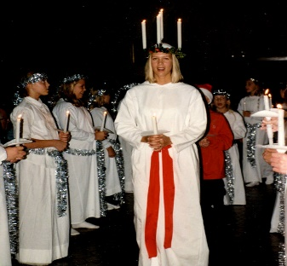
THE STORY OF ST. LUCIA
.
Santa Lucia holds an exceptional place in the hearts of the people of Sweden. She represents charity and love for all men, along with beautiful and shining light during a very long, cold dark winter. During the darkest time of the year, Lucia comes as a symbol of light and hope. Today more than ever, the world needs that message of light and hope.

Santa Lucia appears only once each year, on December 13th, to usher in the Christmas season. The Legend of Lucia goes back to the year 304 AD in Syracuse, Italy. There was the beautiful Lucia, a highborn maiden who lived with her parents, and it is also in that city that Lucia suffered a martyr’s death for becoming a Christian.

In the early days of Christian persecution, she was a courageous woman who brought food to her fellow Christians, who were hiding in the catacombs from the pagan persecutors. Lucia put the candles in her hair to light her way so she could carry her offerings with both hands. Lucia administered to the poor, bringing them food and also hope.

The legend tells us the maiden Lucia became a saint. Among the Scandinavian countries, Sweden is perhaps the country where the Lucia celebration has its deepest roots. Tales of Lucia’s courage were carried to the Northern Scandinavian countries by missionaries.

OCTOBER VISION TEAM REPORT
The Vision Team met on November 14th
- Approved minutes and treasurer’s report from October
- Began review of copier and comcast contracts
- Thanks to Erin Peters, the proposed required changes to our constitution have been highlighted in preparation for distributing to the congregation 30 days prior to our annual meeting when they will be voted on
- The parsonage will not be used for fire personnel training
- Reminder that pledges are due to the church office by December 15th
- We have once again contracted with Tom and Missy Barton to do our snow plowing this winter
- Received two asbestos abatement estimates for the parsonage – both above $3000; agreed that we cannot afford to do this at this time
- New burner for the boiler estimate approved for $1300; this is a must do
- Approved having the lawnmower sent for a full check-up in January; minimum price unless new parts are needed; they will pick up and return no charge
Blessings, Marty Bradley, President

FINANCIAL MATTERS DECEMBER 2023

- 2023 is coming to a close and now is a wonderful time to reflect and review your 2023 donations in support of Grace. Do you need to catch up for the year? Would you like to make a special year-end gift for our ministry? Please note, December 27 is the last date we are able to accept donations in the church office, for the 2023 calendar year.
- Our gratitude and thanks to all for your consideration of your time, talents and tithes in our Stewardship program – The Season of Giving – Prepare the Way of the Lord. We ask that your commitment card be turned in during the service on Dec. 10th, or mailed to the church office by Dec. 15th. The Vision Team will be working on the 2024 budget throughout December and January, in preparation for the Annual Meeting on January 28 **(pls mark this date on your calendars as well)
- Reminder – RE: Building Maintenance Fund: If you wish to donate to this specific fund, please notate “Building Maintenance Fund” on your donation to ensure it will be designated accordingly. We received an anonymous and gracious donation of $1,300 for the burner replacement on our boiler system. Blessings Abound!

Brief recap of October financials:
2023 2022
Oct 2023 Year-to-Date Year-to-Date

INCOME $ 20,524** $ 148,658 $ 140,578
EXPENSES $ 13,831 $ 148,383 $ 165,481
NET +/- $ 6,693 $ 275 $ - 24,903

**Income includes:
Oktoberfest - $555 to Grace (+ $555 to Hesed House), Rummage Sale - $5,953

Your continued donations are a blessing to Grace and allow a variety of ministries to continue at Grace and help serve in our community. Blessings to you all as we continue our mission and ministry, with goals and challenges for 2024.
In Peace, Tricia Painter

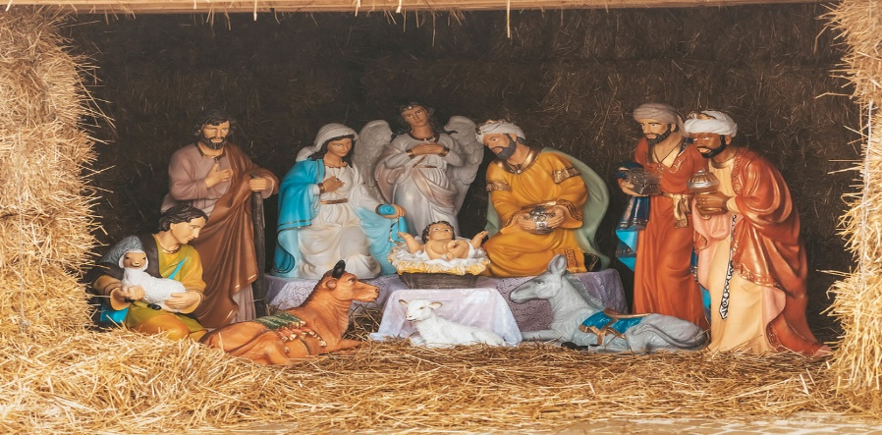
This Photo by Unknown Author is licensed under CC BY
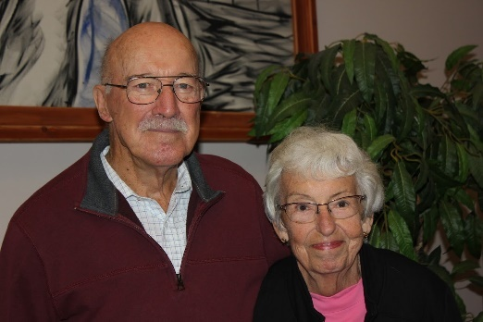 GETTING TO KNOW YOU

Dallas and Barbara Peters were married at a very young age and became members of Grace in the early 60’s. In 1957 they bought 5 acres on Rt. 47 north of Elburn as an investment. Having the desire to own their own home, they had looked around the Fox Valley. In the end, they decided to build on their acreage in Elburn in 1961. No garage, no driveway, no well, no electric…..all of these things being unaccounted for requirements of living 900 feet off of the highway. As a result, very little furniture….but their young children had 5 acres to explore. Have you ever push mowed 5 acres? Dallas did for quite a while. Over time Dallas planted pines and fruit trees, with the idea of becoming a sales area for Christmas trees and apples.
Over a period of many years at Grace, Barbara served in the Choir and as Church Treasurer. Dallas served many years as Church Sexton.

When their youngest child (David) was 12, he expressed an interest in participating in a Bike Hike with Pastor Walker and other youth (mostly older). Dallas & Barbara thought he was too young, so Dallas and another father decided to `ride along’. Dallas caught the `bug’ and participated in many subsequent bike hikes for several years – enjoying it as much as the kids.

All of their children enjoyed participation in the many activities provided for youth at Grace. They also developed life-long friendships, which they enjoy to this day. As their children grew older, each and every one of them was married at Grace. Grace has been a positive influence in their life and the lives of their children.
Barbara enjoys playing Mahjong. Dallas enjoys golf and works at a local golf course a couple of days a week. They both enjoy visiting their children (Idaho, Wisconsin and soon….Georgia) and wintering in Florida.

 ROAD RUNNERS TRIP 2024
The Grace Roadrunners decided at their October potluck to travel to the Smoky Mountains/Gatlinburg, TN area in 2024. They will be leaving Grace on Monday, September 16^{thand} return on the 20th or 21st, 2024. The planning committee will begin meeting the first Tuesday of the month starting January 2024.

REBECCA CIRCLE
Advent and Christmas Greetings from the Rebecca Circle at Grace!
- On Dec. 5th, 2023, we will have our annual Christmas luncheon and will post pictures in the Jan. newsletter.
- For fundraising, we are still selling Frontier Soup Mixes any chance we get, led by Suzanne Girsch, so please watch for them.
- We are again supplying Poinsettia plants for purchase to decorate our chancel AND your home. Plants are $11 and will be in church on Dec. 17th. Order sheets are in the pews. The last day to order is Sun. Dec. 10th.
- Our previous fundraiser for the ELCA was called God’s Global Barnyard and over the last few years we have raised quite a lot of money for our synod’s work. They have changed the name of this project to God’s Good Gifts because now you can also purchase many things other than animals. Stop by the God’s Good Gifts Christmas Tree in the Gathering Room and look through the catalog. Then fill out a donation form and enclose that, along with your donation, in the available envelopes.
- And please, help us to continue our Shepherding project by letting us know of the needs of our congregation. For prayer, for visits, for meals or errands. You can call Jan Docherty at 815-901-0910 or Kathy Hooey at 630-341-2293.
- We have had a busy year and we are thinking and planning for next year. As usual, we take a meeting break in the months of Jan. and Feb. but will resume our monthly (3rd Tues. of the month) meetings on March 19th ,2024. We would love to see you then!

UPCOMING SPECIAL DATES
- December 2nd – Swedish Christmas at St. Lucia Festival, Bethany Lutheran Church in Batavia at 3pm. Reservations required, 630-414-9700. $15, adults, children 6-12 $8. Swedish American Children’s Choir and the Swedish Folk Ensemble performing.
- December 5th – Rebecca Circle Luncheon at Sorrentos in Maple Park at noon.
- December 10th, Pledge Card Sunday (cards must be in by the 15th)
- December 16th - Christmas Cookie/Baked Goods Bazaar at Grace – 9 am – 1 pm. See below
- GRACE LUTHERAN ANNUAL MEETING, Sunday, January 28th immediately following worship. A quorum is needed to accept ELCA required changes to our constitution and to elect new Vision Team and Committee members!

CHRISTMAS COOKIE / BAKED GOODS BAZAAR

Grace's Christmas Cookie/Baked Goods/Bazaar will be held on Saturday, Dec. 16 from 9 am – 1 pm. Please sign up to provide baked goods and/or help with the Bazaar. Baked goods may be dropped off on Friday December 15 at church between 1-3 am, 5 – 7 pm or Saturday December 16 by 8 am. Flour, sugar, eggs, butter, etc. are available in the church kitchen for your use.

If you would like to have a vendor table ($20 donation), please contact Candice Verner at 630-362-4659 or Tricia Painter at 708-624-0400 (cell # - please leave a message or text) to reserve your table. Vendors already include: Frontier Soup, Silpada/Grace & Hears Jewelry, Chair Massage, Young Living, handmade cards, ornaments and holiday décor.

**We already have the holiday decor set up after the rummage sale - we are not seeking anymore holiday donations, nor cookie tins - thank you for these previously donated items.

MISCELLANEOUS
Reminder: please save shoe boxes with lids and wrapping paper and bring them to church for Operation Christmas Shoebox. Volunteers will be needed to wrap the boxes and lids. See Cathy Whiteside for more information.

NOISY OFFERING
Every Sunday we collect a “noisy offering” when you wish to empty your change purse or pockets. We are currently collecting for miscellaneous maintenance items including additional window work. Thank you.

COVID 19, FLU AND RSV SAFETY PROTOCOLS
We follow the recommendations of the CDC, ELCA and IL Department of Health.
If you wish to mask and social distance, please do so. Please do not come to church if
have symptoms of illness. If you do not feel comfortable worshipping with others, we invite
you to join us for worship via our website.
CONTACTS:
For emergencies please contact Marty Bradley, President, at 640-777-1074 or leave a message at the church office at 630-365-6751.
For prayer requests or other needs please call Kathy Hooey at 630-341-2293 or leave a message at the church office at 630-365-6751. Messages are checked daily at noon & 5 pm.

Information for the January newsletter will be due by December 26th – please send it to Marty Bradley at martybradley@mchsi.com. Thank you

