 | DECEMBER 2024
 | AMAZING GRACE  CONNECTIONS  Faith > Family > Community

Grace Lutheran Church of Lily Lake
5N600 Hanson Rd, St. Charles, IL 60175
Pastor David Mercurio

Worship every Sunday
At 9:30 am with Communion
.
- Dec 1 – Worship and Sunday School (no coffee hour)
- Dec 8 – Worship & Coffee Hour with St. Lucia
- Dec 15 – Worship with special music by Sunday School & PDO
- Dec 22 – Worship
- Dec 24 – Christmas Eve Service at 7 pm
- Dec 29 – Worship

The new church year begins on December 1st with the four week Advent season followed by the Epiphany season.

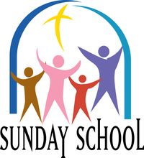
SUNDAY SCHOOL – WINTER 2024

Sunday School for 3 year olds – 13 year olds will meet every 1st and 3rd Sunday. The children will be singing at worship on December 15^{th.} Sunday School dates for January 2025 are 1/5 and 1/19; for February are 2/2 and 2/16. More to come…!

EVENTS NOT TO BE MISSED
(see Sunday worship information above)

- December 1st – The Advent Season begins the new church year. CHARITABLE OPPORTUNITIES:
- Giving Tree tags: help support needy children with gifts for the holiday season. Tags available in the gathering room. All gifts will be due back to church by Sunday, December 15th!
Also remember to bring an extra hat or gloves to add to the tree.
- ELCA God Good Gifts (aka Global Barnyard) to help people around the globe; review catalog and donate thru December 31st
- Cathy Whiteside continues to collect Winter Coats, Sweaters and clothing for the homeless. Can be left in the far Sunday School room in the church basement. All ages.
- Tuesday, December 3rd at noon – REBECCA CIRCLE CHRISTMAS LUNCH at Sorrentos in Maple Park on Highway 64. Reservations closed Nov. 22.
- December 7th at 2 pm – St Lucia Festival at Bethany Lutheran Church in Batavia. For more information and to make reservations, call 630-414-9700.
- December 14th – HOLIDAY BAKE SALE/BAZAAR from 9am – 1pm in Fellowship Hall at Grace. Bakers, pick up supplies in the church kitchen beginning Saturday, November 30th. Drop off baked items Friday, December 13th 11am – 1:30pm or 5 - 8pm.
- Sunday, December 15 – SPECIAL MUSIC by our Sunday School children and Parents Day Out friends
- December 22 – CHRISTMAS EVE WORSHIP SERVICE at Grace at 7 pm
- December 31st – NEW YEAR’S PARTY FOR ALL AGES, 10:30am – 1 pm. Food, games, songs….dress up if you wish. Reservations needed. See flyer below.
- LINE DANCING continues on Wednesdays through December 15th from 6-7 pm in Fellowship Hall. It will then start up again on January 8, 2025.
- Our ANNUAL MEETING will be held on Sunday, February 2nd, after the worship service. We will gather downstairs in Fellowship hall for refreshments and conduct the meeting. Please mark your calendars. Please note: ** We are also seeking members to step up for nominations on the Vision Team (ideally 2 ppl), Audit Team (1 person), Nominating Team (ideally 2-3 ppl). Please see Lee Strom, Cara Turner to discuss or any Vision Team member – Dallas Peters, Nancy Schnaitman, Kurt Redemann, Cathy Lindquist or Tricia Painter.

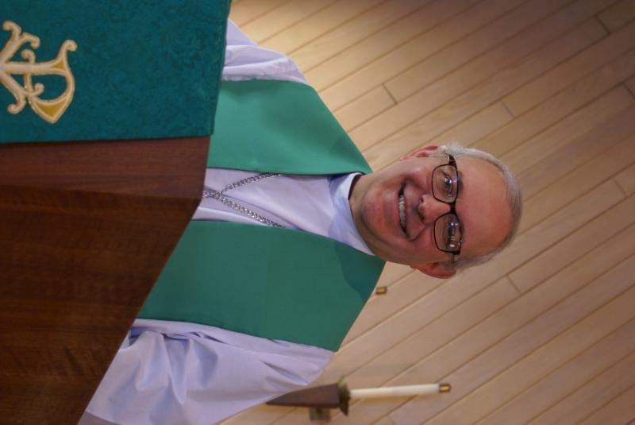
From PASTOR DAVID, December 2024

We are now entering the new liturgical year: Advent, Christmas, Epiphany, Ash Wednesday, Lent, Easter. What an exciting time to be a Christian! While the world still searches for truth, we celebrate that THE truth has come down to be among us, Immanuel, God with us. And while there will be many opportunities to spend time with friends and family, which is always a good thing, don’t forget that there are many opportunities to spend time with our church family too, including the annual Rebecca Circle Luncheon on December 3, our annual cookie sale on December 14, and our Christmas Eve service at 7:00 PM.
And as you start to shop for Christmas presents, don’t forget that we have been given the greatest gift of all, forgiveness and reconciliation with our Father through the blood of the lamb. You have received him and worship him, Jesus Christ our Lord, as we wait in eager expectation to be united with the Trinity through eternity.
May God bless you and your family this Christmas season.
Blessings to you,
David

Pastor’s Hours: Tuesdays and Thursdays from 6 pm – 9 pm, and Sundays from 8:30 am for 3-4 hours and by appointment when requested.

We pray for the family of Shirley Turner who passed away on Friday, November 1st surrounded by her family. The funeral was held at Grace on Sunday, November 10th . She was an inspirational follower of Christ and a blessing to us all. Her obituary is available on Conley Funeral Home’s website.


STEWARDSHIP 2024
A Special Message from Pastor David
I was thinking the other day about all the things that Grace does for its neighbors, including (in no particular order): Oktoberfest, potluck dinners, Boy Scouts, Girl Scouts, Habitat for Humanity, Prayer Shawls, Ash Wednesday at the train station, Elburn Food Pantry, Northern Illinois Food Bank, Feed My Starving Children, Parents Day Out, the semi-annual rummage sale, Line Dancing, Life Line screening, Giving Tree, ELCA Good Gifts, Lazarus House Lunches, to name a few, but not all.
In the universe of churches, you are a David among Goliaths, and given our relatively small size, you do more for the community, pound-for-pound, than any other church I have ever seen. And this love and support for your neighbors is no random anomaly. You have served this community for generations. How? Only through your sacrificial and loving donations of money, time, talents, blood, sweat, and tears. And most of what you do is hidden from the limelight, behind the curtain if you will, because you ask for no recognition for yourselves but give all glory and honor to our Father in heaven and His son, our savior.
Normally around this time, we start our annual stewardship campaign including a request that you fill out a pledge card indicating your planned giving for the following year. We’re going to skip the cards this year. I want no one to feel burdened by a card, but rather that you give freely as the Spirit moves you. As you give by faith, the Vision Team will run the church by faith. I am convinced that God will bless all of us abundantly next year.
In my three years here, you have never failed to inspire me with your maturity and love for one another. I am so excited to see what next year brings.
Blessings to you, Pastor David


SPECIAL THANKS to all who have shared their time and talents with Grace , including but not limited to:
- All those who have donated old pill bottles. We are no longer collecting them as they cannot be shipped overseas any longer.
- Worship Committee: George Theros, Pastor David, Helen Gruber, Twyla Strom, Pat Penfold, Kathy Hooey, Tricia Painter and Marty Bradley and all who regularly assist with ushering, power points, cleaning of pews, lectoring, etc.
- Received a than you note from David and Carol Langseth for all the assistance we give to Anna-Kari’s ministries. Also, a congratulations on our 130th anniversary and wishes for a Christ centered Advent, Christmas and New Year’s. It included a suggestion that we give thanks for something using all the letters of the word THANKSGIVING
FINANCIAL MATTERS - DECEMBER 2024

Winding down to the last month of 2024. All of your donations to Grace, allow a variety of ministries to continue to serve our community for 130 years!

- We have made a principal payment to our mortgage of $22,328, from our 130th year celebration ($15,519), autumn rummage sale ($5,400) and further donations received. ** Please note, we will continue to accept “mortgage principal donations” through the end of the year – please indicate “Mortgage” on your check.
- Please contact me (Tricia) or Dallas Peters to advise (well, remind me) IF you are a current American Eagle Bank customer. We know several people have opened accounts now in 2024, and the mortgage committee is needing to get a count again. Thank you!
- The end of the year is the perfect time for a charitable gift that makes an impact and reduces your taxes. Whether through cash gifts, retirement securities, IRA contributions – your gift supports Grace of Lily Lake and its ministries.
- Please note - Dec. 29th is the last day for us to receive your donations for 2024.

Brief recap of October financials:
2024 2023
Oct 2024 Year-to-Date Year-to-Date

INCOME $ 32,662** $ 174,679 $ 148,658
EXPENSES $ 34,244** $ 167,349 $ 148,383
NET +/- $ -1,582 $ 7,330 $ 275

**Income incl 130th anniversary + rummage sale; Expenses incl $19,798 for payment for new boiler

Pray for continued blessings upon Grace as we continue our mission and ministry, with new goals for 2025. If you have some expertise in accounting, we can use your help on the Finance Team – please see me. ~ In Peace ~ Tricia Painter, Treasurer


Parents day out
This Photo by Unknown Author is licensed under CC BY-ND
A new ministry at grace

Our new Parents Day Out program, under the direction of Janice Muncie will began on Monday September 9th. The program for children 3 – 5 years (potty trained only) will be open on Mondays and Wednesdays in Fellowship Hall from 9:15 am – 1:15 pm. Two teachers will be on site each day. The program will be using Christian materials. Costs and registration are now open. If you wish to register your child or volunteer to be a substitute teacher, please contact Janice at Janice.muncie@gmail.com.

VISION TEAM REPORT
Meeting was held on November 12, 2024
- Minutes and treasurer’s reports from October were approved
- Parents Day Out now has 8 children, 2 of which are asking for Mondays as well as Wednesdays starting in January. We are growing!
- Boiler install is complete with a pot feeder still to be installed.
- Mortgage Committee to meet with the bank president regarding interest rates.
- Next meeting is December 10th.


REBECCA CIRCLE

CHRISTMAS BLESSINGS TO ALL FROM THE REBECCA CIRCLE AT GRACE!

The Rebecca Circle Christmas Luncheon is to be held at noon on December 3rd at Sorrento’s Ranch in Maple Park. Reservations were due by November 22nd. It should be a lovely afternoon and we will post a picture in the January 2025 newsletter.

Each month, as a roll call item, our Circle members bring food items for the Elburn Food Pantry. As we do not have meetings through the winter months (December, January and February) we have decided that we will bring our food items to church monthly on the Sunday that our congregation has a coffee hour. So, for December, that would be the 8th, when we celebrate St. Lucia. We will have a basket in the Gathering Room and one in the Fellowship Hall. We encourage you to join with us in this effort to engage in ministry and action in our community. Especially needed are large cans of soup, toilet paper, ketchup and mustard, low sugar cereals, syrup and pancake mix, canned spaghetti (various kinds), and spaghetti sauce.

We will once again be selling poinsettia plants to decorate our altar and then your home!
They will be placed around the altar for the 12/15 and 12/22 morning worship services and then available for take home. Our price from Heinz Brothers in St. Charles is again $11.00 for a 6” pot. The order forms are in the pews and on the Welcome Table in the Gathering Room and are due by December 8th. Please include your payment with your order and make any checks out to Grace Lutheran Church. Thanks for participating in this program.

HOLIDAY BAKE SALE

Candice Hopkins is coordinating the bake sale again this year on Dec. 14th. We are looking for BAKERS ! Candice has secured Thrivent Action Team funds and will be able to purchase some baking ingredients for you to use again. To help in your baking tasks, flour, sugar, brown sugar, and misc. will be available for you to pick up on Saturday, Nov. 30th 10am to noon and available through the following week, in the kitchen/lower level. Cookies can be put in one large container. Please price and package any other items (breads, pretzels, pie, cake or ?)
Please deliver baked items to church on Friday, December 13th from 11am – 1:30pm or 5pm – 8pm.
Please see the sign up sheet in the gathering room. Candice’s # is 630-352-4659.
Tricia Painter is coordinating any vendors who would like to have a table for a $20 donation – please contact her to reserve your spot. Tricia’s # is 708-624-0400.




MISCELLANOUS INFORMATION
- If you can knit or crochet, we need you to help make more prayer shawls as we are running low (a wonderful problem to have). We have the yarn so please contact Helen Gruber if you can help. If you know of someone who could benefit from having a PRAYER SHAWL, please let Twyla Strom know.
- The Finance Team is looking for volunteers to sign up as counters (counting our weekly offerings after worship) to have a rotating list of counters Please see Linda Smykowski or Tricia Painter for further details.
- The Worship Team is seeking additional volunteers to sign up to help run our power point during worship which brings the bulletin onto the TV screens in the sanctuary. Especially needed on the 1st and 3rd Sundays of the month. Please see Tricia Painter. If interested.
- Our new website sign on is graceoflilylake.org (not .com)


ROAD RUNNERS TRIP 2024
AND 2025 TRIP

Twenty-two Roadrunners gathered on Sunday, October 20th to share memories of this year’s trip to Gatlinburg, TN and Asheville, NC and to vote on where to go next year. It was narrowed down to Frankenmuth/Detroit, MI and Dubuque/Cedar Rapids, IA to mid IA. Iowa received the most votes! So, mark your calendar for the 2025 Roadrunner Trip to Iowa on September 22-27.

SPECIAL MINISTRY INFORMATION:
Operation Christmas Child –Shoe Box Ministry: Need shoe boxes, toys, and more ideas can be found at https://www.samaritanspurse.org/what-we-do/operation-christmas-child/ Cathy Whiteside (630/605-1096) contact person@ Grace. Thank you to all helping with this ministry.
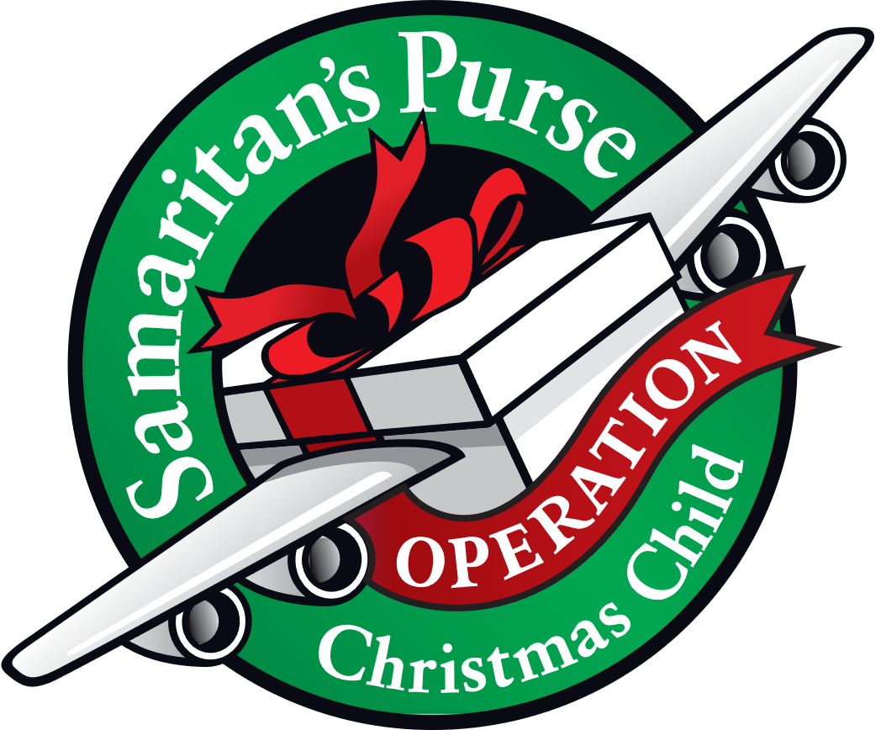
NEEDED: EMPTY SHOE BOXES
For:“Operation Christmas Child” Mission.
Please place shoe box donations in front entrance to the church. For more information:https://www.samaritanspurse.org/operation-christmas-child/mission- and-history
Bridge to Life Group’s Jesus Closet (homeless in Elgin): Items needed are backpacks, blankets, gym shoes, t-shirts, jeans, coats and socks. Please mark donated items to the attention of Cathy Whiteside (630/605-1096). Thank you for all the donations.
Clothing and miscellaneous items for the migrants in Chicago are being collected by Cathy Whiteside (630/605-1096) to be given to Pastor Anna-Kari Johnson for distribution in Chicago. Thank you to all who have donated in the past. Left overs from our Spring Rummage Sale were already passed on to this ministry in June.
We are no longer collecting old pill bottles as they cannot be shipped overseas any longer. Thank you!

NOISY OFFERING
Every Sunday we collect a “noisy offering” when you wish to empty your change purse or pockets. We are currently collecting for maintenance items, including our new boiler. Thank you.

COVID 19, FLU AND RSV SAFETY PROTOCOLS
We follow the recommendations of the CDC, ELCA and IL Department of Health.
If you wish to mask and social distance, please do so. Please do not come to church if you have symptoms of illness. If you do not feel comfortable worshipping with others, we invite you to join us for worship via our website, graceoflilylake.org
CONTACTS:
For emergencies, please contact the church office at 630-365-6751.
For prayer requests or other needs please call Kathy Hooey at 630-341-2293 or leave a message at the church office at 630-365-6751. Messages are checked daily at noon & 5 pm.

Information for the January newsletter will be due by December 23rd – please send items to Marty Bradley at martybradley@mchsi.com. Thank you

