February 2023, VOL. 38
 | AMAZING  GRACE  CONNECTIONS
Faith > Family > Community
Grace Lutheran Church of Lily Lake
5N600 Hanson Rd, St. Charles, IL 60175
Pastor David Mercurio

Worship every Sunday at 9 am
with Communion
Sunday, February 5, Worship, Coffee Hour & Sunday School
Sunday, February 12, Worship
Sunday, February 19, Worship & Sunday School
Vicar Sharai Jacob from Geneva Lutheran will be preaching
Weds., February 22 ASH WEDNESDAY Worship at 7 pm
Sunday, February 26, Worship


.

WELCOME TO OUR NEWEST MEMBERS

- Kelly and Piotr Gwidzala, children: James, Nathan and Claire
- Janice Muncie
- Marla and Josh Roach, children: Bethany, Abby

RETURNING MEMBERS:
- Debra and Dallas Peters


This Photo by Unknown Author is licensed under CC BY

Ash Wednesday occurs 6 ½ weeks before Easter and is a solemn reminder of human mortality and the need for reconciliation with God and marks the beginning of the Lenten Season. It is a time for silence, solitude and scripture. A time for quiet prayer with God and listening to Him. In many places, including Grace, a cross made of ashes is placed on the forehead of believers. The ashes are made from burning the palms we use on Palm Sunday. “Remember that you are dust and to dust you shall return,” is said as the ashes are placed on the forehead.

As many other traditions of Christianity, the origins of Ash Wednesday can be traced back to ancient Rome. There, sinners and penitents dressed in sackcloth were sprinkled with ashes to start their period of public penance on the first day of Lent. We show repentance and mourning for our sins because we believe that Christ died for us.


This Photo by Unknown Author is licensed under CC BY-NC-ND

ASHES AT THE ELBURN METRA STATION

We will again be providing ashes on foreheads for anyone who wishes them at the Elburn Metra Station
on Wednesday, February 22 from 6:30 am to 7:30 or 8 am.
If you wish to join us in this outreach ministry, please sign up in the gathering room.

“Remember you are dust, and to dust you shall return.”



THE SEASON OF LENT

The Season of Lent begins on Ash Wednesday, six and a half weeks before Easter and provides a 40 day period of repentance, abstinence and fasting (Sundays are excluded) in imitation of Jesus Christ’s fasting in the wilderness before he began his public ministry. During these 40 days, we remember the events leading up to and including the death of Jesus Christ.
During Lent, we focus more on God and our prayers focus on our need for God’s forgiveness. It is about turning away from our sins and receiving God’s mercy and love.

SPECIAL MIDWEEK LENTEN BIBLE STUDIES

Saturdays, February 25 through March 25
9:00 am coffee; 9:30 am Bible Study
&
Wednesdays, March 1 through March 29
Noon soup luncheon; 12:30 pm Bible Study

You are welcome to attend any or all of these. Please sign up if you can
bring coffee treats or soup on any of these days.

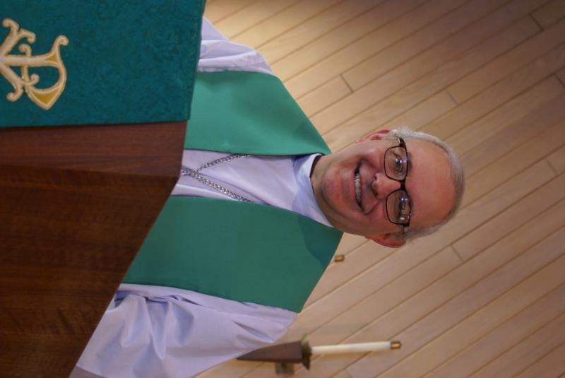
PASTOR’S MESSAGE

From the desk of Pastor David, February, 2023
The book of Ecclesiastes (1:9) tells us that there is nothing new under the sun. Yet Jesus tells us in Revelation (21:5) that he is making everything new. What a beautiful paradox to explain that God has ordained all things yet allows us free will and a chance to start all over again, to reset our path back toward Him. I see this year as such a time for us. The year 2022 was a rebuilding year as we got our “sea legs” back.
We are all on a spiritual journey, but it’s time to push off from the safety of the harbor where all things are calm and familiar, to move into deep waters, for there is where our treasure lies. It is time for us to return to our first love, to be outward focused to seek the lost, and to share the Good News of which we are the good stewards. The Good News was not given to us so we could hide it away in a drawer hidden from view, but to be shared with all. The world needs truth and goodness and order and virtue and direction. The world needs a savior, the true Savior. It always has. Let it be said that in 2023 we were among those with the “beautiful feet carrying the Good News” (Romans 10: 15). Blessings to you all
Blessings to you all,
Pastor David
Pastor’s Hours at church
Tuesdays and Thursdays from 6 pm – 9 pm
Saturdays from 9 – noon Sundays from 8:30 am for 3-4 hours

COVID-19, FLU and RSV Safety Protocols

We follow the recommendations of the CDC, ELCA and the IL Department of Health. If you wish to mask and social distance please do so. Please do not come to church if you have symptoms of illness. If you do not feel comfortable worshipping with others, we invite you to join us virtually for worship via our website.

JANUARY VISION TEAM REPORT
The Vision Team met on January 10th :

- Approved minutes and the December financial report
- Approved compensation for Vicar Sharai Jacob of Geneva Lutheran of $100 each of two Sundays for preaching at Grace
- Prepared for the Annual Meeting: Decision to meet in the Fellowship Hall with coffee and treats and have zoom capabilities available for members who might not be able to come in person
- Safety Deposit box will be closed as it has not been used for many years
- New members to be received on either January 15th or 22nd
- Reviewed two estimates for replacing light bulbs in the hanging fixtures and spotlights in the sanctuary and some parking lot bulbs; approved using Dave Aldridge’s estimate
- Noted that the Village of Lily Lake will be renting the Fellowship Hall on January 31st for their open meeting about the gas station onRte 64 and 47
- AND most importantly spent most of our time reviewing, discussing and approving a proposed budget for 2023 base on pledges received, current needs and increases in such things as utilities

The Vision Team meets on the second Tuesday of each month. If you have items you feel should be discussed by the team, please send them to Marty by the first Tuesday of the month.

Marty Bradley, President


MANY THANKS AND PRAYERS TO THOSE WHO HAVE RECENTLY DONATED THEIR TIME AND TALENTS, including, but not limited to:

- All who served on teams, committees, ad hoc groups and in individual ways in 2022
- Everyone who wrote a report for the Annual Report and got it in on time!!
- Suzanne Girsch, Kathy Hooey, Twyla Strom, Margaret Swanson and Cathy Whiteside for their work in reviewing our membership roster and planning for contact to people who have not been attending – a big job well done
- All those who are already planning future events this winter and spring
- Nancy Corbige for planning and running and dancing her feet off at the Line Dancing Thursday night events
- Dottie Mantsch for continually stirring our souls with music on Sundays.
CONTACT A VISION TEAM MEMBER IF YOU WISH TO VOLUNTEER

 Happy valentine’s day

FINANCIAL MATTERS – FEBRUARY 2023

- Thank you to all of our members who attended the annual meeting on Sunday, January 29, in person or on-line. Your participation is vital to the ongoing ministries at Grace of Lily Lake, as we embark on a new year.
- You should have received your 2022 year-end giving statement (via email or postal mail). If you have any questions or concerns regarding your statements, please contact Dottie & Paul Mantsch or if you did not receive your Giving Statement, please contact Cara Turner - each of them are on our Finance Team.
- For those members who receive Offering Envelopes, there is an “Initial Offering” envelope to help cover the cost of your envelopes : approx. $11.25 per person/per year.
- Thrivent Members – Please consider donating your Thrivent Choice Dollars to Grace of Lily Lake – deadline for completing this is March 31st.
- You are able to make your offering donations electronically -- the Subsplash Giving Link is: - https://graceoflilylake.com/give. Go to our website: graceoflilylake.com, click on the "Giving" link, "Give" , scroll down on the populated page and it will guide you to make a one time, or a recurring donation. We are truly grateful for your financial support @ Grace of Lily Lake.
- Several of our members have made a donation to Grace via a tax-deferred retirement account -- it is the a very tax-efficient way to be charitable both during your lifetime and through your estate. Unlike a distribution to you or an heir, which would be a taxable event, charitable donations from retirement accounts lay no additional tax burden on you or the charity. Estate gifts from these accounts can go directly to charities through a donor-directed distribution agreement or fund named endowments, i.e. Grace Lutheran Church of Lily Lake. Have you prayerfully considered naming Grace Lutheran Church of Lily Lake in your Trust or Will?

Brief recap of December financials:
2022 2021
Dec 2022 Year-to-Date Year-to-Date

INCOME $ 25,465.95 $178,998.99 $161,128.47
EXPENSES $ 14,010.44 $198,366.13 $175,153.92
NET +/- $ 11,455.51 $ -19,367.14 $ -14,024.80

Praying for meeting goals + challenges, as we move into 2023 ~ Peace, Tricia Painter, Treasurer
JOIN US FOR FELLOWSHIP AND FOOD

This Photo by Unknown Author is licensed under CC BY
BOY SCOUT TROOP 46 & GIRL SCOUT TROOP 946 WILL HOST A
PANCAKE BREAKFAST

SUNDAY, FEBRUARY 12 8 am – 11 am
Fellowship Hall
Free will offering
Getting to know Dallas & Debra Peters

Dallas & Debra Peters were married at Grace on May 6th, 1979 (44 years on May, 23). Dallas had been a life-long member of Grace and was active in the many youth-centered activities that the church was involved in during the 60’s and 70’s. His parents, Dallas & Barbara Peters are still members at Grace.
Dallas & Debra met at Kaneland HS (which they both attended) in March of 1976, Dallas’s senior year. In a rather small school, you’d think you’d get to know everyone, but that really isn’t the case - you know OF someone. From their perspective, had two more months elapsed without that chance meeting, they would have missed the opportunity to meet and know the love of their life. God works in mysterious ways.
In 1992, they moved to Crystal Lake, IL and transferred membership to Bethany Lutheran Church where Dallas served as the youth leader for 4 (very active) years.
Dallas & Debra have two grown children (Erin, born 1987, Crystal Lake, IL & Nathan, born 1990, Whitmore Lake, MI). Erin has a teaching degree from UWW (UWiscWhitewater) and is currently working in the logistics field. Nathan has his PhD in Aerospace Engineering (Syracuse) and is currently working for Mahle Power Train in MI. They have two grandchildren, Samuel (4) and Emily (2), with another on the way (April).
Dallas joined the insurance firm of Critchell-Miller in 1985. Its founding dated back to 1868 and the firm was heavily involved in paying claims for the Great Chicago Fire of 1871. After serving as its’ President for 18 years, he merged the company with two others to create the Arachas Group in 2017, where he is currently Senior Partner (by age ). Dallas is also involved in property development in Kentucky with two life-long friends he originally met through the youth group at Grace in the 70’s. Although he looks forward to retirement, his Partners have other ideas…..
Debra worked outside of the home (also in insurance) until Erin was born in 1987, after which time she committed herself full time to her children. She also worked as an in-home caregiver for the elderly for several years, post the children moving out of the house.
Together they enjoy travel, boating, golf, biking, hiking and of course – their grandchildren.
Coming back to Grace has been like coming home. Dallas says “The church’s name is Grace. But, to me, it’s where I found out exactly what `Grace’ is – by definition and example. The Pastor here at the time (whom I still respect and love) lived it for me. As did the countless adults at this church whom I and my friends (as youth) `tested’ at the time. My time at Grace (and the lessons learned here) made me a better person, man, husband, and father. So, in a sense, Grace has always been a part of my life. It’s nice to be home again.”

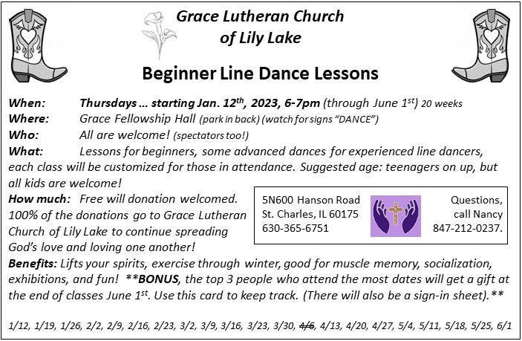



Please mark your calendars, tell others, and plan to attend this event
for this very worthy cause:
A Valentine’s Line Dance Fundraiser for
Habitat for Humanity.
Hosted by the Pottawotomie Partnership, on
Sat. 2/11/23, 5-9pm,
United Methodist Church of Geneva, 211 Hamilton St., Geneva, Fellowship Hall
Tickets: $10/person, $20/family
- Line Dance instruction and open dancing throughout the night
- Silent Auction
- Refreshments
*Accepting donations for silent auction items up until Jan.17th.
*Requesting dancers: beginners who want to learn, experienced dancers, and those that love to watch and enjoy the show!
For information about our local Habitat for Humanity or to volunteer to help, please contact our representative, Nancy Corbige, at 847-212-0237 or NCorbige@gmail.com

2023 FEED THE NEED / FEED MY STARVING CHILDREN
Saturday & Sunday, February 18-19 2023
Grace Lutheran (GLC) is again partnering with Dennis Finney from Bethlehem Lutheran Church (BLC) for this event.

A signup sheet is available in the Narthex as we’ve had in previous years.
There is also a signup sheet for taking M&M tubes, take 1 or more, enjoy the candy then fill the tubes with Quarters or just cash and return to George Theros before Saturday Feb 18th. Proceeds to Feed My Starving Children.

The goal this year is to once again pack well over 1,000,000 meals to feed the hungry children/people. 5,000 plus volunteers are needed, as well as voluntary financial donations, to fund these meals which are 25 cents each.
The funding total goal for FTN 2023 is $240,000 to pay for these meals and associated costs that go with that.

As I am sure you can imagine, an event of this size and scope takes many people working together collaboratively, to make it a success. It requires prayer, trust, and faith to accomplish these goals of feeding kids who are in desperate need.

The Feed the Need, FTN, is held at North Central College in Naperville. We know that all of you are well aware of the far-reaching impact FTN/ FMSC has had on children and people in need. BLC’s and GLC’s past support and involvement with FTN has been wonderful and impactful.
WE NEED YOUR HELP and support for these goals to become a reality.

IMPORTANT DETAILS ABOUT FEED THE NEED 2023:
MOBILEPACK DATES: Saturday & Sunday, February 18-19 2023
LOCATION: North Central College ResRec Center, 440 S Brainard St, Naperville, IL 60540
PACKING SESSIONS:
* SATURDAY: 3:30-5:30PM or 7:00-9:00PM
* SUNDAY: 9:00AM-11:00PM or 12:30-2:30PM or 4:00-6:00 PM.
The sooner we know your shift preferences, the better, as we can then try to reserve a certain number of spots for BLC and GLC, prior to them filling up.

With everyone working together, we can all contribute to helping to reduce and eradicate World Hunger at some point in the future. WE NEED YOUR HELP and support for these goals to become a reality. (cont.)
After all is said and done - The bottom line here is:
Helping to feed the hungry/starving kids/people.
Saving their lives.
It is estimated that 6,200 children in the world die each day, due to starvation/malnutrition.
Annually this would equate to 2,263,000 children.
This is a sobering statistic.
(that's just the ones they know about)
Imagine how many adults there might be?

“A generous person will prosper; whoever refreshes others will be refreshed.”
Proverbs 11:25
Feeding God's Starving Children Hungry in Body and Spirit.
Turn Hunger into Hope with Your Own Two Hands.

GOD’S GLOBAL BARNYARD 2022

During the month of December, 2022, the Rebecca Circle again sponsored the “God’s Global Barnyard” project. For several years, this gifting effort has helped families across the globe climb out of the darkness of poverty. These are gifts that make a difference! This year the funds given reached $4,160.00. WHAT GIFTS OF LOVE! Rebecca Circle wants to express its appreciation for all the families who donated to this project. And they thank those members who prayed and gave their support to the Rebecca Circle.

With this loving and generous giving, we were able to purchase the following:
A family farm, chicks, goats, piglets, a cow, a fish farm, and honeybees. Also, water projects which included irrigation. School fees, school supplies, vaccinations. Add a fruit farm, a community garden including tools. Also, needed soup kitchens. Again, WHAT GIFTS OF LOVE! What a joy this has been. We thank God for giving us this opportunity.
Barnyard supporters (alphabetical order):
Mark, Heidi, and Nathan Anderson
Jan & Jack Docherty In honor of Loved Ones
Suzanne Girsch
Marge Granquist In memory of David Granquist
Paul & Kay Kinsel
David & Carol Langseth In honor of A. Langseth
Vicki Linden In memory of my parents: Harry & Violet Johnson
Cathy Lindquist In honor of Loved Ones
Dottie & Paul Mantsch
Charitable Foundation
Cheryl Nelson
Andra Norwind In memory of Janis Baumanis (Andra’s father)
Tricia Painter
Pat Penfold For Blessings Received
(cont.)
Kurt Redemann

Nancy Schnaitman In memory of James Schnaitman
Linda & Ted Smykowski In memory of John T. Smykowski
Twyla Strom In honor of the bee keepers in our family
Gloria Theros
Shirley Turner
Lori & Bill U’Ren
John Verner
Cathy Whiteside With grateful thanks, THE REBECCA CIRCLE


*Additional DATES TO REMEMBER*
.
Saturday, March 4 (5 to8 pm)
CHILI COOK OFF & Bingo
March 31 at Grace: LifeLine Screening – details to follow
May 19 & 20 (set-up May 18) – Yes, the Spring Rummage Sale


LOOKING FOR A POOL TABLE?

The pool table in our Youth Room is available to you! Requirements include: $50 donation and purchaser must disassemble and transport the table. Please spread the word among your family and friends. We will advertise to the public after February 15th.

CONTACTS:
For emergencies please contact Marty Bradley, President, at 640-777-1074 or leave a message at the church office at 630-365-6751.
For prayer requests or other needs please call Kathy Hooey at 630-341-2293 or leave a message at the church office at 630-365-6751. Messages are checked daily at noon & 5 pm.

ELCA MISSION WEBSITES

LUTHERAN DISASTER RESPONSE:
https://www.elca.org/our-work/relief-and-development/lutheran-disaster-response
ELCA WORLD HUNGER APPEAL:
https://www.elca.org/Our-Work/Relief-and-Development/ELCA-World-Hunger
LUTHERAN WORLD RELIEF:
https://lwr.org/
REFUGEE ONE https://www.refugeeone.org/

Information for the March newsletter will be due by February 25th – please send it to Cathy Whiteside Cathy@imotay.com Thank you!

