 | FEBRUARY 2024
 | AMAZING GRACE  CONNECTIONS  Faith > Family > Community
Grace Lutheran Church of Lily Lake
5N600 Hanson Rd, St. Charles, IL 60175
Pastor David Mercurio

Worship every Sunday
At 9:30 am with Communion
- February 4 – Worship with Sunday School and coffee hour following
- February 11 – Transfiguration of our Lord Worship and
Pancake Breakfast hosted by our scouts,
from 8:30-11:30 am
- February 14 – Ash Wednesday Worship at 7 pm
- February 18 – First Sunday in Lent and Sunday School.
Vicar Aaron Musser, intern from Geneva Lutheran, will be preaching. Pastor will preside.
- February 25 – Second Sunday in Lent Worship

Time after Epiphany  Jan. 7, 2024 through Feb. 13, 2024 | Season of Lent  Feb. 14, 2024 through Mar. 27, 2024
The Three Days  Mar. 28, 2024 through Mar. 30, 2024 | Easter Season  Mar. 31, 2024 through May 22, 2024
Time after Pentecost
May 23, 2024 through Nov. 27, 2024
TRANSFIGURATION OF OUR LORD: Jesus leads just three of His disciples, Peter, James, and John, to a "high mountain." This is where the Transfiguration takes place, in which His appearance is radiantly transformed. A "high mountain" is often a place of divine revelation in Scripture. The transfiguration of Jesus Christ was a powerful demonstration of His divine nature and the manifestation of His glory, which Jesus possessed prior to coming to earth in the human body.
LENT & ASH WEDNESDAY: Lent is a time of preparation for Easter marked by repentance, fasting, reflection, and ultimately celebration. Each year, Ash Wednesday marks the beginning of the 40 days of Lent which represents Christ’s time of temptation in the wilderness. Ash Wednesday focuses the Christian’s heart on repentance and prayer, usually through personal and communal confession. The day is called Ash Wednesday because it is customary to mark the foreheads of the faithful with ashes in the shape of a cross. The ashes are obtained by burning the palms used on the previous Palm Sunday. The ashes serve as a reminder of human mortality and the need for reconciliation with God. The words “Remember that you are dust, and to dust you shall return” are often spoken when the ashes are applied.
LENTEN BIBLE STUDIES
Saturdays at 3 pm: February 17, 24 and March 2, 9, 16
Wednesdays at noon with soup lunch: February 21, 28 and March 6, 13 and 20

Note that the Bible Study on Wednesdays will be a repeat of the study from the previous Saturday.


This Photo by Unknown Author is licensed under CC BY-NC-ND
SUNDAY SCHOOL
Sunday School for 3 through 13 year olds EVERY 1ST and 3RD SUNDAY at 9:30 am in the Grace Room.
February dates are Sundays the 4th and 18th .

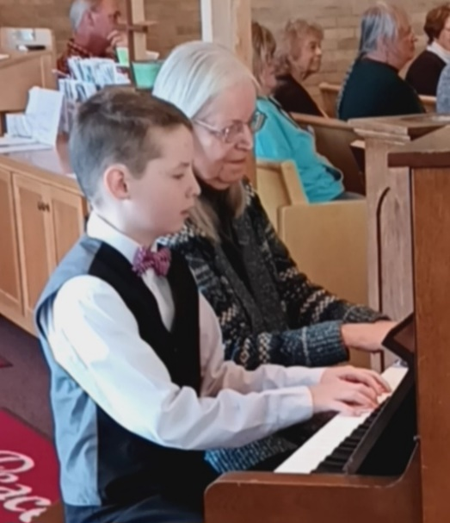
Special thanks to our organist Dottie and her student James Gwizdala for their wonderful duet of Christmas songs played during worship on January 7th.
James has only been studying piano for a month!

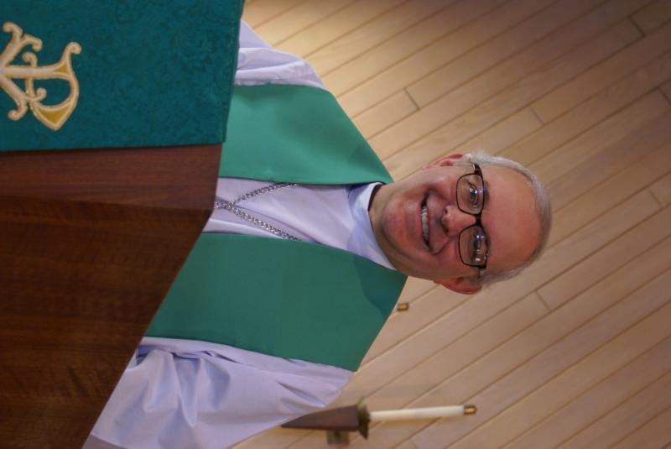
PASTOR’S MESSAGE FEBRUARY 2024

We definitely ended 2023 on a positive note. Our membership and attendance increased during the year, we recorded a positive cash flow, and we celebrated another season of very successful community outreach events. And even though funerals are never a happy event, per se, we celebrated many of our members who served Grace faithfully and went home to be with the Lord.
We barely had time to celebrate a positive year when we crashed into 2024. Our organ blower motor went up in smoke. The office copier popped a belt and went offline. And worst of all, in the middle of an arctic blast, our boiler went down. As my grandfather (an avid poker player) used to say, “if we didn’t have bad luck, we’d have no luck.”
But God can make lemonade out of lemons. On Sunday, January 21, after a week of sub-zero weather, our “newer” HVAC unit, the one that heats and cools the sanctuary, decided that 48 degrees was the best it was going to give us that morning. Not wanting anyone to suffer frostbite, the decision was made to move the worship service into the Grace Room.
Because of the cold and snow, and because some of our members were out of town, I was expecting maybe 15 or so to be in attendance that day, so I felt good that the Grace Room could comfortably hold everyone. Oh, me of little faith. Our attendance that morning was 50 hearty souls, including seven children! And while we were packed in pretty tightly, everyone enjoyed their worship time. Comments included: “I really enjoyed the intimacy of the experience;” “It was great to hear everyone’s singing so clearly;” and “It felt like family.”
While stained glass windows and marble altars certainly add a sense of nobility to a liturgy, these comments underscore the fact that true worship is all about community. And Grace is an awesome community!
Now this experience is causing me to wonder if we should institute a “January worship in the Grace Room” in the same way we do the outdoor worship in the pavilion?
Pastor David
Pastor’s Hours: Wednesdays from 10 am to 2 pm; Tuesdays and Thursdays from
6 pm – 9 pm, and Sundays from 8:30 am for 3-4 hours and by appointment when requested.


MANY THANKS AND PRAYERS TO THOSE WHO HAVE RECENTLY DONATED THEIR TIME AND TALENTS, including, but not limited to:

- Margaret Swanson wants to give her thanks to her church family for all the care and love you have shown her in so many ways. “I have seen God’s love for us in your actions, your help and your caring. God Bless you all.”
- Ian Engberg and others for all their assistance in providing and keeping heaters going in the basement. Paul and Dottie Mantsch for facilitating the repair of the organ.
- Marty Bradley wishes to thank Pastor David and all the members of the Vision Team for time given, support, guidance and service: Tricia Painter, Dallas Peters, Nancy Schnaitman, Kurt Redemann.

FINANCIAL MATTERS – FEBRUARY 2024

- Thank you to our members who were able to attend the annual meeting on January 28, in person or on-line. Your continuing participation is vital to the ongoing ministries at Grace of Lily Lake, as we embark on a new year.
- We will be working on completing your 2023 year-end giving statement (via email or postal mail), by early February. If you have any questions or concerns regarding your statements, please contact Dottie & Paul Mantsch or if you did not receive your Giving Statement, please contact Cara Turner - each of them are on our Finance Team.
- You are able to make your offering donations electronically -- the Subsplash Giving Link is: - https://graceoflilylake.com/give. Go to our website: graceoflilylake.com, click on the "Giving" link, scroll down on the populated page and it will guide you to make a one time, or a recurring donation. We are truly grateful for your financial support @ Grace of Lily Lake.
- For those members who receive Offering Envelopes, there is an “Initial Offering” envelope to help cover the cost of your envelopes : approx. $11.25 per person/per year. Please advise Cara if you no longer wish to receive envelopes.
- Thrivent Members – Please consider donating your Thrivent Choice Dollars to Grace of Lily Lake – deadline for completing this is March 31st.
- Several of our members have made a donation to Grace via a tax-deferred retirement account -- it is a very tax-efficient way to be charitable both during your lifetime and through your estate. Unlike a distribution to you or an heir, which would be a taxable event, charitable donations from retirement accounts lay no additional tax burden on you or the charity. Estate gifts from these accounts can go directly to charities through a donor-directed distribution agreement or fund named endowments, i.e. Grace Lutheran Church of Lily Lake. Have you prayerfully considered naming Grace Lutheran Church of Lily Lake in your Trust or Will?
Brief recap of December financials:
2023 2022
Dec 2023 Year-to-Date Year-to-Date
INCOME $ 25,649 $188,439 $ 178,998
EXPENSES $ 13,214 $176,089 $ 198,366
NET +/- $ 12,435 $ 12,350 $ - 19,368

Praying for meeting goals + challenges, as we move into 2024 ~ Peace, Tricia Painter, Treasurer

JANUARY VISION TEAM REPORT
The Vision Team met on January 9th
- Approved minutes and treasurer’s report from December
- Discussed status of organ motor – it has been replaced; and boiler issues – estimates have been received and insurance contacted. Costs will be reported to the congregation as soon as possible. Heaters are currently being used to keep the lower level as warm as possible.
- Discussed the need for members to listen to, respect and respond to “orders” from either Pastor or the President during emergenies such as the smell and smoke of the organ issue.
- 2024 ELCA increase in pulpit supply costs when pastor is on vacation and another pastor is asked to preside at worship : $200 for one service with $ 0.67 for mileage.

Many thanks to all who have supported me as President for the last two years. It has been a challenge but also a privilege to serve you in this capacity. A new president will be voted on at the February Vision Team meeting.

Blessings, Marty Bradley, President

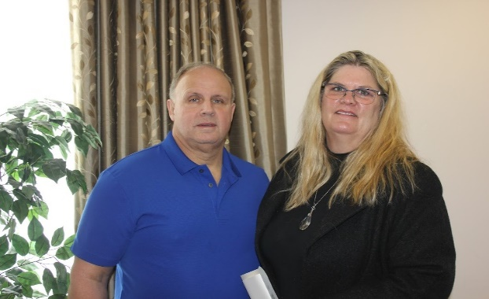
GETTING TO KNOW YOU
Ann and Steve Butcher

We have been asked to share a little about ourselves as new members of Grace Lutheran Church of Lily Lake. We are happy about joining a local Lutheran Church. We have been married almost 34 years. We raised our three sons in North Aurora and attended both Good Shepherd Lutheran Church and eventually moved our membership to St. Marks Lutheran Church when the boys were of age to participate in the youth programs. Ann is a life-long Lutheran and Steve converted from Christian Science as an adult, before we met.

We are both retired teachers, teaching in West Aurora SD129. Steve retired three years ago (after 31 years in the classroom), formerly teaching Middle School Social Studies and coaching Cross Country and Track at his school, and coaching baseball for our boys, when they were young. He currently is a volunteer Golf coach with our youngest son at Geneva High School. He is an avid golfer, counting down the days until he can get on the course again, and sports fan (all sports but mostly baseball). He is at the fitness center or running most days. His undergrad degree was in Business but he returned to school for his Masters of Arts degree to teach.

Ann is newly retired, May 2023. She taught 35 years at the elementary level. She loves learning, receiving her Masters of Science degree in Educational Leadership and Curriculum, and her Doctorate in Curriculum and Instruction with her doctoral research in the area of girls in Math and Science. She also taught as an adjunct professor at Aurora University for ten years in addition to her teaching the elementary classes. This past year, Ann was honored to be named the Kane County Elementary and Early Childhood Educator of the Year. She loves the outdoors, and you may see her hiking in the local forest preserves with one of our dogs, Roxy. (She loves Line Dancing on Wednesdays with Nancy too!)

We moved to Elburn 7 years ago, after our youngest son finished high school.
(continued on next page)
We live in a multi-generational home with our oldest son (Master Automotive Tech), daughter-in-law (teacher), and
our three grandchildren. Our middle son is a Maxillofacial Surgeon and his wife is an attorney in Wisconsin. Our youngest son is a Middle School Science teacher and High School Golf Coach and his wife is finishing up her Doctorate studying Child Psychology. Our family lives in unincorporated Elburn and we are also third generation beekeepers. (This year we completed the whole process - including extraction of the honey, from our home.) We are very family focused.

We are happy to have found a home at Grace Lutheran where everyone is friendly, helpful, and provides a positive Christian community. We are working on meeting everyone, please forgive us if we mess up. I am sure as time goes on it will get easier. We are looking forward to meeting everyone. Ann and Steve

UPCOMING SPECIAL DATES
- LINE DANCING every Wednesday from 6-7 pm in the Fellowship Hall
- St. Olaf College (ELCA affiliated) Band at DeKalb High School Auditorium: The St. Olaf Band, conducted by Henry Dorn, will perform at DeKalb High School Auditorium on Monday, February 5 at 7:00 p.m. Tickets are $10, except students and educators are free!
- SCOUT PANCAKE BREAKFAST – all are welcome. Free will offering. Sunday, February 11 from 8:30 – 11:30 am.
This Photo by Unknown Author is licensed under CC BY-SA-NC


REBECCA CIRCLE
- For fundraising, we are still selling Frontier Soup Mixes any chance we get, led by Suzanne Girsch, so please watch for them.
- And please, help us to continue our Shepherding project by letting us know of the needs of our congregation. For prayer, for visits, for meals or errands. You can call Jan Docherty at 815-901-0910 or Kathy Hooey at 630-341-2293.
- As usual, we take a meeting break in the months of Jan. and Feb. but will resume our monthly (3rd Tues. of the month) meetings on March 19th ,2024. We would love to see you then!

 ROAD RUNNERS TRIP 2024

The Grace Roadrunners decided at their October potluck to travel to the Smoky Mountains/Gatlinburg, TN area in 2024. They will be leaving Grace on Monday, September 16^{thand} return on the 20th or 21st, 2024. The planning committee will begin meeting the first Tuesday of the month starting January 2024

NOISY OFFERING
Every Sunday we collect a “noisy offering” when you wish to empty your change purse or pockets. We are currently collecting for maintenance items, including our boiler. Thank you.

COVID 19, FLU AND RSV SAFETY PROTOCOLS
We follow the recommendations of the CDC, ELCA and IL Department of Health.
If you wish to mask and social distance, please do so. Please do not come to church if
have symptoms of illness. If you do not feel comfortable worshipping with others, we invite
you to join us for worship via our website.

CONTACTS:
For emergencies, please contact Marty Bradley, President, at 640-777-1074 or leave a message at the church office at 630-365-6751.
For prayer requests or other needs please call Kathy Hooey at 630-341-2293 or leave a message at the church office at 630-365-6751. Messages are checked daily at noon & 5 pm.

Information for the March newsletter will be due by February 25th – please send it to Marty Bradley at martybradley@mchsi.com. Thank you



