 | FEBRUARY 2025
 | AMAZING GRACE  CONNECTIONS  Faith > Family > Community

Grace Lutheran Church of Lily Lake
5N600 Hanson Rd, St. Charles, IL 60175
Pastor David Mercurio

Worship every Sunday
At 9:30 am with Communion
.
- Feb 2 – Worship, Sunday School and ANNUAL MEETING
- Feb 9 – Worship
- Feb 16 – Worship and Sunday School
- Feb 23 – Worship

The season of Lent will begin on Ash Wednesday, March 5th and lasts six weeks.
Holy week begins on Palm Sunday, April 13 through Easter Sunday on April 20th.

March Sunday School dates are the 2nd and 16th.

ANNUAL MEETING OF GRACE LUTHERAN

Our important ANNUAL MEETING will be held on Sunday, February 2nd, after the worship service. A quorum is required and a number of important items will be voted upon including our 2025 budget and new committee members. The 2024 Annual Report was available beginning January 26th.

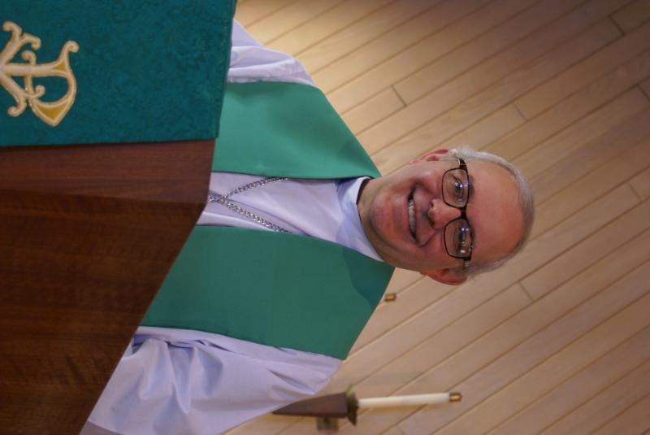
From PASTOR DAVID, February 2025

The results of the 2024 U.S. Presidential election have brought either great
exhilaration or great dread to most of the country, with very few expressing indifference. Mr. Trump has promised (and is quickly delivering) his great reset and new vision for America. As a result, the entire world is now focused on his every move and its effect on the status quo. As with all such similar situations, there will be winners and losers across every land.

But no one said democracy would be pretty or easy, and despite its critics, it is still a better form of governance of the people and by the people than any other. The sad part, though, is that the flurry of activity since this election has drawn everyone’s attention to the worldly here and now and further removed our focus away from the spiritual and the eternal. I understand the myriad emotional and psychological effects such an event can cause, even on Christians, but we need to stay focused and alert to the mission we have voluntarily undertaken and the life we have chosen to lead.
For “our struggle is not against flesh and blood, but against the rulers, against the authorities, against the powers of this dark world and against the spiritual forces of evil in the heavenly realms.”

Blessings to you,
David

Pastor’s Hours: Tuesdays and Thursdays from 6 pm – 9 pm, and Sundays from 8:30 am for 3-4 hours and by appointment when requested.


SPECIAL THANKS to all who have shared their time and talents with Grace , including but not limited to:
- All who assisted with taking down the Christmas decorations
- Nancy Schnaitman for compiling the 2024 Annual Report and to all those who submitted reports.
- Pastor Jane Perkolup for filling in during Pastor’s vacation.
- All who continue to pray regularly for those on our prayer list. Please keep us up-to-date on those on the list.
And many more of you who give generously of your time!
FINANCIAL MATTERS – FEBRUARY 2025

The month of January was spent paying the last of 2024 bills, finalizing 2024 reports, working on the proposed 2025 budget (thus this shortened report). Please review the annual report and get acquainted with the many workings taking place at Grace.
Where can you envision yourself? What can you join and lend a helping hand? Where can you give of your time and talents at your church = Grace of Lily Lake.

- Extra principal payments made to our mortgage in 2024, were just over $29,000. Thank you for the many who contributed to this effort. More news on the mortgage renewal, % rate, etc. will be discussed at the annual meeting on February 2nd following worship.

Brief recap of December financials:
2024 2023
Dec 2024 Year-to-Date Year-to-Date
INCOME $ 22,894 $ 214,448 $ 188,439
EXPENSES $ 23,658 $ 227,747 $ 176,089
NET +/- $ - 764 $ - 13,299 $ 12,350

Pray for blessings upon Grace as we continue our mission and ministry and reach new goals with God’s Guiding Hands ~ In Peace ~ Tricia Painter, Treasurer




This Photo by Unknown Author is licensed under CC BY-ND
Parents day out
A new ministry at grace

This program for children 3 – 5 years (potty trained only) is open on Mondays and Wednesdays in Fellowship Hall from 9:15 am – 1:15 pm. Two teachers will be on site each day. The program will be using Christian materials. Costs and registration are now open. If you wish to register your child or volunteer to be a substitute teacher, please contact Janice at Janice.muncie@gmail.com.
VISION TEAM REPORT
Meeting was held on January 14th
- Minutes from December 10th Vision Team meeting and treasurer’s report were approved.
- Updates on financial reports and improvements for maintaining them were discussed.
- Leyden electric will be repairing our cross on the south side of the building at no cost so that it lights up again.
- Two new thermostats have been installed.
- Repairs to the pavilion will be addressed in the spring in conjunction with the Boy Scouts.
- Next Vision Team meeting will be February 11.


REBECCA CIRCLE

.We plan to resume meeting in March, so look for information in the March
Newsletter. We usually meet on the third Tuesday of each month so please
join us!

NEWS FROM REBECCA CIRCLE REGARDING 2024/2025 DONATIONS TO OUR GOD’S GOOD GIFTS DRIVE!

We continued to accept donations through last Sunday, January 19th and were very pleased at the response from our Grace congregation to support ELCA’s work in 86 countries around the globe.

To begin our drive, the Rebecca Circle voted to donate $1000 to support an initiative for safe water access. At an average cost of $2,500, a spring box is one of the main types of water projects supported by these gifts. Water wells can range from $2,500 to $10,000. With a simple well, spring box or other water point, many families gain access to clean, safe water. We were blessed with added donations of $5200 to aid in this effort! We also had donations towards the purchase of goats, roosters, honeybees and school supplies, which are so necessary to overcome poverty!

So all in all, we will be sending a check for $6,385 to support the ELCA’s GOOD GIFTS PROGRAM. Thank you, Grace Lutheran, for your outpouring of love and caring for all of God’s people around the world!
EVENTS NOT TO BE MISSED
(also see Sunday worship information above)
LINE DANCING continues on THURSDAYS:
- February 6, 13, 20 and 27
- March 6, 13, 20 and 27,
- April 3, 10, no class on the 17th as we will have a Maundy Thursday worship service, and 24,
- May 1 and 8.
PANCAKE BREAKFAST, February 9 in Fellowship Hall from 8am – 11am.
Presented by our Scout Troops. Free Will Offering.
CHILI COOK OFF – February 22 from 5 to 8 pm. Open to the community.
Sign up sheets are in the gathering room. Bingo and prizes. Contact Candice Hopkins at 630-362-4659 for more information.
ANNUAL SYNOD ASSEMBLY - Friday and Saturday, May 30-31. Theme is: Go Therefore! Meetings will be at the Q Center in St. Charles. We need two representatives to attend and vote. Registration opens Tuesday, February 4th. Please see Dallas Peters or Tricia Painter if you are interested in attending.



*ANNUAL PANCAKE BREAKFAST*

Presented by the Grace Scout Troops
Fellowship Hall
SUNDAY, FEBRUARY 9TH from 8am – 11am

Free will offering
Please join us!



MISCELLANOUS INFORMATION
- If you can knit or crochet, we need you to help make more prayer shawls as we are running low. We have the yarn so please contact Helen Gruber if you can help. If you know of someone needing a PRAYER SHAWL, please let Twyla Strom know.
- The Finance Team is looking for volunteers to sign up as counters (counting our weekly offerings after worship). Please see Linda Smykowski or Tricia Painter for further details.
- The Worship Team is seeking volunteers to help run our power point during worship which brings the bulletin onto the TV screens in the sanctuary. Especially for the 1st and 3rd Sundays of the month. See Tricia Painter.
- Our new website sign on is graceoflilylake.org (not .com)
SPECIAL MINISTRY INFORMATION:

Bridge to Life Group’s Jesus Closet (homeless in Elgin): Items needed are backpacks, blankets, gym shoes, t-shirts, jeans, coats and socks. Please mark donated items to the attention of Cathy Whiteside (630/605-1096). Thank you for all the donations.
Clothing and miscellaneous items for the migrants in Chicago are being collected by Cathy Whiteside (630/605-1096) to be given to Pastor Anna-Kari Johnson for distribution in Chicago. Thank you to all who have donated in the past. Left overs from our Spring Rummage Sale were already passed on to this ministry in June.


ROAD RUNNERS 2025 TRIP

The 2025 Road Runners Trip will include Dubuque/Cedar Rapids,IA to mid IA. So, mark your calendar for the 2025 Roadrunner Trip to Iowa on September 22-27, 2025. See Suzanne Girsch for more information.

NOISY OFFERING
Every Sunday we collect a “noisy offering” when you wish to empty your change purse or pockets. We are currently collecting for maintenance items, including our new boiler. Thank you.

COVID 19, FLU AND RSV SAFETY PROTOCOLS
We follow the recommendations of the CDC, ELCA and IL Department of Health.
If you wish to mask and social distance, please do so. Please do not come to church if you have symptoms of illness. If you do not feel comfortable worshipping with others, we invite you to join us for worship via our website, graceoflilylake.org

CONTACTS:
For emergencies, please contact the church office at 630-365-6751.
For prayer requests or other needs please call Kathy Hooey at 630-341-2293 or leave a message at the church office at 630-365-6751. Messages are checked daily at noon & 5 pm.

Information for the March newsletter will be due by February 25th– please send items to Marty Bradley at masbradley50@gmail.com. Thank you

New Years Party - December 31st





