 | FEBRUARY 2026
 | AMAZING GRACE  CONNECTIONS  Faith > Family > Community
Grace Lutheran Church of Lily Lake
5N600 Hanson Rd, St. Charles, IL 60175
Pastor David Mercurio

Worship every Sunday
At 9:30 am with CommUNION
- February 1 – Worship and Sunday School & Coffee Hour
- February 8 – Worship and Pancake Breakfast (8am-11:30am)
- February 15 – Worship and Sunday School
- February 18 – Ash Wednesday Worship Service at 7 pm
- February 22 – Worship

LENTEN / HOLY WEEK SCHEDULE
February 18th – Ash Wednesday – distribution of ashes at the Elburn Metra Station at 6 am (see Pastor to assist) and 7pm evening worship at Grace.
Lenten Bible Studies – Wednesdays at noon (soup lunch) on February 25 – March 25 with a repeat study on Saturdays (coffee & treats) at 9:30am, February 28 – March 28th.
April 2nd, Maundy Thursday – Seder meal at Grace in Fellowship Hall at 6 pm. Reservations needed.
April 3rd – Good Friday – Community Worship at the Congregational Church on Empire Road at 7 pm.
April 5th – EASTER SUNDAY – worship at 10:30 am withBreakfast before and/or after worship from 8:30 am to 11:30am (free will offering.)

EVANGELICAL LUTHERAN CHURCH IN AMERICA
The Evangelical Lutheran Church in America (ELCA) is one of the largest Christian denominations in the United States, with nearly 2.7 million members in more than 8,400 worshiping communities across the 50 states and in the Caribbean region. Grace of Lily Lake is one of those worshiping communities. As such, a small part of our annual budget goes to the ELCA. Where does this money go? Please take a few minutes to read the last two pages of this newsletter, “Mission Support, Where Does My Offering Go?” to find out.
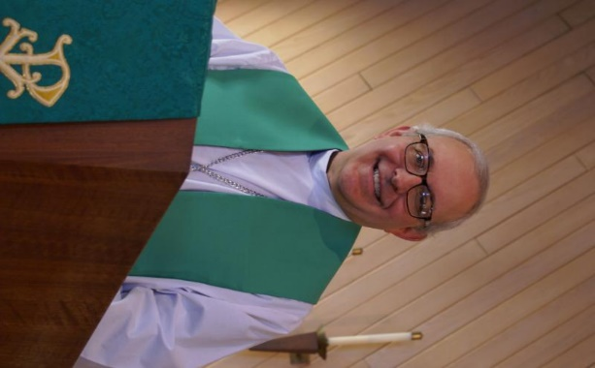
FROM PASTOR DAVID, FEBRUAY 2026

Easter comes earlier than usual this year so the Lenten cycle will be upon us soon. We start with our “Ashes at the Elburn Train Station” event on Wednesday, February 18 at 6:00AM. All are welcome to join me to bestow a blessing on the early morning commuters.

Then we start our 5-week Lenten Bible study series on Wednesday, February 25. As usual, we will be hosting a soup lunch at Noon followed by a lecture series. This year the topic is: “Judaism: Christianity’s Foundation and Signpost.” A repeat of the Wednesday lessons will occur on the following Saturdays at 9:30AM with cake and coffee. The Wednesday lessons will run from February 25 to March 25 and the Saturday lessons will run from February 28 to March 28. Since the Wednesday and Saturday lessons are the same, feel free to drop in to either (or both!) as your schedule allows. We will be posting sign-up sheets soon.

After a four-year hiatus, we are bringing back our Seder Dinner celebration on Maundy Thursday, April 2 at 6:00PM. We will recreate the Passover meal that Jews around the world celebrate every year.

On Friday, April 3 we have our community Good Friday service with Country Covenant Church, Congregational Church and Burlington Methodist Church at Congregational Church on Empire Rd at 7:00PM. All are welcome to join us.

Finally, we will celebrate Easter, the high point of the Christian calendar, on Sunday, April 5. I look forward to worshipping with you as we continue to deepen our relationship with God and each other. Blessings to you all.

Pastor’s Hours: Mondays, Wednesdays and Fridays plus Sundays and as needed and by appointment when requested.

VISION TEAM REPORT
If you have any questions or concerns, please contact a Vision Team member:
Dallas Peters (President), Steve Butcher, Cathy Lindquist, Nancy Schnaitman, & Lee Strom
At their January meetings the Vision Team:
- Approved minutes and treasurer’s reports.
- Michele Brazee will be assisting with our accounting procedures
- Reviewed and approved the 2026 proposed budget to be voted on at the annual mtg.
THE ANNUAL Meeting was held on January 25th following the worship service. There were 42 members in attendance (32 are required as a quorum to do business).
- If you did not pick up a 2025 annual report please do so.
- New computers being purchased and phone and computer assistance to be provided by an outside vendor.
- All Congregational meeting minutes from 2025 were approved.
- Received reports from Pastor, Vision Team and Mission areas.
- Elected new members: Dallas Peters and Cathy Lindquist re-elected to remain on the Vision Team and Steve Butcher elected. Tricia Painter’s term has ended but she will remain as our Treasurer. Janice Muncie was elected to the Audit Team and Tricia Painter and Pat Penfold were elected to the Nominating Team.
- Approved the 2026 budget as presented.
THANK YOU FOR YOUR SUPPORT
FINANCIAL MATTERS – FEBRUARY 2026
The month of January was spent prepping for the annual meeting, finalizing
2025 reports and working on the proposed 2026 budget with the Vision Team.
- My gratitude to Pastor over the past year in helping to oversee and amend some financial reports. Michelle Brazee, CPA with her own business, has volunteered to provide some monthly financial review/oversight, and become familiar with our Church Windows software.
- Cara Turner was able to send out the 2025 Giving statements in January. If you did not receive your statement (via email or USPS) please contact Cara. If you have questions on your statement please contact Dottie Mantsch.

Brief recap of December 2025 financials:.
2025 2024
Dec. 2025 Year-to-Date Year-to-Date
INCOME $ 24,795 $ 298,321 $ 227,747
EXPENSES $ 21,410 $ 235,850 $ 185,280
NET +/- $ 3,385 $ 62,470* $ 23,299
- Grace graciously received 2 large memorials in 2025 totaling $49,531.

Please review the annual report and get acquainted with the many venues
that are available to you. What interests you? Where can you give of your
time, talents and tithes at your church? = Grace of Lily Lake
Pray for blessings upon Grace, with God’s Guiding Hands, as we continue
our mission and ministry ~ Tricia Painter, Treasurer


REBECCA CIRCLE
Dear Grace Family,
Our kitchen project is finished and if you haven’t peeked in, please do so. This wasn’t by any means a small task to undertake, but the outcome is well worth it. I have so many members to thank and want to start by thanking the Vision Team for giving us the go ahead to get this done. Not only did they say OK, but they allotted money from a memorial to be used and then the Rebecca group paid for the rest. I want to thank Linda Smykowski and Cathy Lindquist for being my
sounding board on all the details and for their help in taking everything out of the cabinets to get the kitchen ready for painting, along with Marty Bradley and Nancy Schnaitman. Thanks to Cathy Whiteside for the use of the many tubs and wire racks to store kitchen items for two months. Thanks to Mitch Hendry helping with the slant of the pass-through counter and to Ken Kush who installed new lights and ceiling fans. Next came the cleaning of cabinets after all the painting was finished and on January 8th, the Rebecca Circle had a workday to put everything back into the kitchen. What a great group of ladies to help with this. Marty Bradley, Suzanne Girsch, Helen Gruber, Kathy Hooey, Vicki Linden, Dottie Mantsch, Cheryl Nelson, Linda Smykowski, Char Sportsman and I all worked to get this done. I couldn’t have done this without all your help, and I appreciate each and every one of you.
Blessings, Twyla Strom
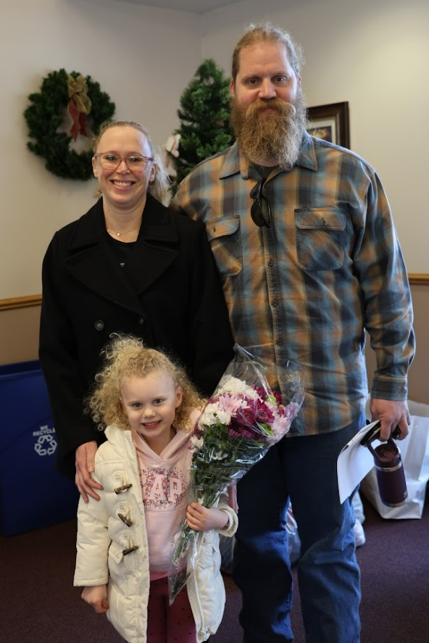
Welcome new members: Bill and Cassi Muenster & Maryann

Meet the Muenster family: Bill, Cassi and our daughter Maryann. We have lived in the area for almost 40 years. Bill grew up in Geneva, and I grew up in Plato Center. Together we have lived in Maple Park for the past 10 years. My best friend is married to Bill’s brother, which is cool. Our daughter Maryann was born in 2021. It’s obvious where she gets her curls. Our introduction to Grace began about a year ago when I saw a post on Facebook about the preschool program. While I didn’t
initially follow up with my inquiry, it was always on my mind to explore what Grace Lutheran was about. However, Janice Muncie, did follow up with me about Maryann potentially joining the program and that is what piqued our interest in the church.
We have always looked for and have been open to joining a church but, it wasn’t until we started to attend Grace that we felt a sense of community that aligned with our values. All three of us felt welcomed and accepted from the first day we visited. What a rare experience to have! The friendliness of every member is such a special gift that we knew we wanted to be a part of that community.
Strangely enough, prior to us visiting Grace for the preschool inquiry: the last time I was at the church was 25 years ago for a funeral for a fellow classmate.
We have 60 chickens, 2 dogs and 4 cats. Maryann loves animals and loves to visit the zoo. We do technically have our own little zoo.
Some of my hobbies include reading, photography, chasing after Maryann, and yoga (once upon a time). Bill’s hobbies are prepping for future disasters working on their
farm and watching over his truck graveyard. Bill is a diesel mechanic.
Every night since Maryann was born, we would recite the Lord’s Prayer.
We pray every day and are thankful for all our blessings,
Cassi and Bill

GRACE PRESCHOOL

Our Preschool has been a wonderful addition to our mission programs. Registration for preschool for the 2026-2027 school year will be open beginning in February. Janice Muncie (our Director) sent out a survey to parents asking for their feedback. The Preschool Board met on January 26th and discussed: finances, current enrollment, scholarship status, teacher training, survey results, any challenges, and possible expansion. Parent and student feedback has been very positive.
Special thanks to Janice for her Leadership!

ROADRUNNERS 2026 TRIP

The next Roadrunners trip is scheduled for September
21-25 (or 26), 2026. We will be going to Frankenmuth, Michigan. Save the dates – more information to come.

SPECIAL THANKS to all who have given of their time, talent and gifts:
- Twyla Strom for coordinating the redo of the kitchen and all who helped sort through the items that had accumulated in the kitchen and returned them to the cabinets.
- Everyone who contributed to our special missions over the holidays.
- Everyone who helped take down the Christmas decorations in the Sanctuary and Gathering Room.
- Nancy Schnaitman for gathering and putting together our Annual Report. It is a large job.
- All who assist with getting the sanctuary ready for worship each Sunday and all who donate flowers.
- Our sexton, Ian Endberg, for all the behind the scene clean up, set up and overseeing he does.

LINE DANCING continues on Tuesdays
from 6-7 pm in Fellowship Hall from 1/6/26 to 4/28/26. Continue thanks to Nancy Corbige for teaching this class. Come enjoy the fun.


HABITAT FOR HUMANITY - POTTAWATOMIE
Grace Lutheran is a partnership church. Nancy Corbige, our representative to Habitat for Humanity, reports that they have started building a new house in St. Charles, north of Rte 64 and that volunteers are needed. Times you may volunteer include, Wednesday, Friday or Saturday from 8:30 am to 4 pm.

If you can volunteer a day or more, please send your name and email address to Nancy at ncorbige@gmail.com. She will keep us updated on the progress of the build. Volunteers do a variety of jobs, including providing lunches, doing clean up, painting and construction work.

SPECIAL MINISTRY INFORMATION
Bridge to Life Group’s Jesus Closet (homeless in Elgin): Items needed are backpacks, blankets, gym shoes, t-shirts, jeans, coats and socks. Please mark donated items to the attention of Cathy Whiteside (630/605-1096). Thank you for all the donations. Clothing and miscellaneous items for those in need in Chicago are being collected by Cathy Whiteside (630/605-1096) to be given to Pastor Anna-Kari Johnson for distribution in Chicago. Thank you to all who donate.

NOISY OFFERING Every Sunday we collect a “noisy offering” when you wish to empty your change purse or pockets. We are currently collecting for maintenance items. Thank you.

MISCELLANOUS INFORMATION
- SPECIAL TECH NEED: Are you familiar with IT / computer technology / streaming ?? We are asking for several people to become familiar with or learn the technology that we use to record our church services with. Seeking several people so we will be able to spread out the weekly tasks ~ contact Pastor or Tricia Painter
- If you can knit or crochet, we need you to help make more prayer shawls as we are running low. We have the yarn so please contact Helen Gruber if you can help. If you know of someone needing a PRAYER SHAWL, please let Twyla Strom know.
- The Finance Team is looking for volunteers to sign up as counters (counting our weekly offerings after worship). Please see Linda Smykowski or Tricia Painter.

CONTACTS:
For emergencies, please contact the church office at 630-365-6751. For prayer requests or other needs please call Kathy Hooey at 630-341-2293 or leave a message at the church office at 630-365-6751. Messages are checked daily at noon & 5 pm.

Information for the March newsletter will be due by February 25th– please send items to Marty Bradley at masbradley50@gmail.com. Thank you


Ash Wednesday, February 18th – Worship at Grace at 7 pm
