January 2023, VOL. 37
 | AMAZING  GRACE  CONNECTIONS
Faith > Family > Community
Grace Lutheran Church of Lily Lake
5N600 Hanson Rd, St. Charles, IL 60175
Pastor David Mercurio
Blessed New Year

This Photo by Unknown Author is licensed under CC BY-NC
Worship every Sunday at 9 am
with Communion
Sunday, January 1, Worship & Coffee Hour
First Sunday of Christmas
Sunday, January 8, Worship and Sunday School
The Baptism of our Lord
Sunday, January 15, Worship
Sunday, January 22, Worship and Sunday School
Sunday, January 29, Worship with ANNUAL MEETING FOLLOWING

JANUARY 6th, EPIPHANY
This Photo by Unknown Author is licensed under CC BY-SA-NC
The word “epiphany” comes from A Greek word meaning “appearance” or “showing forth.” It names the day that the church tells Matthew’s story of the magi from foreign lands who follow the light of the star and thus see Jesus as Christ. We celebrate the Epiphany of Our Lord on Jan. 6. We look to the Wise Men as the first of the Gentiles to know and worship Jesus as their Savior and Lord. When they arrived in Jerusalem following a long and arduous journey, they immediately began asking about the newborn King. It seems they expected the entire nation to be caught up in the excitement of this momentous event, the coming of the long promised Messiah. They made it clear that they were coming to worship Him. This was something more than the usual honor paid when a new crown prince was born. They were searching for their spiritual king..

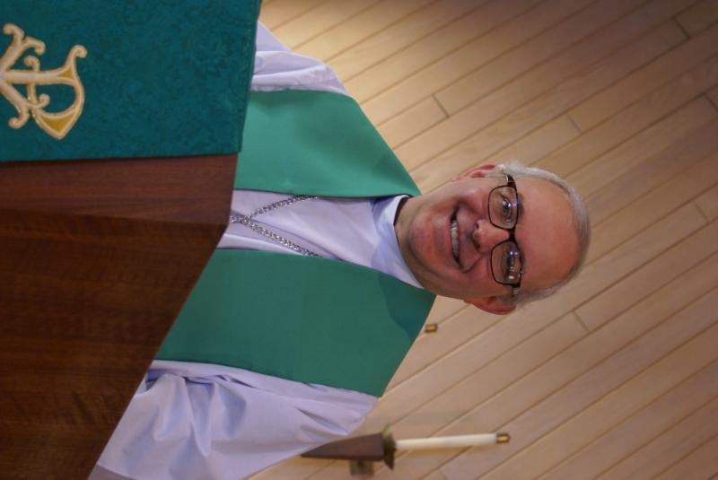
PASTOR’S MESSAGE

From the desk of Pastor David, January, 2023
How am I supposed to remember to write 2023 when I’m just getting used to 2022? (My “First World” problem). As I draft this letter, our crack weather team is predicting the next “snowmageddon” to arrive in two days with heavy snowfall, freezing temperatures and blizzard-like winds, just in time for Christmas. That would be a good thing for me because it will force me to stay inside to finalize plans for the coming year.
I am anxious to keep ramping us higher, so I have a number of ideas as an add on to all the wonderful things we already do. All of which are meant to help us continue to grow and thrive. These include: a weekly Saturday morning Bible study, an expanded children’s ministry, more performances by our choir, possibly another Seder dinner at Easter, another Spoke Folk concert, an expanded ministry for shut-ins, a guest speaker series, and additional community outreach events. The reason I feel excited and confidant that these are all achievable is how you have all worked so hard this past year to make Grace Lutheran Church a loving and hospitable congregation.
An increasing percentage of the population may believe they can lead a joyful life without God, but we’re going to work hard to show them how wrong they are. Buckle your seatbelts!
Blessings to you all,
Pastor David
Pastor’s Hours at church
Tuesdays and Thursdays from 6 pm – 9 pm
Saturdays from 9 – noon Sundays from 8:30 am for 3-4 hours

SPECIAL NOTE: SUNDAY SCHOOL WILL MEET ON THE SECOND AND FOURTH SUNDAYS IN JANUARY

COVID-19, FLU and RSV Safety Protocols
We follow the recommendations of the CDC, ELCA and the IL Department of Health. There has been an uptick in cases of Covid in our area so please wear a mask at worship and social distance if you feel you need to. If you do not feel comfortable worshipping with others, we invite you to join us virtually for worship via our website.

GRACE LUTHERAN ANNUAL MEETING
SUNDAY, JANUARY 29TH immediately following worship
Please mark your calendar for this important meeting.
If you are one of those who is responsible for writing a report for our Annual Report, please complete it by the end of the first week in January as the complete report must be available to the congregation by January 15th and return it to Nancy Schnaitman at jschnaitman@netscape.net.
ANNUAL REPORTS DUE

DECEMBER VISION TEAM REPORT
The Vision Team met on December 13th and discussed::
- Maintenance Fund balance has been used for new garage roof, a leaking spigot, final payment of boiler repairs and fall service and the new annunciator panel. Balance would have been 0 except for a very recent $5,000 donation. Thank you.
- 2023 budget discussion: SPECIAL THANKS TO ALL WHO MADE A PLEDGE FOR 2023. IT IS NOT TOO LATE IF YOU STILL WISH TO DO SO. Vision Team will be meeting to review the 2022 budget and shortfalls which occurred and to create a 2023 budget to be approved at the Annual Meeting on January 29 following worship.
- Reports for the Annual Report from 2022 must be submitted by the end of the first week of January.
- Annual Fire Inspection was completed and Grace is in compliance with all requirements.
- Estimates being gathered for light bulb replacement in the Sanctuary.
- Recap of Thanksgiving Service: Service was wonderful with 40 in attendance. $275 in donations was collected and split between the four churches to be given to the local food pantry of their choice.
The Vision Team meets on the second Tuesday of each month. If you have items you feel should be discussed by the team, please send them to Marty by the first Tuesday of the month.

A BLESSED NEW YEAR TO ALL OF YOU! Marty Bradley, President


SERVING GRACE – YOU ARE NEEDED

If you are interested in nominating someone to serve on the Grace Vision Team, Audit Team or Nominating Team, or if you yourself are interested in serving, please contact Heidi Anderson. Team members will be elected at the Annual Meeting on January 29th following worship.
FINANCIAL MATTERS – JANUARY 2023

- We were blessed with receiving over 30 commitments/pledges for 2023 – blessings to all of you for your prayer and consideration for 2023. The Vision Team will be working diligently in the next couple of weeks on Grace’s budget for 2023.
- Reminder: Please plan to attend our annual meeting on Sunday, January 29, 2023, starting shortly after our worship service that day.
- Noisy Offering continues to be collected: we have collected over $1,500 for specialized lightbulbs to be replaced in our sanctuary, front and back parking lots, the rental cost of a lift to get to the high ceilings. Thank you for lightening your pockets of the heavy change you may be carrying! We anticipate having this project completed in the beginning of 2023.

- We have received a year-end donation of $5,000 to our Building Maintenance savings account. Previous funds in November and December have covered boiler maintenance and repairs, leaking (flat) roofs, sprinkler system control panel.

- The Finance Team plans to have your 2022 Year-End giving statements to you by the end of January 2023.

- You are able to make your offering donations electronically -- the Subsplash Giving Link is: - https://graceoflilylake.com/give. Go to our website: graceoflilylake.com, click on the "Giving" link, "Give" , scroll down on the populated page and it will guide you to make a one time, or a recurring donation. We are truly grateful for your financial support @ Grace of Lily Lake.

- Several of our members have made a donation to Grace via a tax-deferred retirement account -- it is a very tax-efficient way to be charitable both during your lifetime and through your estate. Unlike a distribution to you or an heir, which would be a taxable event, charitable donations from retirement accounts lay no additional tax burden on you or the charity. Estate gifts from these accounts can go directly to charities through a donor-directed distribution agreement or fund named endowments, i.e. Grace Lutheran Church of Lily Lake. Have you prayerfully considered naming Grace Lutheran Church of Lily Lake in your Trust or Will?

Brief recap of November financials:
2022 2021
Nov, 2022 Year-to-Date Year-to-Date

INCOME $ 12,364.55 $152,943.38 $148,036.48
EXPENSES $ 18,717.06 $184,403.69 $160,586.75
NET +/- $ - 6,352.51 $ -31,460.31 $ -12,550.27

Praying for meeting goals, and challenges, in 2023 ~ Peace, Tricia Painter, Treasurer


MANY THANKS AND PRAYERS TO THOSE WHO HAVE RECENTLY DONATED THEIR TIME AND TALENTS, including, but not limited to:

- All who donated gifts to the Giving Tree children and to the ELCA Good Gifts/Global Barnyard projects
- All who assisted with the successful Cookie, Bake Sale Bazaar, especially Candice Hopkins
- Everyone who assisted in putting together the wonderful Advent and Christmas services, read, sang, picked up and arranged flowers and the atlar, set up communion, ushered, greeted, created bulletins and power points, ran computers and worshipped etc. It takes a village…

CONTACT A VISION TEAM MEMBER IF YOU WISH TO VOLUNTEER

SUCCESSFUL COOKIE/BAKED GOODS/BAZAAR!!
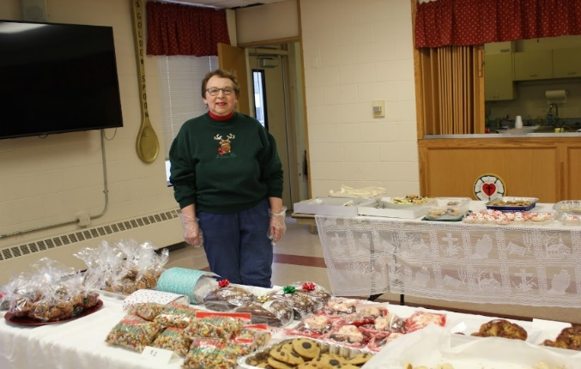
It 'twas a busy day at church on Sat., Dec 17. There was a funeral service held for Margaret McDonald upstairs; meanwhile, downstairs we held a Holiday Cookie Sale and Bazaar. The cookies, vendors, and Christmas rummage sale items were a-plenty - and the cookies sold quickly. A BIG THANK YOU to all of the volunteers -- especially the cookie bakers who made the event possible. There were many elves who came to help set up and greet our shoppers, and to all of the BUYERS who came to support our church. "We have different gifts, according to the grace given us" - Romans 12:6. I simply love to be able to help organize and put events together for fellowship.
~ Candice Hopkins

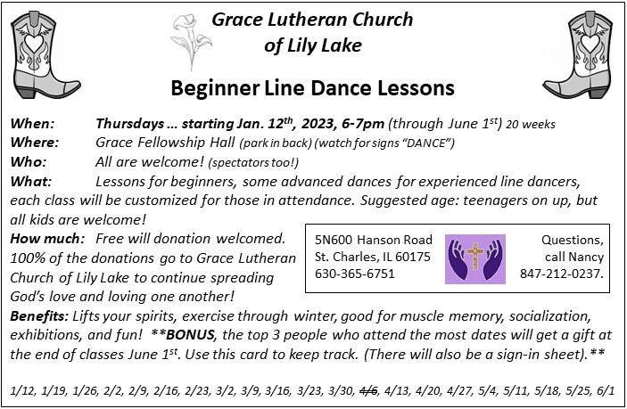



Please mark your calendars, tell others, and plan to attend this event
for this very worthy cause:
A Valentine’s Line Dance Fundraiser for
Habitat for Humanity.
Hosted by the Pottawotomie Partnership, on
Sat. 2/11/23, 5-9pm,
United Methodist Church of Geneva, 211 Hamilton St., Geneva, Fellowship Hall
Tickets: $10/person, $20/family
- Line Dance instruction and open dancing throughout the night
- Silent Auction
- Refreshments
*Accepting donations for silent auction items up until Jan.17th.
*Requesting dancers: beginners who want to learn, experienced dancers, and those that love to watch and enjoy the show!
For information about our local Habitat for Humanity or to volunteer to help, please contact our representative, Nancy Corbige, at 847-212-0237 or NCorbige@gmail.com
CONTACTS:
For emergencies please contact Marty Bradley, President, at 640-777-1074 or leave a message at the church office at 630-365-6751.
For prayer requests or other needs please call Kathy Hooey at 630-341-2293 or leave a message at the church office at 630-365-6751. Messages are checked daily at noon & 5 pm.

ELCA MISSION WEBSITES

LUTHERAN DISASTER RESPONSE:
https://www.elca.org/our-work/relief-and-development/lutheran-disaster-response
ELCA WORLD HUNGER APPEAL:
https://www.elca.org/Our-Work/Relief-and-Development/ELCA-World-Hunger
LUTHERAN WORLD RELIEF:
https://lwr.org/
REFUGEE ONE https://www.refugeeone.org/

Information for the February newsletter will be due by January 25th – please send it to Cathy Whiteside Cathy@imotay.com Thank you!



