 | JANUARY 2024
 | AMAZING  GRACE  CONNECTIONS  Faith > Family > Community
Grace Lutheran Church of Lily Lake
5N600 Hanson Rd, St. Charles, IL 60175
Pastor David Mercurio

Worship every Sunday
At 9:30 am with Communion
- January 7 – First Sunday after Epiphany / Baptism of our Lord with Sunday School and coffee hour following
- January 14 – Second Sunday after Epiphany
- January 21 – Third Sunday after Epiphany & Sunday School
- January 28 – Fourth Sunday after Epiphany with Annual
Meeting immediately following worship


SUNDAY SCHOOL
This Photo by Unknown Author is licensed under CC BY-NC-ND
Sunday School for 3 through 13 year olds EVERY 1ST and 3RD SUNDAY at 9:30 am in the Grace Room.
January dates are Sundays the 7th and 21st.

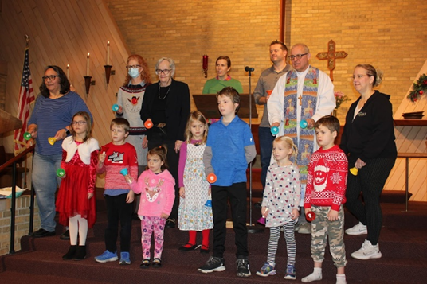

BELL CHOIR WITH SUNDAY SCHOOL ASSISTANCE
Sunday, December 17th

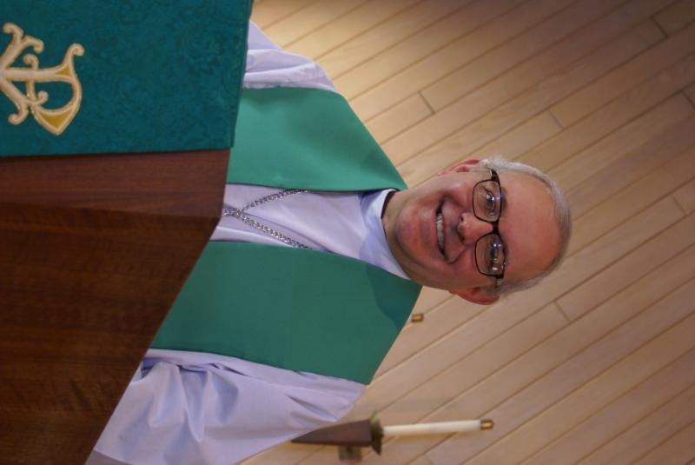
PASTOR’S MESSAGE JANUARY 2024
The last of the eggnog has been poured, the Christmas wrapping that was torn off in haste has been discarded into the recycle bin, and the Nativity characters have been carefully replaced in their boxes and put into storage until next year. Another year’s cycle is complete and it’s time to go back to normal life. This is a good time, if I may use a sports analogy, to break huddle and hit the field. I am giving you three questions you can use with your nonbelieving friends and neighbors to casually start a conversation. Plant the seed; let God take over from there. Have fun with it!
1. Where will you be in 100 years?
They may not answer you, but it’s a question that they themselves have pondered often. It’s also a question everyone must grapple with.
2. Mathematics. Did man invent it or discover it?
If they say discovered it, then the follow up question is, what higher power created it? If they say invented it, then ask if the area of a rectangle is still length times width on Mars.
3. If life came about through the random mixture of chemicals over millions of years, how do we explain the genetic code called DNA? Did randomness bring it together, then step aside to leave it alone once patterns were established in all life forms?
Blessings to you.
Pastor David
Pastor’s Hours at church Tuesdays and Thursdays from 6 pm – 9 pm
Sundays from 8:30 am for 3-4 hours


MANY THANKS AND PRAYERS TO THOSE WHO HAVE RECENTLY DONATED THEIR TIME AND TALENTS, including, but not limited to:

- Choir members and George for enhancing our worship and the children and adults who helped ring bells on the 17th
- Twyla for all the beautiful pillowcases for our Elgin Crisis Center children, Dottie for all the teddy bears and George, Helen and Kurt for delivering the gifts & all the gift givers
- Pastor for the wonderful Advent/Christmas Eve sermon.
- Vision Team members for extra time spent putting together a draft budget for 2024 to be approved at the annual meeting on January 28th following worship; special thanks to all who have pledged (you may still do so if you wish)
- Rebecca Circle for sponsoring the ELCA Good Gifts program and for all who donated to it
- Marla Roach for updating several areas of our website
- Everyone who donated baked goods/cookies and time to the Cookie Walk/Exchange and those who had booths (scarves sold well after church on the 17th, especially due to the small children who were there to ring bells)!

FINANCIAL MATTERS – JANUARY 2024
- We were blessed with receiving over 33 commitments/pledges for 2024. As members of Grace, we should all count the blessings that abound. Thank you to all, for your prayer and consideration for 2024. The Vision Team will be working diligently in the next couple of weeks on Grace’s budget for 2024.
- Reminder: Please plan to attend our annual meeting on Sunday, January 28, 2024, starting shortly after our worship service that day. We are close to meeting our 2023 year-to-date budget.
- Cara Turner, Finance Team, plans to have your 2023 Year-End giving statements to you by the end of January 2024. Are you experienced in the accounting field? Our Finance Team is looking for someone to review the monthly financials and assist in corrections, and monthly reports.

- You are able to make your offering donations electronically -- the Subsplash Giving Link is: - https://graceoflilylake.com/give. Go to our website: graceoflilylake.com, click on the "Giving" link, "Give" , scroll down on the populated page and it will guide you to make a one-time, or a recurring donation. We are truly grateful for your financial support @ Grace of Lily Lake.

- Several of our members have made their offering/donation or special one-time giving, to Grace, via a tax-deferred retirement account. Also, it is a very tax-efficient way to be charitable both during your lifetime and through your estate. Unlike a distribution to you or an heir, which would be a taxable event, charitable donations from retirement accounts lay no additional tax burden on you or the charity. Estate gifts from these accounts can go directly to charities through a donor-directed distribution agreement or fund named endowments, i.e. Grace Lutheran Church of Lily Lake. Have you prayerfully considered naming Grace Lutheran Church of Lily Lake in your Trust or Will?

Brief recap of November financials:
2023 2022
Nov, 2023 Year-to-Date Year-to-Date

INCOME $ 11,287 $ 159,946 $ 159,943
EXPENSES $ 13,971 $ 162,355 $ 184,403
NET +/- $ - 2,684 $ - 2,409 $ - 24,460

Please pray for Grace Lutheran – our forward planning, meeting our goals, and challenges, in 2024 ~ Peace, Tricia Painter, Treasurer

REMINDER: ANNUAL MEETING IS JANUARY 28TH
IMMEDIATELY FOLLOWING WORSHIP IN THE FELLOWSHIP HALL
We will be voting on new Vision Team members and other Committee
members, the 2024 budget and required revisions from the ELCA to our
constitution. A quorum (32 people) is needed.
OCTOBER VISION TEAM REPORT
The Vision Team met on December 14th
- Approved minutes and treasurer’s report from November
- Constitution revision handouts are available; revisions to be approved at the annual meeting on January 28th. These revisions are simple and do not change how we operate or are set up (mostly just some language changes). Please be prepared to vote on the revisions at the annual meeting on January 28th. Would like to keep discussion on these to a minimum.
- New boiler burner has been installed.
- Parent of a scout, who is a plumber, has complete several plumbing fixes in the building
- Christmas cookie Walk was very successful and fun.
- Don’t forget line dancing is starting up again on Wednesday nights from 6-7 pm.
- MEMBERS ARE NEEDED TO BE NOMINATED FOR A FEW POSITIONS ON THE VISON TEAM AND THE NOMINATING COMMITTEE. Please see Suzanne Girsch if you wish to nominate someone. We will vote on these at the Annual meeting following worship on January 28th.
Blessings, Marty Bradley, President

 ROAD RUNNERS TRIP 2024
The Grace Roadrunners decided at their October potluck to travel to the Smoky Mountains/Gatlinburg, TN area in 2024. They will be leaving Grace on Monday, September 16^{thand} return on the 20th or 21st, 2024. The planning committee will begin meeting the first Tuesday of the month starting January 2024.


REBECCA CIRCLE
- For fundraising, we are still selling Frontier Soup Mixes any chance we get, led by Suzanne Girsch, so please watch for them.
- And please, help us to continue our Shepherding project by letting us know of the needs of our congregation. For prayer, for visits, for meals or errands. You can call Jan Docherty at 815-901-0910 or Kathy Hooey at 630-341-2293.
- As usual, we take a meeting break in the months of Jan. and Feb. but will resume our monthly (3rd Tues. of the month) meetings on March 19th ,2024. We would love to see you then!
UPCOMING SPECIAL DATES
- LINE DANCING returns beginning January 1, every Wednesday from 6-7 pm in the Fellowship Hall
- Join in un-decorating the church, Saturday, January 6th at 9 am
- GRACE LUTHERAN ANNUAL MEETING, Sunday, January 28th immediately following worship. A quorum is needed to accept ELCA required changes to our constitution and to elect new Vision Team and Committee members!

NOISY OFFERING
Every Sunday we collect a “noisy offering” when you wish to empty your change purse or pockets. We are currently collecting for miscellaneous maintenance items. Thank you.
COVID 19, FLU AND RSV SAFETY PROTOCOLS
We follow the recommendations of the CDC, ELCA and IL Department of Health.
If you wish to mask and social distance, please do so. Please do not come to church if
have symptoms of illness. If you do not feel comfortable worshipping with others, we invite
you to join us for worship via our website.
CONTACTS:
For emergencies, please contact Marty Bradley, President, at 640-777-1074 or leave a message at the church office at 630-365-6751.
For prayer requests or other needs please call Kathy Hooey at 630-341-2293 or leave a message at the church office at 630-365-6751. Messages are checked daily at noon & 5 pm.
Information for the February newsletter will be due by January 25th – please send it to Marty Bradley at martybradley@mchsi.com. Thank you

All is calm and all is bright…

Somewhere in your silent night…
From heaven’s height to manger low
There is no distance the Prince of Peace won’t go
From manger low to Calvary’s hill
When your pain runs deeper still
He has always loved you, child
And he always will

Heaven hears the song your broken heart has cried
Hope is here, just lift your head
For love has come to find you
Somewhere in your silent nignt

(From Somewhere in Your Silent Night, partial lyrics by Bernie Herms, John Mark Hall & Matthew West)
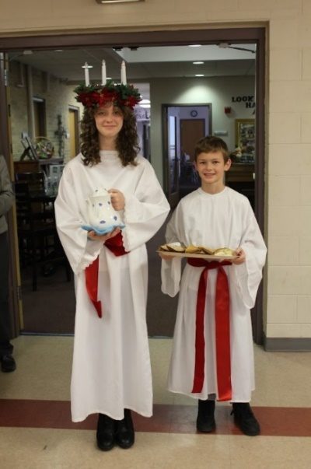
CELEBRATION OF ST. LUCIA
SUNDAY, DECEMBER 13
St. Lucia – Rika Ballard
Helper – Teddy Ballard

And special thanks for the beautiful decorations and delicious food!


SUNDAY, DECEMBER 17^{TH,} love your scarves & headbands!

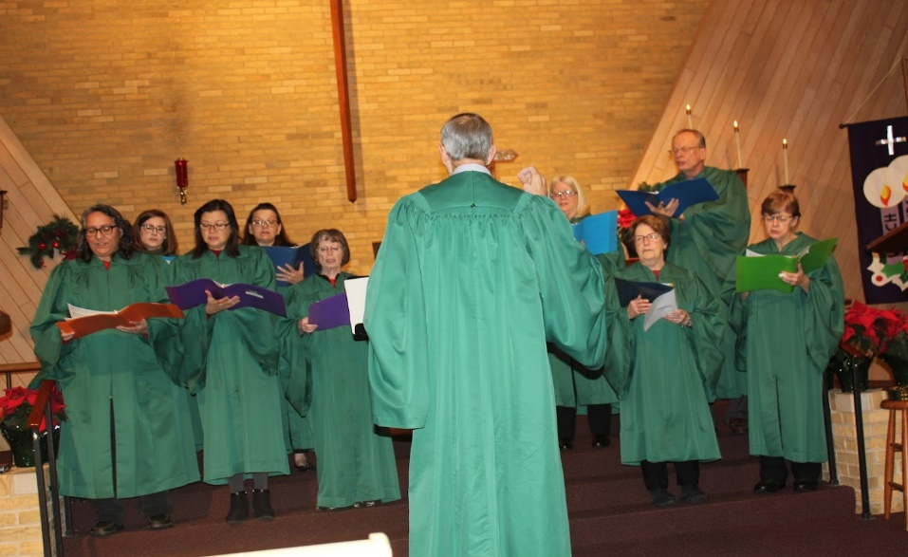

CHOIR - 4TH SUNDAY of ADVENT/CHRISTMAS EVE
BLESSED NEW YEAR!

