 | JANUARY 2025
 | AMAZING GRACE  CONNECTIONS  Faith > Family > Community

Grace Lutheran Church of Lily Lake
5N600 Hanson Rd, St. Charles, IL 60175
Pastor David Mercurio

Worship every Sunday
At 9:30 am with Communion
.
- Jan 5 – Worship, Sunday School and Coffee Hour
- Jan 13 – Worship, Pastor Jane Perkolup preaching
- Jan 19 – Worship and Sunday School, Pastor Jane Perkolup
- Jan 26 – Worship

February Sunday School dates are the 2nd and 16th.

ANNUAL MEETING OF GRACE LUTHERAN

Our important ANNUAL MEETING will be held on Sunday, February 2nd, after the worship service. A quorum is required and a number of important items will be voted upon including our 2025 budget and new committee members. Please mark your calendars. We are also seeking members to step up for nominations on the Vision Team (ideally 2 ppl), Audit Team (1 person), Nominating Team (ideally 2-3 ppl). Please see Lee Strom, Cara Turner to discuss or any Vision Team member – Dallas Peters, Nancy Schnaitman, Kurt Redemann, Cathy Lindquist or Tricia Painter.

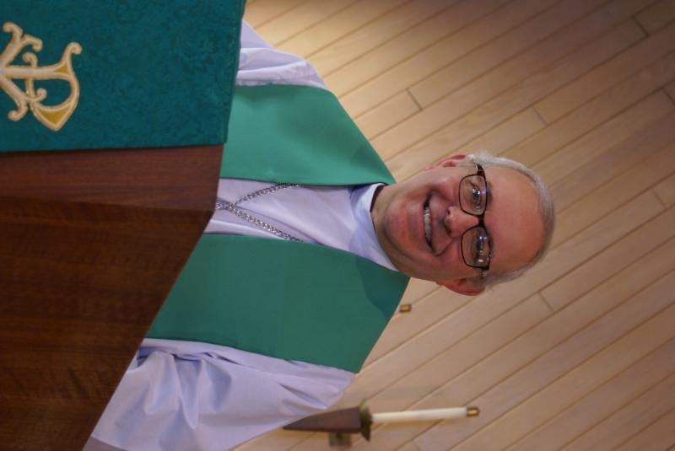
From PASTOR DAVID, January 2025
Every Advent season, Christian pastors, (yours included), make sure to incorporate the themes of thanksgiving and gratefulness in their sermons. Despite it being abundantly obvious that we have so much to be thankful for, it should warm our hearts to be reminded of those reasons. And as I have been working on those themes in my messages, I couldn’t help but think of what Grace Lutheran Church has given me. I’ve spoken with too many pastors over the years whose congregations are at war with each other or the pastor, and usually over some silly non-doctrinal issue. Here, on the other hand, I have experienced nothing less than complete harmony. Many congregations are shrinking to the point of disbanding; we are growing. Many churches are struggling to pay their basic expenses. Yes, we have had our share of financial stress, but through your sacrificial giving, our finances have gotten healthier. Many churches are desperate to find the necessary volunteers for even basic functions. Here, every one of you helps in a great way according to your gifts and abilities.
I know that as long as we continue to preach the Word and live it out, God will continue to bless this congregation.
I thank my God every time I remember you. In all my prayers for all of you, I always pray with joy because of your partnership in the gospel from the first day until now, being confident of this, that he who began a good work in you will carry it on to completion until the day of Christ Jesus. (Paul’s letter to the Philippian church)
Blessings to you,
David

Pastor’s Hours: Tuesdays and Thursdays from 6 pm – 9 pm, and Sundays from 8:30 am for 3-4 hours and by appointment when requested. He will be on vacation from January 9th through January 23rd.

SUNDAY SCHOOL AND PARENTS DAY OUT CHILDREN
Bell Playing and Singing on December 15th

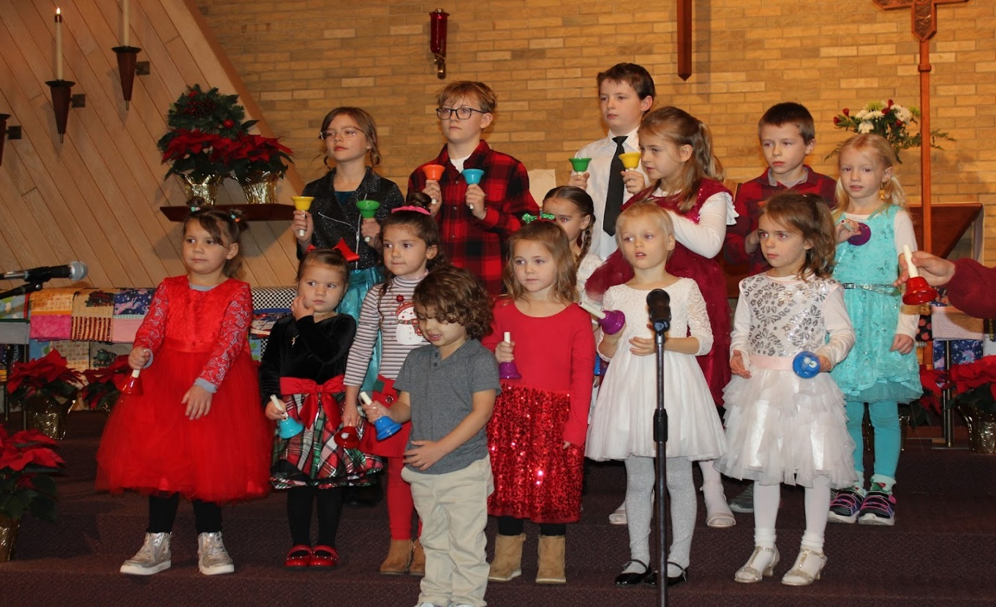


SPECIAL THANKS to all who have shared their time and talents with Grace , including but not limited to:
- All those who assisted with the candle lightings for our Advent wreath.
- Emmy and James and Natalia for their wonderful piano playing.
- George and the choir for the great music.
- The Sunday School and PDO children for their music program on Dec. 15th.
- The anonymous donor of gift cards for pastor to use at his discretion.
- All of you who baked for the cookie sale and helped set up/take down.
- All who helped with the noon New Year’s Eve program on Dec. 31st especially Nancy Corbige, chief coordinator.
- Linda Smykowski for making sure our coffee hours happen and on the correct dates.
- All of you who contributed to the Giving Tree, ELCA God’s Good Gifts, & the Hat, Glove and Sock Tree.
- All who have made contributions to help pay down our mortgage.
And many more of you who give generously of your time!

FINANCIAL MATTERS – JANUARY 2025

Financial Matters – “end of” December 2024 – looking to “January 2025”

We have made it to the last month in the year and many recaps, overviews and budgeting decisions to be discussed and decided. Everyone’s gracious donations to Grace, allow a variety of ministries to continue and expand within our building and in our community.

- The Holiday Bake Sale with vendors participating, was quite busy and successful on Dec. 14 raising $1,300. This fundraiser goal was to help our Grace family and donated to the mortgage principal. Thank you to all of the volunteers and esp. the ‘bakers’ who contributed their time and culinary talents to our mission.
- Our donations earmarked for extra principal: $22,328 (pd in Nov), and (at the time of this writing), with Dec. donations earmarked for the mortgage, we are hopeful to make another principal payment before Dec. 30th (~$6,500).

Brief recap of November financials:
2024 2023
Nov 2024 Year-to-Date Year-to-Date

INCOME $ 14,134 $ 188,713 $ 160,651
EXPENSES $ 14,424 $ 185,280 $ 163,755
NET +/- $ - 290 $ 3,433 $ - 3,104

Pray for blessings upon Grace as we continue our mission and ministry, complete a budget for 2025 – and reach new goals with God’s Guiding Hands ~ In Peace ~ Tricia Painter, Treasurer


This Photo by Unknown Author is licensed under CC BY-ND
Parents day out
A new ministry at grace

This program for children 3 – 5 years (potty trained only) is open on Mondays and Wednesdays in Fellowship Hall from 9:15 am – 1:15 pm. Two teachers will be on site each day. The program will be using Christian materials. Costs and registration are now open. If you wish to register your child or volunteer to be a substitute teacher, please contact Janice at Janice.muncie@gmail.com.

VISION TEAM REPORT
Meeting was held on December 10th
- Minutes from November 12th meeting were approved.
- Discussed the possibility of providing a scholarship for a three year old from a needy family to our Parents Day Out. Parents Day Out is now operating in the black!
- 2025 Budget meeting was held on December 17th. Results to be voted on at the February 2nd Annual meeting.
- Pastor will be reviewing our “donation” recommendations for those wishing to use our building for events, funerals, weddings, etc. including different costs for members and non-members. Our volunteer members spend hours planning for funerals and being in the building during them.
- Dallas is working on putting together a Welcome Packet for new members.
- Projected cost of boiler maintenance for our new boiler is $2,700 for spring and fall maintenance. Grace had been paying $5,600 to $6,000 a year for repairs prior to the new boiler.
- Pastor’s goal is to eventually have 100 people at worship each Sunday!
- Next Vision Team meeting will be January 14th, 2025!

EVENTS NOT TO BE MISSED
(see Sunday worship information above)
- LINE DANCING continues on Wednesdays through December 15th from 6-7 pm in Fellowship Hall. It will then start up again on January 8, 2025.

- ANNUAL MEETING, February 2nd immediately following worship.

MISCELLANOUS INFORMATION
- If you can knit or crochet, we need you to help make more prayer shawls as we are running low (a wonderful problem to have). We have the yarn so please contact Helen Gruber if you can help. If you know of someone who could benefit from having a PRAYER SHAWL, please let Twyla Strom know.
- The Finance Team is looking for volunteers to sign up as counters (counting our weekly offerings after worship) to have a rotating list of counters Please see Linda Smykowski or Tricia Painter for further details.
- The Worship Team is seeking additional volunteers to sign up to help run our power point during worship which brings the bulletin onto the TV screens in the sanctuary. Especially needed on the 1st and 3rd Sundays of the month. Please see Tricia Painter. If interested.
- Our new website sign on is graceoflilylake.org (not .com)


REBECCA CIRCLE

The Rebecca Circle takes a break through the winter months but that
doesn’t mean we aren’t preparing for our missions for 2025! We will not
have official meetings in January or February, but lots of planning will be
going on behind the scenes! And hopefully some new, meaningful things for
next year!
We plan to resume meeting in March, so look for information in the March
Newsletter. We usually meet on the third Tuesday of each month so please
join us!

We will continue collecting for God’s Good Gifts through most of January, so
look for our report in the February Newsletter. It should be exciting to hear
all the good that our little church in Lily Lake, IL can do for needy families in
other parts of the world. Please stop by the Rebecca Circle Christmas tree
in the Gathering Room and browse a catalogue and see what ways your
donations can help and how they are used by the ELCA.

SPECIAL MINISTRY INFORMATION:

Bridge to Life Group’s Jesus Closet (homeless in Elgin): Items needed are backpacks, blankets, gym shoes, t-shirts, jeans, coats and socks. Please mark donated items to the attention of Cathy Whiteside (630/605-1096). Thank you for all the donations.
Clothing and miscellaneous items for the migrants in Chicago are being collected by Cathy Whiteside (630/605-1096) to be given to Pastor Anna-Kari Johnson for distribution in Chicago. Thank you to all who have donated in the past. Left overs from our Spring Rummage Sale were already passed on to this ministry in June.
We are no longer collecting old pill bottles as they cannot be shipped overseas any longer. Thank you!


ROAD RUNNERS TRIP 2024
AND 2025 TRIP

Twenty-two Roadrunners gathered on Sunday, October 20th to share memories of this year’s trip to Gatlinburg, TN and Asheville, NC and to vote on where to go next year. It was narrowed down to Frankenmuth/Detroit, MI and Dubuque/Cedar Rapids, IA to mid IA. Iowa received the most votes! So, mark your calendar for the 2025 Roadrunner Trip to Iowa on September 22-27, 2025

NOISY OFFERING
Every Sunday we collect a “noisy offering” when you wish to empty your change purse or pockets. We are currently collecting for maintenance items, including our new boiler. Thank you.

COVID 19, FLU AND RSV SAFETY PROTOCOLS
We follow the recommendations of the CDC, ELCA and IL Department of Health.
If you wish to mask and social distance, please do so. Please do not come to church if you have symptoms of illness. If you do not feel comfortable worshipping with others, we invite you to join us for worship via our website, graceoflilylake.org

CONTACTS:
For emergencies, please contact the church office at 630-365-6751.
For prayer requests or other needs please call Kathy Hooey at 630-341-2293 or leave a message at the church office at 630-365-6751. Messages are checked daily at noon & 5 pm.

Information for the February newsletter will be due by January 25th– please send items to Marty Bradley at masbradley50@gmail.com. Thank you

BLESSINGS FOR
2025

