 | JANUARY 2026
 | AMAZING GRACE  CONNECTIONS  Faith > Family > Community
Grace Lutheran Church of Lily Lake
5N600 Hanson Rd, St. Charles, IL 60175
Pastor David Mercurio
Worship every Sunday
At 9:30 am with CommUNION
- January 4 – Worship and Sunday School & Coffee Hour
- January 11 – Worship
- January 18 – Worship Sunday School
- January 25 – Worship

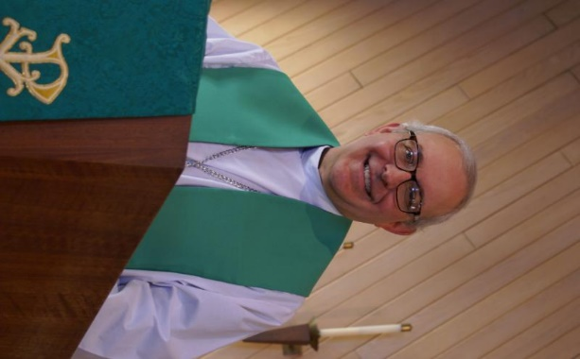
FROM PASTOR DAVID, JANUARY 2025

It’s a new year and the obligatory time for making resolutions, plans, and goals. It has become mandatory that losing a few pounds (from chocolate chip cookies), getting more exercise, and eating healthier are at the top of everyone’s list. After that, it becomes customized, so to speak. It is the time of year when we reflect on the year past, our accomplishments, our unfulfilled dreams, our wins and our losses. It is also the time when all the major media outlets will go through their own year in review: celebrities who died, sports champions, political trends, world events. Ultimately, these are all trivia and noise, the constant rhythm of the cycle of life.
Our focus is on the eternal. My prayer is that all of you will have a healthy and prosperous 2026, that illnesses will be healed, that broken relationships will be mended, that enemies will become friends. I pray that your faith will continue to grow and that your love will extend outward to touch even more of the lost so they too can come to know Jesus. I believe that as a faith community, we are well poised to see God do great things in His name. Our attendance continues to trend upward, our finances are on more solid ground than they have been in prior years, our service to our neighbors is vibrant, our faith is secure, our love for God is evident.
I am excited to see what plans God has in store for us this year and I continue to be humbled and honored to serve as your pastor. AMEN
Pastor’s Hours: Mondays, Wednesdays and Fridays plus Sundays and as needed and by appointment when requested.

VISION TEAM REPORT
If you have any questions or concerns, please contact a Vision Team member
At their December meeting the Vision Team:
- Approved minutes and treasurer’s reports.
- .Noted that Geneva Lutheran Church will soon have a new intern and will share this intern with us so that they can practice officiating in services.
- Fifty people attended the Nov. 23rd Community Thanks giving service.
- The kitchen has been painted and looks great. Cost was $6,070 – with $5,000 from Grace and the rest from the Rebecca Circle.
- Tricia Painter has served as many Vision Team terms as she is allowed. She will remain as our Treasurer and in that capacity, continue to attend the meetings.
- Vision Team is still reviewing new accounting programs and looking at IT concerns.
- Vision Team budget meeting will be 1/7/26.
- Annual Congregational Meeting is 1/25/26 following worship. The new budget and voting for new committee members will happen then.
- Please consider running for an open position on one of Grace’s Committees or the Vision Team. Your help is needed. Voting will take place following worship on January 25th at our Annual Meeting.

FINANCIAL MATTERS – JANUARY 2026

Financial Matters – “end of” Dec. 2025 – looking to “Jan. 2026”
Last month in the year and many recaps, overviews and budgeting
decisions to be discussed and decided - thus a brief update. Everyone’s
gracious donations to Grace, allow a variety of ministries to continue and
expand within our building and in our community.
- The Holiday Bake Sale, with vendors participating, was quite busy
and successful on Dec. 13, raising $1,200. Thank you to all of the
volunteers and especially to those that baked, who contributed their
time and culinary talents to our mission.
- Please mark your calendars and plan to attend the Annual Meeting to
be held after worship on Sunday, Jan. 25th , 2026.

Brief recap of November financials:
2025 2024
Nov 2025 Year-to-Date Year-to-Date
INCOME $ 23,392 $ 273,378 $ 188,713
EXPENSES $ 17,634 $ 214,386 $ 185,280
NET +/- $ 5,758 $ 58,992 $ 3,433

Continue to pray for blessings upon Grace as we continue our mission and
ministry, complete a budget for 2026 – and reach new goals with God’s
Guiding Hands ~ In Peace ~ Tricia Painter, Treasurer


REBECCA CIRCLE
Rebecca wishes all of you New Year’s blessings. We will continue our monthly meeting on the third Tuesday of March. The Circle has made a donation of $1,000 to Grace’s General Fund. The kitchen remodel has been completed and it looks wonderful.
We thank all of you who have supported this years ELCA Good Gifts Program. You will continue to have a chance to do so until the end of January. Please see the tree and catalog in the gathering room.


ROADRUNNERS 2026 TRIP

The next Roadrunners trip is scheduled for September
21-25 (or 26), 2026. We will be going to Frankenmuth, Michigan. Save the dates – more information to come.


SPECIAL THANKS to all who have given of their time, talent and gifts:

- Nancy Corbige and team for coordinating the New Year’s Eve party. Special gifts were given to 50 children.
- All who contributed gifts to the Elgin Crisis Center and the ELCA Good Gifts program.
- Sunday School and Preschool students for special music on December 21st.


LINE DANCING continues on Tuesdays
from 6-7 pm in Fellowship Hall in the new year from 1/6/26 to 4/28/26. Come enjoy the fun.


HABITAT FOR HUMANITY - POTTAWATOMIE
Grace Lutheran is a partnership church. Nancy Corbige, our representative to Habitat for Humanity, reports that they have started building a new house in St. Charles, north of Rte 64 and that volunteers are needed. Times you may volunteer include, Wednesday, Friday or Saturday from 8:30 am to 4 pm.

If you can volunteer a day or more, please send your name and email address to Nancy at ncorbige@gmail.com. She will keep us updated on the progress of the build. Volunteers do a variety of jobs, including providing lunches, doing clean up, painting and construction work.

SPECIAL MINISTRY INFORMATION
Bridge to Life Group’s Jesus Closet (homeless in Elgin): Items needed are backpacks, blankets, gym shoes, t-shirts, jeans, coats and socks. Please mark donated items to the attention of Cathy Whiteside (630/605-1096). Thank you for all the donations. Clothing and miscellaneous items for those in need in Chicago are being collected by Cathy Whiteside (630/605-1096) to be given to Pastor Anna-Kari Johnson for distribution in Chicago. Thank you to all who have donated in the past.

NOISY OFFERING Every Sunday we collect a “noisy offering” when you wish to empty your change purse or pockets. We are currently collecting for maintenance items. Thank you.

MISCELLANOUS INFORMATION
- SPECIAL TECH NEED: Are you familiar with IT / computer technology / streaming ?? We are asking for several people to become familiar with or learn the technology that we use to record our church services with. Seeking several people so we will be able to spread out the weekly tasks, so your assistance is not necessary every week ~ please consider ~ and contact Pastor or Tricia Painter
- If you can knit or crochet, we need you to help make more prayer shawls as we are running low. We have the yarn so please contact Helen Gruber if you can help. If you know of someone needing a PRAYER SHAWL, please let Twyla Strom know.
- The Finance Team is looking for volunteers to sign up as counters (counting our weekly offerings after worship). Please see Linda Smykowski or Tricia Painter for further details.

CONTACTS:
For emergencies, please contact the church office at 630-365-6751. For prayer requests or other needs please call Kathy Hooey at 630-341-2293 or leave a message at the church office at 630-365-6751. Messages are checked daily at noon & 5 pm.

Information for the Febuary newsletter will be due by January 25th– please send items to Marty Bradley at masbradley50@gmail.com. Thank you

“God’s purposes never change. Kingdoms may come and go, wars may rage and nations may be in uproar, but God wants to bring all people to know Him. It is God’s will to bring His peace to everyone, everywhere. All God’s people are made in the image of God, a people for whom God sent his Son into the world. And God loves us all.” (Paraphrased from the book, “A Table in the Presence” by Lt. Carey H. Cash, Marine Chaplain.)

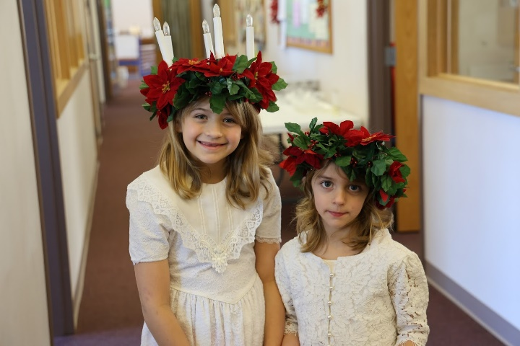
Bethany and Abby Roach as St Lucia, 12/7/25

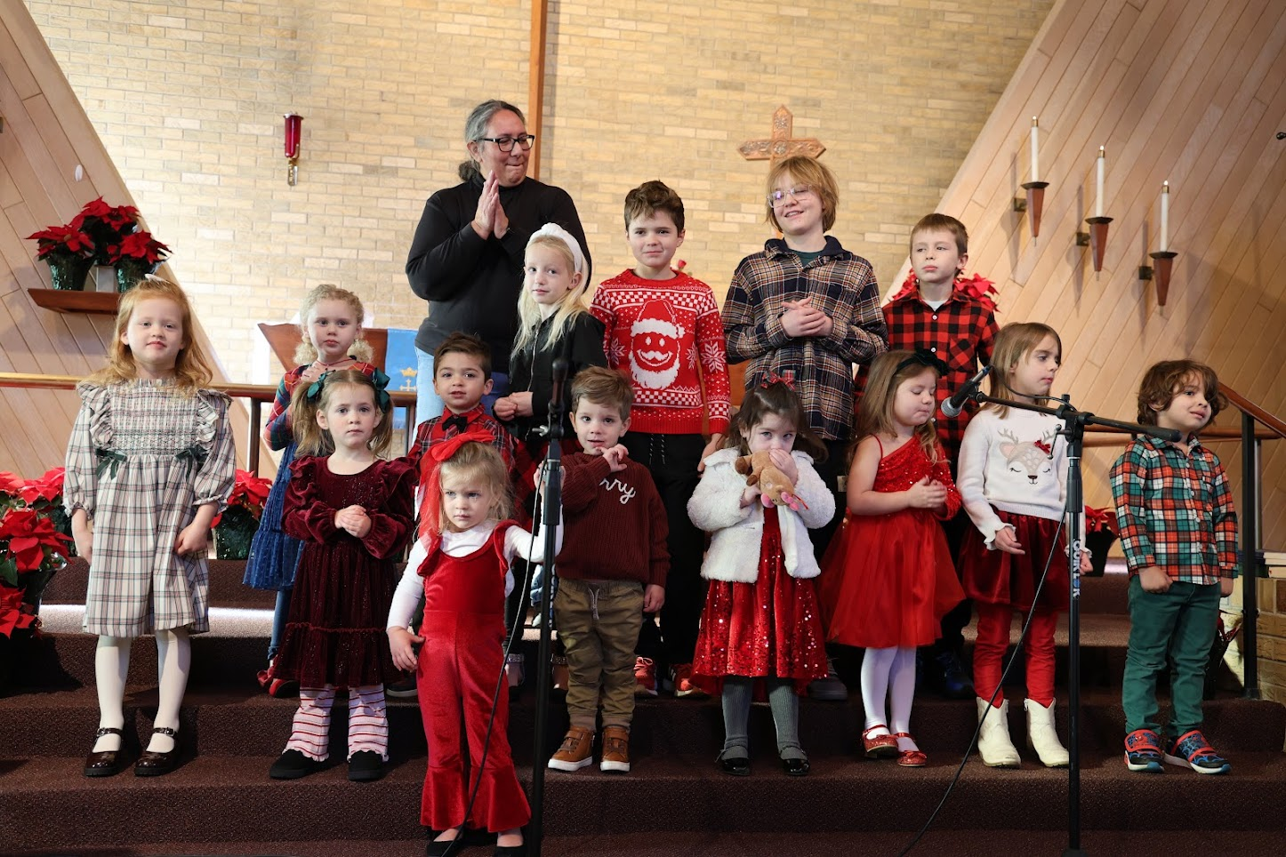
Sunday School and Preschool children singing in worship on 12/21/25

