.JULY 2022, VOL. 31
 | AMAZING  GRACE  CONNECTIONS
Faith > Family > Community
Grace Lutheran Church of Lily Lake
5N600 Hanson Rd, St. Charles, IL 60175
Pastor David Mercurio

Worship every Sunday at 9 am
With Communion
Sunday, July 3, Worship in the sanctuary, Coffee Hour following

Sunday, July 10, Outdoor Worship

Sunday, July 17, Outdoor Worship

Sunday, July 24, Outdoor Worship, special music by Pastor Jane and Steve

Sunday, July 31, Outdoor Worship
You are welcome to bring your own chair for outdoor worship if you wish.
(The nursery is available on Sundays for use by any parent)
Blessed fourth of july

COVID-19 Safety Protocols
We follow the recommendations of the CDC, ELCA and the IL Department of Health. We continue to watch the Kane County statistics. Face masks are recommended, but optional but we will continue to practice social distancing. We encourage everyone who is eligible to be vaccinated and boosted. This is the single, most effective way for us to protect ourselves and each other during this pandemic. If you don’t feel comfortable worshipping with others we invite you to join us virtually for worship via our website.
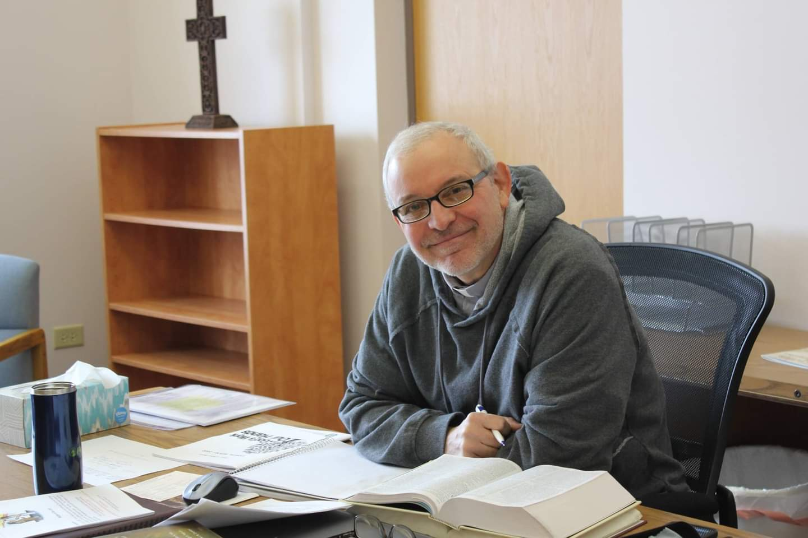
PASTORS MESSAGE
It has been another busy month here at Grace and I am so happy to see new faces almost every week. Here are some highlights on what has been happening:
- On Sunday, June 19, Grace Lutheran Church hosted Spoke Folk, a group of 35 high school and college students who were on a week-long bike trip practicing their evangelism skills and making new friends along the way. It was wonderful to see such energy and zeal in this next generation of disciples. And a special thank you to all our members who donated time, talents, food, and energy to put this all together.

- We have three more baptisms scheduled for June and July.

- On Saturday, June 4th, I attended the 35th annual Assembly of the Metropolitan Chicago Synod, held at the Chicago Marriott Naperville. There were 337 members in attendance, 220 lay leaders and 117 rostered ministers and deacons. A budget was presented and approved for the coming year and the Synod reported a small surplus for the past year. Four resolutions were presented and passed: 1) To petition Illinois legislators to stop suppressing protest for Palestinian civil rights 2) To treat ethnic ministers with special care and cultural sensitivity in the discipline process 3) To clarify and provide uniformity in the treatment of rostered pastors and deacons who are on leave or between calls 4) To establish a commission to review all governing documents of the Synod. A full description of all the presentations and documents can be found at: https://mcselca.org/who-we-are/synod-assembly.

These are trying times: We are going through high inflation, a steep decline in the stock market, a war in Eastern Europe, political divisions in our own country and increasing attacks on the Church worldwide. It is easy to get discouraged. But remember the words God spoke to Joshua: No one will be able to stand against you all the days of your life. As I was with Moses, so I will be with you; I will never leave you nor forsake you.

Pastor David

Pastor’s Hours at church
Tuesdays and Thursdays from 6 pm – 9 pm
Saturdays from 9 – noon Sundays from 8:30 am for 3-4 hours

VISION TEAM REPORT
At the June meeting the Vision Team discussed the synod assembly, approved a simple Good Samaritan procedure, the details of the Spoke Folk stay, noted the primary voting taking place at Grace on June 28th and any security concerns, accepted and discussed four estimates on having the garage roof replaced brought by Cathy Lindquist.

CONGREGATIONAL MEETING NOTES – JUNE 26TH
The Congregational Meeting occurred on June 26th as scheduled with a quorum of 37. Pastor opened and closed the meeting with prayer. Marty Bradley presented the 2021 audit and it was approved unanimously. Results of the pastoral survey: 35 were received and 31 noted that they wanted Pastor’s contract to be extended; no “No” boxes were checked. Comments from the surveys have been give to Pastor. Marty presented current 2022 budget information. It was noted that with the increase in expenses (that all of us are feeling), we may be $2000+ in the red every month. $6000 has been taken out of our savings account so far this year to cover normal expenses along with $15,000+ for the approved sanctuary furnance and sprinkler updates. Pastor and Marty discussed the need for all of us to seek to spread the gospel and encourage others to come to church. A list of building maintenance was also presented including some items that members could assist with. The list is long and includes some costly items including a new roof for the garage (4 estimates have been received; best one is $3700 and all four roofers noted that this needs to be done before winter), parking lot patching and sealing, some possible new windows, etc. The Vision Team approved opening an ongoing Building Maintenance Fund so that members can help to address these issuses. If you wish to contribute to this Fund, please note on your check or online that the money is to be put in the Building Maintenance Fund. Also, please keep your pledges and giving current over the summer as donations tend to drop at this time.

The main agenda item for this meeting was a vote to extend Pastor’s contract as it expired on June 30, 2022. Discussion included budget issues, the need to bring in new members, and meeting Pastor’s needs. Pastor explained a few options we might have for using an intern or seminary student to meet some of our needs, however, he also stated that he very much wants to continue his ministry with us and feels he is in the right place at the right time. We understand that we can only continue to keep him as part-time. The Vision Team recommended that we extend his contract for one year, until June 30, 2023. At that time we may be in a better financial place and he should be available to accept a true call, not just a contract.
Ballots were handed out to vote on the one year contract extension. All (37) were returned with yes votes. A special thank you to all who attended the meeting.
A letter with the financial information and building maintenance issues will be sent to all members. If you have questions, please contact Marty Bradley or Tricia Painter.
In Christ, Marty Bradley

FINANCIAL MATTERS – JULY 2022
- Noisy Offering being collected in June & July will go toward the expenses of getting the lightbulbs needed in our sanctuary and parking lots, along with rental cost of a lift to get to the high ceilings.
- Did you know that giving a gift from a tax-deferred retirement account can be one of the most tax-efficient ways to be charitable both during your lifetime and through your estate? Unlike a distribution to you or an heir, which would be a taxable event, charitable donations from retirement accounts lay no additional tax burden on you or the charity. Estate gifts from these accounts can go directly to charities through a donor-directed distribution agreement or fund named endowments. Contact a representative from your retirement fund company to learn further details.

Short recap on our May financials:
 |  |  |  | 2022 |  | 2021
 |  | May, 2022 |  | Year-to-Date |  | Year-to-Date
INCOME |  | $ 19,241.09 |  | $73,906.75 |  | $81,014.12
EXPENSES |  | $16,041.70 |  | $92,494.13 |  | $77,504.27
NET +/- |  | $3,199.39 |  | -$18,587.38 |  | $3,509.85
- Our Spring Rummage sale helped with our May finances as you can see above. We recoup some wonderful donations both to sell and in the $$s they bring in. Some have inquired if May 2022 “is this the most we have made at a sale?”, so I needed to go back to my notes…..(!) The earliest I have in my papers is May 2014 ($3,050); May 2017 ($2,252); May 2019 ($3,021); May 2021 ($4,210 – everyone wanted to get out to shop after COVID shutdown 2020 ); May 2022 ($4,600). So, this most current spring sale is the largest amount of funds we have raised in one sale - and on-line ads continue throughout the year as well. Thank you Linda Smykowski for letting me hand the baton to you and your continuing this task and coordinating all the details with on-line sales.

- Mid-year Giving statements will be sent out (email or USPS) around mid-July. Please be reminded that generally in summer months, with vacations, etc., the giving receipts tend to decrease in the summer as we forget to make our contributions. Please be mindful of your donations in the next few months as it will help to keep up with the ongoing activities at Grace. As in all our own homes, the ComEd bill will be higher in these summer months – so too, will Grace’s monthly bill.

2 Corinthians 9:6-8: Remember this, whoever sows sparingly will also reap sparingly, and whoever sows generously will also reap generously. Each of you should give what you have decided in your heart to give, not reluctantly or under compulsion, for God loves a cheerful giver.
In Peace, Tricia Painter, Treasurer

MANY THANKS AND PRAYERS TO THOSE WHO HAVE RECENTLY DONATED THEIR TIME AND TALENTS, including, but not limited to:

- To all who assisted with and contributed to the Spoke Folk potluck and breakfast, especially Vicki Linden, Suzanne Girsch, Linda Smykowski, Ian Engberg, Margaret Swanson for the beautiful center piece. If you missed their presentation, it was wonderful and very inspiring to see so many young people expressing their personal faith and sharing it with us. Cathy Whiteside for getting the article about Spoke Folk in the Daily Herald.
- Kathy Hooey for handling baptism requests and taking messages off our church phone every day.
- Again and again, George for creating our bulletins and setting up for outdoor worship.
- To Cathy Lindquist for getting four estimates to reroof the garage.
- To all of you who completed the pastoral review surveys.
- To all who assisted with Sunday’s service, June 26 and the Congregational Meeting.

If you wish to volunteer, please
contact Pastor or any Vision Team member.

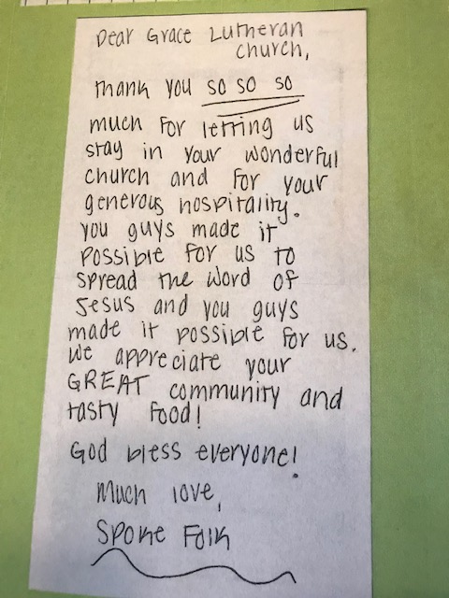


To My Family of Grace:

For some time, I've been wanting to find a way to express my sincere gratitude for the love and support shown to me and Norm these past four years. Briefly, over Memorial Day weekend in 2018, I was diagnosed with non-Hodgkin’s lymphoma. During this time there were many ups and downs: days of encouragement and days of wanting to give up: moments of great hope and those of great despair. Throughout it all one thing was constant and that was prayer from many sources including our family of Grace. How to say thank you?

Inspiration struck a few days ago from Facebook of all places! I enjoy reading "Sean from the South" authored by Sean Dietrich who writes human interest observations of everyday people. Some are funny, some challenging and some touching. The one I responded to was entitled "Close Knit” about those who
make prayer shawls. He had a long list of names of people who've made shawls and they've blessed people. He named churches and their locations from all over the country.

CLICK -- I responded: "Add Grace Lutheran Church of Lily Lake, IL" to your list! It's my home church. I received one (prayer shawl) just a few days after being diagnosed with cancer. It has been with me through everything. It reminded me of the love and support of my church family who were praying faithfully for me. Ever grateful!

Today my devotional reading was from Psalm 91 and while the reading took a different slant, I felt affirmation in sharing my experience with you. Vs. 4 says " He shall cover you with His feathers (and prayer shawl) and under his wings you shall take refuge (a safe place). His truth shall be your shield and buckles (in the battle of cancer). Vs. 5 “You shall not be afraid (of more bad news) of the terror by night (not able to sleep or nightmares) over the arrow that flies by day” (nor all the rounds of chemo or surgery or hospitalizations) and finally Vs. 11 “For He shall give His angels charge over you to keep you in all your ways.”

And so, a big THANK YOU to everyone who sent cards and notes; made calls or stopped by; brought food or sweet gifts; sat with me, cried with me and even laughed with me! Most of all whomever made my lovely white shawl and offered a prayer on my behalf, Norm and I are both eternally grateful.

In closing, my latest scans show "stable mass"--it's there but not changing. For me it means that I praise God for each day in humble adoration and great joy!

Blessings,
Shirley and Norm Turner
June 2022

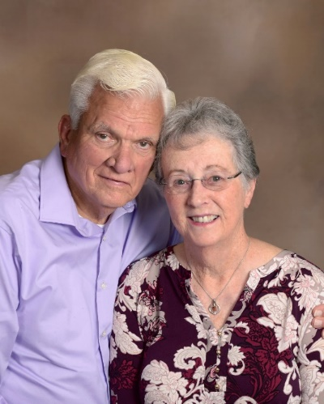
Getting to know Karen & Ken Patterson

My maiden name was Kuhl, pronounced cool. When I would meet someone, they would have no idea how to spell it; if they saw the written name, they had no idea how to pronounce it. I was so relieved to marry a McDonald! My dad worked at Cyclone Fence in DeKalb until Parkinson’s disease forced him to retire. I have a younger brother who has lived his entire adult life in Arizona. He repaired gambling machines in a casino for many years and always said he knew better than to play the machines! Ken is the oldest of two brothers and one sister. I worked at different offices over the years, but the most interesting was my last job as receptionist and medical records analyst for twenty years at Ecker Center for Mental Health in Elgin. One of my favorite memories is the several times a group of the clients were brought to our house for a picnic which included fishing and horseback riding. These people were so appreciative to come to the country for the day.

I grew up in Sycamore, moved away when I got married, and now I am again living in Sycamore, about a mile from my childhood home. I have three children and eight grandchildren. My first husband, Allen (Mick) McDonald, was killed when his ultralight crashed in 1993. Ken and I have been married for almost seventeen years. Ken has two daughters, four grandchildren and two greats. Ken was a lithographer until he retired. His passions include his lake home in northern Wisconsin, fishing and trap shooting. We both enjoyed snowmobiling and ATV’ing up north.

I became good friends with Linda Walker when we both sang in a barbershop chorus. Over the years we often socialized with Linda and Arne, and eventually we decided to join Grace. I always enjoyed singing and have sung in a variety of choruses, including many years in Grace’s choir. I have loved horses since I was a child and owned many over the years. We had many trails throughout our forty acres for horseback riding, ATV riding, and walking with our dogs and even a few cats. Now I walk in Sycamore neighborhoods and parks. There is an ELCA church within walking distance of our house, but I can’t imagine leaving my Grace family!

picnic & Bingo - tuesday july 19, 2022, 2pm
Bring White elephant gift for bingo prizes

everyone is welcome (Men, women, kids)
sponsored by rebecca circle
(food provided)
FELLOWSHIP HALL
For more information call:
Karen Patterson 847-683-2043
Cathy Whiteside 630/605-1096

MINISTRY NEWS

Homeless in Chicago: Cathy Whiteside took the donated jeans, hoodies, sweat shirts, suitcases, back packs, bags and hand sanitizer to Anna-Kari in June. Thank you to everyone for all the great donations.

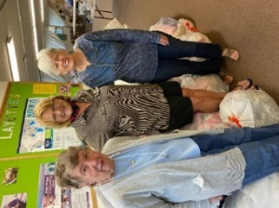
Lord of Life Lutheran Church in Schaumburg -Mission Quilters & Layettes: A large quantity of sheets and children’s clothes size 0-2T and blankets was taken to them from Grace in June. A thank you note was received from the Mission Quilters. They are so grateful and will put the donations to good work. They said to imagine the comfort those who receive a quilt we have helped supply will feel. Cathy Whiteside was able to take the items to Schaumburg with the blessing of Carol and Dave Langseth (they are still not getting around much). A huge thank you for all the donations!
Jesus’s Closet at Newlife Covenant Church Elgin IL: The donations of clothes for the homeless was taken to Elgin. Some items were from the last Rummage Sale at Grace and some given specifically for Elgin homeless.
Redeemer Fellowship Church in St. Charles opens a free clothes closet once a month for those in need. Cathy Whiteside, Paul and Dottie Mantsch brought summer clothes and linens and blankets to Redeemer in June. These clothes were left over from our Rummage sale and also a very generous collection of children’s clothes brought to us by Tricia Painter from her niece’s resale shop in Paw Paw, IL. Such beautiful clothes that give a person a good feeling to pass them on to those in need. Thank you Lord.

Adventure! MISSION TRIP To El Salvador Central America August 1- 7, 2022
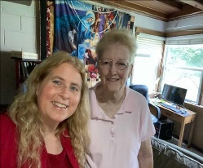
YOU CAN MAKE THE DIFFERENCE
El Salvador Trip 2022 – You are invited to come to El Salvador for an annual mission experience, August 1-7th, 2022! Pastors Kristian and Anna-Kari Johnson of Pilgrim Lutheran Church and School, Chicago, have been leading delegations to the Lutheran Church of El Salvador for nearly 25 years. We walk alongside the Salvadorans as they support children to go to school, install solar panels, help build churches, conduct medical campaigns, and participate in a peace march for human rights. Pastor Anna-Kari Johnson said that the following items would be gratefully received if someone wants to help the trip by donating: Over the counter meds (aspirins, pain meds, vitamins [all types), band aids, anti-bacterial ointment, Benadryl type gel etc. Since they will be going to schools any type of items suitable for school children. Anna-Kari said that the children really enjoyed the “bunnies” that were made out of washcloths and soap. A box will be provided in the Gathering Room to collect any donated items. This year’s trip brochure can be found here: https://tinyurl.com/elsalv22bro For more information, contact pastorkristian@pilgrimchicago.org

GRACE LUTHERAN CHURCH
HELP WANTED!
We are still looking for part time secretarial help (10-12 hours/week) in the church office. Microsoft Word and Powerpoint needed. Please pass this along to anyone who may be interested and have them contact Marty Bradley at general@graceoflilylake.com or 630-777-1074.

Please spread the word.
Grace Roadrunners…
This Photo by Unknown Author is licensed under CC BY-SA
will be taking their motorcoach trip to Wisconsin and Minnesota September 19-24th. Some of the scheduled stops will be at the International Crane Federation and Circus World Museum in Baraboo and a cranberry marsh and the Discovery Cranberry Center in Warrens, WI. We’ll tour the Capitol Building and the Cathedral of St. Paul in St. Paul. In Minneapolis we’ll go to the American Swedish Institute and Mill City Museum. A dinner theater event and lake dinner cruise are also on the itinerary. More events are scheduled. Yes, we continue to eat well on these trips! The cost will be about $900 per person for double occupancy which includes most of your meals, motel and entrance fees to events. Registration forms will be in the Roadrunner mailbox slot soon.
Questions-see Suzanne Girsch.

CONTACTS:
For emergencies please contact Marty Bradley, President, at 640-777-1074 or leave a message at the church office at 630-365-6751.
For prayer requests or other needs please call Kathy Hooey at 630-341-2293 or leave a message at the church office at 630-365-6751. Messages are checked daily at noon & 5 pm.
ELCA MISSION WEBSITES

LUTHERAN DISASTER RESPONSE:
https://www.elca.org/our-work/relief-and-development/lutheran-disaster-response
ELCA WORLD HUNGER APPEAL:
https://www.elca.org/Our-Work/Relief-and-Development/ELCA-World-Hunger
LUTHERAN WORLD RELIEF:
https://lwr.org/
REFUGEE ONE https://www.refugeeone.org/
Information for the August newsletter will be due by
August 25th – please send it to Cathy Whiteside Cathy@imotay.com Thank you!

