JULY 2023, VOL. 43
 | AMAZING  GRACE  CONNECTIONS

Faith > Family > Community
Grace Lutheran Church of Lily Lake
5N600 Hanson Rd, St. Charles, IL 60175
Pastor David Mercurio

Worship every Sunday at 9 am
with Communion
Sunday, July 2, Outdoor worship with inside coffee hour
Sunday, July 9, Outdoor Worship
Sunday, July 16, Outdoor Worship
Sunday, July 23, Outdoor Worship
Sunday, July 30, Outdoor Worship
Worship will remain outdoors through the summer unless weather is prohibitive, then we will worship indoors; signs will be posted. Outdoor or indoor, there will be a coffee hour inside, the first Sunday of each month.

BLESSINGS AND CONGRATULATIONS
At the June 25th Congregational Meeting, the 50 members of Grace in attendance unanimously voted to officially call Pastor Mercurio to Grace. For the past year and a half he has been working under contract for us. After the Synod’s approval, they will provide us his official call date. He will remain part time.
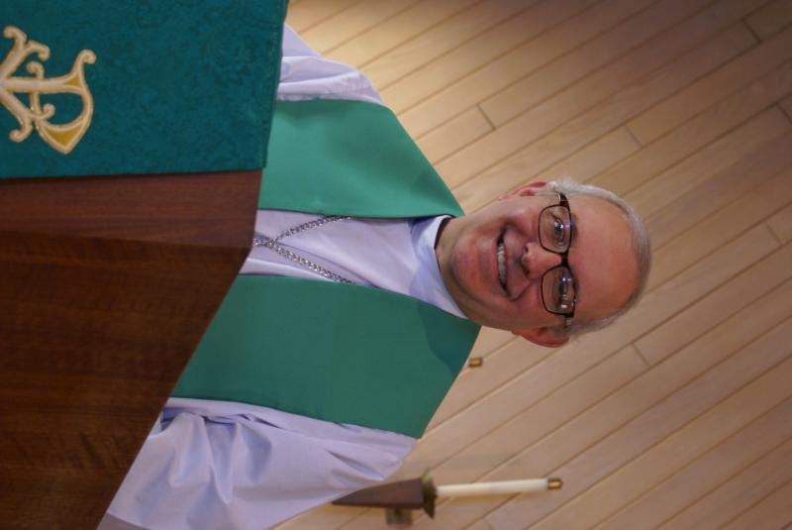
PASTOR’S MESSAGE

From the desk of Pastor David, July, 2023
.
I regularly follow a handful of Roman Catholic theologians in print and on podcasts. (I also regularly watch You Tube music videos of bands from the ‘60’s and ‘70’s, but that’s a topic for another newsletter). And while we Lutherans have many theological differences with our Catholic brethren, I admire them especially for two reasons. For one, they are well-schooled in the history of the church fathers (e.g., Tertullian, Augustine, Thomas Aquinas, to name a few) and regularly offer commentary that gives me insight into the early church. But more relevant and important is how they have taken up the gauntlet in the culture wars.
The Catholic Church’s problems with child abuse are well documented but seem to be for the most part well behind them. It would have been easy for the Church to “lay low” to avoid criticism and charges of hypocrisy, but today many Catholic leaders (lay and clergy) have taken a firm and vocal stand promoting the sanctity of life, the protection of children, parental rights, freedom to worship, and even traditional liturgies. I am inspired by their courage and commitment.
It is easy for us to become discouraged when we see declining numbers of congregants across all denominations. But two quotes come to mind. “So too, at the present time there is a remnant chosen by grace.” (Romans 11:5); and a quote by Tertullian, a 2nd century Christian writer: “The blood of martyrs is the seed of the church.” (I read “blood” in today’s context figuratively, not literally). I believe we are God’s remnant, and He has called us for such a time as this. Stay faithful; stay strong; stay connected to the true vine. Continue to let your light shine in this dark world.
Blessings to you all, Pastor David
Pastor’s Hours at church: Tuesdays and Thursdays from 6 pm – 9 pm
Saturdays from 9 – noon Sundays from 8:30 am for 3-4 hours

PLANNING FOR FALL SUNDAY SCHOOL
We are already looking ahead to fall Sunday School. We would like to have a
Sunday School coordinator and additional teachers (you would not have
to teach every Sunday). Please prayerfully consider volunteering
and contact Marty Bradley for more information and to volunteer.
 WORSHIP INFORMATION

- Altar flowers – If you wish to provide the altar flowers, please see the sign up sheet in the gathering room. There are still Sundays available in August and throughout the fall.
- Bulletins – The intent of all the TV screens in the sanctuary was to be able to decrease the number of bulletins we copy each Sunday to save money on paper and copying costs as well as post announcements, pictures, etc. We will gladly provide bulletins for those who cannot see or read the screens, but hope that you would forego requesting a bulletin if you can use the screens instead. Thank you.



The famous line dancing group…look for more fun this fall.
Lots of visitors came each week and were very generous in their free will donations.

JUNE VISION TEAM REPORT
The Vision Team met on June 13th
- Approved minutes and treasurer’s report
- Vision Team meeting in July changed to Thursday, July 13th
- Vice President Kelly Diehl resigned from the Vision Team due to increased time needed as President of the Lily Lake Village board. Per the consititution, the Vision Team can apoint someone to fill this role through the end of the year. Dallas Peters, Jr. has agreed to fill this role until the end of the year. Thank you Dallas!
- Approved recruiting volunteers to serve as leaders for baptisms/weddings and funerals.
- Approved Fall Sunday School to be every Sunday for at least Sept – Nov.
- Worship time change to 9:30am approved at June 4th Congregational Meeting to begin on September 10th.
Please remember to greet visitors each Sunday and ask them to sign the register.

The Vision Team meets on the second Tuesday of each month. If you have items you feel should be discussed by the team, please send them to Marty by the first Tuesday of the month.

Blessings, Marty Bradley, President

Financial Matters – July 2023

- Our 2nd quarter income was boosted by the Rummage Sale. Generally in the couple of upcoming summer months, our donations trend downwards. Your continued donations are a blessing to Grace and allow us to carry on a variety of ministries to serve our community.
- We have received $906 in Thrivent Choice Dollars, from 8 members and 4 outside individuals. Thank you for choosing Grace as your beneficiary of these Thrivent donations.
- Presently the Building Maintenance Fund balance is $3,820. The Building Maintenance Team reviews building and safety needs, outside of the regular maintenance services . If you wish to donate to this specific fund, please notate “Building Maintenance Fund”, so the donation will be designated accordingly.
- Thank you for the donation of copy paper – we have a full supply. Each of these donations helps keep our expenses down.

Brief recap of May financials:
2023 2022
May 2023 Year-to-Date Year-to-Date
INCOME $ 20,277** $ 89,217 $ 73,906
EXPENSES $ 14,068 $ 78,743 $ 92,494
NET +/- $ 6,209 $ 10,474 $ -18,588

**Spring rummage sale income was $4,666**

Pray for blessings upon Grace as we continue our mission and ministry, with goals and challenges in 2023 ~ In Peace, Tricia Painter, Treasurer
 REBECCA CIRCLE

Next meeting is Tuesday, July 18th
Picnic and bingo in Fellowship Hall at noon.
Please join us!


MANY THANKS AND PRAYERS TO THOSE WHO HAVE RECENTLY DONATED THEIR TIME AND TALENTS, including, but not limited to:

- Our wonderful “kitchen” crew for assistance with funeral luncheons
- Kathy Hooey for picking up messages twice daily from our church phone, putting together the weekly “What’s Happening” sheet, coordinating funerals and baptisms, altar care and set-up for communion, etc.
- Ken Kusch for attending to a number of electrical issues in our building
- Natalia Diehl for filling in when Dottie is on vacation; she is a great pianist
- Nick Rex for continuing to send out Eblasts until we get another volunteer up and running
- Linda Smykowski for tending our garden and spraying for any ants in the building
- Cathy Lindquist and Linda S for counting/depositing the offering every Sunday
- George Theros and Dallas Peters for cable wiring work to boost a signal to outdoor worship

VOLUNTEERS NEEDED
- Volunteers needed to assist with computers and set up during worship – easy tech items; please see George if you can help
- Fall Sunday School: coordinator and teachers needed, see Marty to volunteer

NOISY OFFERING
Every Sunday we collect a “noisy offering” when you wish to empty you change purse or pockets. We are currently collecting for caulking of windows. We have several windows that need work. Thank you, cha-ching…

COVID 19, FLU AND RSV SAFETY PROTOCOLS
We follow the recommendations of the CDC, ELCA and IL Department of Health.
If you wish to mask and social distance, please do so. Please do not come to church if
have symptoms of illness. If you do not feel comfortable worshipping with others, we invite
you to join us for worship via our website.
UPCOMING SPECIAL DATES
- July 18th – Rebecca Circle and Bingo
Noon in Fellowship Hall
- August 5th – Cancellation of Car Show that was being planned due to logistics, time and volunteers
- August 18th - Elburn Days Parade at 5 pm
Grace will have a float in the parade. Leader and Volunteers to help decorate
the float and ride on it are needed.
- September 14th from 6 – 7 pm beginning of fall Line Dancing thru Dec. 14th
Every Thursday (except Nov. 23rd)
- September 18 – 23 - Roadrunners Trip to Niagara Falls
See Suzanne Girsch for more information
- September 30th – Octoberfest from 5 – 9 pm at Grace
Please contact George Theros if you can help; sign up sheet to come soon
- October 6 & 7th – Fall Rummage Sale
Start saving items for the sale (please do not bring to church until that week)
- November 10th – Life Line Screening at Grace


GRACE ROADRUNNERS

Registration is still open for the Grace Roadrunners trip to Niagara Falls, September 18-23. Some places and sights we’ll be exploring are Notre Dame, RV/MH Museum, Rock and Roll Hall of Fame and many sites around Niagara Falls including Niagara on the Lake and Old Fort Niagara. As we head back home we’ll see a Jaws with Paws demonstration and Rutherford B. Hayes’ home. This trip will cost $1100-$1300 per person based on double occupancy and how many people sign up. A deposit of $500 holds your place with the balance due August 1st. The first 40 registrations are guaranteed a spot and then a wait list will be started. Registration forms will be in the Roadrunner mailbox in the church office. Contact Suzanne Girsch if you have questions.

CONTACTS:
For emergencies please contact Marty Bradley, President, at 640-777-1074 or leave a message at the church office at 630-365-6751.
For prayer requests or other needs please call Kathy Hooey at 630-341-2293 or leave a message at the church office at 630-365-6751. Messages are checked daily at noon & 5 pm.

Information for the August newsletter will be due by July 25th – please send it to Marty Bradley at martybradley@mchsi.com. Thank you!

