.JUNE 2022, VOL. 30
 | AMAZING  GRACE  CONNECTIONS
Faith > Family > Community
Grace Lutheran Church of Lily Lake
5N600 Hanson Rd, St. Charles, IL 60175
Pastor David Mercurio

Worship every Sunday at 9 am
With Communion
Sunday, June 5th – PENTECOST Indoor Worship
Coffee Hour following
Sunday, June 12th – Outdoor Worship
Sunday, June 19th - Outdoor Worship
Spoke Folk in the evening
Sunday, June 26th – Outdoor Worship with Baptisms
**CONGREGATIONAL MEETING FOLLOWING WORSHIP ON 6-26-2022**
Indoor worship will continue on the first Sundays of June, July and August. Outdoor worship (weather permitting) will take place on the remaining Sundays of those months. You are welcome to bring your own chair if you wish.
(The nursery is available on Sundays for use by any parent)


SPOKE FOLK COMING TO GRACE
This Photo by Unknown Author is licensed under CC BY-NC-ND
SPOKE FOLK is a biking ministry that is passionate about living and sharing the love of Christ. You may remember them being here several years ago. We will be hosting them on Sunday, June 19th through the morning of the 20^{th.} We will share a potluck meal with them at 6:30 pm on Sunday and they will provide a musical presentation for us at 7 pm that evening. Please sign up if you plan on attending the potluck and presentation. We also need helpers for the evening and morning meals.
COVID-19 Safety Protocols
We follow the recommendations of the CDC, ELCA and the IL Department of Health. We continue to watch the Kane County statistics. Face masks are recommended, but optional but we will continue to practice social distancing. We encourage everyone who is eligible to be vaccinated and boosted. This is the single, most effective way for us to protect ourselves and each other during this pandemic. If you don’t feel comfortable gathering indoors with others at this time, we understand, and invite you to join us virtually for worship via our website.
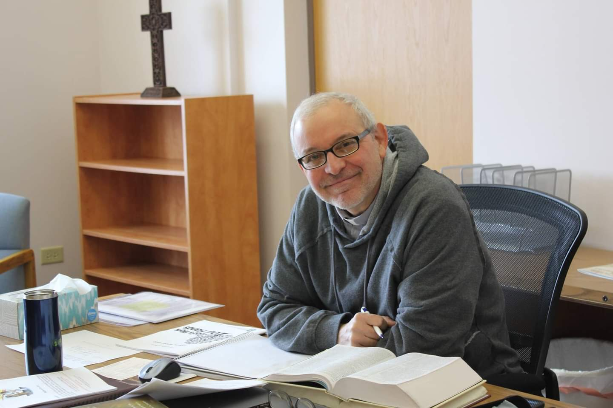
PASTORS MESSAGE
As we continue to celebrate the resurrection of our Savior, Grace Lutheran Church is also experiencing a type of rebirth and renewal. More folks are feeling more comfortable returning to our weekly Sunday service; we have returned to our traditional communion at the altar; young families are coming back to the church; we have even more baptisms scheduled this month; the Girl Scouts and Boy Scouts are entering their season of high activity here at the church; we just finished a very successful Spring rummage sale; we are hosting a youth cycling missionary tour this month; and we are starting our outdoor services. After two years of darkness, we are bathed in light once again.
It is not easy being a Christian in today’s world. Sadly, we are a shrinking minority of the population, and our values and beliefs are under attack in the public square. That is why regularly reuniting with God’s community for a time of refreshing, encouragement, and spiritual nourishment is so important. We look forward to all God’s people returning to worship this summer.
Our God is an awesome God,
Pastor David
Pastor’s Hours at church
Tuesdays and Thursdays from 6 pm – 9 pm
Saturdays from 9 – noon Sundays from 8:30 am for 3-4 hours

VISION TEAM REPORT
- Reviewed needed building maintenance and discussed where to start and possible costs. Member assistance is needed.
- Discussed our budget shortfall and possible ways to address it.
- We are still seeking secretarial help in the office.
- NEEDED: one or two people to be trained on our worship computer system. Please contact George Theros if you are interested.
- Note: Kane County will be using the building on June 28th for voting.
Don’t forget to join us for the Spoke Folk potluck at 6:30pm
and program at 7pm on June 19^{th.} Please sign up.
Financial Matters – June 2022
Financial Matters – June 2022
Just a reminder that we are not sending out 1st quarter giving statement, 2nd qtr statement will be sent by end of July. With having prepared your own taxes recently, we are hopeful you have reviewed your tithes and giving to Grace for the first half of 2022.
Noisy Offering being collected in May & June will go toward the expenses in getting the lightbulbs needed in our sanctuary and parking lots, along with rental cost of a lift to get to the high ceilings.

Spring Rummage Sale raised over $4,600 in May – the largest amount we have raised in one sale. Please(!) see the Rummage Sale recap.
 |  |  |  | 2022 |  | 2021
 |  | April, 2022 |  | Year-to-Date |  | Year-to-Date
INCOME |  | $ 13,598.87 |  | $54,665.66 |  | $65,647.70 *rcvd PPP $$$
EXPENSES |  | $28,687.07** |  | $76,452.43 |  | $64,012.17
NET +/- |  | -$15,088.20 |  | -$21,786.77 |  | $1,635.53
**Previously approved sanctuary heating system – funds will come from savings

MANY THANKS AND PRAYERS TO THOSE WHO HAVE RECENTLY DONATED THEIR TIME AND TALENTS, including, but not limited to:

- Tricia Painter for her continuing wonderful organizing of the Rummage sale and for all the helpers and donators
- Those who donated 11 x 17 paper, Norm and Shirley Turner, Pat and Chili Lindgren
- Pat Penfold and Kelly Diehl for their superb and gracious leadership in our spring Sunday School sessions
- Kurt Redemann and Ian Engberg for their continuing assistance in helping to keep the building in working order
- Marla Roach for volunteering to assist with our website – Hurray!!!
- The Boy Scouts for the wonderful pancake breakfast and some of the leaders/parents for taking down our dead tree out front
- SPECIAL Thanks to Nancy Corbige for providing a line dancing event at the Elburn Community Center from January 12 through April 27 to assist a family with medical expenses. A free-will donation was taken each week and provided a significant contribution.

If you wish to volunteer, please
contact Pastor or any Vision Team member.


SPRING RUMMAGE SALE "
SPRING RUMMAGE SALE – MAY 2022 – What a wonderful event , with support and dedication from so many at Grace and throughout our community. “Thank you’s” to the many who had accumulated and saved your donations. We were spread out on Grace property: clothing, shoes, purses, etc. were staged under the pavilion – coordinated by Cathy Whiteside. The garage area displayed our ‘outdoor related’ items and some furniture: coordinated by Linda Smykowski. Jewelry and fine collectibles area in Fellowship Hall: coordinated by Margaret Swanson and Suzanne Girsch. The rest of Fellowship Hall was for household items (thank you Twyla and Debbie who came early and organized fabrics, bedding, linens, etc.) and one SS room was used for children’s equipment, toys, and games (thank you Helen, Cara and Ian for helping earlier in the week to organize this room!). Utilizing so many areas, allowed many shoppers to casually peruse + shop. (**there was even space out on the property for the Boy Scouts to have a campout!) The weather cooperated, tho quite warm for the beginning of May! I am certainly appreciative and proud of all of your support and assistance from many of our members with the numerous tasks before, during and after the sale. Some pre set-up in Fellowship Hall by the Scouts after their meeting on Monday night, followed by other volunteers Ian Engberg, Cara Turner, Twyla Strom, Debbie Brown, Cathy Whiteside, Karen Patterson, Marty & Craig Bradley, Lee Gerke, Dianne (Gerke) Lily, Chris Gerke, Jon Whiteside, Helen Gruber, Nancy Corbige + Danny, Linda Smykowski , Dottie & Paul Mantsch, Nancy Schnaitman, Kathy Hooey, Pat & Lee Eineke, John Verner, Kurt Redemann, Pat Penfold and Gloria Theros. Sale signs were set up/placed by Bill + Lori U’Ren, Casey Engberg, Heidi Anderson, Dottie & Paul Mantsch. The success of this sale comes from a church-wide effort with all of your ‘material’ donations and contributions along with your time and talents. (** I apologize as I may have missed a name or two – but try to track the willing hands that are with us during the plethora of sale tasks each day). Special note of thanks to the several members who stepped up at the last minute and loaded their cars with some leftovers on Sunday – making their way to Salvation Army.
Our gracious thanks to Cathy Whiteside ( please greet her with your thanks!) who continues to coordinate several avenues and charities before and after the sale, taking clothing items that are very welcomed : select items taken to Lord of Life in Schaumburg to help make LWR Quilts and layettes (in hopes that some of their handmade items, made with love and prayers, will reach some Ukraine refugees too) , Redeemer Fellowship Church (St Charles) , Elgin Homeless, Pastor Anna-Kari Johnson’s outreach in Chicago and small items to be used to fill some Operation Christmas Shoeboxes.
So many of you reading this report were a part of this sale, in big and small ways, from donating items (and we don’t always know who the donors were) to volunteering at the sale. It is gratifying to see so many helping hands. I was exhilarated (yes, even at the end of the sale) by the clean-up help - we’re getting this down to an efficient routine. I feel so blessed that so many of you dedicated time out of your schedules, to help with this fundraiser for Grace (I take off 2 days of work, but maybe I need to take 3 days!). I would not be able to coordinate these sales without all of you – “rumors” I have heard that some of you have had fun with this event as well !! Our shoppers were given a Grace flyer and welcomed them to visit Grace for worship (we had a visitor return on Sunday morning.) Our 2- day sale netted just over $4,600 – I believe this to be our highest dollar amount raised at one sale. We continue with some on-line ads and sales and have exceeded the goal for our targeted mid-year budget. These funds help our finances as we are incurring building maintenance expenses. I thankfully pray for all of the support that so many of you have given – many hands to make the tasks at hand run smoothly and provide a very successful fundraiser.
In Peace, from Your Fellow Grace Member, Tricia Painter, Rummage Sale Coordinator (**tentatively looking at Oct 7 & 8 for our Autumn Sale**)

Adventure! MISSION TRIP To El Salvador Central America August 1- 7, 2022
YOU CAN MAKE THE DIFFERENCE

El Salvador Trip 2022 – You are invited to come to El Salvador for an annual mission experience, August 1-7th, 2022! Pastors Kristian and Anna-Kari Johnson of Pilgrim Lutheran Church and School, Chicago, have been leading delegations to accompany the Lutheran Church of El Salvador for nearly 25 years. We walk alongside the Salvadorans as they support children to go to school, install solar panels, help build churches, conduct medical campaigns, and participate in a peace march for human rights. This year’s trip brochure can be found here: https://tinyurl.com/elsalv22bro For more information, contact pastorkristian@pilgrimchicago.org

GRACE LUTHERAN CHURCH
HELP WANTED!
We are still looking for part time secretarial help in the church office. Please pass this along to anyone who may be interested and have them contact Marty Bradley at general@graceoflilylake.com or 630-777-1074.

Please spread the word.

Grace Roadrunners…
This Photo by Unknown Author is licensed under CC BY-SA
will be taking their motorcoach trip to Wisconsin and Minnesota September 19-24th. Some of the scheduled stops will be at the International Crane Federation and Circus World Museum in Baraboo and a cranberry marsh and the Discovery Cranberry Center in Warrens, WI. We’ll tour the Capitol Building and the Cathedral of St. Paul in St. Paul. In Minneapolis we’ll go to the American Swedish Institute and Mill City Museum. A dinner theater event and lake dinner cruise are also on the itinerary. More events are scheduled. Yes, we continue to eat well on these trips! The cost will be about $900 per person for double occupancy which includes most of your meals, motel and entrance fees to events. Registration forms will be in the Roadrunner mailbox slot soon.
Questions-see Suzanne Girsch.

Military Gift Boxes: The Rebecca Circle is planning again this year to remember both our military and our college family. We are planning to send gift boxes to the military this spring and boxes to our college students in the fall. For the military mailing, we are asking your help in verifying/updating the military addresses. There are forms available on the bulletin board in the social entry at church. You may leave the completed form in the church office. Small items, appropriate for mailing, are being accepted for the gift boxes. Examples: gum, candy, notebooks, pens, etc.
Thank you for your help and participation.

CONTACTS:
For emergencies please contact Marty Bradley, President, at 640-777-1074 or to leave a message call the church office at 630-365-6751.

For prayer requests or other needs please call Kathy Hooey at 630-341-2293 or to leave a message call the church office at 630-365-6751. Messages are checked daily at noon and 5 pm.

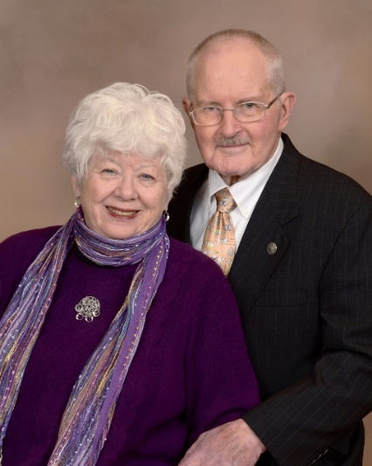
Getting To Know..
David & Carol Langseth
- ANCIENT HISTORY: WW2 MODELS, 1940-1969
David: I was born in Williston, North Dakota (ND) on May 7, 1940. Dad was a school teacher and we moved every few years living in four small ND towns. In 1947, we moved to a Langseth Homestead in Pelican Rapids, Minnesota (MN), where we cultivated a small diversified dairy farm, which included Holstein dairy cows, Angus beef cows, Leghorn chickens, and a Collie dog who ran the place. I graduated from Pelican Rapids Public School in 1958, Concordia College, Moorhead, MN in 1962, and attended Luther Theological Seminary, St. Paul, MN. The third year of theological studies is called “Internship in a Congregation,” which for me was Grace Lutheran Church, Washington, D. C. I was ordained July 2, .196 at Grove Lake Lutheran Church, rural Pelican Rapids, Minnesota. I officially retired on February 15, 2006.
Carol: I was born in Portland, Oregon (OR), on May 9, 1942. My father, Ralph Martinson, owned a neighborhood grocery store. My mother, Phyllis Nelson Martinson, “retired” from being a Registered Nurse when she was married December 25, 1940, and concentrated on raising her children. I am the oldest of four siblings, two girls and two boys. I have attended Portland State University Oregon State University, and the University of Oregon, from which I graduated in 1964. In 1965, I received a Master’s Degree from Boston (MA) University , majoring in Economics and African Studies. I then worked as an Economist specializing in Africa for the U. S. Government in Washington, D. C.
- WORKING AS A TEAM, 1969-2006
Carol attended Grace Lutheran Church in Washington, D. C. when we met. We eloped July 21, 1969, while men were first walking on the moon. While all the world was “watching and talking about the moon, men, modules, and things, we were in Fairhaven, MA exchanging rings!”
These have been exciting years. We have lived in Boston, MA (1969-1971); The Bronx, New York (1971-1974); Staten Island, NY (1974-1984); Schaumburg, IL (1984-2006); and Huntley, IL (2006-present).
We hav made three major additions to our family: Three lovely daughters: Anna-Kari Joy, b. June 26, 1971; Lizbet Dori, b. February 6, 1973; and Aili Marta, b. August 20, 1975.
- FACING THE FUTURE TOGETHER, 2006-PRESENT
These three daughters have found three wonderful husbands and live respectively in Chicago, IL; Hastings, MN; and Minnetonka, MN.
The future continues to unfold with breath-taking speed and in surprising ways: Eight grandchildren (three girls and five boys), which includes eight Baptisms, three Confirmations, one High School graduate, three drivers’ licenses, musical instruments, athletic teams, academic recognitions, defeating Grandpa and Grandma in “Sorry” and “Parcheesi” and stumping Grandpa and Grandma with riddles and questions!
These three daughters have found three wonderful husbands and live respectively in Chicago, IL; Hastings, MN; and Minnetonka, MN.
There are four (4) reasons. we became a part of “the family” of Grace.
Reason #1 I had visited Grace Lutheran Church of Lily Lake one time, perhaps around 1990. Pastor Rex was working with a Seminary Intern at Grace. I was working with a Seminary Intern at Lord of Life Lutheran Church in Schaumburg. There were perhaps 10 or 12 Pastors and Interns in the Chicago/Rockford area doing the same thing. The Lutheran School of Theology at Chicago (LSTC) set up a Support Group for these Pastors and Interns, which met perhaps six (6) times during that year. One of these meetings was held at Grace of Lily Lake. I liked the setting, the area, the building, and the ladies of Grace gave us an outstanding lunch! This was the first time that I met Pastor Rex and the first time I saw the Grace building and grounds.

Reason #2 The closest ELCA (Evangelical Lutheran Church in America) congregation to where we live is Shepherd of the Prairie Lutheran Church in Huntley. We attended this Church one of the first Sundays when we moved to Huntley in 2006. We knew 19 people there, some of which had been former members of Lord of Life Lutheran Church in Schaumburg. We thought it would be more fun to join a Congregation, where we hardly knew anyone.
Reason #3 The third reason has to do with the internal polity of the ELCA. As you know I am an ordained Pastor of the ELCA. The roster of ordained Pastors of the ELCA is maintained by the individual Synods. There are 65 Synods, so there are also 65 synodical rosters. It is continually discussed and sometimes debated within the ELCA whether a Pastor should be rostered. . . . .1). . In the Synod where he/she lives; or. . . . .2). .In the same Synod where the congregation (the congregation to which he/she belongs) is rostered; or. . . . .3) . .In the Synod where he/she received his/her present (or last for retired Pastors) Call. This is especially an important question for Synods that are home to some large Church institutions, such as colleges, seminaries, social service agencies, Churchwide administrative offices, etc. The Metropolitan Chicago Synod is home to Lutheran School of Theology; Churchwide offices; Lutheran Social Services of Illinois, etc. While I live in Northern Illinois Synod, I did not want to lose my place on the Metro Chicago Synod roster. It was attractive to us that Grace is in the Metro Chicago Synod.
Reason #4 Pastor Norm Nelson, whom I have known as a friend for a long time, was twisting my arm!
The future continues to unfold with breath-taking speed and in surprising ways: Eight grandchildren (three girls and five boys), which includes eight Baptisms, three Confirmations, one High School graduate, three drivers’ licenses, musical instruments, athletic teams, academic recognitions, defeating Grandpa and Grandma in “Sorry” and “Parcheesi” and stumping Grandpa and Grandma with riddles and questions!
Submitted April 29, 2022 by Pastor David and Carol Langseth

St Peter’s has graciously invited any of our
children to join them for Bible School !
VACATION BIBLE SCHOOL 2022
St. Peter’s Lutheran Church
43W301 Plank Road
Hampshire, IL 60140
Bible Stories and new friends * Amazing experiments * Creative Crafts * Snacks
Missions * Games and More!
Welcoming children ages 4 through Grade 6
Children 7th grade and up will be youth helpers
M-Th June 20-23 9 am to 11:45 am; Friday June 24 9 to 10 am
Church office: 847-464-5721 (Hours 9 am to 1 pm)
Church website: www.stpetersnorthplato.org
Registration: Please register online beginning on 4/15/22*
Registration Fee: $10.00 per child payable the first day of VBS
* We are hoping to have all of our registrations done online this year. However, if you do need a paper registration form, please contact the church office (info above) and we will get one to you. If possible, please get your registrations in by June 10th. Thank You!



.
ELCA MISSION WEBSITES

LUTHERAN DISASTER RESPONSE:
https://www.elca.org/our-work/relief-and-development/lutheran-disaster-response
ELCA WORLD HUNGER APPEAL:
https://www.elca.org/Our-Work/Relief-and-Development/ELCA-World-Hunger
LUTHERAN WORLD RELIEF:
https://lwr.org/
REFUGEE ONE:
https://www.refugeeone.org/

Information for the July newsletter will be due by
June 20th – please send it to Cathy Whiteside Cathy@imotay.com Thank you!

