JUNE 2023, VOL. 42
 | AMAZING  GRACE  CONNECTIONS

Faith > Family > Community
Grace Lutheran Church of Lily Lake
5N600 Hanson Rd, St. Charles, IL 60175
Pastor David Mercurio

Worship every Sunday at 9 am
with Communion
Sunday, June 4, Inside worship, coffee hour
and Congregational Meeting
(we prefer you to attend the meeting in person but if you need to connect from home please contact George Theros for zoom information)
Sunday, June 11, Outdoor Worship
Sunday, June 18, Outdoor Worship
Sunday, June 25, Outdoor Worship
Worship will remain outdoors through the summer unless weather is prohibitive, then we will worship indoors. Whether outdoor or indoor, there will be a coffee hour inside, the first Sunday of each month.

PLANNING FOR FALL SUNDAY SCHOOL
We are already looking ahead to fall Sunday School. We would like to have a
Sunday School coordinator and additional teachers (you would not have
to teach every Sunday). Please prayerfully consider volunteering
and contact Marty Bradley for more information and to volunteer.
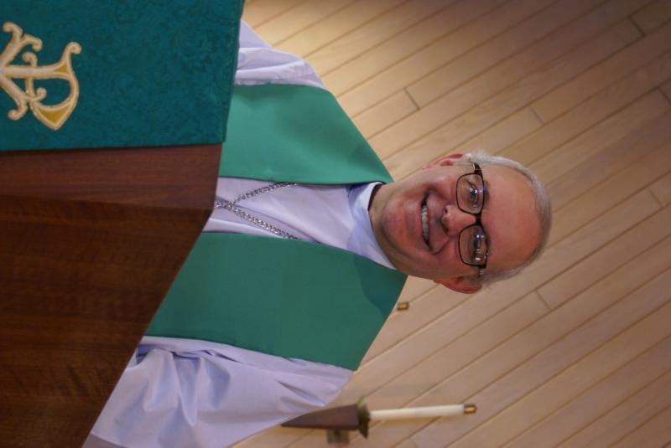
PASTOR’S MESSAGE

From the desk of Pastor David, June, 2023
A few years ago, a friend of mine suggested that the world had lost its mind. Given the chaos, the tribalism, the vitriol, the perversions, the rage, the disillusionment, and the anxiety of today, I suspect he would double-down on his assessment. And it’s hard not to agree.

But putting things into perspective, the world has always been engulfed in such things. How different is Covid 2020 with the Bubonic Plagues of the 14th century? Aren’t the hooligans tormenting every major city center today just an iteration of the Fascist Black Shirts under Mussolini in the period leading up to WWII? Do we really value human life these days any more than the ancient civilizations who practiced human sacrifice in the name of religion? The more things change…

This is why I love being at Grace. In addition to the natural beauty of the surrounding countryside, the congregation is an oasis of peace, calm, joy, and love. A community who looks upward and outward has tranquility inward. Continue to pray that more of our neighbors will join us to experience God’s love
Blessings to you all, Pastor David
Pastor’s Hours at church: Tuesdays and Thursdays from 6 pm – 9 pm
Saturdays from 9 – noon Sundays from 8:30 am for 3-4 hours

MAY VISION TEAM REPORT
The Vision Team met on May 9th
- Approved minutes and treasurer’s report
- Discussed the June 4th congregational meeting and appropriate motion to bring to the congregation about officially calling Pastor Mercurio
- Reviewing our current insurance policy
- Discussed the possibility of having 50/50 raffles and requirments. Members agree with Pastor that this was not how we want to do ministry
- Outdoor worship will begin June 11th through the summer with coffee hours on the first Sunday of the month INSIDE

Please remember to greet visitors each Sunday and ask them to sign the register.

The Vision Team meets on the second Tuesday of each month. If you have items you feel should be discussed by the team, please send them to Marty by the first Tuesday of the month.

Blessings, Marty Bradley, President

FINANCIAL MATTERS – MAY 2023

- Our 1st Qtr of the year has proved to be fruitful for Grace in meeting our financial needs. Your donations have been a blessing to Grace and allow us to continue on our journey in a variety of ministries and help us serve our community. Our prayers for continued growth in Christ and continued growth here at Grace as we journey through the 2nd qtr.

- The community Spaghetti Dinner held on April 1, helped raise funds for the Northern IL Food Bank: $438. Thank you to George + Gloria Theros for heading up this event, with many helping hands assisting at the event.

- Nancy Corbige has graciously shared her time, talents and leadership with bringing line-dancing to Grace AND our community each week since January. Fun, fellowship and exercise = has also raised over $1,300.

- The Building Maintenance Team has been reviewing and addressing building and safety needs. If you wish to donate to this specific fund, please notate “Building Maintenance Fund”, so the donation will be designated accordingly. Present Building Maintenance Fund balance is $4,665. Noisy offering collections add up as well – we are grateful for all donations big and small.

Brief recap of March financials:
2023 2022
March 2023 Year-to-Date Year-to-Date

INCOME $ 14,901 $ 49,654 $ 41,066
EXPENSES $ 15,054 $ 47,757 $ 47,765
NET +/- $ - 153 $ 1,897 $ - 6,699

Pray for blessings upon Grace as we continue our missions with goals and challenges in 2023.
In Peace, Tricia Painter, Treasurer
.
REBECCA CIRCLE
This Photo by Unknown Author is licensed under CC BY

Next meeting is Tuesday, June 20th
At 1 pm in Fellowship Hall
Please join us!
Spring Rummage Sale Recap

Our Spring Rummage Sale held on May 19 & 20 – was blessed with a little rain before we opened on Friday morning, and was sunny and bright otherwise. Set up groups assembled on Tues + Wed (which definitely gives us a great jump on organization!) and Thursday had quite a gathering in preparing and setting up our donation items. “Thank you” to the many ‘donors’ who had accumulated and saved your donations. We were spread out on Grace property: under the pavilion with clothing, etc. (coordinated by Cathy Whiteside) garage/outdoor related items (coordinated by Linda Smykowski), jewelry and fine collectibles (coordinated by Margaret Swanson and Suzanne Girsch), and household items were on display at lower entryway, Fellowship Hall, and 2 Sunday School rooms. Utilizing so many areas, allowed many shoppers to casually peruse + shop. We certainly are grateful for all of your support and assistance with the numerous tasks before, during and after the sale. Some pre set-up in Fellowship Hall by the Scouts after their meeting on Monday night, followed by other volunteers Ian Engberg, Cara Turner, Twyla Strom, Debbie Brown, Cathy Whiteside, Karen Patterson, Marty Bradley, Lee Gerke, + granddaughter: Becca Gerke, grandson: Austin Lilly, Diane Lilly, Chris Gerke, Jon Whiteside, Nancy Corbige, Helen Gruber, Linda Smykowski , Cathy Lindquist, Dottie & Paul Mantsch, Kathy Hooey, Kay Kinsel, Kathy Fritschel, Rose Davis, Kurt Redemann, Shirley Turner, Cheryl Nelson, Margaret Swanson, Suzanne Girsch, Kay Kinsel, Jan Myers, Katie Delahanty, Bev Crosby. Sale signs were set up/placed/taken down by Bill/Lori U’Ren, Dottie/Paul Mantsch, Cara Turner, Tricia. The success of this sale comes from a church-wide effort with all of your ‘material’ donations and contributions along with your extra time and talents. (** I apologize as I may have missed a name or two – tho, I do try to track the willing hands that are with us during the many tasks each day ). Special note of thanks to those that helped in our clean up efforts and filled their cars with some of our leftovers – as we had Fellowship Hall packed up by 4pm and Heidi packed/picked up the rest by 7pm !

Ongoing thanks and gratitude to Cathy Whiteside (who coordinated her team diligently from afar when she couldn’t be here) who continues to coordinate several avenues and charities before and after the sale with various clothing items, select items for Carol Langseth’s connection with the ladies who sew LWR Quilts, items for Christmas Shoeboxes. Other children’s items were donated to the Joe Boway Family for the Liberian Children’s Mission school, a local neighbor ships items to Honduras (nuns help support local homeless and domestic violence shelter), books/cds/dvds to the Elburn Library.

Many of you reading this report were a part of this sale, in big and small ways, from donating items to volunteering at the sale. It is gratifying to see so many helping hands. Without the help of many of you, it would not be such an efficient routine. I feel so blessed that so many of you dedicate your time, talents and goods to support this fundraiser for Grace. What a wonderful community event with visitors and repeat shoppers coming to Grace , showing their support within our community. Our 2-day sale netted just over $4,550 – the blessings abound! The dollars raised certainly help offset some of our building maintenance expenses in our continuing care of God’s house. I’m grateful and thankfully pray for all of the support that so many of you have given – many hands does make all of the tasks at hand, run smoothly. The fellowship and support are priceless! In Peace, from Your Fellow Grace Member, Tricia Painter, Rummage Sale Coordinator
(**Autumn Sale dates: Oct 6 & 7)


MANY THANKS AND PRAYERS TO THOSE WHO HAVE RECENTLY DONATED THEIR TIME AND TALENTS, including, but not limited to:

- Tricia Painter, our Rummage sale leader and coordinator!!!!
- All of the choir members who supplied beautiful music this past year
- The Audit Team for completing the 2022 audit
- Our altar “guild”, Kathy Hooey, Helen Gruber, Twyla Strom and others who pitch in
- Those who put together lunches to be delivered to Lazarus House
- To all who completed the survey about Pastor

VOLUNTEERS NEEDED
- Volunteers needed to assist with computers during worship – easy tech items; please see George if you can help
- Fall Sunday School: coordinator and teachers needed, see Marty to volunteer

THANKS YOUS TO GRACE

- The Northern Illinois Food Bank thanks us for the donation from Grace of $427.50 received as a part of the money raised at our spaghetti dinner.
- Lazarus House thanks us for assistance given to them, in particular lunches made and delivered to them.
- Jakab Schmidt, a grandson of Robert Jaeger, thanks us as a recipient of a scholarship from the Swanson Family Scholarship Fund which goes to a family member related to a member of Grace.

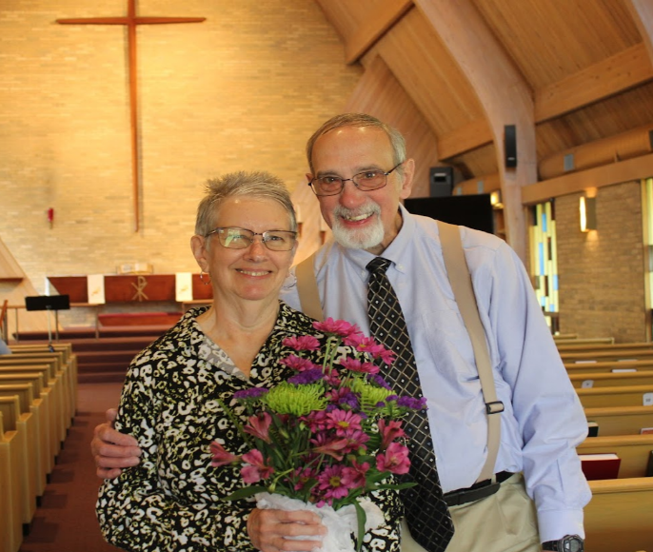
COVID 19, FLU AND RSV SAFETY PROTOCOLS
We follow the recommendations of the CDC, ELCA and IL Department of Health.
If you wish to mask and social distance, please do so. Please do not come to church if
have symptoms of illness. If you do not feel comfortable worshipping with others, we invite
you to join us for worship via our website.

*Additional DATES TO REMEMBER*
June 3 – 2023 ELCA Metropolitan Chicago Synod Assembly
Theme: In Jesus: Make Disciples
Dottie and Paul Mantsch will be representing us there.

OUTDOOR WORSHIP BEGINS JUNE 11
and will continue through the summer months.
Indoor coffee hour will continue on the 1st Sunday
of each month indoors

VACATION BIBLE SCHOOL
St. Peter’s Evangelical Lutheran Church
open to all Grace members on June 26-30 9:00 am - 11::45 am (M-TH) 9:00 am - 10:00 am (F) For ages 4 through Grade 6. And students in Grade 7 and up can register as youth crew leaders* Fee: $10/child (payable first day of VBSS. *There is no fee for student volunteers) Registration opens May 1st.
43W301 Plank Road Hampshire, IL 601
www.stpetersnorthplato.org 847-464-5721


GRACE ROADRUNNERS
Registration is still open for the Grace Roadrunners trip to Niagara Falls, September 18-23. Some places and sights we’ll be exploring are Notre Dame, RV/MH Museum, Rock and Roll Hall of Fame and many sites around Niagara Falls including Niagara on the Lake and Old Fort Niagara. As we head back home we’ll see a Jaws with Paws demonstration and Rutherford B. Hayes’ home. This trip will cost $1100-$1300 per person based on double occupancy and how many people sign up. A deposit of $500 holds your place with the balance due August 1st. The first 40 registrations are guaranteed a spot and then a wait list will be started. Registration forms will be in the Roadrunner mailbox in the church office. Contact Suzanne Girsch if you have questions.
CONTACTS:
For emergencies please contact Marty Bradley, President, at 640-777-1074 or leave a message at the church office at 630-365-6751.
For prayer requests or other needs please call Kathy Hooey at 630-341-2293 or leave a message at the church office at 630-365-6751. Messages are checked daily at noon & 5 pm.

Information for the July newsletter will be due by July 25th – please send it to Marty Bradley at martybradley@mchsi.com. Thank you!

A message from the ELCA presiding bishop in the May/June
“Living Lutheran” magazine:
The church is a people created by God in Christ, empowered by the Holy Spirit, called and sent to bear witness to God’s creative, redeeming, and sanctifying activity in the world: (ELCA Constitution). Do we always get it right? No. Since, as it has been said, the church is not a hotel for saints, but a hospital for sinners… And yet, God continues to use the church, and our branch of it to be an ambassador of hope and to keep telling the radical story of grace. We are a church that understands the baptized to be at once saints and sinners.
Here is part of an essay by 20th century Roman Catholic brother Carlo Carretto: “How baffling you are, Church, and yet how I love you! How you have made me suffer, and yet how much I owe you! I would like to see you destroyed, and yet I need your presence. You have given me so much scandal and yet you have made me understand what sanctity is. I have seen nothing in the world more devoted to obscurity, more compromised, more false, and yet I have touched nothing more pure, more generous, more beautiful. How often have I wanted to shut the doors of my soul in your face, and how often I have prayed to die in the safety of your arms.”
That pretty well sums up the beautiful maddening, sublime and broken reality of the church and of its people. God alone preserves the church and God alone renews it. But God, in God’s inscrutable wisdom, continues to call, gather, enlighten and make “holy the whole Christian church on earth and keeps it with Jesus Christ in the one common, true faith” (small Catechism) and invites sinners to be part of the body of Christ.

Pray for the church, for openness to God’s spirit, humility in discernment, and bold trust that God will bless our efforts as we seek to give the gospel free course in the world.


