 | JUNE 2024
 | AMAZING GRACE  CONNECTIONS  Faith > Family > Community
Grace Lutheran Church of Lily Lake
5N600 Hanson Rd, St. Charles, IL 60175
Pastor David Mercurio

Worship every Sunday
At 9:30 am with Communion
- June 2 – Worship and coffee hour with CONGREGATIONAL MEETING – a quorum is need so please attend
- June 9 – Outdoor Worship,
- June 16 – Outdoor Worship
- June 23 – Outdoor Worship
- June 30 – Outdoor Worship

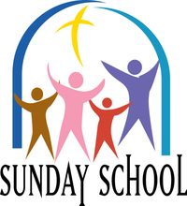
This Photo by Unknown Author is licensed under CC BY-NC-ND
SUNDAY SCHOOL & SUMMERTIME
Sunday School is in recess until the fall. Look for possible summer events for the kids. If you wish to help plan these events please contact Marty Bradley. Thank
you to all the kids and teachers.

CONGREGATIONAL MEETING, Sunday, June 2nd following worship: quorum of at least 32 members needed. Vote to be taken to approve the 2023 Audit. Discussion will also include our mortgage, update on the boiler and start up of parents out program in the fall..

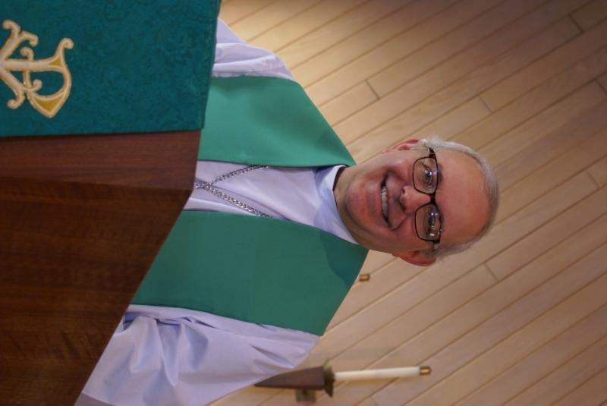
FROM the DESK of PASTOR DAVID, May 2024
I pray you all enjoyed a safe and fun Memorial Day. After the hot dogs, potato salad, lemonade, and apple pie were thoroughly consumed, hopefully you were able to experience some relaxing time with friends and family.
Memorial Day started right after the Civil War to mourn soldiers killed in battle. It is estimated that the number of Americans who have died in all wars since the American Revolution is about 650,000 due to direct combat and approximately another 539,000 from all other war causes such as wounds, friendly fire, vehicle accidents and suicide. That’s about 1.2 million Americans who gave their lives to protect their country and their loved ones. All war is bad, yet each side’s rulers always provide ample justification as to why participation is necessary.
Ironically, it is the common foot soldier who experiences the highest death rate, while, not surprisingly, the rate of death for rulers is nil. A million lives, had they not died, could have changed the course of history. Yet their bravery and sacrifice are still remembered today.
But all this time, even for thousands of years prior, there has been another kind of war going on, a spiritual war. And this spiritual war is even more noxious than traditional war because it is largely unseen, and it leaves its victims with (eternal) life threatening wounds which are never treated.
Just as our brave American soldiers in earthly battles serve as examples of courage and discipline, all the martyrs who died claiming their faith do the same for us who acknowledge that a better kingdom is reserved for us elsewhere. As Paul said in his letter to the Colossian Church: “Set your minds on things above, not on earthly things.” And to the Church in Corinth as an example for all of us: Be on your guard; stand firm in the faith; be courageous; be strong.” AMEN
Blessings to you. Pastor David
Pastor’s Hours: Tuesdays and Thursdays from 6 pm – 9 pm, and Sundays from 8:30 am for 3-4 hours and by appointment when requested.

MEMBERSHIP UPDATE:
- At their May meeting, the Rebecca Circle celebrated the lives of Lee Gerke, Eileen Morris (& George), and Marlene Klinger with memories, prayers and laughter.
- Sadly, on May 10th, one of our newest members, Jane Cutler, passed away peacefully. There was no memorial/funeral service. She led a very interesting life. Her obituary is available on Conley Funeral Home’s website. Her husband James is also a member. Please keep him in your prayers.
- Ask Kathy Hooey and Pat Penfold about the ELCA Lay Leadership Conference they attended. Thank you ladies for representing Grace.

MANY THANKS AND PRAYERS TO THOSE WHO HAVE RECENTLY DONATED THEIR TIME AND TALENTS, including, but not limited to:

- Tricia Painter and the whole Rummage Sale crew and all who donated. It was very successful.
- Sunday School teachers and kids for a great year – Janice Muncie, Pat Penfold, Natalia Diehl, and Nancy Corbige
- Nancy Corbige for leading our wonderful Line Dancing program!
- Linda Smykowski for planting and tending our garden.
- And, as always, all of you who take care of the major things and the little things at Grace.

FINANCIAL MATTERS –JUNE 2024

- Your donations have been a blessing to Grace and allows us to continue on our journey in a variety of ministries and help serve our community. Our prayers for continued growth in Christ and continued growth here at Grace as we journey through the 2nd qtr., into the summer months.

Brief recap of April financials:
2024 2023
April 2024 Year-to-Date Year-to-Date

INCOME $ 14,953 $ 68,817 $ missing at time
EXPENSES $ 13,857 $ 59,295 $ of printing
NET +/- $ 1,096 $ 9,522 $ ~ my apologies ~
.
- The 2-day Spring Rummage raised just over $5,000 - see recap in this newsletter – many of you reading this were a part of this event!

- Nancy Corbige has graciously shared her time, talents and leadership with continued line-dancing at Grace and our community each week. Fun, fellowship and exercise = has also raised over $1,400 for Grace with free-will donations. Line Dancing is off on a summer break and resumes in September. Thank you and Blessings to you, Nancy!

- The Building Maintenance Team continues to review and address building and safety needs. If you wish to donate to this specific fund, please notate “Building Maintenance Fund”, so the donation will be designated accordingly. Presently, the Building Maintenance Fund balance is $8,625. Noisy offering collections add up as well – we are grateful for all donations big and small. We thank Ken Kusch (Cara’s husband) for working on several electrical tasks in the pavilion and flagpole spotlight, and David Russell (a Scout leader) for plumbing repairs – for donating their time and expert talent.

Pray for blessings upon Grace as we continue our mission and ministry, with goals and achievements in 2024 ~ In Peace, Tricia Painter, Treasurer
.
MAY VISION TEAM REPORT
- Vision Team met on May 19th to discuss a proposed Parents Day Out program which would begin in the fall. They approved the program and will discuss it at the Congregational Meeting on June 2.
- May 28th meeting: The ELCA Foundation made a presentation to the Team as did our Girl Scouts who planted a tree on our property and donated $200 to Grace. Thank you.
- The April meeting minutes and treasurer;s report were approved.
- Long term planning items were discussed: Mortgage, Church Property Maintenance and the need for Treasurer’s assistance.
- Building Issues discussed included a boiler update and issues with the thermostat on rooftop AC unit, entryway water issues, the pavillon power line and the flagpole spotlight. The Fellowship Hall floor will be cleaned sometime during the first two weeks of June.

If you are unable to attend the Congregational Meeting on June 2, the minutes will be posted on the bulletin board in the gathering are.

Grace music and arts forum

The purpose of the Grace Music Arts Forum is to foster and further the development of music and arts at Grace Lutheran Church and in the greater Lily Lake community, including Music/Art Studies, Music/Art Events or Music/Art Lessons and fundraising. A yearly amount up to $500.00, which is administered by the Rebecca Circle, is available. Applications are due by September 1, 2024. Please contact Twyla Strom if you are interested.

UPCOMING SPECIAL DATES
- SUNDAY, JUNE 2ND – INDOOR WORSHIP, COFFEE HOUR AND CONGREGATIONAL MEETING – quorum is needed!
- SUNDAY, JUNE 9TH – Outdoor worship begins
- TUESDAY, JUNE 18th Rebecca Circle at 1 pm in Fellowship Halll
- SATURDAY, JUNE 29TH at 9 am – CLEAN UP DAY AT CHURCH! Lots of hands are needed.


REBECCA CIRCLE

Please join us on Tuesday, June 18th at 1:00pm in the Fellowship Hall for the June meeting of the Rebecca Circle. Hostesses are Kay Kinsel and Nancy Corbige.
Opportunities to serve include……
Maintaining our “Little Library”
Supervising our “Prayer Shawl Ministry”
Changing our floral decorations through the seasons
Soup Sales
Managing our “Music and Arts” Scholarship funds
And so much more.
Join us to see how you can enjoy Christian fellowship, prayer and the extending of God’s love and example to the whole world

Spring 2024 ~ Rummage Sale RECAP
Our Spring Rummage Sale was held on May 17 & 18 – blessed with some great spring weather too! Set-up groups assembled on Wednesday and Thursday with many helping hands working in staging our donation items. “Thank you” to the many ‘donors’ who had accumulated and saved their donations. Once again, sale areas were spread out on Grace property: under the pavilion with clothing, etc. (coordinated by Cathy Whiteside) garage/outdoor related items (coordinated by Linda Smykowski), jewelry and fine collectibles (coordinated by Margaret Swanson and Suzanne Girsch), and household items were on display at lower entryway, Fellowship Hall, and 2 Sunday School rooms. We certainly are grateful for all of your support and assistance with the numerous tasks before, during and after the sale. Some pre set-up in Fellowship Hall by the Scouts after their meeting on Monday night, followed by other volunteers Ian Engberg, Cara Turner, Twyla Strom, Debbie Brown, Cathy Whiteside, Karen Patterson, Chris Gerke, Diane Lilly, Jon Whiteside, Nancy Corbige, Helen Gruber, Linda Smykowski , Cathy Lindquist, Dottie & Paul Mantsch, Marty Bradley, Kay Kinsel, Kathy Hooey, Kurt Redemann, Cheryl Nelson, Margaret Swanson, Suzanne Girsch, Vicky Linden, Steve/Ann Butcher, John Verner, Janice Muncie, Leonette Pahr, Heidi Anderson and her sister Peggy, Mary Pizzi, Bill/Lori U’Ren. Sale signs were set up/placed/taken down by Bill/Lori U’Ren, Cara Turner, Kurt Redemann and Tricia. The success of this sale comes from a church-wide effort with all of your ‘material’ donations and contributions along with your extra time and talents. (** I apologize as I may have missed your name as I do try to track the willing hands that are with us during the many tasks each day ).

Special note of thanks to those that helped in our clean up efforts and helped load a few cars with donations going to Baseline Animal Shelter, MSHV/Help-a-Veteran (Wheaton + Downers Grove).

Ongoing thanks and gratitude to Cathy Whiteside, with her ‘team’ that carries on in her absence, and who continues to coordinate several avenues and charities before and after the sale with various clothing items: select items for Christmas Shoeboxes, in-season clothes are assembled and given to Pastor Anna-Kari for the people coming into Chicago (all ages); Karen Broten with various items she sends to the Joe Boway Family for the Liberian Children’s Mission school, in Liberia )
(shoes, some clothes, toys, equipment, books); Pregnancy Center in Elgin (0-5 year old clothing); Elgin Homeless (men); Help-A-Veteran (men) .
(continued on next page)
Many of you reading this report were a part of this sale, in big and small ways, from donating items to volunteering at the sale. It is gratifying to capture so many volunteer helping hands. Without the help of many of you, it would not be such an efficient routine. I feel so blessed that so many of you dedicate your time, talents and goods to support this fundraiser for Grace. What a wonderful community event with visitors and repeat shoppers coming to Grace , showing their support within our community, and a remark made that they enjoy coming to Grace – “when are your worship services”. Our 2-day sale netted ~ $5,000 – the blessings abound! The dollars raised certainly help offset some of our building maintenance expenses in our continuing care of God’s house. I’m grateful and thankfully pray for all of the support that so many of you have given – many hands does make all of the tasks at hand, run smoothly. The fellowship and support are priceless!

In Peace, from Your Fellow Grace Member, Tricia Painter, Rummage Sale Coordinator
(**Autumn Sale dates: to be determined)

 ROAD RUNNERS TRIP 2024
Registration for the September Roadrunner trip has begun. We will be leaving Grace on Sunday, September 15th and return Saturday, September 21^{st.} Some places we’ll be visiting are Anakeesta: a new attraction in Gatlinburg, Dollywood, the Island in Pigeon Forge, The Biltmore in NC and Brushy Penitentiary. The estimated cost of this trip will be $1400-$1450. Registration forms will be in the Roadrunner mailbox in the church office or see Suzanne Girsch.

NOISY OFFERING
Every Sunday we collect a “noisy offering” when you wish to empty your change purse or pockets. We are currently collecting for maintenance items, including our boiler. Thank you.

COVID 19, FLU AND RSV SAFETY PROTOCOLS
We follow the recommendations of the CDC, ELCA and IL Department of Health.
If you wish to mask and social distance, please do so. Please do not come to church if
have symptoms of illness. If you do not feel comfortable worshipping with others, we invite
you to join us for worship via our website.

CONTACTS:
For emergencies, please contact the church office at 630-365-6751.
For prayer requests or other needs please call Kathy Hooey at 630-341-2293 or leave a message at the church office at 630-365-6751. Messages are checked daily at noon & 5 pm.

Information for the July newsletter will be due by June 25th – please send items to Marty Bradley at martybradley@mchsi.com. Thank you

