 | JUNE 2025
 | AMAZING GRACE  CONNECTIONS  Faith > Family > Community

Grace Lutheran Church of Lily Lake
5N600 Hanson Rd, St. Charles, IL 60175
Pastor David Mercurio

Worship every Sunday
At 9:30 am with Communion
.
- June 1 – Worship, Coffee Hour and celebration of John Schaefer’s 90th birthday
- June 8 – Worship, Celebration of PENTECOST
- June 15 – Outdoor worship
- June 22 – Outdoor worship
- June 29 – Outdoor worship

Pentecost is a Christian Holiday that takes place on the 49th day after Easter. It commemorates the descent of the Holy Spirit upon the Apostles of Jesus as described in the book of Acts 2:1-4. You may wish to wear red clothing that Sunday as a symbol of the fire of the Holy Spirit.

SUMMER WORSHIP SCHEDULE
Beginning Sunday June 15th, worship will be held outdoors in the pavilion, except for Sunday July 6th and August 3rd, when worship will be held inside followed by a coffee hour. Our regular indoor worship will begin again Sunday, September 7th along with the start of Sunday School.

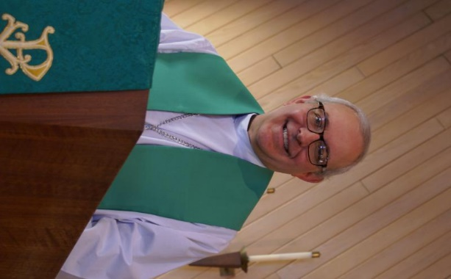
From PASTOR DAVID, 2025

I am writing this month’s letter from my bed as I am struggling with severe back pain from a herniated disk (something that has vexed me on and off for the last 30 years). I did this to myself because I keep forgetting I’m not 30 anymore and lifting ten bags of mulch into and out of a small car has consequences.

It is ironic for me to be going through this right now because an extraordinary number of our members have also been suffering from a plethora of maladies, so I have made more pastoral visits to hospitals and rehab facilities than at any other time of my ministry here at Grace. But I’m not telling you all this to depress you, rather, to encourage you.

We know the routine. “There is a time for everything, and a season for every activity under the heavens: a time to be born and a time to die” (Ecclesiastes 3). And we know that our status as Christians does not exempt us from pain, sickness, or discouragement, especially as we grow older.

Every day we see and hear stories of people passing away, rich and poor, young and old, famous and infamous. Many of them, by all appearances, had no relationship with God and rejected the Way of Life. All the things that supported them and gave them hope, their wealth, their power, their relationships, their status, their careers, their possessions; all are gone from them and are of no use to them anymore, the epitome of disappointment and despair.

But we who have persevered as faithful disciples of Jesus have a glorious hope, that no
matter what troubles come our way in this life, a different place has been prepared for us
where we will experience no sickness, no pain, no suffering, no disappointment; only peace,
joy, and love in perpetual adoration of our God and Father through Jesus Christ our Lord and
Savior. Amen and Amen

Pastor’s Hours: Mondays, Wednesdays and Fridays plus Sundays and as needed and by appointment when requested.

CHILDREN’S EVENTS
11am to 1pm – DATES TO BE ANNOUNCED
This will be two events to gather our Sunday School children together over the summer They will include special information, crafts, games food and a couple of Christian lessons. Open to our Sunday School children from 4 to 12 years old. Each child may also bring a friend. Please text Marty Bradley (630-777-1074) with the number of children coming when the time comes so that we can plan for lunch and craft items needed.


This Photo by Unknown Author is licensed under CC BY


SPECIAL THANKS to all who have shared their time and talents with Grace , including but not limited to:
- Tricia Painter, Twyla Strom and all who helped in any way with the Rummage sale.
- All of you who are caring for those who are struggling with illness and their families.
- Kurt R coordinating lawn mower maintenance and repair; Linda S coordinating AC maintenance/start up for the season
- Norm Turner for donation of printer ink cartridges.
And to many more of you who give generously of your time!

FINANCIAL MATTERS – JUNE 2025

- Thank you for the many donations, helping hands to make another successful rummage sale come to fruition. Your volunteer time is priceless. We’ve reached our goal of $5,000, and some donations are still arriving. These funds will be used towards ongoing building maintenance needs here at Grace.
- Spring has sprung – We are looking for a used, in very good condition, zero turn lawn mower for back-up to our present mower to help with our 5 acres. Please contact a Vision Team member if you have further ideas or leads.
- If you wish to donate to the “Building Maintenance Fund” for extra repairs, please notate that on your donation.

Brief recap of April financials:
2025 2024
April 2025 Year-to-Date Year-to-Date

INCOME $ 20,574 $124,120** $ 53,864
EXPENSES $ 17,981 $ 75,498 $ 45,237
NET +/- $ 2,593 $ 48,622 $ 8,627

**includes Norm Nelson memorial

Pray for blessings upon Grace as we continue our mission and work to expand our ministries at Grace in 2025 ~ In Peace, Tricia Painter

VISION TEAM REPORT

At their May 20th meeting the Vision Team:

- Final Pavilion walls replacement materials and job were approved.
- Sexton duties were discussed.
- Re-issue of church keys and new key policy was approved.
- Board of directors for the Grace Preschool was approved as well as their moving to the Grace Room in the fall.
If you have any questions or concerns, please contact a Vision Team member: Pastor David, Dallas Peters,Tricia Painter, Lee Strom, Nancy Schnaitman,and Cathy Linquist.


This Photo by Unknown Author is licensed under CC BY-ND
PRE School Program
Our Parents Day Out Program is now called a Pre-School program. The school year is complete and will resume in September still on Mondays and Wednesdays. Registration begins March 3rd for the 2025-2026 school year. Please tell anyone you know with a 3 to 5 year-old child to check out our website at graceoflilylake.org/PDO. You can also contact Janice Muncie directly at 630-854-1066.
Excerpts from a letter to the parents of our students:
What a bittersweet time of year this always is! We love seeing the big kids everyone has turned into over the past year, but we will miss seeing you all every week. Congratulations to our now Kindergartners: Braylin, Brooklyn, Katie, Molly and Olivia!! Please come back anytime to visit us. And congratulations to our now PreK kids: Abby, Luciana and Valente!!

Pastor David came in for a visit on Wednesday, our last day this spring. He read the book, "Just Me and My Dad" by Mercer Mayer. The kids loved telling Pastor David when they spotted the spider hiding on each page!

We all enjoyed getting outside this week. Both Monday and Wednesday, we ate lunch outside. We then just continued to play outside painting with chalk, flying our homemade kites, eating popsicles on our last day and enjoying each other's company.

This has been a fantastic experience for Donna and I. We can't thank you all enough for participating in our first year of running this program. Donna and I have been teaching for many years, but this past year has a special place in our hearts. This was a very special group of kids who all really enjoyed being at school and so curious about what we wanted to teach them. You are all raising some really great kids!

We hope you all have a wonderful summer and we wish you all the best!
Mrs. Muncie and Mrs. Scola


HABITAT FOR HUMANITY - POTTAWATOMIE

Grace Lutheran is a partnership church. Nancy Corbige, our representative to Habitat for Humanity, reports that they have started building a new house in St. Charles, north of Rte 64 and that volunteers are needed. Times you may volunteer include, Wednesday, Friday or Saturday from 8:30 am to 4 pm.

If you can volunteer a day or more, please send your name and email address to Nancy at ncorbige@gmail.com. She will keep us updated on the progress of the build. Volunteers do a variety of jobs, including providing lunches, doing clean up, painting and construction work
.

RUMMAGE SALE RECAP
. Spring 2025 ~ Rummage Sale

Our Spring Rummage Sale was held on May 16 & 17. We had some very warm days and high winds, then a cool down on Saturday; “we managed!” A tremendous “Thank you” to the many donors who had accumulated and saved their donations, and to the volunteers who assembled and staged these donations on Wed + Thurs of the sale week. Sale areas were spread out on Grace property: under the pavilion with clothing, etc. (coordinated by Cathy Whiteside, and many other volunteer days/hours prior months to the sale: Vicky Linden, Karen Patterson, Lee Pahr, Adrianne Mikrut, Andra Nordwind), garage/outdoor related items (coordinated by Linda Smykowski), jewelry and fine collectibles (coordinated by Margaret Swanson and Suzanne Girsch).
Household items were on display on lower entryway, Fellowship Hall, and Sunday School rooms (coordinated by Twyla Strom). We certainly are grateful for all of your support and assistance with the numerous tasks before, during and after the sale. Some pre set-up in Fellowship Hall by Janice Muncie (preschool area), by the
Scouts after their meeting on Monday night, followed by other volunteers Ian Engberg, Cara Turner, Twyla Strom (+ sister Loanne Weller), Marty Bradley, Debbie Brown, Cathy Whiteside, Karen Patterson, Chris Gerke, Diane Lilly, Jon Whiteside, Nancy Corbige, Danny Lenart, Helen Gruber, Linda Smykowski , Dottie & Paul Mantsch (+ Dottie’s brother and wife!), Kay Kinsel, Kurt Redemann, Cheryl Nelson, Margaret Swanson, Suzanne Girsch, Vicky Linden, Ann Butcher, Janice Muncie, Lee Pahr, Mary Pizzi,
(continued on next page)
Bill/Lori U’Ren. Sale signs were set up/placed/taken down by Bill/Lori U’Ren and Tricia (tho some also were damaged or lost with high winds!). The success of this sale comes from a church-wide effort with all of your ‘material’ donations and contributions
along with your extra time and talents. (** I apologize as I may have missed your name as I do try to track the willing hands that are with us during the many tasks each day ).
Special note of thanks to those that helped in our clean up efforts and helped load a few cars with donations. Ongoing thanks and gratitude to Cathy Whiteside, with her ‘team’ that carries on in her absence, and who continues to coordinate several avenues and charities before and after the sale with various clothing items: select items for Christmas Shoeboxes, Pastor Anna-Kari for transporting many items to Chicago **see note below; ; Karen Broten who collected children’s shoes, clothing, books, toys) with various items she sends to the Joe Boway Family for the Liberian Children’s Mission school, in Liberia. Many of you reading this report were a part of this sale, in big and small ways, from donating items to volunteering at the sale. It is gratifying to capture so many volunteer helping hands. Without the help of many of you, it would not be such an efficient routine. I feel so blessed that so many of you dedicate your time, talents
and goods to support this fundraiser for Grace. What a wonderful community event with visitors and repeat shoppers coming to Grace , showing their support within our community, and a remark made that they enjoy coming to Grace – “when are you worship services”. Our 2-day sale netted just over $5,000 – the blessings abound! The dollars raised certainly help offset some of our building maintenance expenses in our continuing care of God’s house. I’m grateful and thankfully pray for all of the support that so many of you have given –many hands does make all of the tasks run smoothly. The fellowship and support are priceless!

In Peace, from Your Fellow Grace Member, Tricia Painter, Rummage Sale Coordinator
(foreward planning: **Autumn Sale dates: Oct 3+4)

Any further questions, please contact Tricia Painter, 708-624-0400 (leave message/text)


ROAD RUNNERS 2025 TRIP

Dear Grace Roadrunners,

Spring Greetings! Plans are coming together for our 2025 Roadrunner trip –“Let’s Travel to Iowa.” The trip leaves Monday, September 22 and returns Saturday 27. We decided to concentrate on the NE corner of the state -Decorah, Dyersville, Mason City and Dubuque. We found some interesting stops in some of the smaller towns in this area too. We’ll go to the Field of Dreams, National Mississippi Museum and Aquarium, Vesterheim- the National Norwegian-America Museum, Bily Clocks Museum and Music Man Square.
Continued on next page
This trip will cost $1030 - $1130 per person based on double occupancy. If you desire a single room, add $340. A deposit of $500 due June 26th holds your place with the balance due August 1st . Checks should be made out to Grace Lutheran Church of Lily Lake with Grace Roadrunners written on the memo line.

The first 40 registrations are guaranteed a spot on the coach, and then a waiting list will be started. Please mail your registration sheet and check to: Suzanne Girsch, 370 Delnor Glen Dr., St. Charles, IL 60174. The $500 deposit will be refundable before July 31st . Refunds after the final payment is due will be based on what we are able to be compensated for. Contact Suzanne Girsch at sgirsch1012@gmail.com or 630-888-7254 if you have questions.

Blessings this Spring, Roadrunner Planning Committee:
Suzanne Girsch, Karen North, Dawn Root and Sharon Sabin


REBECCA CIRCLE

We are in need of knitters and crocheters to help us restore our prayer shawl ministry. See Twyla Strom or Kathy Hooey for more information on this.
Also, we have a Rebecca Circle prayer chain and we pray for those who ask. So if you have a request, please call Kathy Hooey and she will get her prayer team on it!

Our next meeting is our Spring Salad and Dessert Lunch on Saturday, June 14th at noon in the Fellowship Hall. See information below. Community members are invited. Reservations are required; please contact Twyla Strom.


REBECCA CIRCLE ANNOUNCES
A SPECIAL SALAD & DESSERT LUNCHEON
JUNE 14TH at GRACE at NOON
Special Birding Adventure presentation with Jackie Bowman, an exceptional wildlife photographer. She will share stories and photos from St. Paul Island in the Pribilofs, a remote gem in the Bering Sea 300 miles off the Alaskan Coast. The adventure continues to Utqiagvik, formerly known as Barrow, the northernmost point in the United States. Birders from around the world gather there to spot rare migrants in an awe-inspiring landscape.

Community members/guests are welcome. Grace members are asked to provide the salads and desserts. Reservations are required – by contacting Twyla Strom.

Presented by Jackie Bowman, Vice President of Kane County Audubon and member of the Illinois Audubon Society, along with Nancy Schnaitman, Secretary of Kane County Audubon and fellow member of the Illinois Audubon Society.
NOISY OFFERING
Every Sunday we collect a “noisy offering” when you wish to empty your change purse or pockets. We are currently collecting for maintenance items. Thank you.

EVENTS NOT TO BE MISSED
(also see Sunday worship information above)
- REBECCA CIRCLE Spring Salad and Dessert Lunch and Bird Presentation: June 14th at noon in Fellowship Hall. Reservations required.
- Children’s summer get-together, Saturday, June 28th in Fellowship Hall from 11 am to 1 pm. Games, lunch, crafts, Bible lesson, etc. Please let Marty Bradley know how many are coming.

MISCELLANOUS INFORMATION
- SPECIAL TECH NEED: Are you familiar with IT / computer technology / streaming ?? We are asking for several people to become familiar with or learn the technology that we use to record our church services with. Seeking several people so we will be able to spread out the weekly tasks, so your assistance is not necessary every week ~ please consider ~ and contact Pastor or Tricia Painter
- If you can knit or crochet, we need you to help make more prayer shawls as we are running low. We have the yarn so please contact Helen Gruber if you can help. If you know of someone needing a PRAYER SHAWL, please let Twyla Strom know.
- The Finance Team is looking for volunteers to sign up as counters (counting our weekly offerings after worship). Please see Linda Smykowski or Tricia Painter for further details.
- The Worship Team is seeking volunteers to learn to run our technical equipment and to help run our power point during worship which brings the bulletin onto the TV screens in the sanctuary. Please contact George Theros if you can help!

SPECIAL MINISTRY INFORMATION
Bridge to Life Group’s Jesus Closet (homeless in Elgin): Items needed are backpacks, blankets, gym shoes, t-shirts, jeans, coats and socks. Please mark donated items to the attention of Cathy Whiteside (630/605-1096). Thank you for all the donations.
Clothing and miscellaneous items for those in need in Chicago are being collected by Cathy Whiteside (630/605-1096) to be given to Pastor Anna-Kari Johnson for distribution in Chicago. Thank you to all who have donated in the past.

CONTACTS:
For emergencies, please contact the church office at 630-365-6751. For prayer requests or other needs please call Kathy Hooey at 630-341-2293 or leave a message at the church office at 630-365-6751. Messages are checked daily at noon & 5 pm.

Information for the July newsletter will be due by June 25th– please send items to Marty Bradley at masbradley50@gmail.com. Thank you

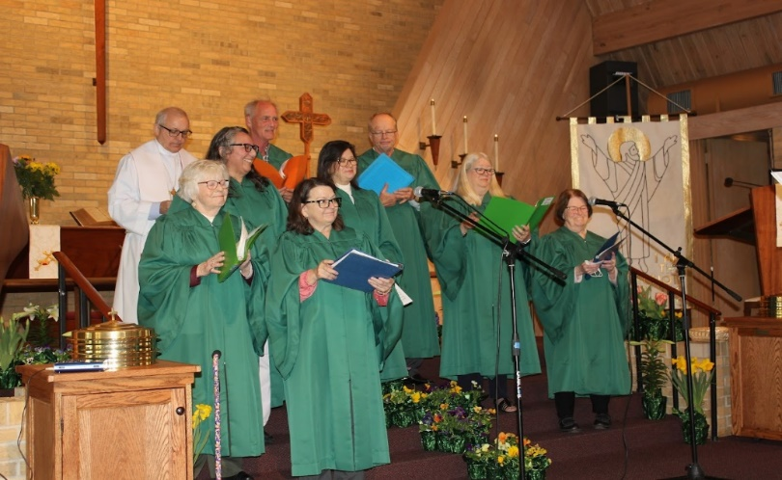
Choir in Action

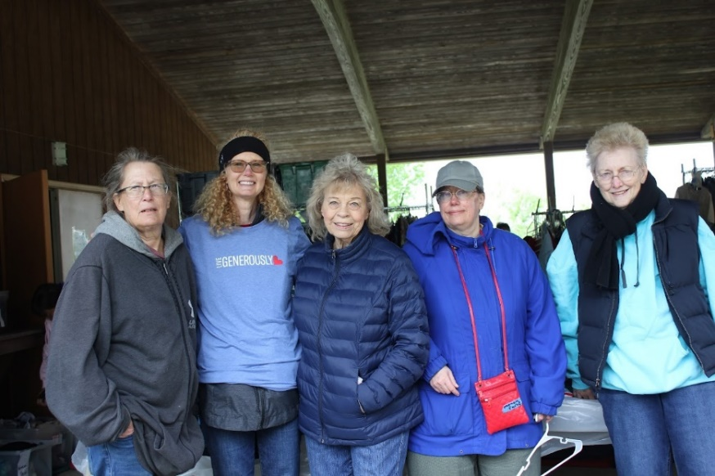
Rummage Sale clothing crew

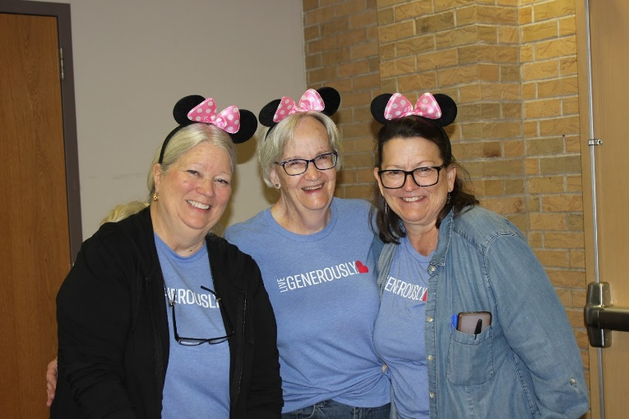
It’s not all work and no play…

