 | JUNE 2026
 | AMAZING GRACE  CONNECTIONS  Faith > Family > Community

Grace Lutheran Church of Lily Lake
5N600 Hanson Rd, St. Charles, IL 60175
Pastor David Mercurio

Worship every Sunday
At 9:30 am & celebration of HOly CommUNION
- June 7 – Indoor Worship, and Coffee Hour
- June 14 – Outdoor Worship in the pavilion
- June 21 – Indoor Worship
- June 28 – Outdoor Worship
Outdoor worship will happen on the second and fourth Sundays of June (14 & 28), July (12 & 26) and August (9 & 23) and will occur only if the weather is dry and not extremely hot. On the first and third Sundays and the fifth Sunday in August, we will worship inside in the sanctuary with coffee hour on the first Sundays.

The Church Year – Ordinary Time
- In the Evangelical Lutheran Church in America (ELCA) liturgical calendar, Ordinary Time is the season of growth and mission that follows the Easter season and precedes Advent. It is one of the two main stretches of Ordinary Time in the Western liturgical year, the other being the short Ordinary Time between Epiphany and Lent. There is also a sense that is true for us that the season feels like the “ordinary” between the mountain top moments of the church year like Christmas and Easter!
- Ordinary time is an important season of growth. The ordinary season in the church year is marked by the color green to represent growth. Just as plants need consistent sun, water, and nutrients for healthy growth, we need the consistent contact with the Giver of Life to experience the growth that He would have for us!
- It prepares our hearts for waiting and feasting. The days outside of Ordinary Time are either times of waiting (Advent/Lent) or feasting (Christmas, Easter, etc.). God uses times in the valley and on the mountain, but He also calls us to spend time in the green pastures of the fertile plain.
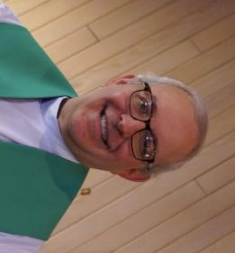
FROM PASTOR DAVID, JUNE 2026
I recently had the pleasure of visiting with Pastor Nixon Mwitula who leads First Evangelical Lutheran Church in the north side Logan Square neighborhood of Chicago. The church was founded in 1930 and the building, once vibrant with a large congregation, was constructed in a cathedral style. Much has changed since then. After years of declining attendance, the church was eventually closed during covid. Pastor Nixon, originally from Tanzania, East Africa, studied at Lutheran School of Theology in Hyde Park and, two years ago, accepted a call from our Chicago Synod to re-open the church as a “mission developer,” that is, one who starts a new church from scratch. His challenges are many. First Evangelical’s building, like many in our synod, suffers from years of neglect and has much-needed deferred maintenance. While some gentrification of the neighborhood has occurred, his primary outreach is to the homeless and migrants. Additionally, the neighborhood suffers from more than its fair share of crime, vandalism, and drug dealing. (Interesting factoid: My maternal grandfather owned a small corner grocery store in Logan Square back in the day when the CTA Blue Line ended at Fullerton Ave. My paternal grandparents lived on Dickens Street, not far from the church. So, this trip was like a homecoming to me. I was not happy to see what had become of my home!) We know Pastor Nixon through our own Cathy Whiteside who has delivered items to him previously from our clothing ministry. I made my visit to meet Pastor Nixon, to see the church, and to work out the logistics of delivering much of the residual from last month’s rummage sale to him to support his outreach. This man has a real heart for God and for the poor, the needy, and the downtrodden. He is on the front lines of ministry, and it is my prayer that we can support him on an ongoing basis in some way, be it an occasional helping hand, resources, or prayer. I truly believe God has put First Evangelical Lutheran Church before us, knowing the tenderness of your hearts. I will keep you informed as God reveals more of the situation and their needs to us.
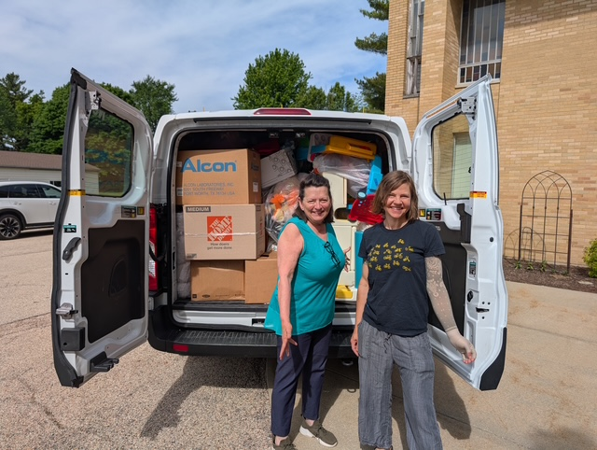
Tricia P. and Megan B. helped to load the van.
Blessings to you.

Pastor’s Hours: Mondays, Wednesdays and Fridays plus Sundays and as needed and by appointment when requested.
VISION TEAM REPORT
If you have any questions or concerns, please contact a Vision Team member:
Dallas Peters (President), Steve Butcher, Cathy Lindquist, Nancy Schnaitman, & Lee Strom
At their May meeting the Vision Team:
- Approved minutes and treasurer’s reports
- Verified that our Preschool does not need county or village approval or oversight and discussed our scholarship program.
- Approved charging $500 per day for use of Fellowship Hall for corporate organizations such as Life Line Screening.
- Confirmands will now be assisting with worship as acolytes.
- Cara Turner-Kusch will take over coordination of our clothing ministry.
- We will be replacing sanctuary lights that are burned out.
- Approved replacement of some window blinds.
- Church gutters have been cleaned.
- The much needed brick repairs have been completed


REBECCA CIRCLE
Circle Meeting in June will be on Tuesday, June 16th at 1pm in the Fellowship Hall. Food items for the Elburn Food Pantry are always welcome – Shelf stable juices – orange, cranberry, apple, grape – both regular and low sugar are always in low supply.

Women of Grace who are interested in joining the Rebecca Circle, please contact Twyla Strom or Kathy Hooey for more information.
Twyla, 847-977-5891 or Kathy, 630-341-2293

FINANCIAL MATTERS – APRIL 2026

Our monthly giving and donations has stayed steady these past months to meet our monthly needs and expenditures. The summer months are coming up and we pray for continuation of our tithes, time and talents.
Brief recap of April financials:

April 2026 April 2026 2025
INCOME $ 21,721 $ 89,588 $ 124,120 **
EXPENSES $ 22,274 $ 91,546 $ 75,498
NET +/- $ - 553 $ - 1,958 $ 48,622
**Includes Norm Nelson memorial

Submitted by Tricia Painter, Treasurer

This Photo by Unknown Author is licensed under CC BY-SA
RUMMAGE SALE RECAP
Many Helping Hands!

Our Spring Rummage Sale was held May 15th & 16th – and spring weather accompanied our days here at Grace. We are most grateful to the many ‘donors’ who accumulated and saved their donations. As we did last fall, we were able to get a jump start on the week, which helped with the many volunteer hours each day. Comments from shoppers: ‘…how everything is laid out nicely, it is clean, a variety of areas to look at -- they look forward to these events’.
Our volunteers assembled on Wed + Thurs with helping hands working in staging our donations. Areas included the garage (thanks to Linda Smykowski), under the pavilion with clothing, etc. (coordinated by Cathy Whiteside), jewelry (Char Sportsman, Suzanne Girsch), Fellowship Hall/+ 2 Sunday School rooms (Twyla Strom, Marty Bradley, Debbie Brown + helper Shelby). Other volunteers at various times during the week were: Ian Engberg, Cara Turner, Karen Patterson, Chris Gerke, Diane Lilly, Jon Whiteside, Nancy Corbige, Helen Gruber, Dottie Mantsch, Kathy Hooey, Kurt Redemann, Cheryl Nelson, Vicky Linden, Steve/Ann Butcher, Megan Brannen, Dallas and Deb Peters, Nancy Schnaitman, Norm Turner, Heidi Anderson (& sister Peggy), my sister, Lee, Pastor David, Jan Myers, shopper/helper Mary P. Thank you Cheryl Nelson for being our lunch coordinator on Fri. and Sat. Sale signs were set up/placed/taken down by Bill/Lori U’Ren, Kurt, and myself. (** I apologize as I may have missed your name. I do try to track the willing hands that are with us during the many tasks each day).
Special note of thanks to those that stayed and packed up many goods. Donations were paid forward to: MSHV/Help-a-Veteran (Wheaton + Downers Grove) a/k/a Operation Sweet Life; Karen B. collects various children’s items, clothing that is sent to the Joe Boway Family for the Liberian Children’s Mission school in Liberia; friend Josephina collects clothing for women/children’s shelter in Honduras, Operation Christmas Shoebox.
Cathy Whiteside has dedicated many years to serving others and has grown the clothing ministry to large proportions. She has coordinated this into a year-round effort with several local homeless groups before and after the sale with various clothing items. On May 26, Pastor David drove a “loaded to the gills” cargo van full of clothing, furniture, children’s games, puzzles and misc. items to the First Evangelical Lutheran Church in Chicago (kudos to Megan and Tricia who helped Pastor load the van). Pastor Nixon welcomed the variety of sale goods that they will continue to pay forward in their community in Logan Square. Please convey your own word of thanks + gratitude to Cathy when you see her as she is passing on the reins of this year-round ministry. Quite the ministry she has grown and maintained over the years – blessings received by many!
The success of this sale comes from a church-wide effort with all of your ‘material’ donations and contributions along with your extra time and talents. It is gratifying to capture so many volunteer helping hands. This event draws many from the community and with our continued efforts we pray this brings these visitors back to join in worship and other ministries with us. Without the help of many of you, it would not be such an efficient routine.
I feel so blessed that so many of you dedicate your time, talents and goods to support this fundraiser for Grace. Our 2-day sale netted ~ $5,100! The dollars raised certainly help offset some of our building maintenance expenses in our continuing care of God’s house (the weeks before the sale, structural pillars were re-rebuilt/reinforced in several areas). I’m grateful and thankfully pray for all of the support that so many of you have given – many hands does make all of the tasks at hand, run smoothly. The fellowship and support are priceless!

In Peace, from Your Fellow Grace Member, Tricia Painter, Rummage Sale Coordinator


SPECIAL THANKS TO ALL WHO HAVE GIVEN OF THEIR TIME, TALENT AND GIFTS
This Photo by Unknown Author is licensed under CC BY-SA
- Special thanks to Cara Turner-Kusch for volunteering to coordinate our clothing ministry. Please contact Cara if you can assist her! And our thanks to Cathy Whiteside, prior coordinator.
- Everyone who helped with the Rummage Sale: Tricia Painter, coordinator, and all who worked on the set up, at the sale and the takedown/clean-up.
- Rebecca Circle for its continued support of keeping the church clean and providing updates to the facilities (now looking at painting the Fellowship Hall and cleaning of the chairs).

PRESCHOOL NEWS from Janice Muncie, Director
Grace Lutheran Church Preschool takes place every Monday and Wednesday from 9:15am to 1:15pm during the school year. We will be adding a 2 year old class on Tuesdays from 8:45am to 10:45am in the fall of 2026. We are full for the Monday/Wednesday class with one on the waiting list. We have 4 signed up for the 2 year old class (maximum is 8). Thank you God for continuing to expand this program.


ROADRUNNERS 2026 TRIP
The next Roadrunners trip is scheduled for September
21-25 (or 26), 2026. We will be going to Frankenmuth, Michigan. Check with Suzanne Girsch for availability.

NOISY OFFERING Every Sunday we collect a “noisy offering” when you wish to empty your change purse or pockets. We are currently collecting for maintenance items. Thank you.

HABITAT FOR HUMANITY (HFH) - POTTAWATOMIE
Grace Lutheran is a partnership church. Nancy Corbige, our representative to Habitat for Humanity, reports that the house at 1417 Dean Street, St. Charles is essentially finished except for final inspection and issuing of occupancy permit. The House Blessing has not yet been scheduled. Habitat’s bank account is over $57,000 which is well above our $35,000 per build goal. There are currently no slated properties for build in the Pottawatomie Partnership HFH area yet.

MISCELLANOUS INFORMATION
- SPECIAL TECH NEED: Are you familiar with IT / computer technology / streaming ?? We are asking for several people to become familiar with or learn the technology that we use to record our church services with. ~ contact Pastor or Tricia Painter
- The Finance Team is looking for volunteers to sign up as counters (counting our weekly offerings after worship). Please see Linda Smykowski or Tricia Painter.

CONTACTS:
For emergencies, please contact the church office at 630-365-6751. For prayer requests or other needs please call Kathy Hooey at 630-341-2293 or leave a message at the church office at 630-365-6751. Messages are checked daily at noon & 5 pm.

Information for the July newsletter will be due by June 25th– please send items to Marty Bradley at masbradley50@gmail.com. Thank you

RUMMAGE SALE
Just some of the “2,000 helpers”
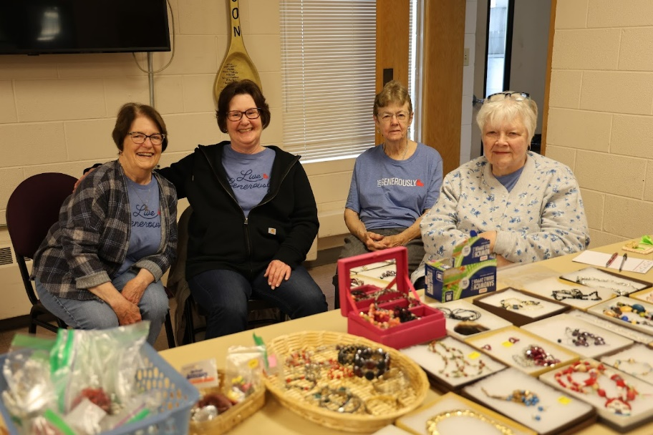
Kathy Hooey, Cheryl Nelson, Helen Gruber, Char Sportsman

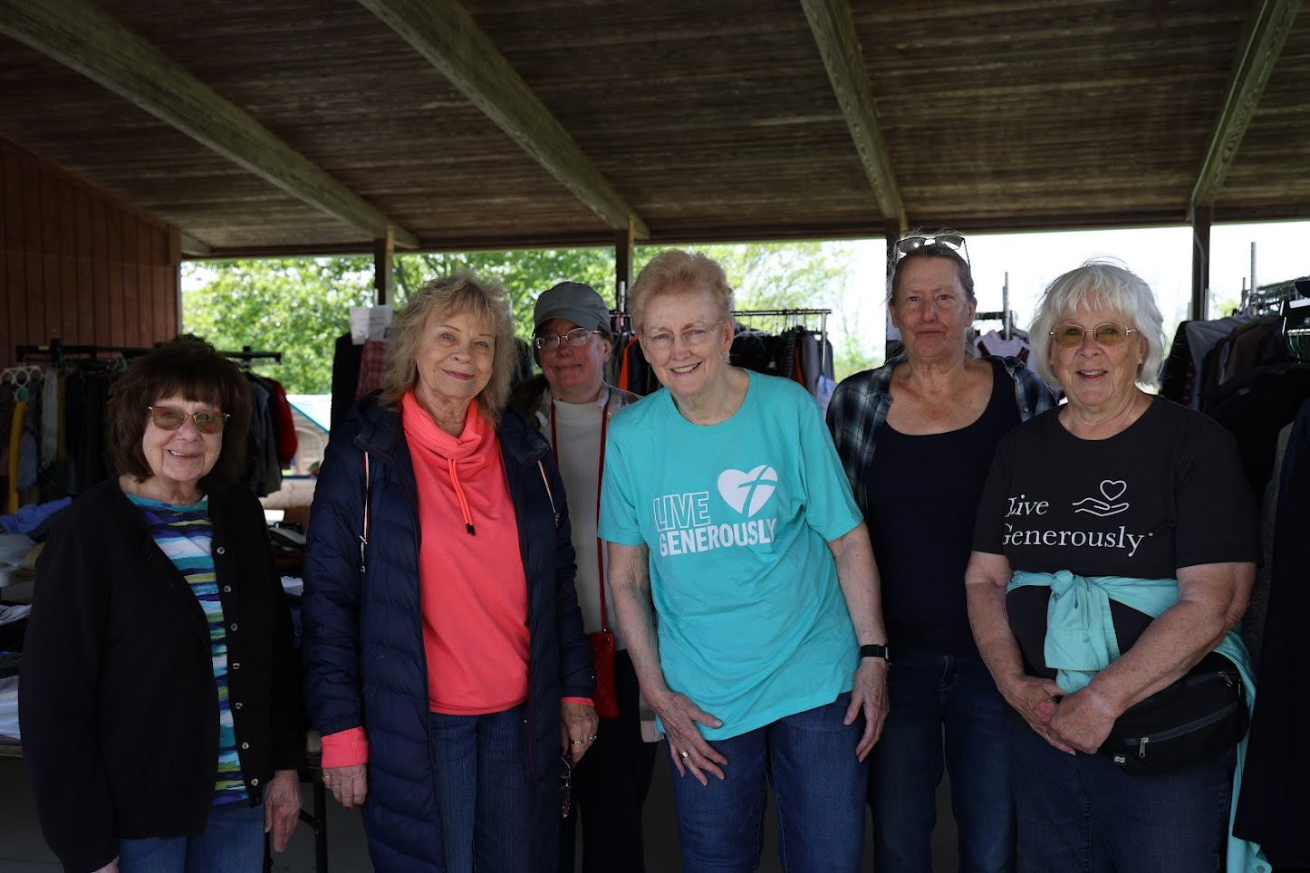
Jan Myers, Vicki Linden, Chris Gercke, Cathy Whiteside, Diane Lilly and Nancy Schnaitmann

