March 2023, VOL. 39
 | AMAZING  GRACE  CONNECTIONS
Faith > Family > Community
Grace Lutheran Church of Lily Lake
5N600 Hanson Rd, St. Charles, IL 60175
Pastor David Mercurio

Worship every Sunday at 9 am
with Communion
Sunday, March 5, Worship, Coffee Hour & Sunday School
Sunday, March 12, Worship
Sunday, March 19, Worship & Sunday School
Vicar Sharai Jacob from Geneva Lutheran will be preaching
Sunday, March 26, Worship

SPECIAL MIDWEEK LENTEN BIBLE STUDIES
Saturdays, through March 25
9:00 am coffee; 9:30 am Bible Study
&
Wednesdays, March 1 through March 29
Noon soup luncheon; 12:30 pm Bible Study

You are welcome to attend any or all of these. Please sign up if you can
bring coffee treats or soup on any of these days.

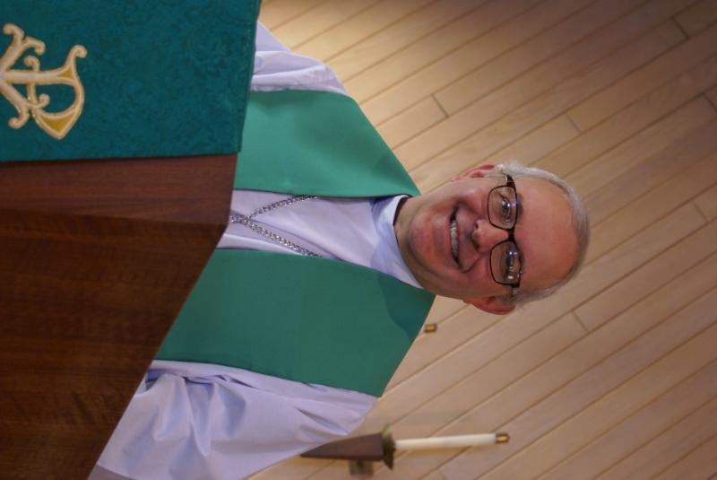
PASTOR’S MESSAGE

From the desk of Pastor David, February, 2023
All of you know the large, old honey locust tree that sits on the northwest corner of the church lot. It has provided shade and beauty to us for decades. Sadly, the tree was covered in ice from the storm on Ash Wednesday and many of its branches were torn to the ground with a few large ones hanging by just a sliver of bark. Because of its age, the tree is susceptible to weather events like ice and high winds and has become a potential safety hazard. Sadly, it may have to be cut down for our protection because it has outlived its usefulness.
I tell this story because it reminds me of us. Many people today believe the Christian church is old and has outlived its usefulness. We are people of “the book,” Scriptures that are thousands of years old. These same people ask, “How can that old text be relevant today in our period of enlightenment, in a world where we can control nature and determine our own destinies? You people are just dinosaurs who practice superstition.”
I would argue that we are just as relevant and needed today as ever in the period of human history. The “enlightenment” of our modern world has caused more suffering, more loneliness, more depression and more dysfunction the more we move away from God. I thank God for all of your hard work and commitment as you continue to show the love of Jesus to our community. Stay the course, endure suffering with patient endurance, fight the good fight. Your reward in heaven will make all our earthly troubles seem like light and momentary troubles.
Blessings to you all,
Pastor David
Pastor’s Hours at church
Tuesdays and Thursdays from 6 pm – 9 pm
Saturdays from 9 – noon Sundays from 8:30 am for 3-4 hours

COVID-19, FLU and RSV Safety Protocols

We follow the recommendations of the CDC, ELCA and the IL Department of Health. If you wish to mask and social distance please do so. Please do not come to church if you have symptoms of illness. If you do not feel comfortable worshipping with others, we invite you to join us virtually for worship via our website.

This Photo by Unknown Author is licensed under CC BY
Sunday, April 2 – Palm Sunday Worship at Grace at 9 am,
Jesus’ triumphant entry to Jerusalem
Monday April 3 – Jesus clears the temple
Tuesday, April 4 – Jesus goes to the Mount of Olives to pray
Wednesday, April 5 – Jesus’ action unknown, perhaps a day of rest
Thursday, April 6 – Maundy Thursday service at 7 pm at Grace;
Jesus and disciples celebrate Passover and the Lord’s Supper
Friday, April 7 – Community Service at Burlington Methodist, 7 pm
Jesus’ trial, death and burial
Saturday, April 8 – Jesus in the tomb; followers mourn
Sunday, April 9 – Easter Worship at Grace, 9 am
Resurrection of Jesus, Alleluia!

"Don't be afraid! I know you are looking for Jesus, who was crucified. He isn't here! He is risen from the dead, just as he said would happen." (Matthew 28:5-6)

 | 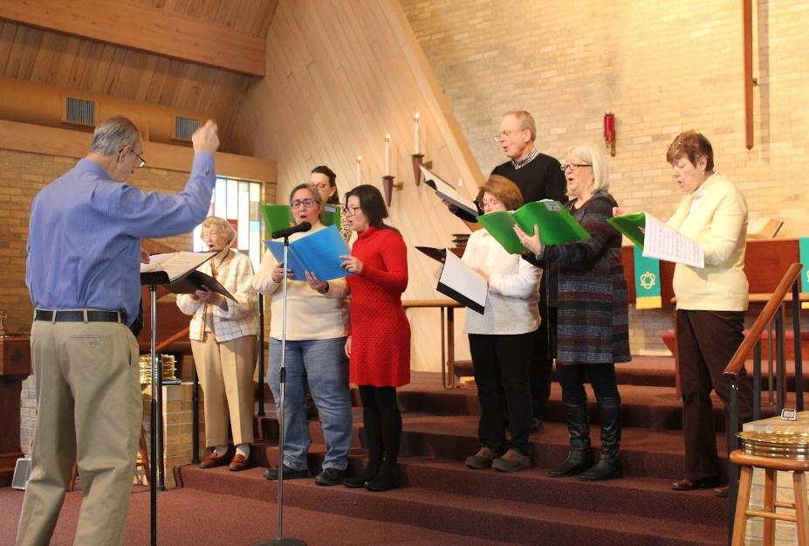  The Light of Jesus Shines…
February VISION TEAM REPORT
The Vision Team met on February 13th

- Approved minutes and the January financial report
- Approved continued time of Vision Team meeting as 630pm on the second Tuesday of every month
- Reviewed and approved duties of the new Maintenance Team
- Reviewed our Building Donation policy and approved revisions; policy is available in the church office
- Discussed possible use of raffles at church; Nancy S. reported on legal issues involved; approval is pending
- Approved mailing letters and offering envelopes for Lent and Easter; Pastor to write the letters
- Discussed possible limited VBS options; Marty to ask congregation if there are any people interested in heading this up; Grace has materials already
- Bulbs in the sanctuary have been replaced; parking lot bulbs to be replaced in late March
- New subplash program is now in place and allows us to live-stream worship services, and send out eblasts

The Vision Team meets on the second Tuesday of each month. If you have items you feel should be discussed by the team, please send them to Marty by the first Tuesday of the month.

Marty Bradley, President


MANY THANKS AND PRAYERS TO THOSE WHO HAVE RECENTLY DONATED THEIR TIME AND TALENTS, including, but not limited to:

- George for always arranging our participation in the Feed My Starving Children/Feed the Need program
- Everyone who filled and returned the M&M containers with donations to Feed My Starving Children/Feed the Need
- Pastor and George for distributing ashes at the Elburn Metra station on Ash Wednesday
- Kurt, Marty and George for branch clean up after the ice storm
- For all the ladies who assisted with the lunch following Ken Patterson’s celebration of life
- For the choir members and all the time they put in and for the great music
- For those who have volunteered to serve on the Maintenance Team: Kurt Redemann (Vision Team Liaison), Mark Anderson, Cathy Lindquist, Dave Nelson and Linda Smykowski
- Nancy Corbige for volunteering to send Eblasts and update our facebook page
- Helen Gruber for coordinating the Lenten Saturday and Wednesday Bible Study food

CONTACT A VISION TEAM MEMBER IF YOU WISH TO VOLUNTEER

FINANCIAL MATTERS – MARCH 2023

- You should have received your 2022 year-end giving statement (via email or postal mail). If you have any questions or concerns regarding your statements, please contact Dottie & Paul Mantsch or if you did not receive your Giving Statement, please contact Cara Turner - each of them are on our Finance Team.
- For those members who receive Offering Envelopes, there is an “Initial Offering” envelope to help cover the cost of your envelopes : approx. $11.25 per person/per year.
- Thank you, Thrivent Members – we have received $327 from your Thrivent Choice Dollars. The deadline for completing any further allocations to Grace is March 31st.
- You are able to make your offering donations electronically -- the Subsplash Giving Link is: - https://graceoflilylake.com/give. Go to our website: graceoflilylake.com, click on the "Giving" link, "Give" , scroll down on the populated page and it will guide you to make a one time, or a recurring donation. We are truly grateful for your financial support @ Grace of Lily Lake.
- You may have read about the AmazonSmiles program that is being discontinued – thank you for your support throughout the few years we were able to capture some donations from this program, through your purchases.

Brief recap of January financials:
2023 2022
Jan 2023 Year-to-Date Year-to-Date
INCOME $ 18,523.51 $18,523.51 $17,067.83
EXPENSES $ 15,669.25 $15,669.25 $16,815.57
NET +/- $ 2,854.26 $ 2,854.26 $ 252.26

Pray for blessings upon Grace as we continue our missions with goals and challenges in 2023 ~ In Peace, Tricia Painter, Treasurer


This Photo by Unknown Author is licensed under CC BY-NC
Lutheran School of Theology at Chicago presents:
WHY WE SHOULD CARE ABOUT MARTIN LUTHER
Martin Luther on the Holy Spirit and Christian Life
A four-part virtual series on Wednesdays,
March 1, March 8, March 15, and March 22
at 7 pm
Presented by Dr. Candace Kohli, Assistant Professor of
Lutheran Systematic Theology and Global Lutheranism

Register at: https://lstc.edu/event/learning-communities-individuals


Please sign up to bring chili or assist with set-up, etc.

SWEDISH MEATBALL DINNER BENEFIT
at Bethany Lutheran Church
8 S. Lincoln St., Batavia, IL

Presented by the Swedish American Children’s Choir

Saturday, March 11, 2023 from 4:30 – 6:30 pm
$15 adults, $7 children 3-10
Reservations required: 630-414-9700
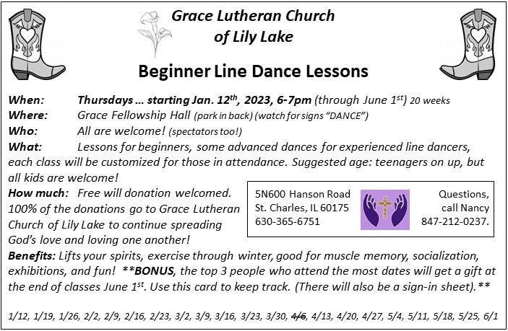

*Additional DATES TO REMEMBER*

- March 31 at Grace: LifeLine Screening – see brochure in the Gathering Room

.
April 1 – Spaghetti Dinner at Grace 4-7pm

- April 3rd Set up for the Kane County Consolidated Election and Voting on the 4th in Fellowship Hall
- May 19 & 20 (set-up May 18) – Yes, the Spring Rummage Sale

- June 3 – 2023 Metropolitan Chicago Synod Assembly
Theme: In Jesus: Make Disciples
Assembly will be held at the Q center in St. Charles
Grace can send two lay voting members
Please see Marty Bradley if you can be our
representatives. Registration is required by April 14th. Other members may also attend (no vote).
BUILDING USE DONATIONS

The Vision Team has approved a guide for donations for personal use of areas of the building and staff (Pastor, Organist, Tech Person, and Sexton) for both members and non-members. I.E.: weddings, funerals, family gatherings, outside meetings, etc. This is standard procedure for congregations and will assist us in maintaining our building as well as covering the use of utilities/maintenance. A copy of the donation list is available in the Church Office.
If you have any questions, please contact any Vision Team Member.

 IN REMEMBRANCE
This Photo by Unknown Author is licensed under CC BY

Our prayers and sympathy go out to the following families:
- The family and friends of Ken Patterson who passed away in January.
- The family and friends of Dr. Wayne Larson who passed away at the end of December.
- The family and friends of Jeannine Luchs who passed away right before Christmas.
Her daughter wrote that she very much appreciated receiving Christmas cards
and the newsletter; knowing that she was being remembered.

THIS AND THAT
WEBSITE INFORMATION: Marla Roach has graciously become our website coordinator.
When you look at our website, you will see many events listed that have already occurred. The upcoming events will always be listed first. This is intentional – in her expertise in this area, she says that people will be more interested in Grace if they can see what goes on during the year. This is a format to keep our various ministries front and center. Please remember to view the newsletter regularly.

LIGHTS: We are trying to keep our utility bills as low as possible. In that regard,
please do as you probably do at home, and only turn on lights in the church that you need and do so just before they are needed; and remember to turn them off immediately when they are no longer needed. Please make sure all lights are turned off when you leave the
building. Don’t forget to check the bathrooms. Thank you.

CONTACTS:
For emergencies please contact Marty Bradley, President, at 640-777-1074 or leave a message at the church office at 630-365-6751.
For prayer requests or other needs please call Kathy Hooey at 630-341-2293 or leave a message at the church office at 630-365-6751. Messages are checked daily at noon & 5 pm.

Information for the April newsletter will be due by March 25th – please send it to Cathy Whiteside Cathy@imotay.com Thank you!

