 | MARCH 2024
 | AMAZING GRACE  CONNECTIONS  Faith > Family > Community

Grace Lutheran Church of Lily Lake
5N600 Hanson Rd, St. Charles, IL 60175
Pastor David Mercurio

Worship every Sunday
At 9:30 am with Communion
- March 3 – Worship with Sunday School and coffee hour following
- March 10 – Worship, special choir…
- March 17 – Worship with Sunday School
- March 24 – Palm Sunday Worship
- March 28 – Maundy Thursday Worship at 7 pm at Grace
- March 29 – Good Friday, Community Worship, 7pm at Country Covenant Church
- March 31 – Easter Worship and breakfast (8:30-11 am)

 | Season of Lent  Feb. 14, 2024 through  March 27, 2024
The Three Days  Mar. 28, 2024 through Mar. 30, 2024 | Easter Season  Mar. 31, 2024 through  May 22, 2024
Time after Pentecost
May 23, 2024 through Nov. 27, 2024

This Photo by Unknown Author is licensed under CC BY-NC-ND
SUNDAY SCHOOL
Sunday School for 3 through 13 year olds EVERY 1ST and 3RD SUNDAY at 9:30 am in the Grace Room.
March dates are Sundays the 3rd and 17th .

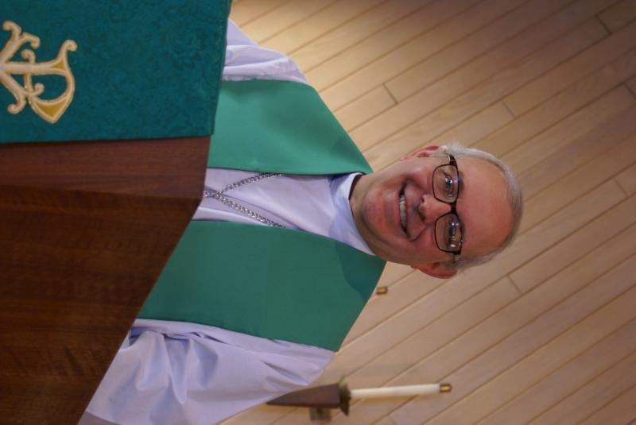
PASTOR’S MESSAGE MARCH 2024

As we move our way through the Lenten season, it is easy to get distracted from the “reason for the season,” which is a time for repentance, reflection, and renewal. Through prayer, fasting, and giving to the poor (the poor in money and the poor in spirit), we reflect the light of Christ. These are all acts we should practice all year (and we do), but as we approach Easter, it is good for us to have a particular focus on this journey we have committed to, this thing called Christianity.
I leave you with an excerpt from “Sacred Meditations,” a work by the 17th century German theologian Johann Gerhard, born about 40 years after the death of Martin Luther. Considered the greatest theologian of his day, in this treatise, he takes away every argument for the reader who believes that being a disciple is too hard.

He takes upon Himself our sins and their just deserts; His precious body is bound, scourged, wounded, pierced, crucified, and laid in the sepulchre; His blood starts forth profusely, like the dew, from all parts of His suffering body; His most holy soul is saddened beyond measure, and became sorrowful even unto death (Matt. xxvi. 38); He is subjected to the very pains of hell, and the Eternal Son of God cries out in horror that He is forsaken of God (Matt. xxvii. 46). He sweats such great drops as of blood, and such anguish does He suffer as to need the comfort of an angel (Luke xxii. 43), who Himself comforts all angels…From the cross He cries:
“Behold, O sinful man, what I am suffering for thee; to thee I cry, because for thee I am dying. Behold the punishment inflicted upon Me! Behold the nails which pierce Me; there is no grief like unto My grief, and yet though My outward sufferings are so great, far greater is the agony of My heart, because I am finding thee so ungrateful.” Have mercy upon us, have mercy upon us, O Thou only God of mercy, and turn our stony hearts to Thee!.
Pastor’s Hours: Wednesdays from 10 am to 2 pm; Tuesdays and Thursdays from
6 pm – 9 pm, and Sundays from 8:30 am for 3-4 hours and by appointment when requested.

LENTEN BIBLE STUDIES
Saturdays at 3 pm: March 2, 9, 16
Wednesdays at noon with soup lunch: March 6, 13 and 20

Note that the Bible Study on Wednesdays will be a repeat of the study from the previous Saturday.


MANY THANKS AND PRAYERS TO THOSE WHO HAVE RECENTLY DONATED THEIR TIME AND TALENTS, including, but not limited to:

- Pastor for the wonderful Lenten studies and George as his tech assistant. Helen Gruber for coordinating the noon soup luncheons – and all who are providing soups, bread and desserts.
- Tom Barton for repairing the brick stoop outside of the exit door from the Grace Room.

FINANCIAL MATTERS – MARCH 2024

- Thrivent Members – Please consider donating your Thrivent Choice Dollars to Grace of Lily Lake – deadline for completing this is March 31st.
- Your 2023 year-end giving statements have been emailed or postal mailed. Thank you for your patience while we waited for the copier to be fixed, and also to those that we needed to send a corrected statement to. If you have questions on your 2023 statement please contact Dottie/Paul Mantsch.
- You are able to make your offering donations electronically -- the Subsplash Giving Link is: - https://graceoflilylake.com/give. Go to our website: graceoflilylake.com, click on the "Giving" link, scroll down on the populated page and it will guide you to make a one time, or a recurring donation. We are truly grateful for your financial support @ Grace of Lily Lake.
- For those members who receive Offering Envelopes, there is an “Initial Offering” envelope to help cover the cost of your envelopes : approx. $11.25 per person/per year. Please contact Cara Turner if you no longer wish to receive envelopes.
- Several of our members have made a donation to Grace via a tax-deferred retirement account -- it is a very tax-efficient way to be charitable both during your lifetime and through your estate. Unlike a distribution to you or an heir, which would be a taxable event, charitable donations from retirement accounts lay no additional tax burden on you or the charity. Estate gifts from these accounts can go directly to charities through a donor-directed distribution agreement or fund named endowments, i.e. Grace Lutheran Church of Lily Lake. Have you prayerfully considered naming Grace Lutheran Church of Lily Lake in your Trust or Will?

Due to vacation I was unable to complete the financial recap for this month. Praying for meeting goals + challenges, as we move into 2024 ~ Peace, Tricia Painter, Treasurer

FEBRUARY VISION TEAM REPORT
The Vision Team met on February 13th
- Approved minutes and treasurer’s report from January
- Welcomed new Vision Team members: Dallas Peters and Cathy Lindquist. Elected officers are Dallas Peters, President; Kurt Redemann, Vice President; Tricia Painter, Treasurer; and Nancy Schnaitmann, Secretary.
- New contract with Comcast with a lower rate has been completed.
- Reviewed copier repair and discussed that it will need to be replaced in the next year or two.
- Approved Eagle Scout project to enhance the burn pile area with gravel, a fire ring and benches.
- Discussed what the duties of the President should be.
- Noted thank you received from the Community Crisis Center for the hats, gloves, and socks collected by us.
- Some tree limbs along exit driveway have been trimmed.
- Boiler issues are still being addressed and estimates requested. Dallas will oversee this and insurance issues.
- A member and relative are working on seeking grants – no bites yet.

GETTING TO KNOW NATALIA AND KELLY DIEHL
Natalia Diehl is a professional music educator, with over 30 years of experience as a piano instructor, teaching in the United States and Russia. Born in Kharkov, Ukraine, her parents had music playing in their home all the time, even though they were not musicians themselves. At 6 years old she began playing piano and went to college to receive her Master's Degree in Piano Performance from Rostov State Music Institute, Russia. In Taganrog, Russia, she taught piano for 11 years at the School of Fine Arts, where she held a position as accompanist for voice students at concerts, competitions, and regular exams. Music is her life-long passion, and she loves sharing it with her students.
Since immigrating to the U.S. in 2000, Natalia has been teaching at various public and private schools around the Chicagoland area. She has served as the pianist at her church for many years, where she accompanies the choir and other vocal ensembles. When she is not teaching or accompanying, she enjoys spending her time with her loving husband and three daughters.
Natalia spent 6 years as a single mother before she was encouraged by her sister-in-law to start dating. She finally met Kelly in 2007 and they got married a year later in 2008. Together they raised their 3 daughters. Kelly lived in Roselle, IL where he was a devout Lutheran. They bought a home in Lily Lake, where they looked for a Lutheran church that they could join as a family. Kelly served a partial term on the Vision Team until he was elected Village of Lily Lake President -a position he still holds. Natalia is currently one of our Sunday School teachers. Kelly, Natalia and their family joined Grace Lutheran Church of Lily Lake in 2016.
UPCOMING SPECIAL DATES
- LINE DANCING every Wednesday from 6-7 pm in the Fellowship Hall
- Saturday, March 30, EASTER EGG HUNT at the park next to the Village of Lily Lake building on Empire Road at 10 am. All are welcome!
- EASTER BREAKFAST, Sunday March 31st at Grace from 8:30 – 11 am; worship at 9:30


REBECCA CIRCLE
PLEASE JOIN US at our March Rebecca Circle meeting in the
GRACE ROOM for a special YEAR OPENER LUNCHEON!!!!!

On Tuesday, March 19th (and yes, we understand that is Primary Day, and you should vote, and then use the upstairs entrance at church to head to the Grace Room) we will be gathering for our opening meeting for 2024.
Our hostesses are Adrian Mikrut, Nancy Corbige and Joan Mortensen and they would like to provide a lunch for us, so as long as we’re switching the meeting room, we may as well switch the time.
12:30pm instead of 1pm, just for this month and luncheon

SO PLEASE NOTE THE CHANGE OF TIME!
AND PLEASE RSVP to Jan at 815-901-0910 or to Kathy at 630-341-2293 or you can sign up on the sign up sheet in the Gathering Room.

We hope to have a busy year, so please come and help us begin our planning. Roll call item is, once again, any items for the Elburn Food Pantry especially low sugar, adult cereals.

 ROAD RUNNERS TRIP 2024

The Grace Roadrunners decided at their October potluck to travel to the Smoky Mountains/Gatlinburg, TN area in 2024. They will be leaving Grace on Monday, September 16^{thand} return on the 20th or 21st, 2024. The planning committee will begin meeting the first Tuesday of the month starting January 2024
NOISY OFFERING
Every Sunday we collect a “noisy offering” when you wish to empty your change purse or pockets. We are currently collecting for maintenance items, including our boiler. Thank you.

COVID 19, FLU AND RSV SAFETY PROTOCOLS
We follow the recommendations of the CDC, ELCA and IL Department of Health.
If you wish to mask and social distance, please do so. Please do not come to church if
have symptoms of illness. If you do not feel comfortable worshipping with others, we invite
you to join us for worship via our website.

CONTACTS:
For emergencies, please contact the church office at 630-365-6751.
For prayer requests or other needs please call Kathy Hooey at 630-341-2293 or leave a message at the church office at 630-365-6751. Messages are checked daily at noon & 5 pm.

Information for the April newsletter will be due by March 25th – please send it to Marty Bradley at martybradley@mchsi.com. Thank you



