 | MARCH 2026
 | AMAZING GRACE  CONNECTIONS  Faith > Family > Community
Grace Lutheran Church of Lily Lake
5N600 Hanson Rd, St. Charles, IL 60175
Pastor David Mercurio

Worship every Sunday
At 9:30 am with CommUNION
- March 1 – Worship and Sunday School and Coffee Hour
- March 8 – Worship
- March 15 – Worship and Sunday School
- March 22 – Worship
- March 29 – Palm/Passion Sunday Worship

LENTEN / HOLY WEEK SCHEDULE
Lenten Bible Studies – Wednesdays at noon (soup lunch) on February 25 – March 25 with a repeat study on Saturdays (coffee & treats) at 9:30am, February 28 – March 28th.
March 29, Palm/Passion Sunday
April 2nd, Maundy Thursday – Seder meal at Grace in Fellowship Hall at 6 pm. Reservations needed.
April 3rd – Good Friday – Community Worship at the Congregational Church on Empire Road at 7 pm.
April 5th – EASTER SUNDAY – worship at 10:30 am with Breakfast before and/or after worship from 8:30 am to 11:30am (free will offering.)



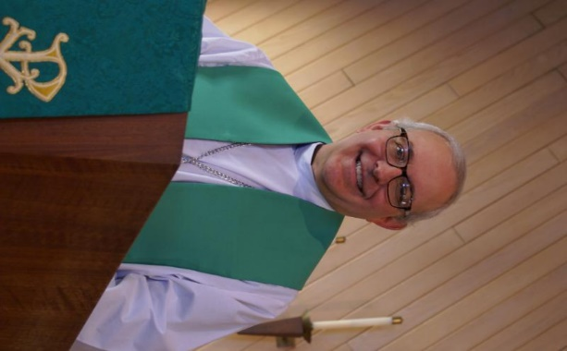
FROM PASTOR DAVID, MARCH 2026

Unless you’re living in the middle of the woods with no access to outside communication, it’s hard these days as an American not to feel discouraged and afraid. Every day we see footage of wars, impending wars, civil unrest between criminals and police, and high and increasing crime rates. Illegal drug use and deaths by overdose continue to mount. Nearly half of all marriages end in divorce; almost half of all newborns are born to unwed mothers; and we continue to abort about 1 million babies a year. The gap between rich and poor continues to grow. Young adults complain of unaffordable housing, crushing student debt, and shrinking job opportunities. Our political leaders appear to have no concern for their own constituencies. Trust in government, media, and even our education system is at an all-time low. We are bombarded with social media data, much of it biased, or worse, generated by artificial intelligence posing as a real person. We are no longer “one nation under God.”
Rather, we have become many tribes, each with their own gods, and all at war with the others. The enemy is at the gate. What is a Christian to do.

I imagine the first disciples felt exactly the same way those first few days after his death, discouraged and afraid. Their rabbi, the master, did not turn out to be the hoped-for messiah who would rid the land of the hated Romans. Instead, they ignominiously hung him on a cross to die. Instead of sitting at the right and left hands of the king, they were being hunted by the Jewish religious authorities and the Roman government. It seemed like all was lost. They had been deceived like so many before them by another false messiah. Society mocked them as fools and simpletons.

But wait! What is this we see and hear? He is risen! How can this be? Could it be that he is part of the Godhead he claimed to be all along? And he instructs us to go and make other disciples as he did with us. His final assurances, his presence that we saw and felt, the Holy Spirit that he left behind, all these gave them (and us) hope to endure any trouble this world throws at us, even to the point of death as a martyr. I pray that such a thing never happens to Christians again, but the point is that this world is passing away. It has nothing good to offer us, and nothing bad in it can harm our eternal destiny. Our hope is in a better future sitting at the feet of God, with no more pain, no more sorrow. Rejoice and be glad.

Pastor’s Hours: Mondays, Wednesdays and Fridays plus Sundays and as needed and by appointment when requested.

VISION TEAM REPORT
If you have any questions or concerns, please contact a Vision Team member:
Dallas Peters (President), Steve Butcher, Cathy Lindquist, Nancy Schnaitman, & Lee Strom
At their February meeting the Vision Team:
- Approved minutes and treasurer’s reports.
- Grace will need two voting representatives to attend the Chicago Synod Association meeting on Friday and Saturday, June 5-6 at the Q Center in St. Charles. Grace will cover the registration fee of $300. Let Pastor know if you would like to attend.
- The Synod Lay Leadership Day till take place on March 14th at Prince of Peace Church in Schamuburg. Check with Pastor if you wish to attend.
- Preschool will add a 2 year old class in the fall on Tuesdays from 8:45 to 10:45. Also, a scholarship program has been developed – applications available. Vision Team has approved $66 to assist with field trip cost to the Hickory Knolls Discovey Center.
- Students in our new confirmation class include Teddy Ballard, James Gwizdala, Ryder and Emmy Brannen.
- A volunteer(s) is needed to take over our donated clothing for the rummage sales and donations. Cathy Whiteside is no longer able to coordinate this.
- Vision Team approved the purchase of $1,752 for a Contractor Control Box for the pressure tank.

FINANCIAL MATTERS – MARCH 2026

- Thrivent Members – Please consider donating your Thrivent Choice Dollars to Grace of Lily Lake – deadline for completing this is March 31st.
- Several of our members have made a donation to Grace via a tax-deferred retirement account -- it is a very tax-efficient way to be charitable both during your lifetime and through your estate. Unlike a distribution to you or an heir, which would be a taxable event, charitable donations from retirement accounts lay no additional tax burden on you or the charity. Estate gifts from these accounts can go directly to charities through a donor-directed distribution agreement or fund named endowments, i.e. Grace Lutheran Church of Lily Lake.
- Have you prayerfully considered naming Grace Lutheran Church of Lily Lake in your Trust or Will?

Brief recap of January financials:

Jan 2026 Jan 2026
Year-to-Date
INCOME $ 12,949 $ 16,359
EXPENSES $ 17,199 $ 16,394
NET +/- $ - 4,250 $ - 35

We are thankful for your time, talents and tithes to Grace, as we continue our mission and ministry in 2026 ~ In Peace ~ Tricia Painter, Treasurer

Getting to Know You - Linda Smykowski

Linda was born and grew up on the Northwest side of Chicago with her parents, Mildred and Glenn Husby, 2 sisters and one brother. Her family were members of Grace Lutheran Church in Elmwood Park where she was baptized, confirmed and married. After graduation from Steinmetz HS, she began working at Illinois Armored Car where she met her future husband, Ted. They had 2 sons: Teddy was confirmed here at Grace Lutheran and is now 31 years old; and John, who sadly has passed away.
The Smykowski’s moved to Elburn 26 years ago to get away from city life and have
more land for Linda to enjoy gardening, one of her favorite things to do. The fresh
vegetables and beautiful flowers are greatly appreciated by family and friends. Linda
worked for Kaneland School District for 19 years and retired in 2019.
They transferred their church membership from one Grace Lutheran Church to another one and we are so happy they did. Linda is very active in the church, volunteering as usher, acolyte, greeter, counter, meeting up with service contractors to unlock the church ~ and just about anything else she is asked to do. She is often found in the church kitchen providing service or cleaning up food for various functions. She is very active with the Rebecca Circle activities also.

Thank you Linda for sharing your story with the people of Grace.


REBECCA CIRCLE

Rebecca Circle will meet on Tuesday, March 10th at 1:00 pm in Fellowship Hall. Hostesses are Cheryl Nelson, Nancy Burtnette and Kathy Hooey. If you are interested in more information about Rebecca Circle, see Twyla Strom or text her at 847-977-5891. Also see the brochure below about the Bread Monk program the circle is sponsoring on April 11th.

SPECIAL THANKS to all who have given of their time, talent and gifts:
- Pastor for leading us in our Lenten Bible Study.
- Helen G., Linda S., Vicki L., and more for hostessing the Lenten lunch during the Bible Study and for all who donated soup, bread and desserts.
- For Linda Symkowski for coordinating the Community Spaghetti Supper on March 14th.
- Bill and Lori U’Ren for ushering during worship on many, many Sundays.
- Special thanks to Cathy Whiteside for all the work she has done with our clothing collections and distributions. A new volunteer is needed to take over this ministry.

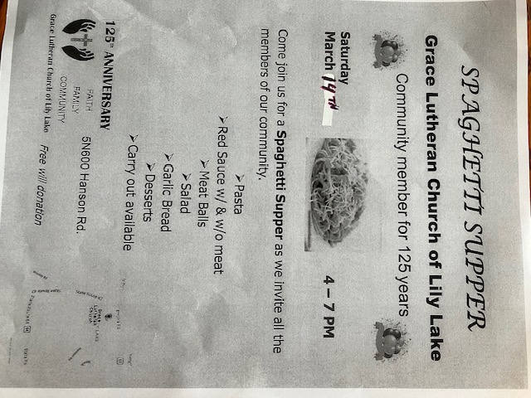

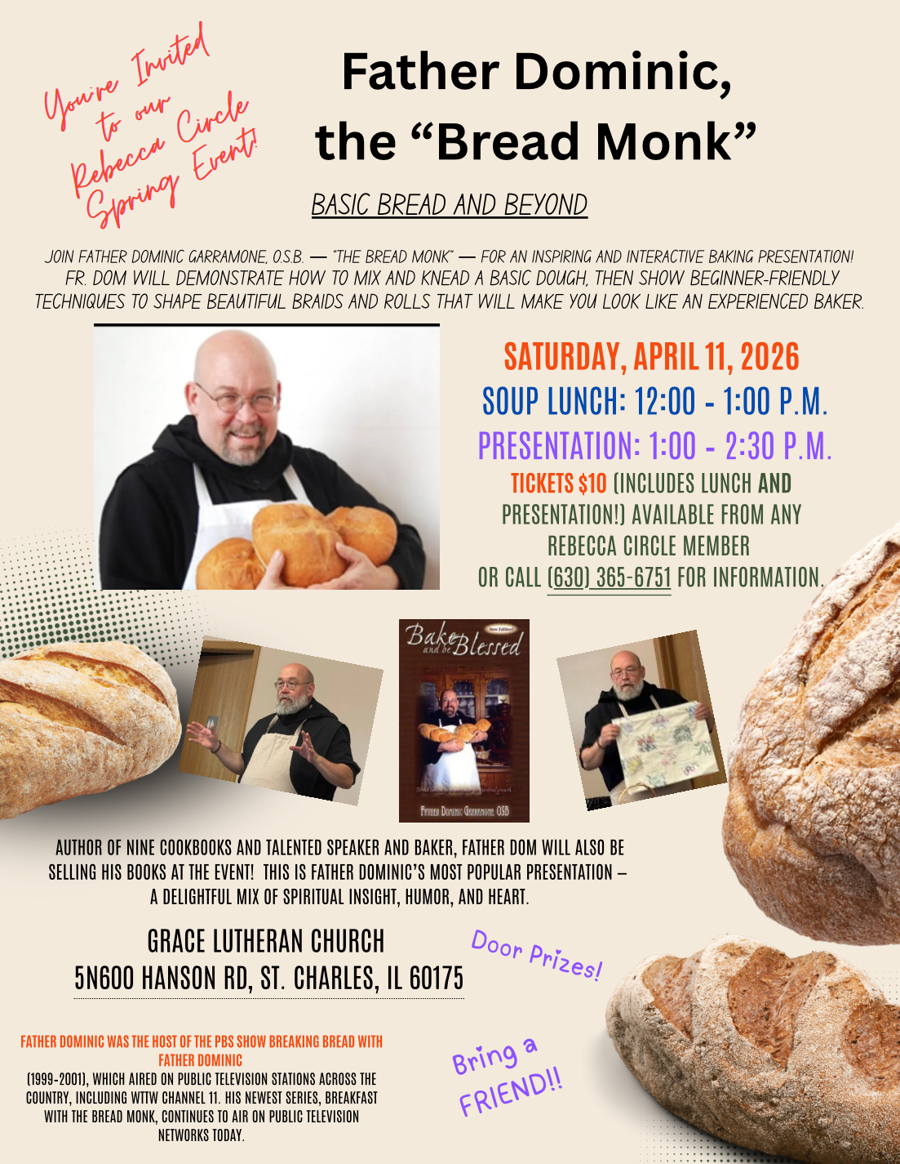


ROADRUNNERS 2026 TRIP

The next Roadrunners trip is scheduled for September
21-25 (or 26), 2026. We will be going to Frankenmuth, Michigan. Save the dates – more information to come.


LINE DANCING continues on Tuesdays
from 6-7 pm in Fellowship Hall from 1/6/26 to 4/28/26. Continue thanks to Nancy Corbige for teaching this class. Come enjoy the fun.


HABITAT FOR HUMANITY - POTTAWATOMIE
Grace Lutheran is a partnership church. Nancy Corbige, our representative to Habitat for Humanity, reports that they have started building a new house in St. Charles, north of Rte 64 and that volunteers are needed. Times you may volunteer include, Wednesday, Friday or Saturday from 8:30 am to 4 pm.

If you can volunteer a day or more, please send your name and email address to Nancy at ncorbige@gmail.com. She will keep us updated on the progress of the build. Volunteers do a variety of jobs, including providing lunches, doing clean up, painting and construction work.

SPECIAL MINISTRY INFORMATION
Bridge to Life Group’s Jesus Closet (homeless in Elgin): Items needed are backpacks, blankets, gym shoes, t-shirts, jeans, coats and socks. Thank you for all the donations. Clothing and miscellaneous items for those in need in Chicago are collected and given to Pastor Anna-Kari Johnson for distribution in Chicago. Thank you to all who donate. A new volunteer is need to continue to coordinate this ministry. Let Pastor know if you can help.

NOISY OFFERING Every Sunday we collect a “noisy offering” when you wish to empty your change purse or pockets. We are currently collecting for maintenance items. Thank you.

MISCELLANOUS INFORMATION
- SPECIAL TECH NEED: Are you familiar with IT / computer technology / streaming ?? We are asking for several people to become familiar with or learn the technology that we use to record our church services with. Seeking several people so we will be able to spread out the weekly tasks ~ contact Pastor or Tricia Painter
- If you can knit or crochet, we need you to help make more prayer shawls as we are running low. We have the yarn so please contact Helen Gruber if you can help. If you know of someone needing a PRAYER SHAWL, please let Twyla Strom know.
- The Finance Team is looking for volunteers to sign up as counters (counting our weekly offerings after worship). Please see Linda Smykowski or Tricia Painter.

CONTACTS:
For emergencies, please contact the church office at 630-365-6751. For prayer requests or other needs please call Kathy Hooey at 630-341-2293 or leave a message at the church office at 630-365-6751. Messages are checked daily at noon & 5 pm.

Information for the April newsletter will be due by March 25th– please send items to Marty Bradley at masbradley50@gmail.com. Thank you



God is not silenced by a dark, overwhelming world!

