MAY 2023, VOL. 41
 | AMAZING  GRACE  CONNECTIONS

Faith > Family > Community
Grace Lutheran Church of Lily Lake
5N600 Hanson Rd, St. Charles, IL 60175
Pastor David Mercurio

Worship every Sunday at 9 am
with Communion
Sunday, May 7, Worship, Sunday School & Coffee Hour
Vicar Sharai Jacob preaching
Sunday, May 14, Worship
Sunday, May 21, Worship & Last day of Sunday School
Sunday, May 28, Worship, Pentecost (wear red)
Sunday, June 4, Worship indoors, coffee hour and *Congregational Meeting*


PENTECOST, MAY 28TH

Pentecost is a Christian holiday which takes place on the 50th day (the seventh Sunday) after Easter Sunday. It commemorates the descent of the Holy Spirit upon the Apostles and other followers of Jesus Christ while they were in Jerusalem celebrating the Feast of Weeks, as described in the Acts of the Apostles (Acts 2:1–31).

PLANNING FOR FALL SUNDAY SCHOOL

We are already looking ahead to fall Sunday School. We would like to provide Sunday School every Sunday for ages 3 -12 years. In order to do so, we will need a
Sunday School coordinator and additional teachers (you would not have
to teach every Sunday). Please prayerfully consider volunteering
and contact Marty Bradley for more information and to volunteer.

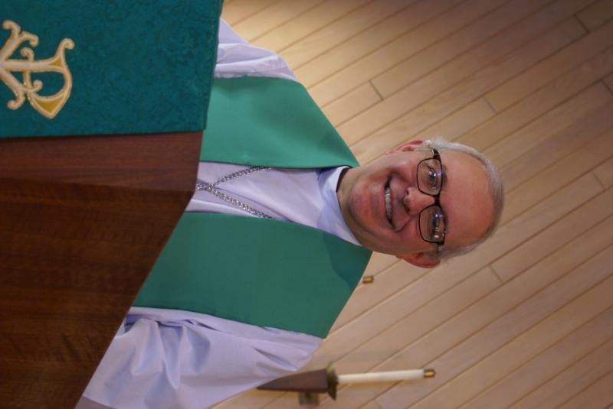
PASTOR’S MESSAGE

From the desk of Pastor David, May, 2023
I am writing you this letter the day before I leave for Thailand, the “Land of Smiles,” to visit my wife’s family. Thailand is called the “Land of Smiles” because the people are truly friendly and welcoming, and the country is a tropical paradise in many areas with some of the most famous and iconic beaches in the world. Most of the food is served with a spice level far above my tolerance, so on a trip like this , I actually expect to lose weight!

Christian missionaries first visited there in the 16th century and, starting in the late 19th century, a larger contingency, primarily from the Nordic countries, made a concerted effort to evangelize and set up schools, hospitals, and orphanages. Sadly, though, despite a serious and continuous effort to evangelize the nation over the past 150 years, today Thailand is less than 1% Christian. Buddhism remains the predominant religion at 95% of the population with Islam second at 4% (primarily in the far south of the country on the border with Indonesia and Malaysia, two of the most heavily populated Muslim countries in the world).

I always thank God for all of you who remain beacons of light of the love of God in our community. Trips like this make me want to work even harder to make sure that light never gets extinguished in our own land.

Blessings to you all,
Pastor David
Pastor’s Hours at church
Tuesdays and Thursdays from 6 pm – 9 pm
Saturdays from 9 – noon Sundays from 8:30 am for 3-4 hours

ASCENSION DAY will be celebrated this year on Thursday, May 18th.
This day commemorates Jesus Christ’s ascension into heaven.
Appropriate scripture passages to focus on during this day include:

Acts 1: 1-11
This Photo by Unknown Author is licensed under CC BY
Psalm 47 or Psalm 93
Ephesians 1: 15-23
Luke 24: 44-53

APRIL VISION TEAM REPORT
The Vision Team met on April 11th

- A congregational meeting will be held immediately following worship on Sunday, June 4th to approve the 2022 Audit, review worship times and discuss/approve Pastor’s contract which is up on July 1st OR officially call him to Grace if we are able to. If you have input about calling Pastor, please let a Vision Team member know and complete a survey, available in the Gathering Room and due by May 21st.
- Grace passed the annual Fire Department inspection
- Discussed the need to review our insurance policy – will meet with our agent

Please remember to greet visitors each Sunday and ask them to sign the register.

The Vision Team meets on the second Tuesday of each month. If you have items you feel should be discussed by the team, please send them to Marty by the first Tuesday of the month.

Easter Blessings, Marty Bradley, President


MANY THANKS AND PRAYERS TO THOSE WHO HAVE RECENTLY DONATED THEIR TIME AND TALENTS, including, but not limited to:

- George and Gloria Theros and many other volunteers and chefs for the wonderful spaghetti dinner on April 1st.
- Linda Smykowski and Cathy Lindquist for coordinating the Easter breakfast and to all who provided food. Delicious!
- Cathy Whiteside for creating and placing ads about Grace
- Tom Barton for providing weed and feed and for spreading it
- Pat Penfold, Nancy Corbige, Natalia Diehl and Janice Muncie for teaching Sunday School this past school year
(continued on next page)
- Paul and Dottie Mantsch for attending and voting on behalf of Grace at the ELCA Metropolitan Chicago synod assembly on June 3rd
- Pastor Jane Perkulop for filling in for Pastor during his vacation.
- Large thanks to Nancy Corbige for leading the Line Dancing each week. It has brought a lot of people into the building as well as a large free will offering. Much fun and some weight lose. Last chance to dance is June 1!
- Rebecca Circle for soup sales that raised $790 for our general fund.

VOLUNTEERS NEEDED
- Volunteers needed to assist with computers during worship – easy tech items; please see George if you can help
- Fall Sunday School: coordinator and teachers needed, see Marty to volunteer

FINANCIAL MATTERS – MAY 2023

- Our 1st Qtr of the year has proved to be fruitful for Grace in meeting our financial needs. Your donations have been a blessing to Grace and allow us to continue on our journey in a variety of ministries and help us serve our community. Our prayers for continued growth in Christ and continued growth here at Grace as we journey through the 2nd qtr.

- The community Spaghetti Dinner held on April 1, helped raise funds for the Northern IL Food Bank: $438. Thank you to George + Gloria Theros for heading up this event, with many helping hands in assisting at the event.

- Nancy Corbige has graciously shared her time, talents and leadership with bringing line-dancing to Grace AND our community each week since January. Fun, fellowship and exercise = has also raised over $1,300.

- The Building Maintenance Team has been reviewing and addressing building and safety needs. If you wish to donate to this specific fund, please notate “Building Maintenance Fund”, so the donation will be designated accordingly. Present Building Maintenance Fund balance is $4,665. Noisy offering collections add up as well – we are grateful for all donations big and small.

Brief recap of March financials:
2023 2022
March 2023 Year-to-Date Year-to-Date

INCOME $ 14,901 $ 49,654 $ 41,066
EXPENSES $ 15,054 $ 47,757 $ 47,765
NET +/- $ - 153 $ 1,897 $ -6,699

Pray for blessings upon Grace as we continue our missions with goals and challenges in 2023.
In Peace, Tricia Painter, Treasurer
.
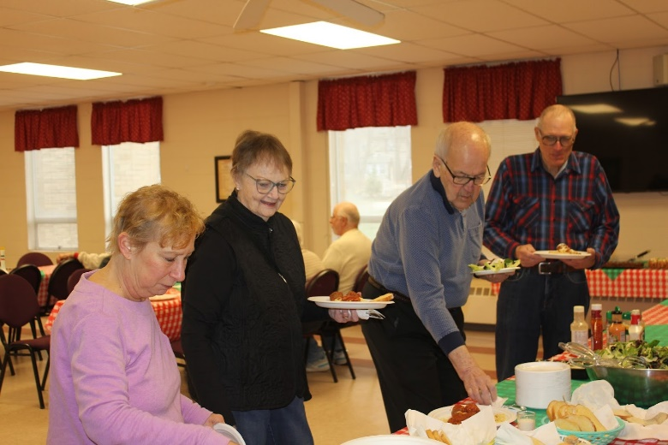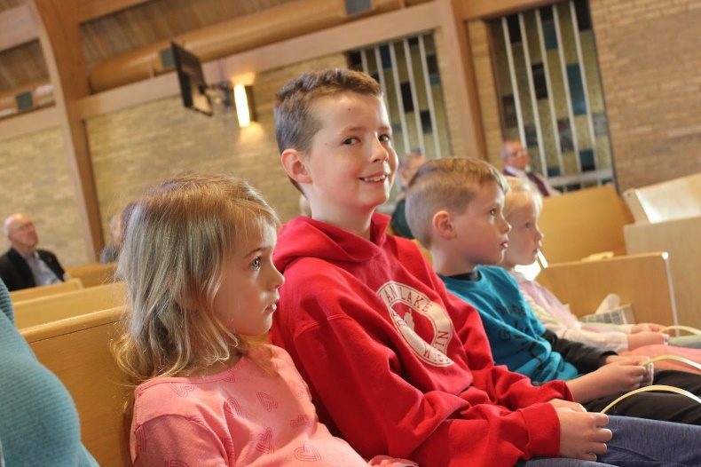



Meet the Roach’s

We are happy to introduce our family: Josh, Marla, Bethany, Abby, and (baby girl to be) Roach. Marla grew up attending Grace Lutheran Church and was baptized and confirmed here.

She is a Software Engineer working part-time at Eagle Engraving in St. Charles and takes care of Grace’s website. Josh grew up in the Northwest (Bellingham, Washington) and is currently an Emergency Room Doctor in Wisconsin.

Marla and Josh met while living in Denver for work and school, moved to Dayton, Ohio for Josh’s residency, and have hopefully made a final move into The Windings neighborhood in St. Charles.

We have two little girls: Bethany (age 4) and Abby (age 2) as well as one on the way due in May. We enjoy outdoor activities, tennis, traveling, cars (Josh), and the kids would like to add that they enjoy the two movies, Frozen and Moana. We are very excited to continue to support the Grace Lutheran Church family.
Welcome!

REBECCA CIRCLE

May meeting will be on Tuesday the 16th at 1 pm in fellowship hall.
Please join us.

Rebecca Circle fundraiser: We purchased a total of 173 Frontier dry soup mixes to sell for a fundraiser. We raised $780 for Grace’s general fund. Besides selling to family and friends before and after church, mixes were sold at the Christmas cookie sale, Thursday line dancing, Lifeline screening event, and at the polls here at Grace. I guess we could say we gave $790 to the general fund because one lady said to give her $10 change to the church!
Thank you Rebecca!

COVID 19, FLU AND RSV SAFETY PROTOCOLS
We follow the recommendations of the CDC, ELCA and IL Department of Health.
If you wish to mask and social distance, please do so. Please do not come to church if
have symptoms of illness. If you do not feel comfortable worshipping with others, we invite
you to join us for worship via our website.

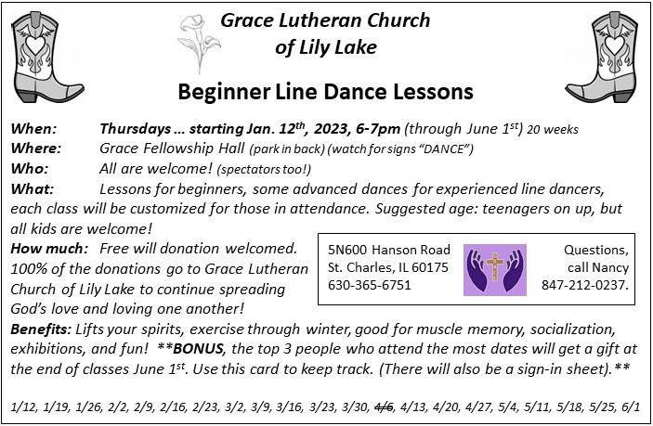
*Additional DATES TO REMEMBER*

- May 19 & 20 (set-up May 18) – Yes, the Spring Rummage Sale
- Thurs. - May 18 – set-up – 9am – until late afternoon/finished
- Fri. - May 19 – Sale: 9am – 4pm – volunteers needed by 8:30 and throughout the day
- Sat. - May 20 – Sale: 9am – 2pm – volunteers needed throughout the day ; ** 2pm Clean-Up
- Donations are being accepted after church services April 30, May 7 & 14. Larger items to be dropped off May 16 & 17 *various times – please contact us if you need assistance when dropping off
- May 18 (drop-offs = 10am-2pm) – please have your donations dropped off before 2pm so we have time to get your items set out – Thank you!
- As a reminder: we cannot accept older TVs, no TV / ‘entertainment’ cabinets. Items that are clean, vacuumed and in working order, with cords, accessories, etc. Ask yourself “would I buy this?” and if ‘no’, please pass this item on yourself (we don’t have the woman/manpower ).
- Please contact any of us with any questions: Tricia Painter 708-624-0400 Linda Smykowski 708-309-3444 Cathy Whiteside 630-605-1096. Looking forward to a wonderful community sale!


- June 3 – 2023 ELCA Metropolitan Chicago Synod Assembly
Theme: In Jesus: Make Disciples
Dottie and Paul Mantsch will be representing us there.


VACATION BIBLE SCHOOL
St. Peter’s Evangelical Lutheran Church
open to all Grace members on June 26-30 9:00 am - 11::45 am (M-TH) 9:00 am - 10:00 am (F) For ages 4 through Grade 6. And students in Grade 7 and up can register as youth crew leaders* Fee: $10/child (payable first day of VBSS. *There is no fee for student volunteers) Registration opens May 1st.
43W301 Plank Road Hampshire, IL 601
www.stpetersnorthplato.org
847-464-5721



GRACE ROADRUNNERS
Registration has begun for the Grace Roadrunners trip to Niagara Falls, September 18-23. Some places and sights we’ll be exploring are Notre Dame, RV/MH Museum, Rock and Roll Hall of Fame and many sites around Niagara Falls including Niagara on the Lake and Old Fort Niagara. As we head back home we’ll see a Jaws with Paws demonstration and Rutherford B. Hayes’ home. This trip will cost $1100-$1300 per person based on double occupancy and how many people sign up. A deposit of $500 due by May 15th holds your place with the balance due August 1st. The first 40 registrations are guaranteed a spot and then a wait list will be started. Registration forms will be in the Roadrunner mailbox in the church office. Contact Suzanne Girsch if you have questions.
BUILDING USE DONATIONS

The Vision Team has approved a guide for donations for personal use of areas of the building and staff (Pastor, Organist, Tech Person, and Sexton) for both members and non-members. I.E.: weddings, funerals, family gatherings, outside meetings, etc. This is standard procedure for congregations and will assist us in maintaining our building as well as covering the use of utilities/maintenance. A copy of the donation list is available in the Church Office.
If you have any questions, please contact any Vision Team Member.

CONTACTS:
For emergencies please contact Marty Bradley, President, at 640-777-1074 or leave a message at the church office at 630-365-6751.
For prayer requests or other needs please call Kathy Hooey at 630-341-2293 or leave a message at the church office at 630-365-6751. Messages are checked daily at noon & 5 pm.

Information for the June newsletter will be due by May 25th – please send it to Marty Bradley at martybradley@mchsi.com. Thank you!



PENTECOST, MAY 28

